Aboriginal and Torres Strait Islander Cultural Learning Strategy 2020–25
© 2020 Victoria Legal Aid. Reproduction without express written permission is prohibited. Written requests should be directed to Victoria Legal Aid, Corporate Affairs, Level 9, 570 Bourke Street, Melbourne Vic 3000.
Disclaimer. The material in this publication is intended as a general guide only. The information contained should not be relied upon as legal advice and should be checked carefully before being relied upon in any context. Victoria Legal Aid expressly disclaims any liability howsoever caused to any person in respect of any legal advice given or any action taken in reliance on the contents of the publication.

Contents
Acknowledgement of Country 1
Foreword 2
Supporting statement from First Nations Staff Network 3
Development of Strategy 3
Introduction 4
Cultural safety – a definition 4
Why do we need a cultural learning strategy? 5
Our cultural learning journey so far 5
Steps to achieving cultural safety – a continuum 6
Our cultural learning program 7
Tier 1 – Building cultural awareness 8
Tier 2 – Developing cultural sensitivity and competency 8
Tier 3 – Establishing cultural safety 9
Monitoring and tracking our progress 9
References 10

Acknowledgement of Country
Victoria Legal Aid acknowledges the Traditional Custodians of the lands where we work, and pays respect to their Elders past, present, and emerging. We recognise their continuing connection to Country and the resilience, diversity and strength of Victoria’s Aboriginal Communities.

Foreword
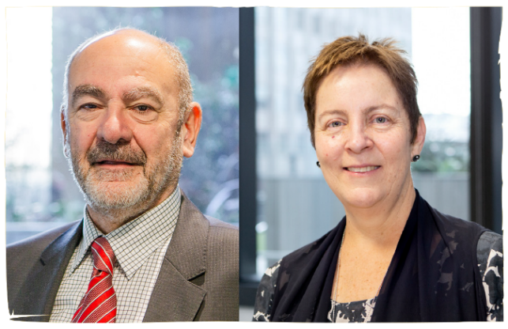
On behalf of Victoria Legal Aid (VLA), we are pleased to present our first Aboriginal and Torres Strait Islander Cultural Learning Strategy 2020–25.
We acknowledge the Victorian Aboriginal Legal Service and Djirra as leaders in providing culturally appropriate legal services for Aboriginal and Torres Strait Islander people. Clients may choose an Aboriginal controlled legal service and we support this thoroughly. Our commitment to self-determination is to ensure that our services are also culturally safe.
As a large legal practice in Victoria we play an important role in improving how Aboriginal and Torres Strait Islander people access and experience our organisation and the legal system more broadly. In order to effectively contribute to social justice for Aboriginal and Torres Strait Islander people, we must be culturally safe and responsive, understand the impact of colonisation and how this continues to be felt by communities today. It is important that we value and respect the cultures, skills, experiences, and voices of First Nations staff, clients and community.
The strategy underpins our commitment to offer robust training and development to all staff so we can build a greater understanding of Aboriginal and Torres Strait Islander peoples and culture. It includes a range of formal and informal learning activities, which have all been developed by First Nations peoples tailored for our operating environment and the specific communities we serve across Victoria. It recognises the diversity within Aboriginal and Torres Strait Islander communities and encourages staff to develop a deeper understanding of their local history and experiences.
The learning that will be supported by this strategy is intended to make us stronger leaders, more thoughtful colleagues and culturally-informed providers of critical services to the Victorian community. The learning and reflection required to offer our clients cultural safety is an ongoing process that requires active commitment and coordination. This strategy formalises and focuses these efforts.
We thank our First Nations Staff Network for their leadership leading the development of this strategy.
Bill Jaboor, Chairperson, Victoria Legal Aid Board
Louise Glanville, Chief Executive Officer, Victoria Legal Aid

Supporting statement from First Nations Staff Network
The First Nations Staff Network welcomes the development of Victoria Legal Aid’s first Aboriginal and Torres Strait Islander Cultural Learning Strategy 2020–25. We are proud of our organisation’s clear commitment to self-determination and recognition of the value and importance of our knowledge and experiences. The objectives of this strategy will be for the betterment of our communities across Victoria. It will also be supporting us, as First Nations staff, to work in a culturally safe and supportive work environment, where our voices are sought, heard, and valued.

Development of strategy
The Aboriginal and Torres Strait Islander Cultural Learning Strategy 2020–25 has been developed in collaboration and consultation with our Aboriginal Services team, People and Culture team and First Nations Staff Network. The First Nation Staff Network provides a collective voice of expertise within Victoria Legal Aid. It offers cultural support and connection between First Nations staff who work across the state.
We would like to acknowledge and thank the efforts, commitments and contributions of all who have assisted in the development of this strategy.

Introduction
The Aboriginal and Torres Strait Islander Cultural Learning Strategy 2020–25 (Cultural Learning Strategy) provides a basis for Victoria Legal Aid (VLA) to create, maintain and sustain a culturally safe and inclusive workplace for First Nations staff and improve our service delivery for Aboriginal and Torres Strait Islander clients.
We aim to position VLA as an employer of choice for First Nations people. We are committed to increasing our First Nations workforce from 2.3 per cent to five per cent by 2025, to be reflective of the proportion of Aboriginal and Torres Strait Islander clients we serve.
The Cultural Learning Strategy provides a five-year roadmap for building cultural competency and safety across our organisation. It introduces:
- the cultural safety continuum, a four-step process towards cultural safety
- a multi-tiered learning approach that supports progression through the continuum
- supporting tools integrated in our performance management process to assist ongoing reflective practice.
The Cultural Learning Strategy aims to embed culturally safe practices across VLA, making cultural safety everyone’s business. We all have a role to play in the delivery of this strategy, as it is up to all staff to build on the capacity and strength of our First Nations workforce.
The Cultural Learning Strategy is informed by and aligns with our Strategy 2018–22 (Strategy 22). It also sits alongside the following organisational plans and initiatives:
- Reconciliation Action Plan 2019–21
- Aboriginal Services Strategy 2020–25
- Aboriginal and Torres Strait Islander Employment Strategy 2020–25
- Cultural Diversity and Inclusion Strategy 2020–23
- Client First Strategy 2020–23
- Capability Framework
- Health, Safety and Wellbeing Strategy 2019–22.

Cultural safety – a definition
The concept of cultural safety emerged from the late 1980s and is drawn from the work of Maori nurses in New Zealand.
A common definition used to define cultural safety is:
‘An environment that is safe: where there is no assault, challenge or denial of their identity, of who they are and what they need. It is about shared respect, shared meaning, shared knowledge and experience, of learning, living and working together with dignity and truly listening.’
Culturally safe practices include actions which recognise and respect the cultural identities of others, and safely meet their needs, expectations and rights. Alternatively, culturally unsafe practices are those that ‘diminish, demean or disempower the cultural identity and well-being of an individual’.
Cultural safety is an outcome where Aboriginal and Torres Strait Islander people experience respect for their cultural identity and ways of being, without challenge or harm. Cultural safety is determined by the person on the receiving end of the interaction, care and/or service. Our First Nations staff and Aboriginal and Torres Strait Islander clients are best placed to provide genuine perspectives on the cultural safety of our organisation and service.

Why do we need a cultural learning strategy?
The Cultural Learning Strategy lays the foundations to progress the priorities and actions outlined in our Reconciliation Action Plan 2019–21 (RAP), Aboriginal and Torres Strait Islander Employment Strategy 2020–25 and Aboriginal Services Strategy 2020–25.
Culturally safe workplaces and services contribute to empowerment and self-determination for Aboriginal and Torres Strait Islander people and communities. The Victorian Government Self-Determination Reform Framework lists cultural safety as one of the eleven guiding principles in enabling self-determination. A workplace that values and respects the cultures, skills, experiences and voices of First Nations staff will be more desirable for First Nations people seeking employment.
Greater cultural safety across our organisation will improve employment opportunities and experiences for First Nations staff, improve attraction and retention outcomes and build a safe and inclusive workplace for everyone. It will ultimately improve outcomes for Aboriginal and Torres Strait Islander peoples within the legal systems.

Our cultural learning journey so far
Prior to 2019, we attempted a number of different approaches to build cultural safety across our organisation, including the provision of face-to-face cultural learning workshops. Analysis of our cultural learning needs highlighted that these offerings were limited, delivered on an ad hoc basis and did not articulate a clear learning path for staff to continuously build their cultural safety competence.
Our 2018 Gender, Diversity and Inclusion survey captured First Nations staff’s experiences of inclusion within VLA. The key themes of the survey drew attention to the lack of awareness around cultural safety demonstrated by our staff. This reinforced the need for committed, ongoing cultural learning for all staff.
From 2019, we shifted the way we approached cultural learning. We recognise that working towards and improving individual and organisational cultural safety is an ongoing learning process and cannot be achieved through one or two stand-alone training sessions.
Keeping these learnings in mind, our Cultural Learning Strategy is phased over five years. It involves building understanding of the cumulative effects of colonisation and how this has created ongoing disadvantage for Aboriginal and Torres Strait Islander people. It is about increasing recognition and respect for the diversity that exists for Aboriginal and Torres Strait Islander people, their communities and culture. This requires staff to develop self-awareness through ongoing reflective practice as well as developing skills for working effectively with Aboriginal and Torres Strait Islander people.
Since February 2019, we have introduced two cultural learning offerings from our multi-tiered approach:
- Aboriginal culture: Other ways of knowing eLearning module
- Aboriginal and Torres Strait Islander cultural awareness face-to-face training (delivered by an Aboriginal-controlled organisation).
We recognise that our cultural learning journey is a continuous process that will take time, effort and commitment. The outcomes will build sequentially on an annual basis, resulting in an ever-increasing organisational capacity to provide a culturally aware, sensitive, competent and safe workplace and service.

Steps to achieving cultural safety – a continuum
Our Cultural Learning Strategy introduces a four-step continuum towards cultural safety. This continuum is further supported by our multi-tiered approach to learning. Progressing through the continuum from left to right will guide staff in developing a stronger and more integrated understanding and application of cultural safety in the workplace and service delivery.
The four steps in the cultural safety continuum:
- Cultural awareness is the first step where we gain knowledge that cultural differences exist. It involves building awareness about Aboriginal and Torres Strait Islander culture and becoming aware of our own cultural values, beliefs and perceptions and how this differs.
- Cultural sensitivity is the second step and involves being sensitive to these cultural differences. It involves a set of skills that allows us to learn and understand people whose cultural background is different to our own without making judgements.
- Cultural competency is the third step and is a set of behaviours, attitudes and policies that come together to allow people to work effectively in cross-cultural situations.
- Cultural safety is the final step. It delivers outcomes where all people are treated in a culturally respectful manner.
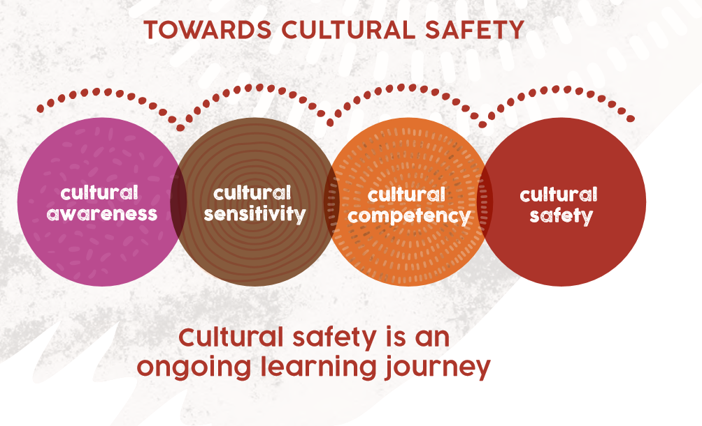
Achieving cultural safety is a cyclical process that is dynamic and ongoing. An individual’s place on the continuum can shift back and forth depending on context.
As individual and organisational cultural safety is strengthened, a change will be triggered in our cultural awareness. This will lead to an increased ability to apply learning and understanding of practices to establish a greater level of cultural safety.
The cultural safety continuum can also be applied when working with people from culturally and linguistically diverse backgrounds, people with a disability and LGBTIQ+ people (lesbian, gay, bisexual, transgender, diverse sex characteristics (intersex), queer, and other diverse gender identities and sexualities).

Our cultural learning program
Our cultural learning program articulates a clear learning path for staff to continuously build their cultural safety competence. It is based on learning as a lifelong journey. Tier 1 and tier 2 consists of a blend of formal and informal learning activities for staff to engage with on an annual basis. It includes access to e-learnings, face-to-face workshops, cultural immersion activities and online resources. The variety of learning options available will contribute to staff building a greater understanding of Aboriginal and Torres Strait Islander people and communities. Tier 3 supports ongoing reflective practice and operates in parallel with tier 1 and tier 2.
The completion of cultural learning offerings at each tier does not necessarily mean a person is ‘culturally aware’ or ‘culturally competent’. Cultural competency is dependent on an individual’s openness, willingness and engagement with the learning activities at each tier.

Tier 1 – Building cultural awareness
Tier 1 is the first step in the learning journey and provides staff with an introduction to Aboriginal and Torres Strait Islander people, culture and community. This tier builds awareness, understanding and appreciation of Aboriginal and Torres Strait Islander culture, beliefs and practices and focuses on a shared understanding of Australia’s history.
Formal cultural offerings available via the Learning Hub:
- Diversity and inclusion in the workplace (e-learn)
- Respectful workplace behaviours training (e-learn)
- Aboriginal culture: Other ways of knowing (e-learn)
- Aboriginal and Torres Strait Islander cultural awareness training (face-to-face).
Staff can consolidate and expand their cultural awareness through informal activities such as:
- reading our Reconciliation Action Plan 2019–21
- reading our Yammer discussion about the 26 January public holiday and some tips on how to approach the 26 January public holiday respectfully
- learning about cultural protocols such as organising a Welcome to Country and conducting an Acknowledgement of Country
- attending VLA and/or local Aboriginal and Torres Strait Islander events and celebrations, such as National Reconciliation Week, NAIDOC Week and the commemoration of the National Apology to the Stolen Generations
- attending exhibitions or other cultural related events such as festivals, film or theatre commemorating or exploring Aboriginal and Torres Strait Islander culture and experience.

Tier 2 – Developing cultural sensitivity and competency
Tier 2 aims to build cultural sensitivity and competency by equipping staff with the skills required to work respectfully with First Nations staff and to deliver culturally responsive services to Aboriginal and Torres Strait Islander clients.
Formal cultural offerings available via the Learning Hub:
- Working inclusively with Aboriginal and Torres Strait Islander clients (e-learn)
- Unconscious bias (e-learn).
This tier will also include a face-to-face cultural learning offering that aims to provide staff with practical tips and skills that can be utilised to improve practice and behaviour, which will assist in Aboriginal and Torres Strait Islander people feeling safe. Scoping is currently underway to identify an Aboriginal-controlled organisation to deliver this offering.
Staff can extend their cultural sensitivity and competency through cultural immersion activities and accessing online resources such as articles, podcasts and videos via our Learning Hub (Diversity, Inclusion and Culture > Aboriginal and Torres Strait Islander culture).

Tier 3 – Establishing cultural safety
Tier 3 commits to establishing an ongoing practice that supports the delivery of outcomes where Aboriginal and Torres Strait Islander people are treated in a culturally respectful manner. This requires the establishment of policies, processes and practices that are inclusive of the cultural needs of Aboriginal and Torres Strait Islander people and clients.
Tier 3 includes cultural safety tools for our staff and practicing partners to support ongoing reflection and practice. This includes:

- Individual Cultural Safety Reflection Tool. This assists staff in reflecting on where they are at in their cultural learning journey and identify further learnings to improve their cultural safety competency through an individual action plan. The tool will be integrated into our performance management process, VLA and Me.
- Organisational Cultural Safety Reflection Tool. This will assist VLA to continually identify and implement the necessary actions to achieve higher levels of cultural safety within our workplace and service delivery.

Monitoring and tracking our progress
We are committed to monitoring and tracking our progress towards achieving cultural safety for Aboriginal and Torres Strait Islander people.
First Nations governance is vital to achieving a culturally safe workplace and service. Our First Nations workforce and clients are best placed to monitor and provide genuine perspectives on the cultural safety of our organisation and services.
Over the next five years, we will assess and report on the following measures to understand our progress:
- increased participation in our cultural learning program
- First Nations staff experience VLA as a culturally safe workplace and feel able to draw strength in their identity, culture and community
- increased satisfaction from Aboriginal and Torres Strait Islander people, families and communities with the service we provide.
Evaluation of these measures will occur through existing mechanisms such as our learning and development reports. We will also establish new or improved mechanisms. These include:
- staff exit interviews and surveys to inform culturally safe practices
- annual cultural safety survey conducted for First Nations staff
- client satisfaction survey strategically deployed for Aboriginal and Torres Strait Islander clients.
Our cultural safety measures will sit alongside the evaluation of our Reconciliation Action Plan 2019–21, Aboriginal Services Strategy 2020–25 and Aboriginal and Torres Strait Islander Employment Strategy 2020–25. It will inform a process of continuous improvement and enable us to develop further approaches to provide a culturally safe workplace for First Nations staff and service delivery for Aboriginal and Torres Strait Islander clients.

References
- Department of Health and Human Services (DHHS) Cultural Safety Framework
- Nursing Council of New Zealand. (2002). Guidelines for cultural safety, the treaty of Waitangi, and Maori health in nursing and midwifery education and practice. Wellington: Nursing Council of New Zealand.
- Strengthening the Cultural Safety of Family Violence Services Project (Strengthening the Cultural Safety Project).
- Williams, R. (2008), Cultural safety; what does it mean for our work practice? Australian and New Zealand Journal of Public Health, 23(2):213-214
- National Aboriginal and Torres Strait Islander Health Workers Association (NATSHIWA): Cultural Safety Framework
- Australian Indigenous Doctors’ Association, 2013, Position Paper Cultural Safety for Aboriginal and Torres Strait Islander Doctors, Medical Students and Patients, AIDA, Canberra.
- Aboriginal Victoria Self-Determination Reform Framework

As of 30 April 2020
Aboriginal and Torres Strait Islander clients currently constitute at least five per cent of our overall clients (VLA’s 2018-19 Annual Report)
Williams, R. (2008), Cultural safety; what does it mean for our work practice? Australian and New Zealand Journal of Public Health, 23(2):213-214
Council of New Zealand. (2002). Guidelines for cultural safety, the treaty of Waitangi, and Maori health in nursing and midwifery education and practice. Wellington: Nursing Council of New Zealand.
Council of New Zealand. (2002). Guidelines for cultural safety, the treaty of Waitangi, and Maori health in nursing and midwifery education and practice. Wellington: Nursing Council of New Zealand
Aboriginal Victoria Self-Determination Reform Framework (https://www.aboriginalvictoria.vic.gov.au/self-determination-reform-framework)
Australian Indigenous Doctors’ Association, 2013, Position Paper Cultural Safety for Aboriginal and Torres Strait Islander Doctors, Medical Students and Patients, AIDA, Canberra.
The Aboriginal culture: Other ways of knowing e-learning is a pre-requisite for staff attending the Aboriginal and Torres Strait Islander cultural awareness face-to-face training.

