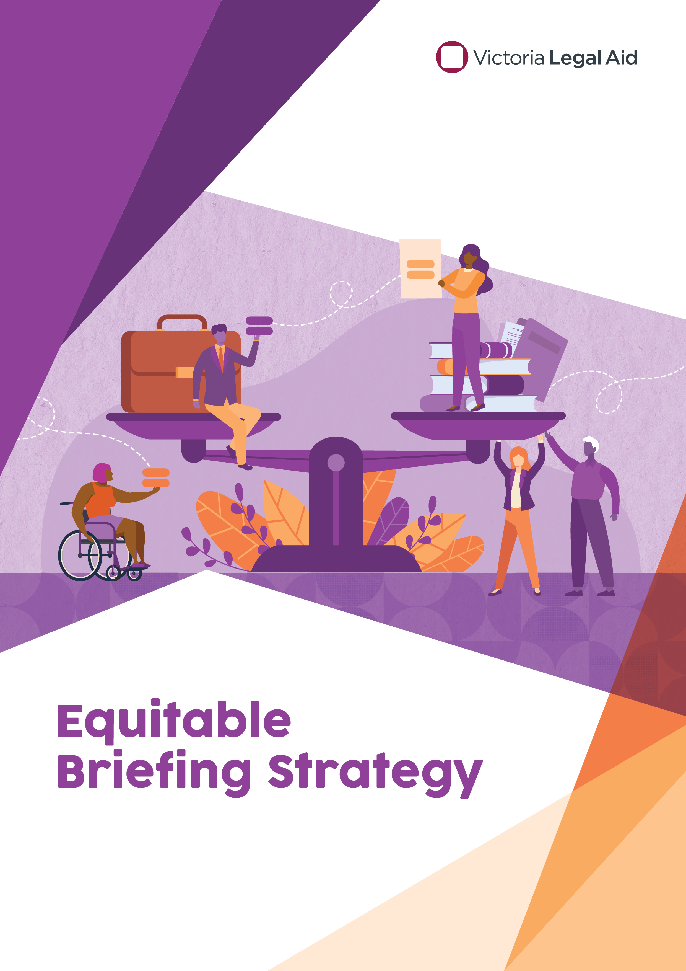
Victoria Legal Aid Equitable Briefing Strategy

Equitable Briefing
Equitable briefing is both a value and a process. As a value, it is the goal of ensuring that, as one of the largest briefers in the State, the barristers and advocates briefed by Victoria Legal Aid (VLA) are reflective of the diversity of the community we serve. It is the process of maximising the briefing of advocates who possess both the skills and knowledge required for a brief, and who reflect the diversity of our community, and minimising discrimination against advocates by reasons of gender, being an Aboriginal and/or Torres Strait Islander person, cultural background, disability, sexual orientation, or age.
As one of Victoria’s largest briefers and providers of legal assistance services, VLA has a unique ability to drive change. As an organisation that is committed to fairness we must strive for equity, not just for our clients, but also in the way we operate. This strategy will guide fairer briefing practices and allow VLA to lead by example by creating more opportunities and promoting greater diversity within the legal profession. A more diverse practice of the law is more likely to reflect the broader community and be sensitive and responsive to community needs and systemic and individual issues that arise.

Connection to VLA’s commitment to diversity and inclusion
Inequality within the legal profession is a long standing and well documented issue. This strategy has been developed with VLA’s vision, values and its commitment to diversity and inclusion in mind, particularly referencing VLA’s:
- Cultural Diversity and Inclusion Strategy 2020–23
- Reconciliation Action Plan 2019 – 2021
- Client First Strategy
- Gender Equality Action Plan
- Disability Action Plan

The six objectives of this strategy
VLA’s Equitable Briefing Strategy focusses on the six objectives of: briefing targets, briefing processes, how we engage for services, training and development, external engagement and performance reporting. Recognising that change will take time, this strategy aims to embed these six areas into VLA’s normal operations over the next four years, with the overall objective of seeing marked improvement in the equality and diversity of briefing practices within VLA and in the wider legal sector by 2025.

Objective 1: We will achieve equitable briefing targets
As one of the largest briefers in the state VLA can influence positive change. VLA is committed to promoting the equity and diversity of barristers who are briefed in legally aided matters, and we will attempt to achieve this goal by setting equitable briefing targets across the organisation.
We will encourage all people or entities who brief or select counsel to make all reasonable endeavours to brief or select women and diverse counsel with expertise and interest in the relevant practice area. Where the term “women” is used, this is intended to include all people who identify as women. We know that equitable briefing means improvement in both the volume and value of briefs given to women and diverse counsel. The percentage targets below will be monitored both in terms of overall number of briefs and fees earned.
- By 31 December 2022:
- We commit to reaching the Law Council of Australia’s National Model Gender Equitable Briefing Policy target of at least 30% of all VLA inhouse briefs / briefing fees going to women counsel (junior and senior).
- Data relating to the gender of briefed counsel is currently only available in a binary way (for men and women) and data about diversity of counsel (for example cultural diversity) is not available at all. We are committed to obtaining and analysing briefing data of diversity of counsel by the end of 2022.
- By 31 December 2023:
- We commit to at least 40% of all VLA inhouse briefs / briefing fees going to women counsel (junior and senior) and to at least 30% of all private practitioner briefs / briefing fees going to women counsel (junior and senior).
- We commit to develop and implement targets for diversity of counsel including across all VLA inhouse briefs.
- By 31 December 2024:
- We commit to at least 50% of all VLA inhouse briefs / briefing fees going to women counsel (junior and senior) and to at least 40% of all private practitioner briefs / briefing fees going to women counsel (junior and senior).
- We commit to increasing the 2023 briefing targets for diversity of counsel across all VLA inhouse briefs and to applying the 2023 briefing targets to private practitioner briefs.
- By 31 December 2025:
- We commit to at least 50% of all VLA funded briefs / briefing fees going to women counsel (junior and senior).
- We commit to increasing the 2024 briefing targets for diversity of counsel across all VLA funded matters (inhouse and private practitioner).
Our ability to monitor briefing trends will rely on having readily available data. We can achieve this by creating an Equitable Briefing data dashboard. Having gender and diversity briefing data ready to hand will enable managers to monitor and discuss equitable briefing practices and any barriers to reaching equitable briefing targets at team meetings and planning days.

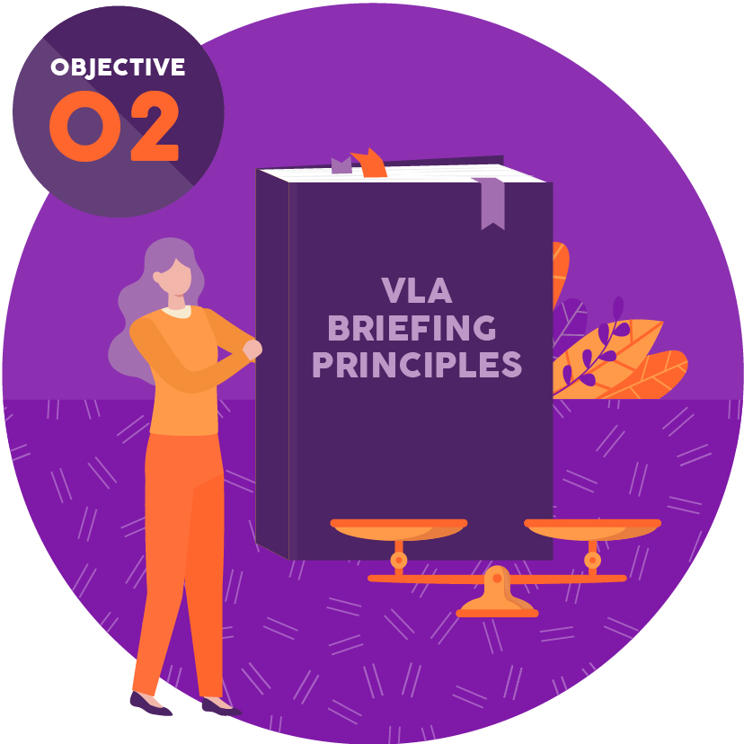
Objective 2: We will consider equitable briefing when selecting barristers
VLA is committed to briefing practices that promote equity and diversity. Currently, apart from some limited formal and informal policies around major criminal cases, solicitor advocacy and use of Chambers advocates, briefing choices are largely left to the discretion of staff. To promote our equitable briefing targets, we will require staff to apply a set of agreed ‘Briefing Principles’ when selecting a barrister for a legally aided case. This more structured and deliberative approach will drive consistent and equitable briefing choices. It will also provide a mechanism for discussion of availability issues or other constraints that are impeding our ability to reach equitable briefing targets.
VLA lawyers will be required to retain evidence on file that they have applied these considerations in briefing decisions. We will explore how this can be easily integrated as a step in the active casefile digitisation process. Managers will be encouraged to review adherence to VLA’s ‘Briefing Principles as part of the “Practice and task development and support” area of VLA’s Supervision Framework.

Objective 3: We will apply equitable briefing principles when we engage for services
To effect meaningful change, we must apply principles of equity and diversity to the significant volume of legal aid work performed by private practitioners and community legal centres (CLCs). We will achieve this by making equity and diversity targets a normal part of doing business with VLA. Examples of how we will do this are:
- By including commitment to equitable briefing targets in the conditions for VLA’s section 29A panel and in CLC funding agreements.
- By promoting equity and diversity when engaging for non-grant related services like private practitioner duty lawyer panels, Help Before Court providers and when briefing circuit court lists.
- By promoting equity and diversity in membership on preferred barrister lists.
Principles of equity and diversity must be considered when reviewing or creating documentation, policies and procedures that govern how we engage for services. An explicit statement should be included in the document addressing how it promotes VLA’s equity and diversity commitment.

Objective 4: We will promote diversity through training and development opportunities
If we accept that inequitable briefing trends are the result of a lack of diverse briefing choices at the Bar, we help to perpetuate the problem. VLA is committed to actively redressing the underrepresentation of women and diverse counsel through our briefing practices and through training and career development opportunities. Examples of how we will do this are:
- By preferencing women and diverse counsel for places in development programs, such as the trial counsel development program and new lawyers’ program.
- By preferencing women, and diverse counsel to act as junior counsel in matters where senior and junior counsel are approved.
- By building networks and extending specific invitations to women and diverse counsel to participate in career development and training opportunities run by VLA.

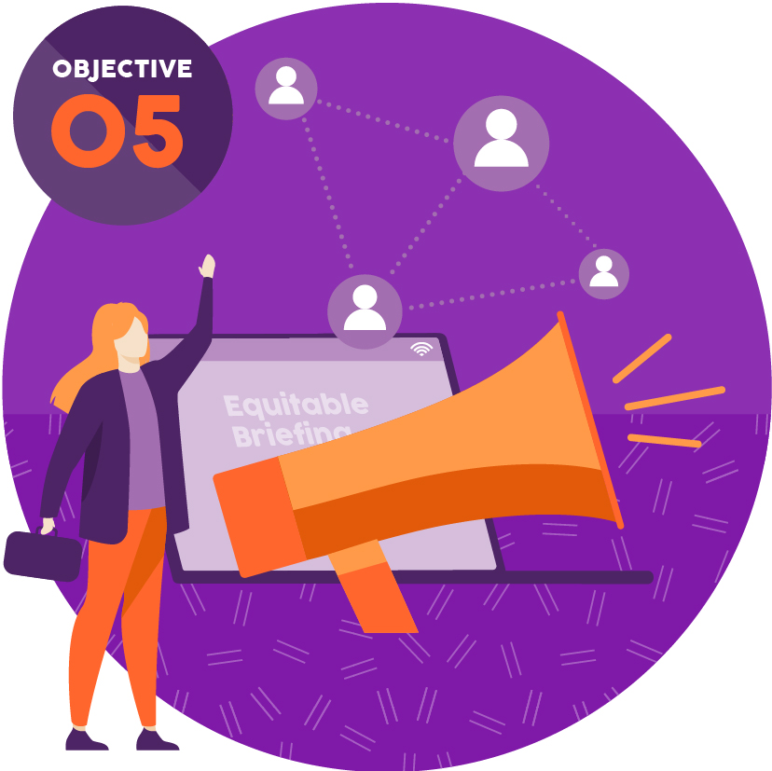
Objective 5: We will engage with external agencies, stakeholders, and the public to promote diversity
VLA will be vocal in its message of support of women and diverse counsel and open about its goal of actively redressing their underrepresentation in the legal profession. We will look for opportunities to share this message with our clients, our stakeholders, and the public. By doing this we will continuously erode the barriers and biases that contribute to inequality in the profession. We will frame our communications around determination, gradual change and long-term gains. This will avoid the possibility of an initial peak of enthusiasm followed by a lapse back to familiar practices.
We will promote our work on diversity through external agencies like the Law Institute of Victoria and Diversity Legal Associations. We will encourage the Victorian Bar to publish diversity information in barrister profiles on VicBar Lists to facilitate our diversity goals. We will create and share training and education on equitable briefing and unconscious bias with our practice partners.

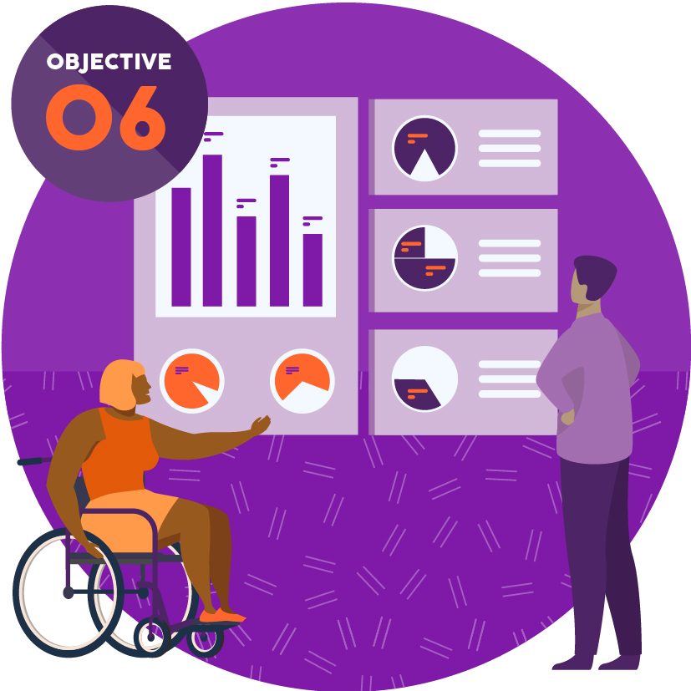
Objective 6: We will monitor and report transparently about our performance
VLA will produce a data dashboard to show real time briefing trends in practice and regional areas. It is expected that area managers will monitor equity and diversity briefing trends in their area and actively engage with staff to achieve briefing targets. If there are barriers to equitable briefing practices identified by the region or program these should be raised with the relevant director. VLA can then decide on strategies to address these barriers.
We are committed to open and transparent reporting of our performance. As an agency that promotes equality and fairness, we will provide the public with data about our operations that demonstrates our commitment. We will publicly report on our website:
- our performance against equitable briefing targets.
- deidentified data about equitable briefing targets achieved by our private practitioner partners.
- initiatives that we have completed to support equitable briefing and equity and diversity within the legal profession.

Implementation plan
This strategy outlines the six objectives for VLA’s overall vision of improved equality and diversity of briefing practices by 2025. An implementation plan that details specific actions, responsibilities and timeframes is being developed.

