Our Disability Action Plan
Victoria Legal Aid is making a Disability Action Plan.

We want to make sure:
- that our workplace is for everyone
- that everyone can be part of our services
- that we speak up to make things better for all people with disability

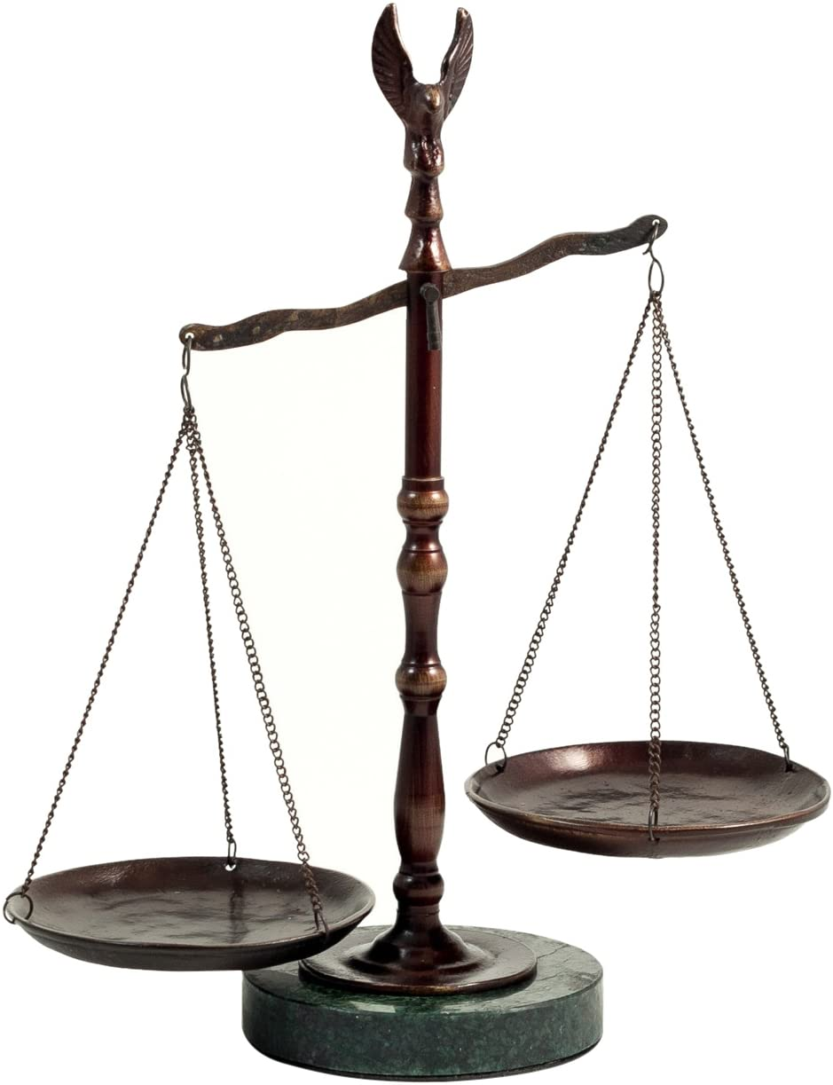

We are doing this so that all people are equal at Victoria Legal Aid and in the community.

We wrote the Disability Action Plan using these ideas
We support Aboriginal and Torres Strait Islander people to lead their own lives.

We listen to people when they tell their stories.
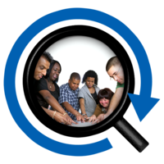
We want to change how things are done to make it better for people with disability

Some people are treated badly because of things like:
- what they believe in (religion)
- the country they were born in (ethnicity)
- who they love (sexuality)
- having a disability
- the colour of their skin (race)

We will support people who were treated badly because of more than one of these things.

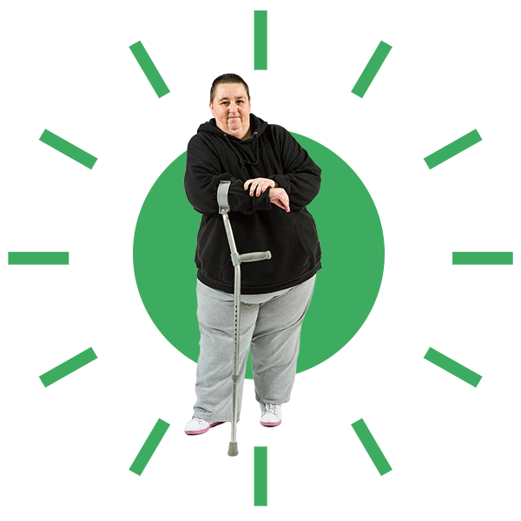

The person who wants our support comes first.

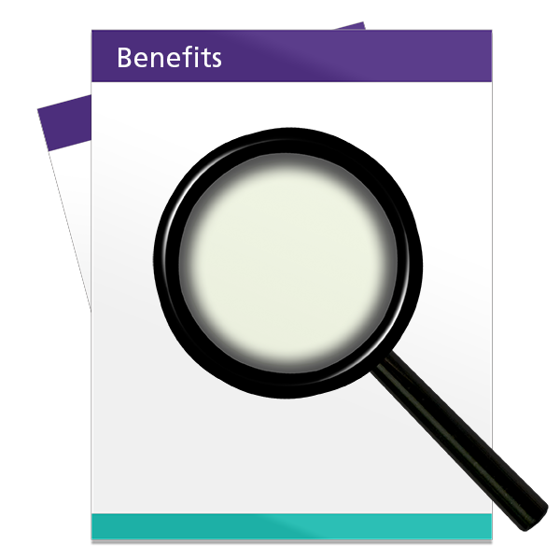
We look at what has been done before, learn from it and
use this to do our work.

How we will support our clients
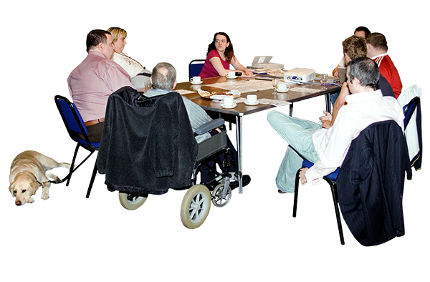
We will start a group made up of people with disability.
We will ask them to help us make our service better.

We will look at all the ways people with disability get information and support from us. We will think about how we can do this better.

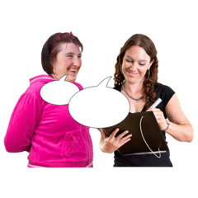

We will be better at how we ask people with disability for their information and how we write it down.

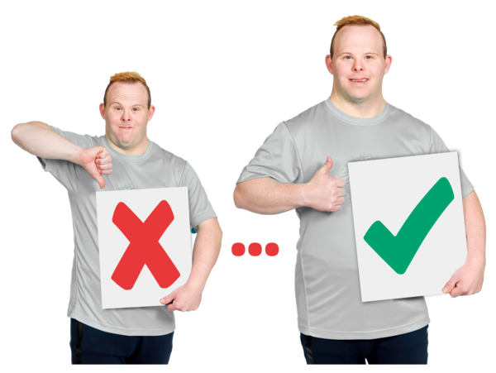
We will be better at how we support people with disability and give them information.

We will think about what people with disability need from us, like:
- the different services we have
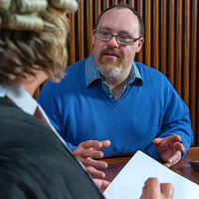
- who can use our service
- the way we do things
How we will support staff
We support our Disability Employee Network (DEN):
- by giving them information about our workplace
- to have a say on our rules and how we do our work
- to make sure everyone can be part of our service

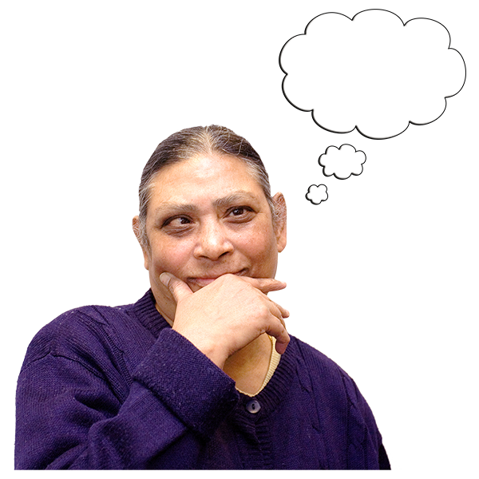

We will make it better for our workers with disability by getting the right information about what they need.

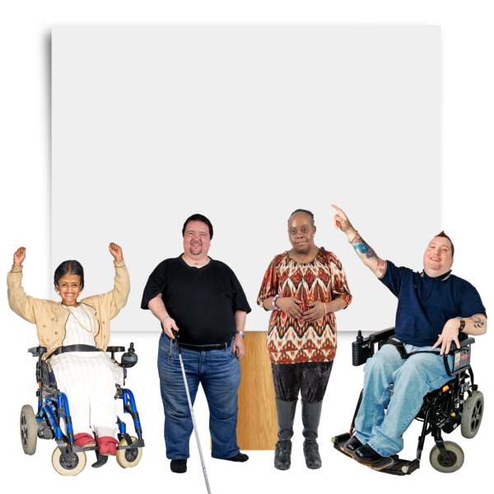
We will make Victoria Legal Aid a place where:
- people with disability are looked at in a good way
- everyone is safe
- everyone feels part of it

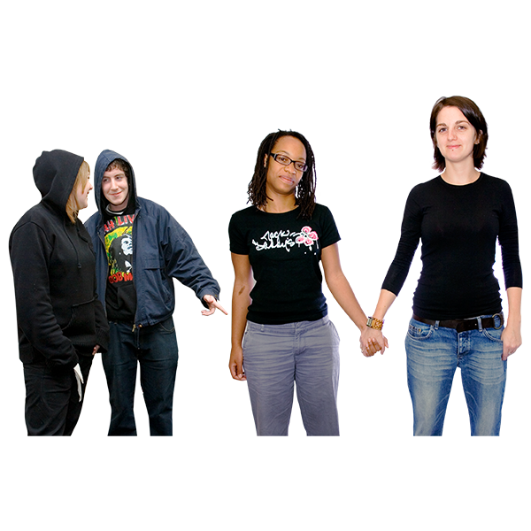

To make sure there is better support for workers who have been treated badly because of their disability and other things, like their race, religion, or sexuality. This will make sure everyone can be part of our workplace.

When we are looking for a new worker, we will give each person the support they need, so everyone has the same chance of getting the job.

To get better at supporting workers with disability who want to learn new things and do other jobs.

How we will support our community
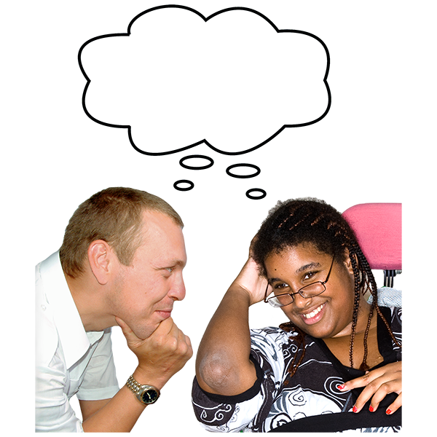
We will make out work better by listening to people with disability about:
- their life stories
- what they think
- what they know.
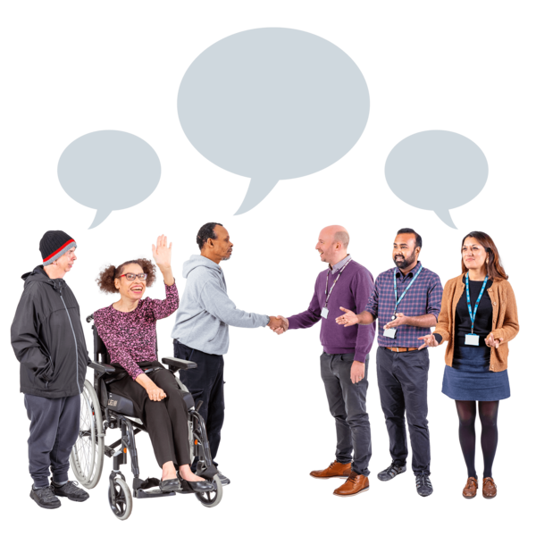

We will work with other services that support people with disability to have a say.

We will speak up for and help make changes. We want the community to think about and treat people with disability in a better way
This was
Developed by VALID (03) 9416 4003

