

Contents

Your guide to parking laws in Victoria 3

Parking your car 4

Parking laws – the basics 4

Where can't I stop or park? 4

How much space should I leave when I park? 7

Parking signs 8

Parking fines 12

Issuing parking fines – the basics 12

When might I not have to pay a parking fine? 12

What happens if I ignore a fine? 13

Getting more help 17

Legal services 17

Government agencies 17

Resources 17

# Your guide to parking laws in Victoria

Parking laws make our roads safer and the use of our parking spaces equitable so people can access shops and services when they need to. This guide explains common parking laws in Victoria and what you can do if you receive a fine. Keep the guide in your car for easy reference.

Find out more at [www.finefixer.org.au](http://www.finefixer.org.au)

To find out more, visit our [website](http://www.victorialawfoundation.org.au).

# Parking your car

This section explains some common parking laws and how to read parking signs so you can park correctly and avoid a fine.

## Parking laws – the basics

There are some rules that you need to obey every time you stop or park.

* Obey relevant parking signs (see page 8).
* Park within marked bays (if marked).
* Don’t obstruct traffic or pedestrians.
* Allow adequate space for cars to pass – if there is a continuous dividing line, there must be at least three metres between the side of your car and the line.

### Parallel parking

* Keep your car’s left wheels close to the kerb.
* Always park facing the same way as the direction of the traffic on your side of the road.
* If there are no marked parking bays, leave at least one metre between you and any car in front or behind you.
* Ensure driveways and foot ramps aren’t obstructed.

### Angle parking

In some places you will need to park at an angle (the signs or the markings will tell you this).

* Park at the angle indicated by the marked bays or by the parking sign.
* If there are no markings or no parking sign showing the angle, then park at 45 degrees.
* Park with the rear of your car to the road (unless the sign says otherwise).

### Parking in the centre of the road

* If signs allow parking in the centre of the road, drive in and out forwards (unless the sign says otherwise).

Remember, always read the parking signs

## Where can’t I stop or park?

Generally parking signs will tell you whether you can stop or park in a particular location. However, here are some common situations where, even if there are no signs, you can’t stop and/or park.

Double **parking**

* Don’t double-park (this means parking parallel next to another parked car).

### Road markings

* Don’t park where a road marking says ‘Keep clear.’
* Don’t park in a bus lane, tram lane or truck lane.
* Don’t park next to a continuous yellow line on the edge of the road.

### Bridges and tunnels

* Don’t park on a bridge, causeway or ramp, or in a tunnel, that’s narrower than the rest of the road. This is dangerous for passing cars.

### Obstructions

* Don’t park near something that’s obstructing traffic, such as a work site or something that’s fallen off a vehicle onto the road.

### Specific locations

* Don’t park with any part of your vehicle in a place you are not allowed to park. Even if only the front of your car is in a ‘No stopping’ area, you are breaking the law.
* Don’t park within 20 metres before a tram stop, unless a sign says you can.
* Don’t park on a bike path, footpath, shared footpath or dividing strip.
* Don’t park on a nature strip next to a road in a built-up area like a suburb or town.
* Don’t park in a slip lane (see image below), unless there are marked parking bays or signs permitting parking, or stop on a painted island.
* Don’t park within 20 metres of an intersection with traffic lights, or 10 metres of an intersection with no traffic lights unless signs permit parking.
* Don’t park on a freeway (except in an emergency stopping lane during an emergency).
* Don’t park across a lane or private driveway (you can stop here for up to two minutes if you’re dropping off or picking up passengers and don’t leave your car).
* Don’t park on the wrong side of the road.
* Don’t park on the curve of a road or a hilltop outside suburbs or towns, unless your car is visible for 100 metres from behind.

|  |
| --- |
| **Specific exceptions for bicycles, motorbikes and scooters**  ***Bicycles***  Unless a sign says otherwise, you can park your bicycle anywhere as long as it’s safe and not in anyone’s way.  ***Motorbikes and scooters***  Unless a sign says otherwise, you can park your motorbike or scooter on the footpath or the nature strip as long as it’s not obstructing pedestrians and drivers. It can also be parked at an angle in parallel parking areas. |

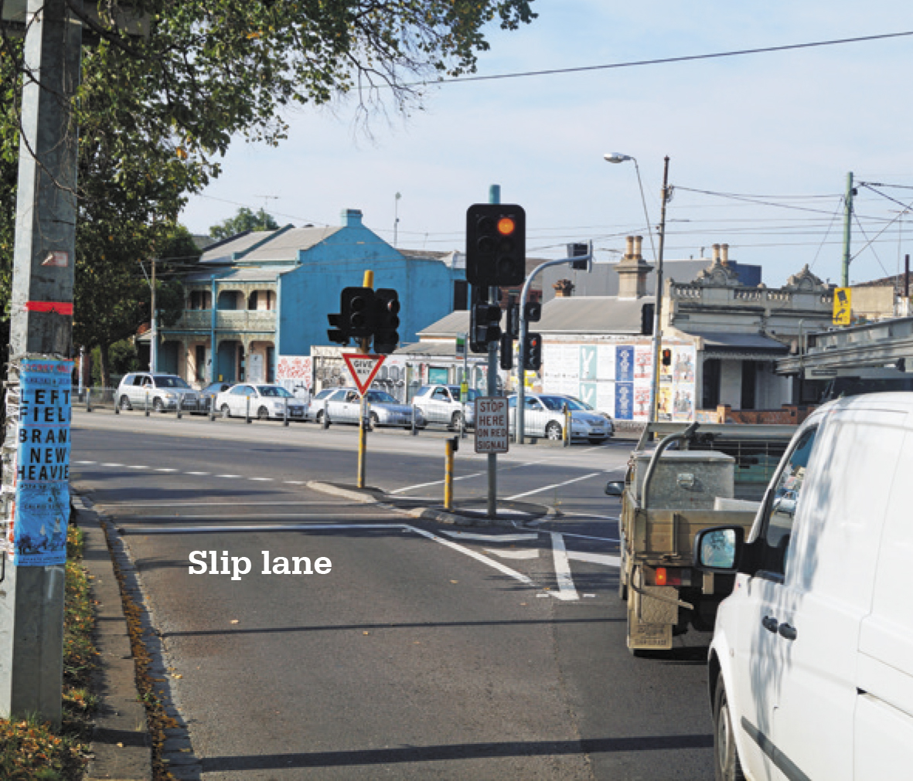

## How much space should I leave when I park?

|  |
| --- |
| Keeping the city moving **Greg is a parking enforcement officer with the City of Melbourne. He enjoys his work keeping the city moving.**  ‘When we walk around the city, we get all kinds of questions from people. We get a lot of questions about parking rules, and we’re always happy to explain them or the signs.  Parking laws are all about giving everyone a fair chance to park in the city.  If we see someone breaking a parking rule, we prefer to explain the problem and ask them to move their car. Our main aim is to keep the city moving.  People often don’t realise that many parking laws are there to keep people safe. For example, “No stopping” signs are really important – they are usually in places where it’d be dangerous to park.  My advice to people tempted to try to get away with parking in the wrong place or overstaying their time limit is to think of others.’ |

For safety reasons, you can’t stop close to the following road features and signs, unless a sign specifically says you can. The table below shows how many metres you need to leave before and after some common road features.

|  |  |  |
| --- | --- | --- |
| Sign or road feature | Metres before | Metres after |
| Australia Post mailbox | 3 | 3 |
| Bike crossing with lights | 10 | 3 |
| Bus stop | 20 | 10 |
| Children’s crossing | 20 | 10 |
| Fire hydrant | 1 | 1 |
| Intersection with traffic lights | 20 | 20 |
| Intersection without traffic lights | 10 | 10 |
| Level crossing | 20 | 20 |
| Pedestrian crossing  (not at intersection) | 20 | 10 |
| Safety zone | 10 | 10 |
| Tram stop | 20 | – |

## Parking signs

### Common parking signs

A range of common parking signs tell you where you can and can’t park. Read parking signs carefully and pay attention to time restrictions.

Parking signs are designed to be read top down, left to right. While the most important restrictions are often at the top of the parking sign, it is important to read the whole sign and determine what restrictions apply to you, and the duration of your parking session.

#### Time limits

1 hour parking sign

The P stands for parking, and the large number tells you how long you can park here in hours. The times below tell you when this sign applies. Your time starts when your car stops in the parking bay, not when you leave the car.

This sign says you can park for one hour (1P), between 7:30 am and 6:30 pm Monday to Friday, and between 7:30 am and 12:30 pm Saturday. You may be able to park for longer outside these times, but check for other sign panels (such as a clearway sign – see below).

Once you’ve reached one hour, you can’t just buy another ticket or re-feed the meter. You must move your car out of the length of road or out of the area that the sign applies to.

#### No parking

No parking sign

You can stop here for up to two minutes* (or the time limit shown on the sign) to pick up or drop off passengers or goods. You must stay within three metres of your car.

* Note: A permit holder of a parking permit for people with disabilities can stop for up to five minutes.

#### No stopping

Pemit zone parking sign

You can’t stop here, even briefly. The same applies if there’s a continuous yellow line on the edge of the road.

#### Clearways

Clearway sign

You can’t stop in a clearway during times on the sign unless you’re driving a public bus, a minibus or a taxi dropping off or picking up passengers.

#### Tow-away zones

Clearway sign with image of cars being towed away

If you park here during the times on the sign, your car will be towed away. You may have to pay a fine, and you’ll have to pay extra (such as the cost of towing and storing your car) to get your car back.

### Special zones

There are some zones where you may not be able to park or where you need to display a permit from your local council. Make sure you read the sign carefully from top to bottom to get all the information you need.

#### Permit zones

Permit zone parking sign

This sign means that you need to display a permit to park here. Local residents can apply to the council for a resident’s permit and usually pay an annual fee. Your permit only lets you park in a particular area; you can’t park in other permit zones.

#### Safety zones

Safety zone parking sign

Safety zones around tram stops allow passengers to get on and off safely. You can’t stop within 10 metres before or after a safety zone sign unless a sign says you can.

#### Special vehicles

Bus zone parking sign

This sign means only public buses can stop here. There are other signs that say the same for taxis and trucks.

#### Works zones

Works zone parking sign

This sign means you can’t stop here during the times on the sign unless you’re driving a vehicle used in construction work in the works zone.

#### Parking Reserved for People with Disabilities

Disabled parking sign

You may only park here if you (or your passenger) have a blue and white parking permit for people with disabilities. Councils issue two types of parking permits: blue and white and green and white. Both permit holders may park in ordinary parking spaces for twice as long. But if you park in an area requiring payment, the driver must pay the initial parking fee unless the instructions on the parking machine exempt permit holders from payment. E.g. if parking in a 1P paid parking area, the driver must pay for the full hour and may park for up to two hours

All permits must be displayed at the left side or centre of your front windscreen with your permit number and expiry date visible from the outside. Also, be prepared to give your name and address, and show your driver licence to the police or a parking inspector if requested.

#### Mail zones

Mail zone parking sign

This sign means that only on-duty Australia Post employees and contractors can stop here.

#### Loading zones

Loading zone parking sign

You can’t stop or park unless you are driving:

• a bus, taxi or other commercial passenger vehicle

• a truck

• a courier or delivery vehicle displaying the required sign

• a vehicle designed for carrying loads which has special registration.

Even if you are driving one of these vehicles, you can only stop while you are dropping off or picking up passengers or goods. For details, search for ‘loading zones’ on the [VicRoads website](http://www.vicroads.vic.gov.au/).

# Parking fines

This section answers frequently asked questions about parking fines (also sometimes called infringement notices) and tells you what to do if you get one.

## Issuing parking fines – the basics

### Who is allowed to issue a parking fine?

Only authorised people can issue parking fines. These include police officers, some council officers and some VicRoads officers.

If you are issued with a parking fine and want to know if the person is authorised, ask to view their identity card. The card should show the person’s photo, signature and the signature of the authorising officer.

### Can a private company issue a parking fine?

Private companies operate some car parks, often ones attached to shopping centres. A parking ‘fine’ from a private company is not the same as a fine from a council or the police.

If you receive a notice from a private company that looks like a ‘fine’, you should read the factsheet from the Consumer Affairs Victoria before paying it or contacting the company. Go to [Consumer Affairs Victoria](https://www.consumer.vic.gov.au/cars/parking-payment-notices-in-private-car-parks).

### How much are parking fines?

The amount of a parking fine will depend on a number of factors. Fine amounts vary depending on the council and how the law has been broken. The parking fine notice will show exactly how much you owe.

Parking fine amounts are set by the State Government and change each year. For information on current penalties go to the [Justice and Regulation website](http://www.justice.vic.gov.au/home/justice+system/fines+and+penalties/penalties+and+values/) or call Fines Victoria on 03 9200 8111.

Remember, never ignore a parking fine – fines don’t go away. Take action early to avoid additional costs and the risk of having your unactioned fines result in the suspension or cancellation of your vehicle registration or driver licence. Visit the [Fines Victoria website](https://online.fines.vic.gov.au/) for more information.

## When might I not have to pay a parking fine?

### If you weren’t driving the car

If the car is registered in your name, you may receive the fine, which you’ll have to pay unless you name the person who was driving at the time. To name the driver, you must complete the formal ‘nomination’ process as set out by the relevant enforcement agency, e.g. Local council or Fines Victoria. Visit the [Fines Victoria website](https://online.fines.vic.gov.au/) for more information.

### Special circumstances

If you have a mental or intellectual disability, disorder, disease or illness or you are seriously addicted to drugs or alcohol, you may also apply to have the fine cancelled. These reasons are considered ‘special circumstances’. You will need to show that, because of your condition, you couldn’t understand that your behaviour was against the law or you couldn’t control your conduct.

If you are homeless, special circumstances may also apply. You will need to show that because you were homeless, you couldn’t control your conduct that lead to the fine.

If you have been a victim of family violence, special circumstances may apply. You must be able to show that at the time of the offence you were a victim of family violence and that that resulted in you being unable to control the behaviour that led to the fine.

For example if you receive a fine for a driving offence and you were the driver of the car, you need to show a connection between the family violence and the fine. Another example would be if you received a parking fine for sleeping in your car because it was unsafe to return home.

For more information on how to challenge your fine using this ground, visit   
<http://www.fines.vic.gov.au/Request-a-review>.

### Family Violence Scheme

The Family Violence Scheme is a scheme to assist victim survivors of family violence within the fines system. You can apply under the Family Violence Scheme if you are a victim of family violence and either:

* the family violence substantially contributed to your offence, or
* at the time of the offence you were the registered operator of a vehicle but not the driver, and the family violence substantially contributed to you being unable to nominate (name) the driver.

An application form is available at <http://www.fines.vic.gov.au/fvs>.

### Exceptional circumstances

You may also apply for a review if you can show there were exceptional circumstances that led to the fine. It is up to the issuing agency to decide whether your situation counts as ‘exceptional’ or not. You will need to show that the circumstances were serious, beyond your control and you must have good written evidence to rely on this ground. Running late for an appointment is not an ‘exceptional’ circumstance.

You may be able to rely on exceptional circumstances if you have parked illegally for reasons beyond your control. Your fine may be withdrawn, for example, if you can show you stopped:

* to avoid a collision
* because your car or someone else’s broke down
* due to a medical emergency
* because it would be unsafe not to stop
* to comply with another road rule.

### If the ticket machine or meter was broken

You may not have to pay the fine if the ticket machine or meter was broken. However, even if a ticket machine or meter is broken, you still have to obey the signs. So for example, if you’re parked in a restricted time area with a 2P sign, you must move your car when two hours are up. If you stay longer than the sign allows, you can be issued with a parking fine for overstaying the time limit.

### If you were unaware of the notice

You may also apply for a review if you were unaware of the fine and it was not given to you personally. You may make a review application on this ground if you apply within 14 days of becoming aware of the fine. An example is if you were hospitalised and unable to check your mail. It is important to remember that failing to update your address within 14 days of the move/change with VicRoads or the council is not a valid excuse.

It’s a good idea to get legal help if any of these circumstances apply to you. Contact Victoria Legal Aid or your nearest community legal centre. See page 20 for contact details.

|  |
| --- |
| How can I prove that I shouldn’t have to pay? If you receive a parking fine and you believe it was issued incorrectly, or that you have a valid reason not to comply, you’ll need to prove why you shouldn’t have to pay.  When you receive the ticket, it is good idea to record as much information as possible to prove that the ticket was issued incorrectly. The type of information you might collect includes: your location, the parking meter number where you were parked, a photograph of your car parked there and the sign showing the parking restrictions.  More detailed information on what to do if you think that you may have been issued a ticket incorrectly can be found on page 12. |

## What happens if I ignore a fine?

When you receive a parking fine you have at least 21 days to pay or contact the council or issuing body. For information on who to contact if you need help challenging a fine (known as requesting a review), see page 20.

|  |  |  |  |
| --- | --- | --- | --- |
| Stage |  | What happens | Options |
| 1 Parking fine issued | | | |
| 21 days to respond | $ | You have been issued with a fine and need to decide whether to pay it or challenge it. | * Pay the fine. * Ask for more time to pay or to pay by instalments. * Challenge the fine (request a review) – see page 12. * Apply for a Work and Development Permit – see page 19. * Apply under the Family Violence Scheme – see page 13. * Choose to have the matter heard in court. * Nominate the responsible driver |
| 2 Penalty reminder notice issued | | | |
| 14 days to respond | $$ | If you did not pay the fine or respond to it within the first 21 days, you will be issued with a penalty reminder notice.  The amount of your fine will increase. | * Pay the fine and any extra costs. * Ask for more time to pay or to pay by instalments – see page 18. * Challenge the fine (request a review) – see page 12. * Apply for a Work and Development Permit – see page 19. * Apply under the Family Violence Scheme –see page 13. * Choose to have the matter heard in court. * Nominate the responsible driver |
| 3 Notice of final  demand issued | | You can no longer contact the council – you need to contact the Fines Victoria | |
| 21 days to respond | $$$ | If you did not pay or challenge the fine after receiving the penalty reminder notice, you will receive a notice of final demand.  The amount you need to pay will increase again  **Power to enforce**  If no payment is made after 21 days, enforcement action may be taken. The Director of Fines Victoria may:   * suspend or prevent you from renewing your driver licence * suspend or prevent you from renewing your vehicle registration * make deductions from your bank account, wages or money owed to you * place a charge on your land, or sell your charged land. | * Pay the fine and any extra costs. * Apply for more time to pay or to pay by instalments – see page 18. * Apply to have the fine reviewed – see page 12. * Apply for a Work and Development Permit – see page 19. * Apply under the Family Violence Scheme – see page 13. |
| 4 Infringement warrant issued | | | |
| 7 days to respond after being served with a seven-day notice. | $$$$ or property seized | If you ignore the notice of final demand and don’t pay your fine, or you stop making payments under a payment plan/ arrangement, an enforcement warrant may be issued against you.  The amount of your fine will increase again.  If an enforcement warrant is issued against you, the sheriff can wheel clamp or seize your vehicle, sell your vehicle (after giving 14 days’ notice), or remove your licence plates.  The sheriff can also demand payment from you and give you a seven-day notice. If you do not pay the fine after seven days, the sheriff can sell your personal property. If you do not have enough property to cover the outstanding fine, you could be arrested and offered community work or bailed to attend court. | * Pay the fine and any extra costs. * Before the seven-day notice period expires, you can: * Apply for more time to pay or to pay by instalments – see page 18. * Apply to have the fine reviewed. * Apply for a Work and Development Permit – see page 19. * Apply under the Family Violence Scheme – see page 13. * When the seven-day notice period expires, these options are no longer available to you. * If you are arrested, seek legal advice immediately |

|  |
| --- |
| You can find more information about fines and the Infringements Court at the [Fines Victoria website.](https://online.fines.vic.gov.au/) However if you are facing arrest or your belongings are being taken away, you need to get legal help immediately. |

### More detail on your options

#### Challenge a parking fine

**– council (stages 1 and 2)**

If you think you have been issued with a parking fine incorrectly, you may want to challenge it.

In order to challenge a parking fine, you will need to show why you think you shouldn’t have to pay it. You will need to show that you fall under one of the categories on pages 12 to 14.

Details on how to contact the issuing body will be included on the parking fine notice. Alternatively, you may choose to have the matter heard in the Magistrates’ Court.

**– Fines Victoria stages 3 and 4**

If a notice of final demand or an enforcement warrant has been issued and you still believe that you shouldn’t have to pay the fine, you can only apply to the Director of Fines Victoria to have the enforcement of the fine cancelled - the issuing council or agency can no longer consider your request for review.

If an enforcement warrant has been issued against you and you have been served with a 7-day notice, it is important to apply for a review before the seven-day notice period expires because afterwards you will not be able to apply.

If the Director cancels the enforcement of the fine that doesn’t mean the infringement itself is cancelled. It just means that they have sent it back to the council. The council will decide whether to withdraw the infringement notice, give you a warning or send the matter to the Magistrates’ Court.

To apply to have a fine reviewed, you will need to submit a review form. For more information, and to download the form, go to [Fines Victoria website](https://online.fines.vic.gov.au/Request-a-review). For your application you will need to supply supporting information.

If you have had a notice of final demand or enforcement warrant issued against you, it is a good idea to get legal advice. See page 20 for contact details.

#### Apply for more time to pay or to pay by instalments

**– stages 1, 2, 3 and 4**

If you are having difficulty paying your fine, you should contact the council that issued the fine (or Fines Victoria if you have received a notice of final demand or an enforcement warrant), to discuss your situation. Do this before the due date to prevent further costs. You may need to provide details of your financial situation.

You can apply for extra time to pay or to pay by instalments. These options may apply if you have a:

* Centrelink pensioner concession card
* Veterans’ Affairs concession card or gold card
* Centrelink health care card.

If you don’t have one of these cards, you may still qualify for alternative payment options. You’ll need to provide details about your financial circumstances.

#### Apply for a Work and Development Permit

The Work and Development Permit (WDP) scheme provides disadvantaged and vulnerable people the opportunity to ‘work off’ their fine debt through an approved WDP treatment or program. The WDP scheme allows an eligible person to undertake activities and treatment under the supervision of a sponsor. A sponsor is an organisation or a health practitioner accredited by Fines Victoria. The time it takes to work off the debt depends on the kind of activity or program that is undertaken.

Approved WDP treatments or programs include:

* unpaid work
* educational, vocational or life skills courses
* medical or health treatment
* counselling and therapy
* financial counselling
* drug and alcohol treatment
* mentoring for eligible people under 25 years old.

### How do you apply for a WDP?

To apply for a WDP, contact the community agency or health practitioner that is providing you with treatment or services. They must be an accredited WDP sponsor to be able to help you. To find out more about WDPs you can contact the Department of Justice and Regulation on 1300 323 483.

# Getting more help

Parking fines can be complicated. Contact any of these organisations if you need help.

If you are facing arrest or your belongings are being taken away because of unpaid fines, you need to get help quickly.

## Legal services

### Victoria Legal Aid

Victoria Legal Aid helps people with their legal problems, focusing on helping people on low incomes and those experiencing disadvantage. You can call the Legal Help phone service for free information, legal advice or other help over the phone. You can speak to someone in English or in your own language. Visit the [Victoria Legal Aid website](http://www.legalaid.vic.gov.au) or phone 1300 792 387.

### Youthlaw

Youthlaw is Victoria’s free community legal centre for people under 25. Visit the [Youthlaw website](http://youthlaw.asn.au/) or phone 9611 2412

### Community legal centres

Community legal centres provide legal information, initial advice and, in some cases, ongoing help. The Federation of Community Legal Centres can help you find the best centre for your situation. Visit the [Federation of Community Legal Centres website](http://www.communitylaw.org.au) or phone 03 9652 1500.

### Private lawyers

Hiring a private lawyer can be the best option in some circumstances. A good place to start is the Law Institute of Victoria. It provides referrals to lawyers across Victoria. Law firms included in the referral service provide a free 30-minute inquiry interview. Visit the [Law Institute of Victoria website](http://www.liv.asn.au/Referral) or phone 03 9607 9550.

|  |
| --- |
| Translating and Interpreting Service (TIS) Phone 131 450 or visit the [TIS website](https://www.tisnational.gov.au). |

## Government agencies

### Local Government Victoria

If you don’t know which local council to speak to about your parking fine, Local Government Victoria can help. Visit the [Local Government Victoria website](http://www.knowyourcouncil.vic.gov.au).

### Fines Victoria

For helpful information about a registered fine or a warrant, contact Fines Victoria. Phone 03 9200 8111 or visit the [Fines Victoria website](http://www.fines.vic.gov.au).

## Resources

### Everyday-Law

Everyday-Law is a free legal information website. It has easy-to-understand resources on common legal topics and an online directory of free or low-cost legal services. Go to Everyday-Law to get the legal information and help you need. Visit the [Everyday-Law website](http://www.everyday-law.org.au).

### Finefixer

Finefixer is a free online tool provided by the Moonee Valley Legal Service that can help you understand what to do when you get a fine in Victoria. Visit the [Finefixer website](https://finefixer.org.au/).

Accurate at March 2018

© Victoria Law Foundation, 2018

ISBN 978 1 876045 55 5

PUB18-05  
First published 1998   
Tenth edition 2016  
Eleventh edition 2018

Photographs: Cover, Corbis Images; p5, Jessica Terrill / Victoria Law Foundation

Disclaimer: This publication is a guide only. While due care has been taken to ensure the accuracy of the material contained in this publication, Victoria Law Foundation cannot take responsibility for any errors, nor do the references and web links to products and services of other organisations constitute endorsement.

Victoria Law Foundation helps Victorians understand the law and their legal system. We are a not-for-profit organisation funded by the Victorian Legal Services Board Public Purpose Fund.

Victoria Law Foundation  
Level 5, 43 Hardware Lane  
Melbourne Vic 3000 Australia   
T 03 9604 8100 F 03 9602 2449   
[contact@victorialawfoundation.org.au](mailto:contact@victorialawfoundation.org.au)

**See the** [**Victoria Law Foundation website**](http://www.victorialawfoundation.org.au)**.**