Personal safety intervention orders: mention hearing

Self-help guide for applicants
July 2020
This booklet is for you if:
- you applied for a personal safety intervention order or the police applied for you
- you are 18 or over
- you do not have a lawyer today.

How will this guide help me?
This self-help guide has information on:
- if a duty lawyer can help you (page 2)
- words you might hear today (page 3–4)
- what today is about, where to go and what you will need to do (pages 5–8)
- what your options are in court today including what you can say (pages 9–17)
- space to write (page 18)
- what to do if you do not come to an agreement today and where to get more help (pages 19–‍20).
Disclaimer: The material in this publication is a general guide only. It is not legal advice. If you need to, please get legal advice about your situation.

This guide has pictures
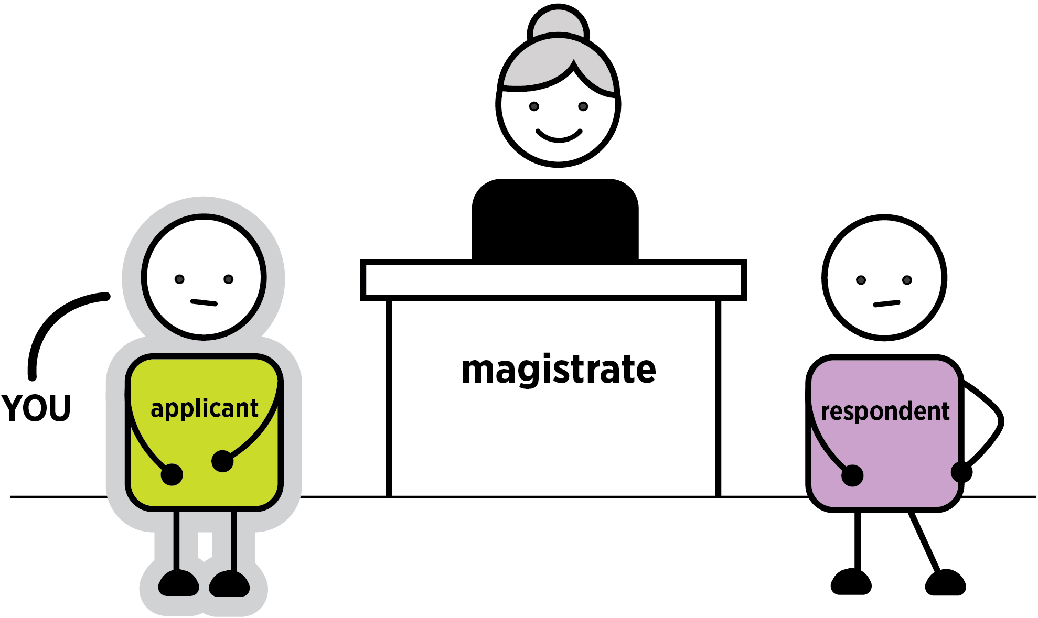
This booklet has pictures of actions you might have to do today.

When you see a this means there are questions you can ask yourself to help make a decision.
When you see a this is what you can say.
When you see an this is important information.
Words you might hear today are explained on page 3. These words are also in bold the first time they appear in this booklet. The word conditions, rules a person must follow, is always in bold. Other legal words are explained in the text.
If you have any questions about personal safety intervention orders or what happens at court, you can call Victoria Legal Aid’s Legal Help line on 1300 792 387.

Can a duty lawyer help me today?
A duty lawyer, a free lawyer who works at court, may be able to help you today if:
- you are under 18. Tell the registrar
- you have a cognitive or neurological disability. Tell the registrar. If a duty lawyer is here today, they may be able to help you. If a duty lawyer is not here today, you can ask to adjourn (put off) your case until you talk to a lawyer.

What are some words I might hear today?

Words about people
Applicant. This is you because you applied for a personal safety intervention order. If the police applied for the personal safety intervention order for you, they are called the applicant and you are called the protected person.
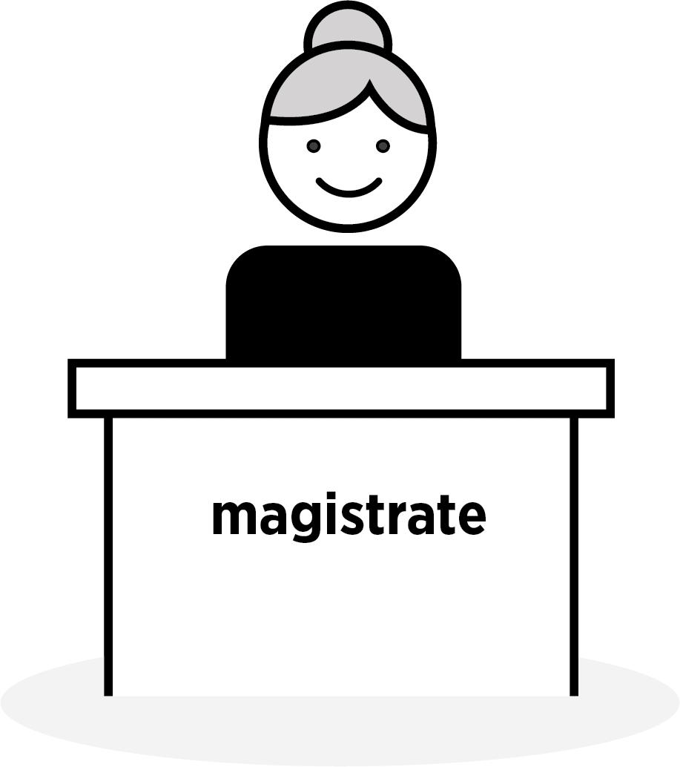
Magistrate. The person in charge of the court.
Mediator. An independent, trained professional. In many cases, they can help people talk about their situation and work out an agreement.
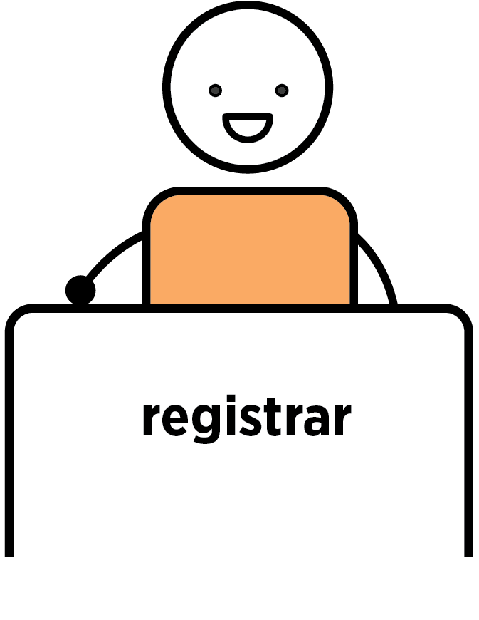
Registrar. A person who works in court and helps the magistrate. They sit at the registry, which is like the front desk for the court.
Respondent. This is the person you want to be protected from.

Words about processes
Case, hearing, mention or matter. When you come to court to talk about your legal issue.
Mediation. When you and the respondent talk to a trained professional to see if you can come to an agreement that makes you feel safe.
Mention hearing. This is the type of hearing that is happening today. It is when you and the respondent speak to the magistrate to work out what happens next.
This booklet also talks about directions hearings and contested hearings. These are hearings which may happen if you do not come to an agreement today.

Words about paperwork
Application. When you ask the court for something. For example, when you asked for a personal safety intervention order, you made an application.
Conditions. Rules that people must follow. For example, a personal safety intervention order might have a condition that the respondent must not contact you.
Personal safety intervention order. When the court says a person must follow certain rules, or they will break the law. There can be two types of these. An interim (temporary) order will last until your case is decided. A final order lasts for as long as the magistrate sets it for.

What is today about?
You are at court today because you applied for a personal safety intervention order against someone, or the police applied for you.
A personal safety intervention order is when the court says the person you want protection from must follow certain rules or they will break the law.
Today is called a mention hearing. This means today is the first day that a magistrate will talk to both you and the person you want protection from. The magistrate will see if you can both agree on how to work things out so that you feel safe. If there is a mediator at court today, you may be able to talk to them to see if mediation is possible instead of taking through your options with the magistrate.
If you already have an interim intervention order, make sure you read the conditions (rules) in the order. The respondent must follow the rules. Call the police if they do not follow the rules.
If the police applied for a personal safety intervention order for you, they will talk to you about your options today. You can talk to the police about what will happen today and what you want. The police may talk to the magistrate for you. The police cannot give you legal advice. If you want legal advice, you can call Victoria Legal Aid’s Legal Help line on 1300 792 387.

Where do I go?
Go to the front desk or the registry at the court. If there is an information counter at court, you can ask where you need to go.
Tell the registrar you are here for a ‘personal safety intervention order mention hearing’.
The registrar will tell you what courtroom you are in and where you should wait.
Tell the registrar if you need an interpreter.
The registrar can give you copies of your paperwork if you do not have it. This can include:
- a copy of your personal safety intervention order application. This has a summary of what you said the respondent did and the conditions (rules) you are asking the respondent to follow so you feel safe.
- an interim intervention order, if you or the police already asked for one.
The respondent has a copy of these too.
The registrar can tell you what will happen today, but they cannot give you legal advice. If you want legal advice, you can call Victoria Legal Aid’s Legal Help line on 1300 792 387.

What will I need to do today?
Today is a mention hearing. You may be able to talk to a mediator or talk with the magistrate in court.
If you feel unsafe in the waiting area, tell a member of the court staff. The court staff may be able to take you to a safe waiting room.

Talk to a mediator
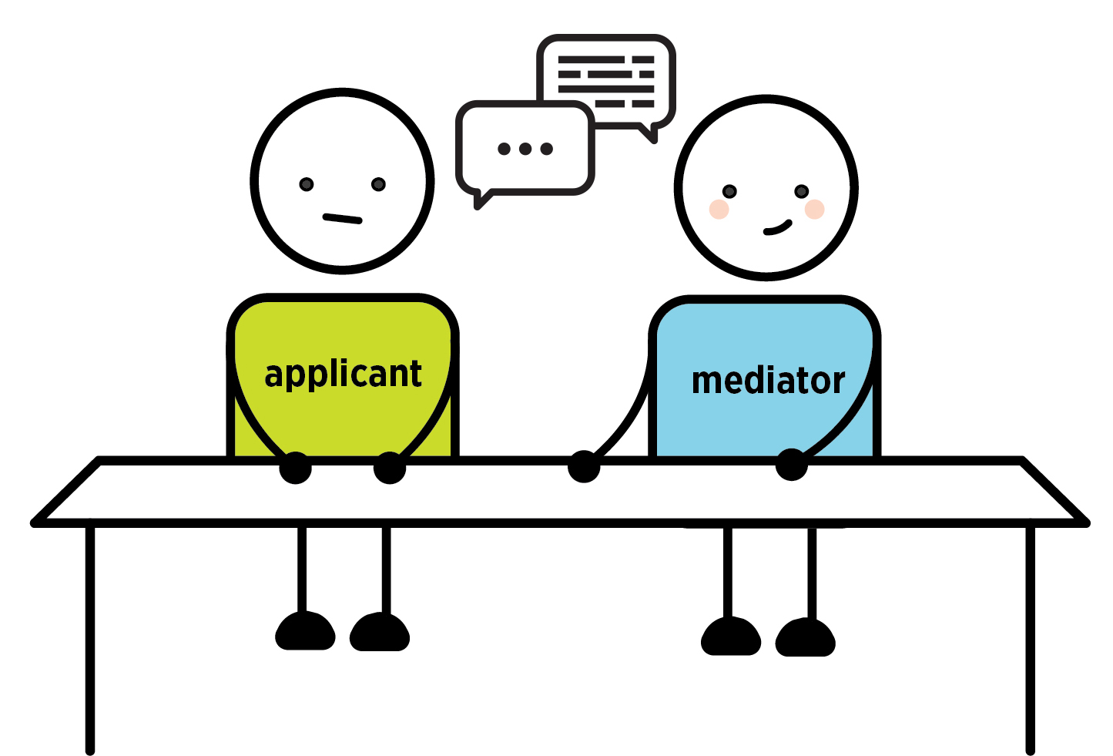
There may be a mediator at court who you can talk to today. The most a mediator can usually do today is a mediation assessment. This means they will talk to you and the respondent to see if mediation is possible. If mediation is possible, you will have to go into court and tell the magistrate you have agreed to mediation. The magistrate will adjourn (put off) your case until you a have had a mediation session. A mediation session is when you talk to a trained professional to see if you and the respondent can come to an agreement that makes you feel safe.

Talk to the magistrate in court
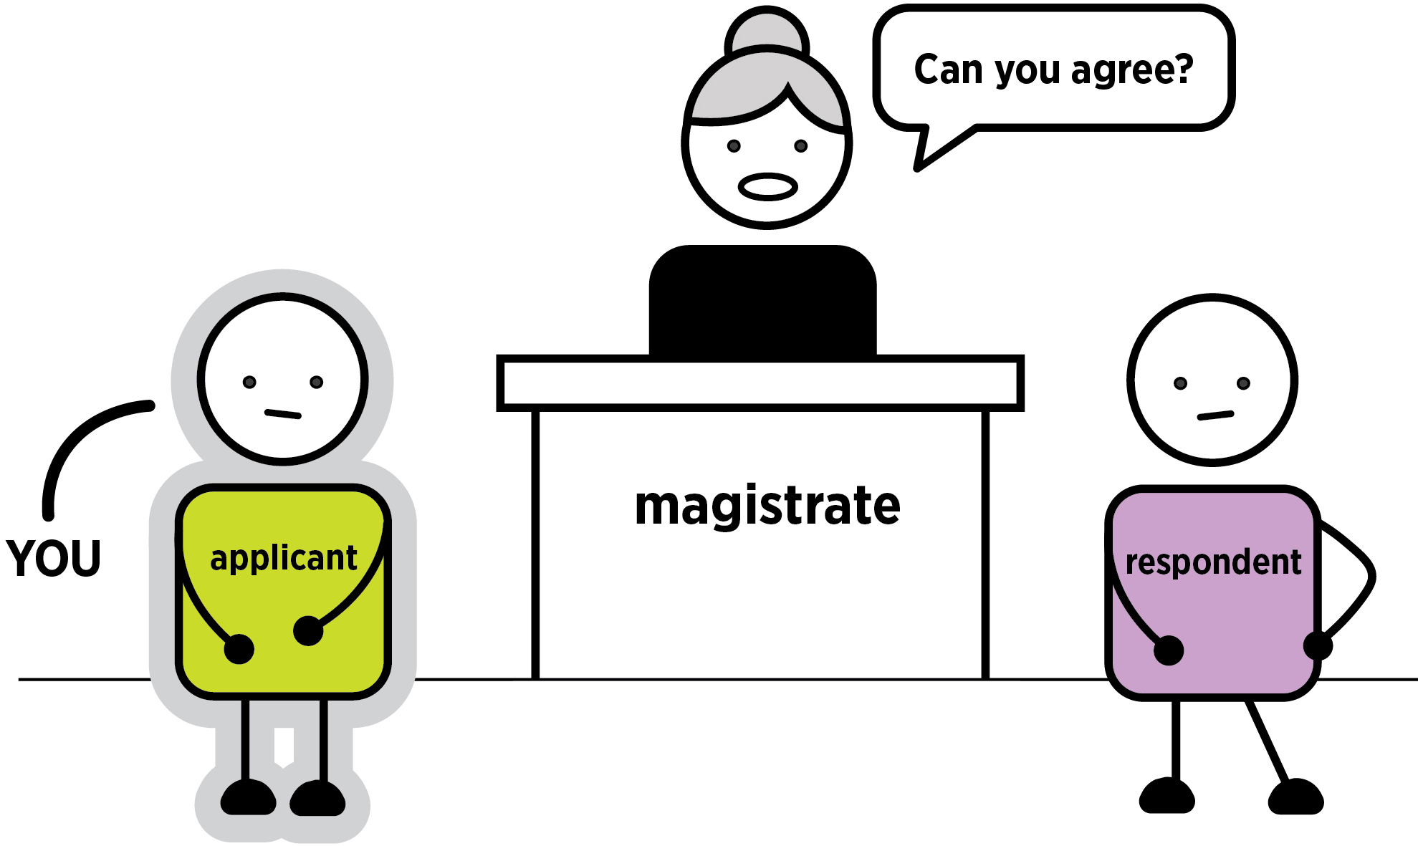
Today is not a day to tell your side of the story in detail.
The magistrate will ask you if you can come to an agreement. You have three options that you and the respondent can agree to:
- Mediation. A mediator will talk to both of you to try and reach an agreement. See page 9.
- A final intervention order. The respondent may agree to the order you asked for or ask to change the conditions (rules). See page 12.
- An undertaking. The respondent promises to you and the court that they will follow certain rules without having an order. See page 15.
The respondent may not agree with something you ask for. In that case you can ask for another option that makes you feel safe.
If you can reach an agreement today that makes you feel safe, you may not have to come back to ‍court.
If you cannot reach an agreement after talking to the magistrate, you will have to come back to court for a contested hearing. You may also need to come back to court for a directions hearing. See page ‍19.
If you do need to come back to court, you can ask for an interim (temporary) order today. This will have conditions (rules) the respondent must follow until your case is decided.
You can say: ‘Your Honour, I would like an interim intervention order’.
If you already have an interim (temporary) order, this will last until this case is decided.

Option one: mediation

What is mediation?
Mediation is when you talk to a mediator to see if you and the respondent can come to an agreement that makes you feel safe.
A mediator is an independent, trained professional who will listen to both you and the respondent. They will listen to what happened and what you want. They can help you make an agreement.
If you do not want to be in the same room as the respondent, you can talk to the mediator separately. This is called shuttle mediation.

There are two steps to mediation
Step one: a mediation assessment. This is where the mediator will see if mediation is possible between you and the respondent. This could happen today if the mediator is here.
Step two: a mediation session. You can talk to the mediator about why you asked for an order, how the respondent’s behaviour makes you feel and whether you and the respondent can work something out to stop the behaviour. Mediation usually happens on another day at a place called the Dispute Settlement Centre of Victoria.

What does mediation mean for my court case?
Your case will be adjourned (put off) while you go to a mediation session. If you both agree on a safe way forward and stick to the agreement, you may not have to come back to court. Ask the mediator about this.
You may need to come back to court and tell the magistrate about some agreements made in mediation. Ask the mediator about this.
You can also call Victoria Legal Aid’s Legal Help line on 1300 792 387 if you have any questions about your mediation agreement and whether you need to go back to court.

What are the benefits of mediation?
- You get to tell your side of the story.
- You can talk about the situation with the support of a trained, independent person.
- If you reach an agreement you will not have to come back to court for a contested hearing. Contested hearings can be stressful and it will be months before you come back to court.
- If you cannot come to an agreement you can still have a contested hearing where a magistrate will decide your case.

Questions to ask yourself about mediation
- Can my situation be solved by talking it through?
- Is it likely I will keep seeing this person? For example, are they a neighbour or a colleague?
- Is it likely I will see them in the future?
If the answer is yes to any of the above questions, mediation could be a good option for you.
- Has this person been violent towards me, threatened me or stalked me?
- Is this person a stranger?
If the answer is yes to either of these questions, you do not have to agree to mediation.

What do I say in court?
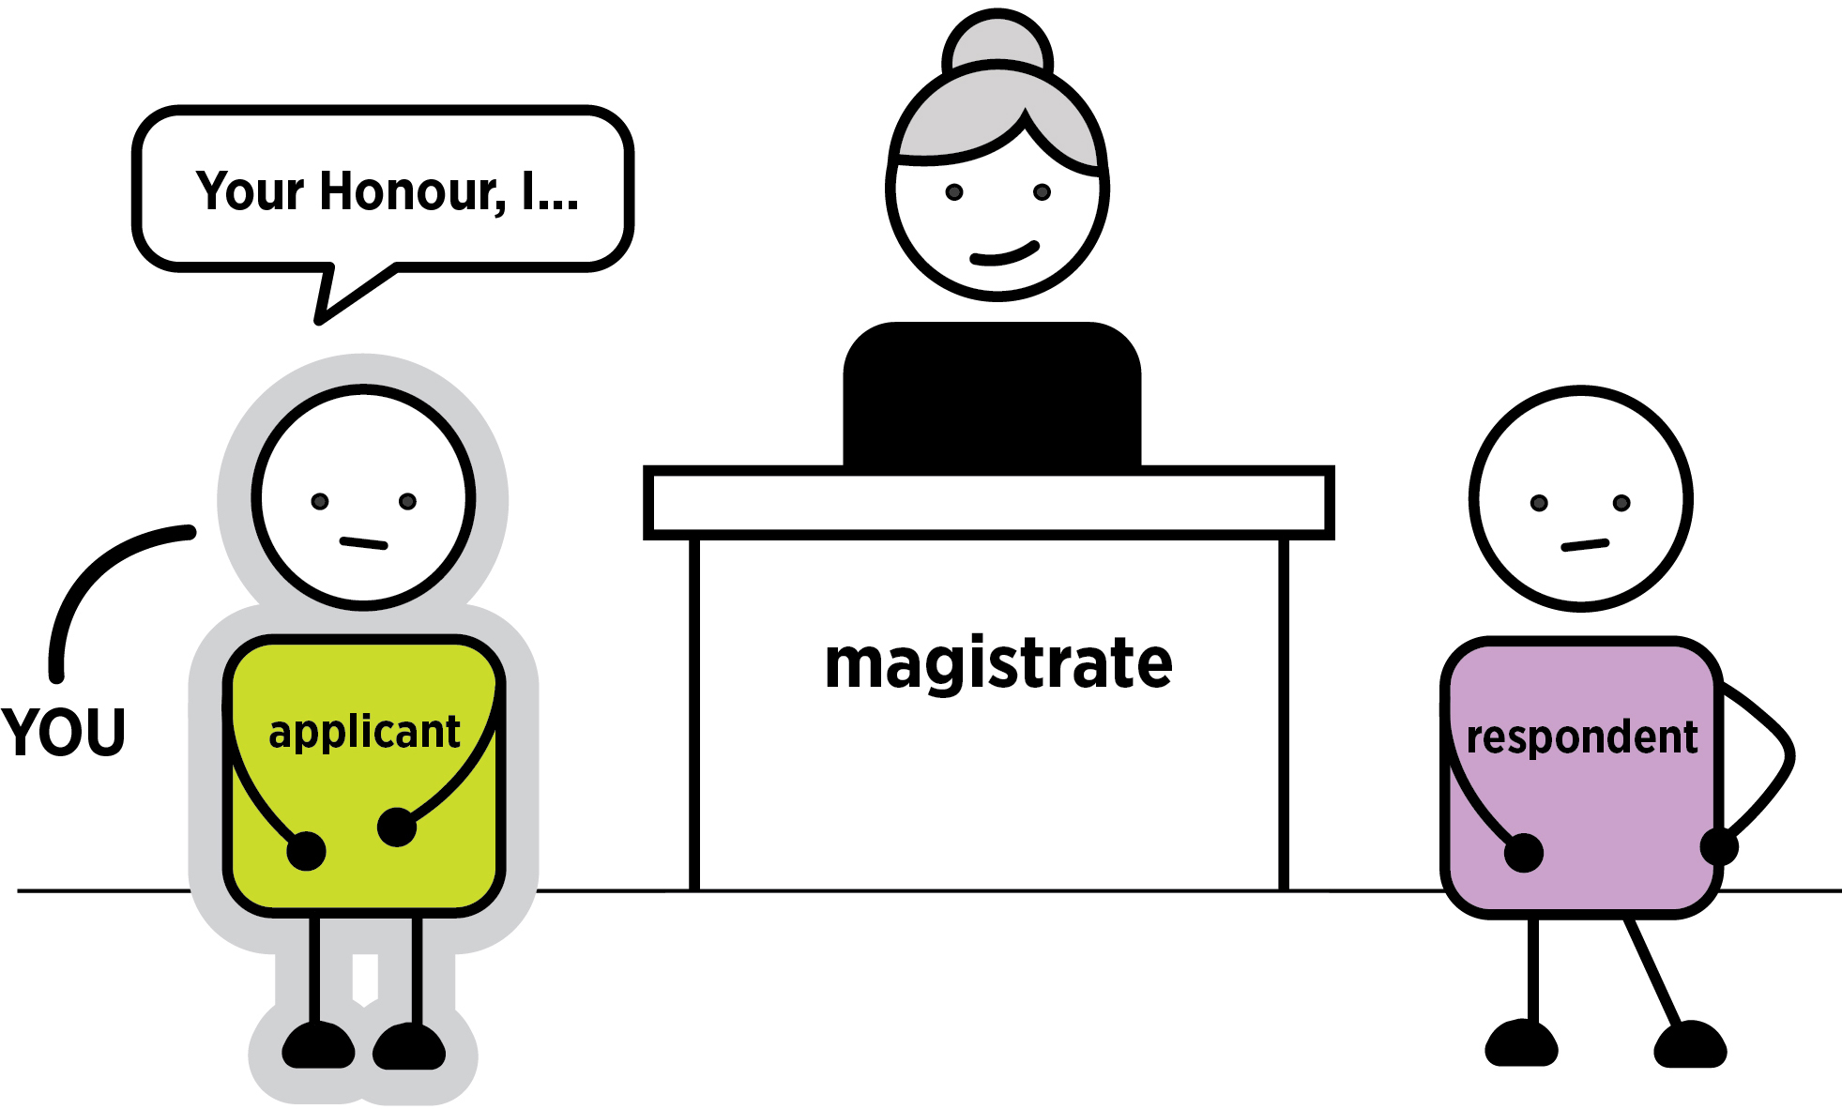

If you want mediation
The magistrate may ask you in court if you have considered mediation.
You can say: ‘Your Honour, I would like to do mediation’.
The respondent can ask for mediation. The magistrate will ask you if you agree.
You can say: ‘Your Honour, I agree to mediation’.

What will happen next?
If you both agree, you may be able to see a mediator today for an assessment.
If you cannot see a mediator today, you will see a mediator another day. Ask the registrar for details about this.

If you do not want mediation
You can say: ‘Your Honour I do not want to do mediation’.
You may have to tell the magistrate why you do not want mediation.

What will happen next?
The magistrate can send you to a mediation assessment or see if you can agree on another option.

Option two: a final intervention order
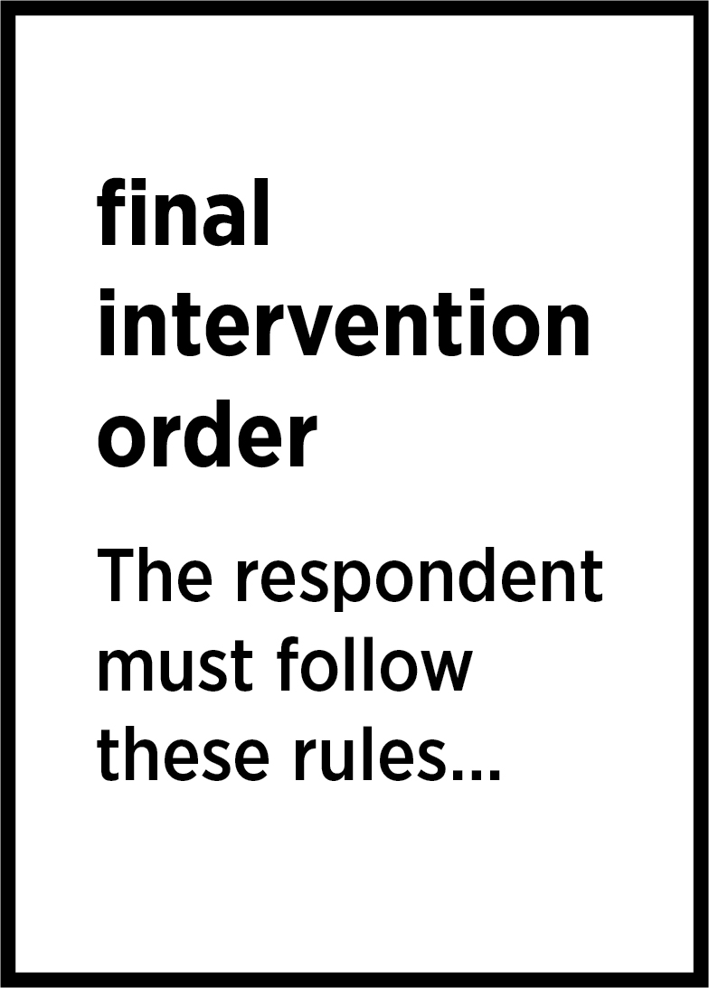
Today the respondent could consent (agree) to a final intervention order.
Final intervention orders are normally for 12 months but can be longer or shorter. The magistrate decides the length.

What can the respondent agree to?
Today the respondent can agree to the conditions (rules) you asked for.
They can also ask the magistrate for different conditions (rules). If the respondent asks for different conditions, the magistrate will only allow changes to the conditions today if you agree to them. If you do not agree, you will come back for a contested hearing and the magistrate will make a decision about the final conditions.

Benefits of a final intervention order
- Your application for an order has been successful. You have a final intervention order to protect you for as long as the magistrate decides you need one.
- The conditions of the order protect you. The respondent must follow these rules.
- If the respondent does not follow the rules, you can call the police. The police can charge the ‍respondent.
Questions if the respondent wants to change the conditions (rules)
- Do I understand the changes?
- How are they different from the conditions (rules) I asked for?
- Will these changes make me feel safe?

What do I say in court?
Listen to what the respondent is agreeing to. This affects what you need to say.

A final intervention order with no changes
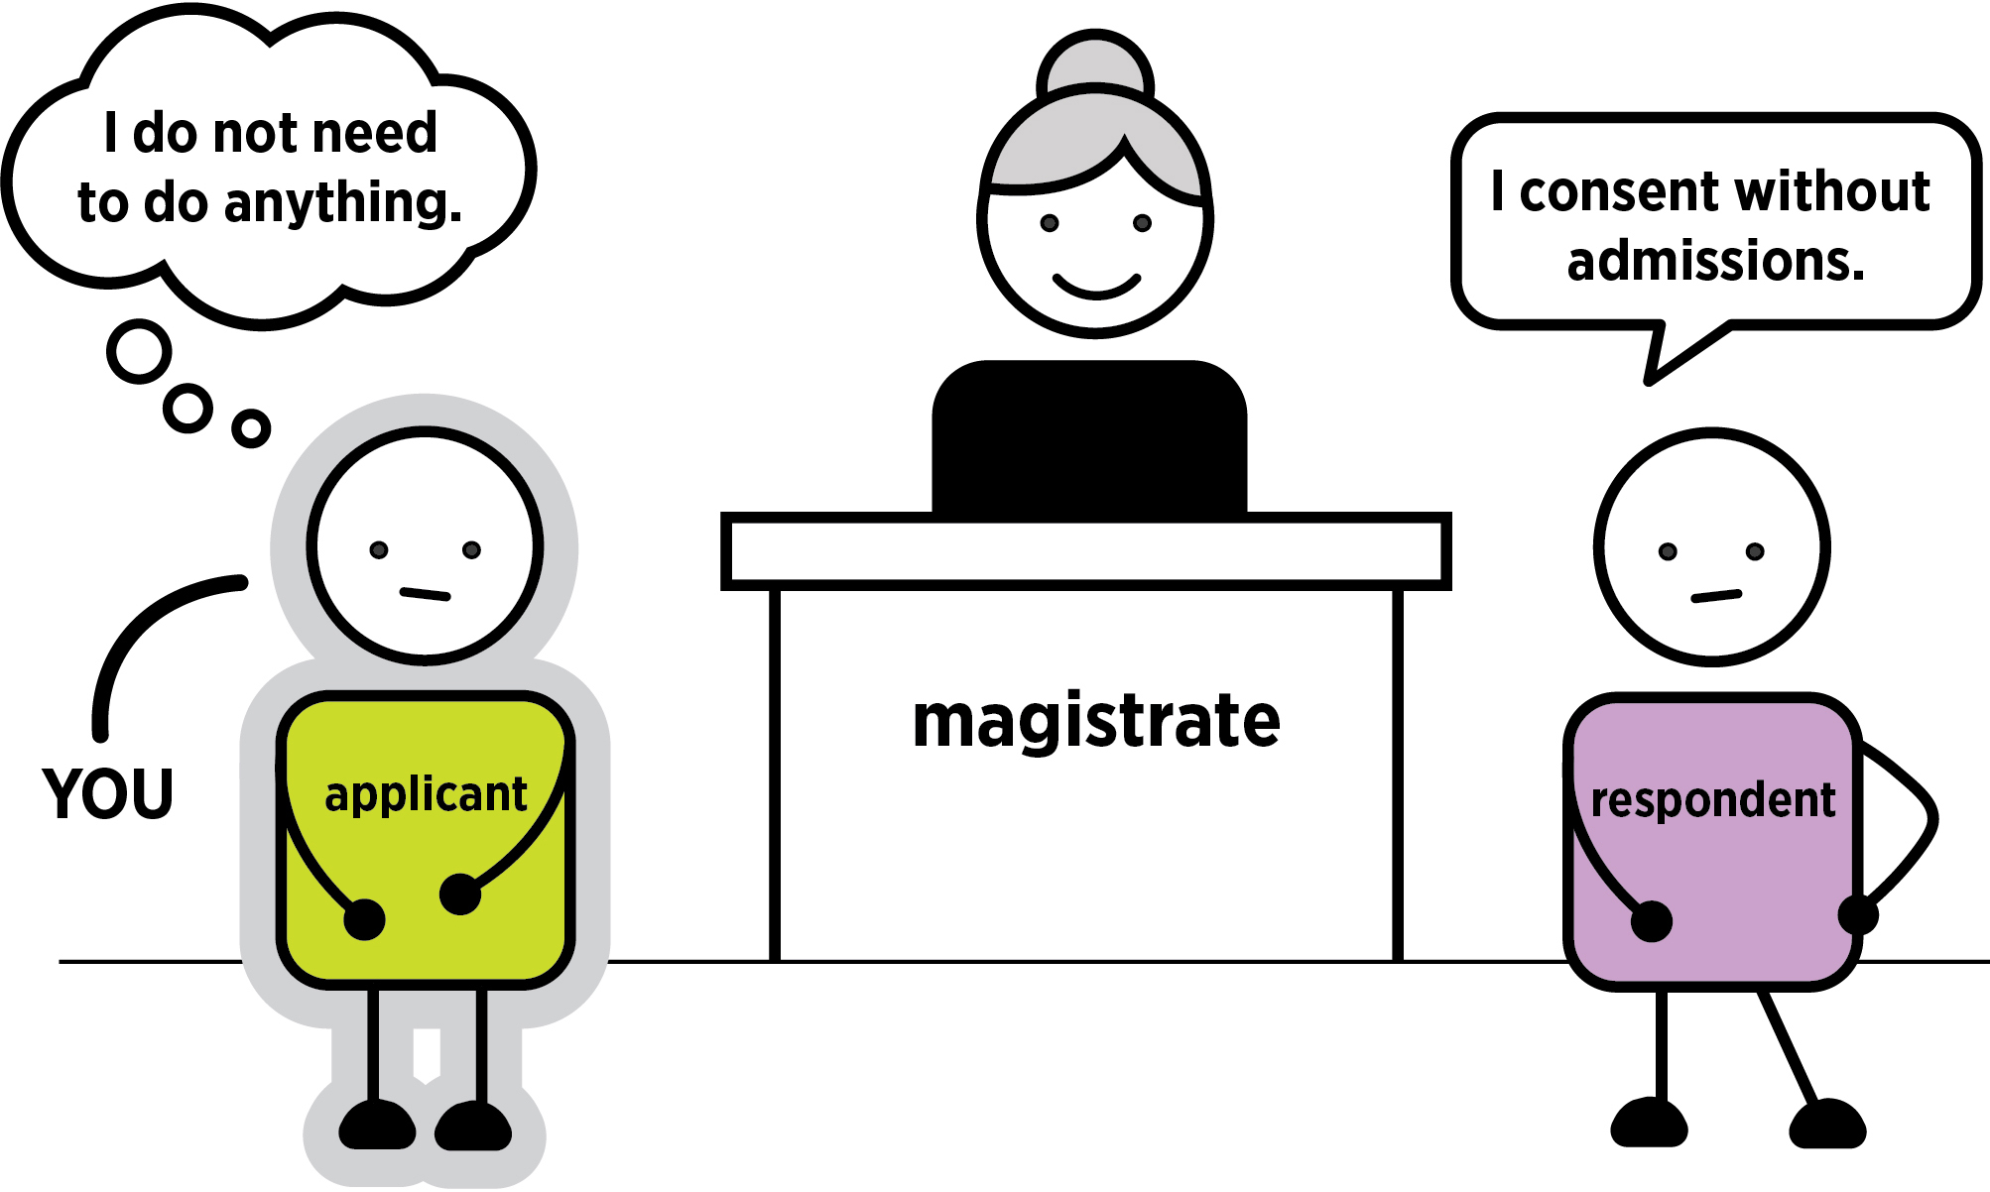
Today the magistrate will ask the respondent if they agree to the order you or the police asked for.
The respondent may agree to the order and not change anything. This is called agreeing to the order in ‍whole.
The respondent may tell the magistrate this by saying they ‘consent without admissions to the whole order’ or ‘agree to a final order in whole’.
If the respondent does this, you do not need to say anything.
The registrar will print it out the final intervention order and give you a copy.
Make sure you read it and understand what the conditions (rules) are. You can call Victoria Legal Aid’s Legal Help line on 1300 792 387 if you do not understand anything in the final intervention order.
If the respondent breaks any of the conditions (rules) in the order, call the police.

Final intervention order with changes
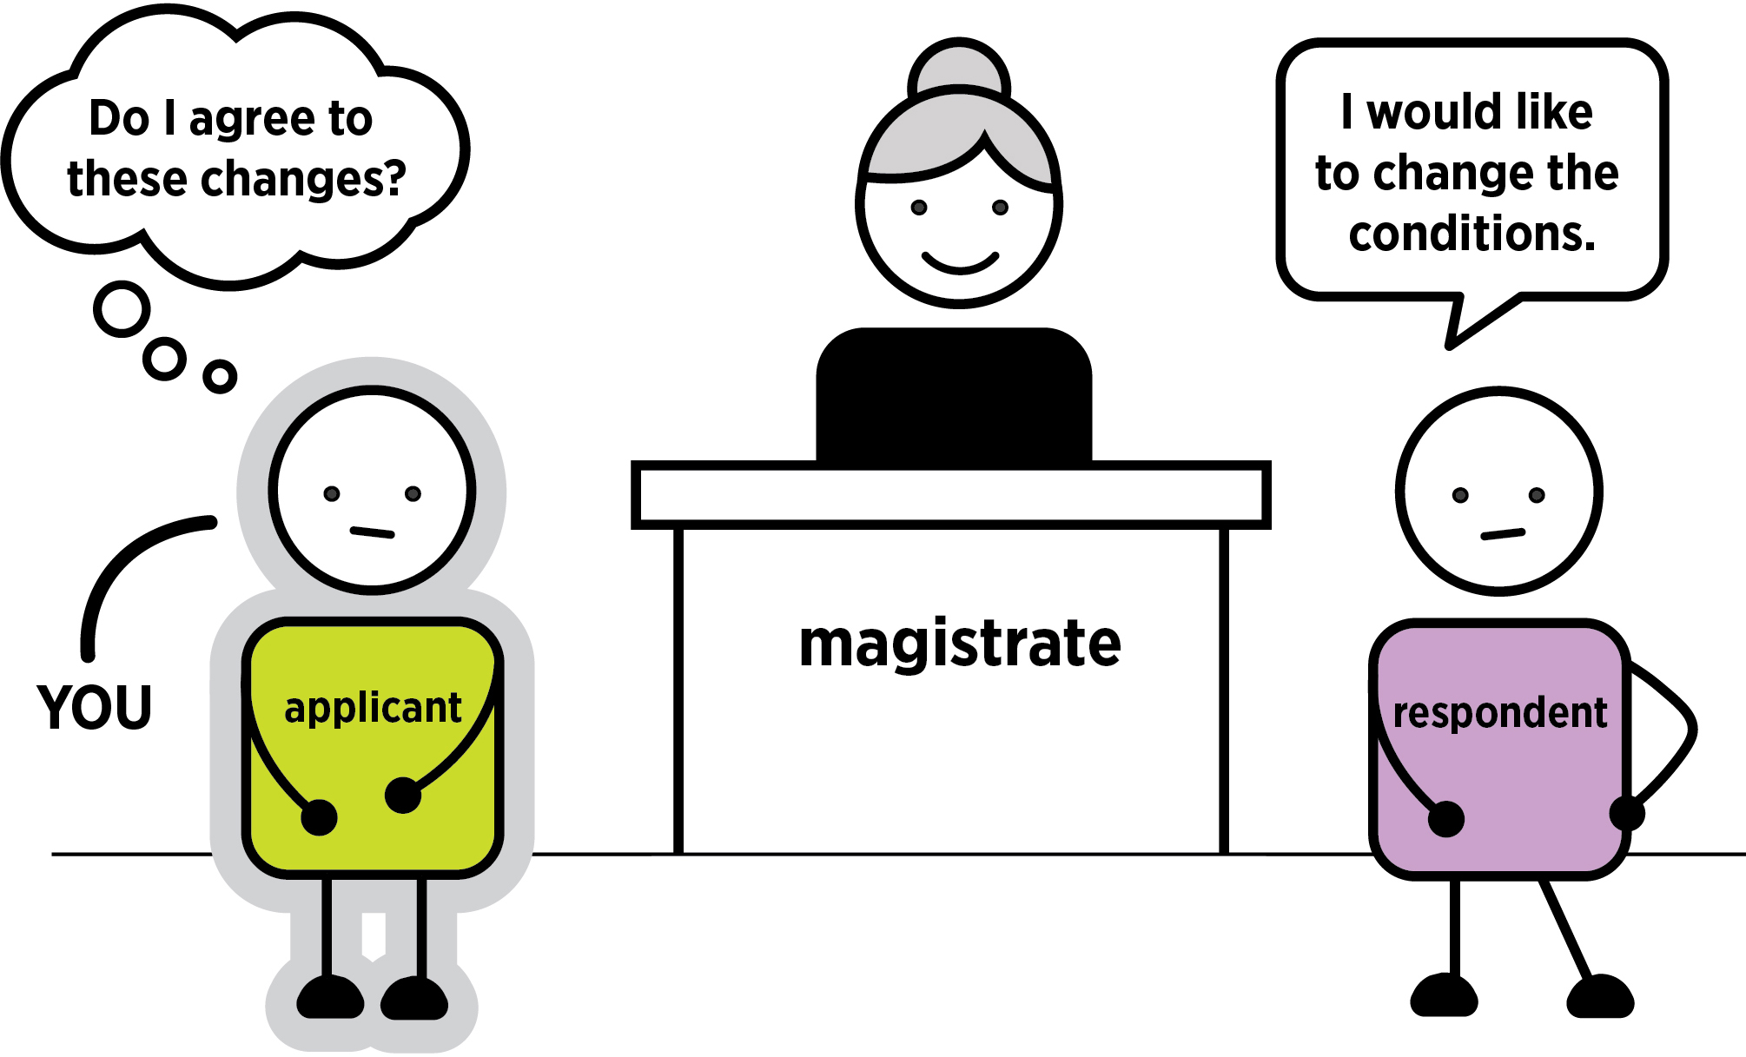
The respondent may tell the judge they agree to a final order but want to change some of the conditions (rules). This means they want to change some of the rules they have to follow. Listen to the changes they would like. You must decide if you feel safe with these changes.

What to say in court if you agree to the changes
You can say: ‘Your Honour, I agree to a changed order’.
If you and the respondent agree to a final intervention order the registrar will print it out.
Make sure you read it and understand what the conditions (rules) are. You can call Victoria Legal Aid’s Legal Help line on 1300 792 387 if you do not understand what is in your order.
If the respondent breaks any of the conditions (rules), call the police.

What to say in court if you do not agree to the changes
If you do not agree, tell the magistrate.
You can say: ‘Your Honour, I do not agree to a changed order’.
The magistrate will ask you and the respondent about the other options to see if you can come to an agreement. If you and the respondent cannot agree, you may have to come back for a contested hearing. See page 19.

Option three: undertaking
The respondent may ask for an undertaking instead of an order.

What is an undertaking?
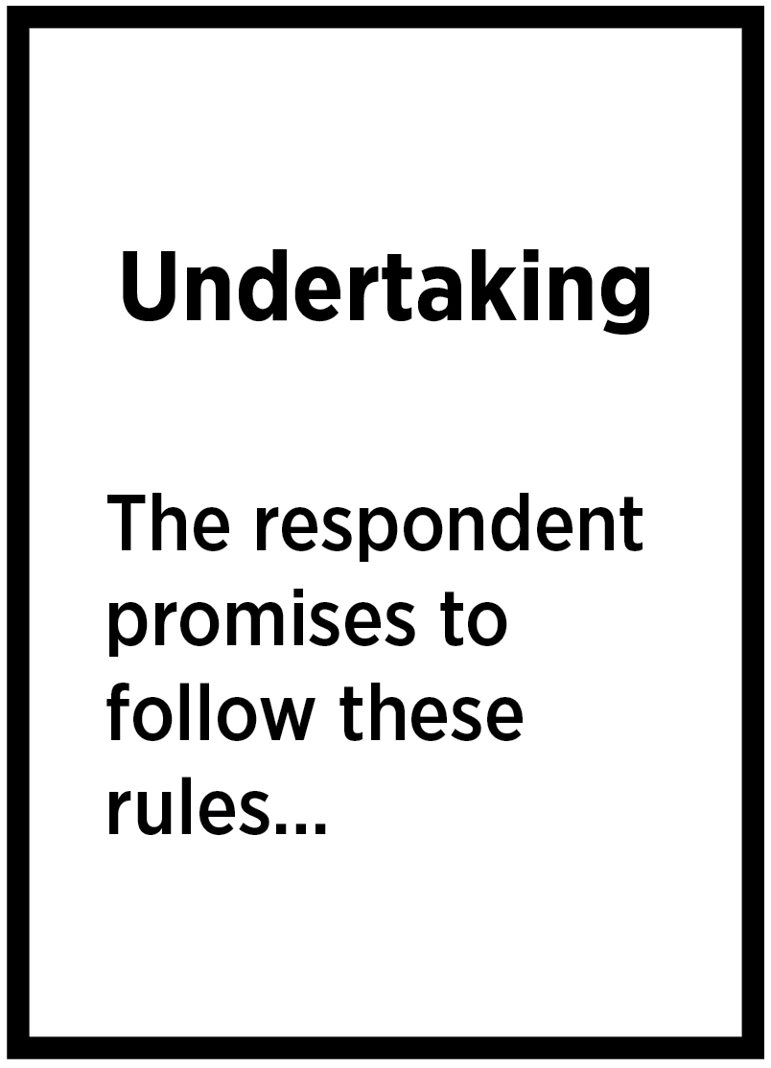
An undertaking is when the respondent makes a written promise to you and the court that they will follow certain conditions (rules). These conditions will be in the undertaking. These could be like the conditions you asked for in your application. An undertaking normally lasts for 12 months, but it can be longer or shorter.

How does an undertaking work?
The respondent must follow the conditions (rules) in the undertaking to keep their promise. Make sure you understand what rules the respondent is promising to follow.
If you agree to the undertaking, you stop your application for an intervention order. This is called withdrawing (stopping) your application.
An undertaking is different from an order. It is a promise by the respondent, not a court order.
The police cannot charge the respondent for breaking the law if they do not follow the rules of an undertaking. The police can still charge the respondent if they do anything criminal.
If the respondent breaks the rules of the undertaking, you can restart your application for an intervention order. You can go back to court and tell the registrar you would like to restart your application. This will be a quicker process than having to apply for the order all over again.

Benefits of an undertaking
- If the respondent keeps their promise, you will not have to come back to court.
- If they do not keep their promise, you can restart your application. You can come back to court and ask for your application to be reinstated. You do not need to start the process again.

Consequences of an undertaking
- Your application for an intervention order stops.
- If the respondent breaks the rules, you can call the police, but the respondent will not be charged for breaking their promise. This is different from an order, where the respondent can be charged if they do not follow the rules.
Questions to ask yourself about an undertaking
- Is this promise enough for me to feel safe?
- Do I trust the other person to keep this promise for as long as the undertaking lasts?
- What conditions (rules) do I want on the undertaking to help keep me safe?

What do I say in court?
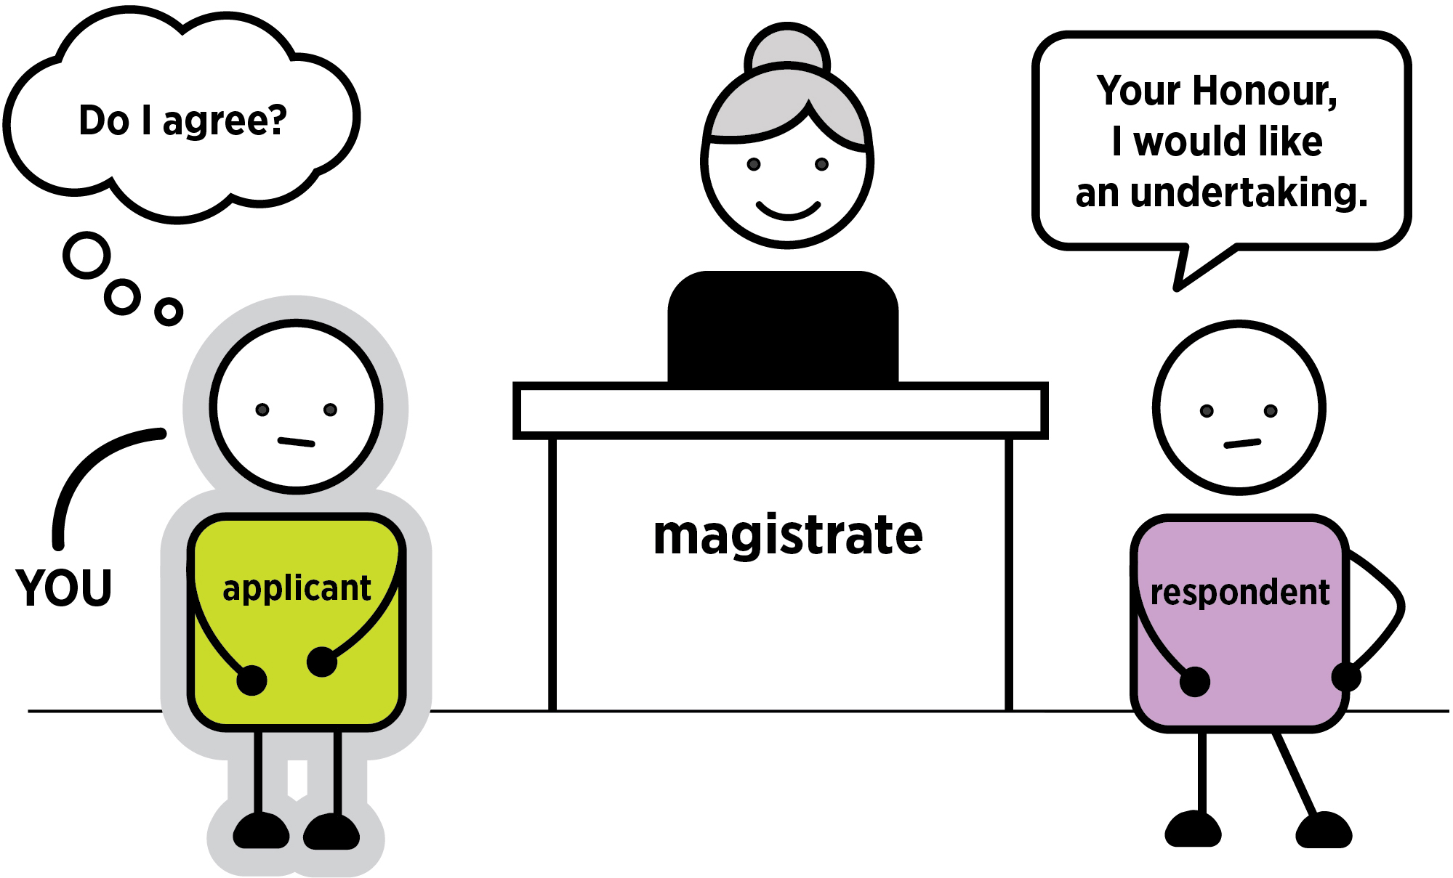
First, you have to decide if you agree to an undertaking or not.

If you agree to an undertaking
You can say: ‘Your Honour, I agree to an undertaking’.
The magistrate will stop your application for a personal safety intervention order.
The registrar will print out a copy of the undertaking. Make sure you read it and understand the conditions. If you do not understand what the undertaking says, ask the registrar. If you need legal advice, you can call Victoria Legal Aid’s Legal Help line on 1300 792 387.

If the respondent wants different conditions in an undertaking
The respondent can agree to an undertaking but can ask for different conditions to the ones in your application.
They may say: ‘Your Honour, I would like an undertaking, but would like to change the conditions’.
You can agree or not agree to this.
Make sure you understand the new conditions the respondent is asking for. Will they make you feel safe?
If you want to agree to a changed undertaking, you can say: ‘Your Honour, I agree to an undertaking with those changes’.
If you do not agree to the changes but still agree to an undertaking you can say: ‘Your Honour, I agree to an undertaking but do not agree to the changes’.

If you do not agree to an undertaking
You can say: ‘Your Honour I do not want an undertaking’.
If you do not agree to an undertaking, the magistrate will not allow one. The magistrate may ask if you and the respondent agree on another option.

Notes space
If you need to write down your decisions, or what to say, you can do it here.
__________________________________________________________________________________
__________________________________________________________________________________
__________________________________________________________________________________
__________________________________________________________________________________
__________________________________________________________________________________
__________________________________________________________________________________
__________________________________________________________________________________
__________________________________________________________________________________
__________________________________________________________________________________
__________________________________________________________________________________
__________________________________________________________________________________
__________________________________________________________________________________
__________________________________________________________________________________
__________________________________________________________________________________
__________________________________________________________________________________
__________________________________________________________________________________
__________________________________________________________________________________
__________________________________________________________________________________
__________________________________________________________________________________
__________________________________________________________________________________
__________________________________________________________________________________
__________________________________________________________________________________
__________________________________________________________________________________
__________________________________________________________________________________
__________________________________________________________________________________
__________________________________________________________________________________
__________________________________________________________________________________
__________________________________________________________________________________
__________________________________________________________________________________
__________________________________________________________________________________
__________________________________________________________________________________

If you cannot agree today: a contested hearing
If you and the respondent cannot agree to mediation, a final intervention order or an undertaking today, you may have to come back to court for a contested hearing. This is when a magistrate decides if you need a final intervention order. You may also have to come back for a directions hearing before the contested hearing.
If you have an interim (temporary) intervention order, the respondent will have to follow the conditions (rules) until your case is decided. If they do not follow the conditions (rules), call the police.
You can apply for an interim order at any time before the contested hearing if you feel unsafe.

Can a contested hearing happen today?
No. It can take a long time before you come back to court. It will depend on when the court can hear it.

What do I need to do?
You should get legal advice before a contested hearing. A lawyer can help explain what will happen and tell you how to prepare. Sometimes a lawyer will represent you (speak for you) in court. You can go to a community legal centre, a private lawyer or call Victoria Legal Aid’s Legal Help line on 1300 792 387.
You can ask them about:
- what happens at a directions and contested hearing
- what you need to do to get ready for a directions and contested hearing
- how many times you need to come back to court.

Was this self-help guide useful to you?
Please email feedback to: cle@vla.vic.gov.au or call (03) 9269 0234.

More help and information

Victoria Legal Aid
For free information about the law and how we can help you:
- visit Victoria Legal Aid’s website (www.legalaid.vic.gov.au)
- ask questions on webchat from 9 am to 5 pm, Monday to Friday.
- call our Legal Help phone line on 1300 792 387 from 8 am to 6 pm, Monday to Friday excluding public holidays.

Federation of Community Legal Centres
Help to find a community legal centre near you.
Tel: (03) 9652 1500
Website: visit the Federation of Community Legal Centres website (www.fclc.org.au)

Law Institute of Victoria
The Law Institute of Victoria can help you find a private lawyer.
Tel: (03) 9607 9950
Website: visit the Law Institute of Victoria’s website (www.liv.asn.au)

Dispute Settlement Centre of Victoria
The Dispute Settlement Centre of Victoria provides free information, advice and mediation services.
Tel: 1300 372 888 (Melbourne).
For other locations, visit their website.
Website: visit the Dispute Settlement of Victoria’s website (www.disputes.vic.gov.au)

Do you need help calling us?
Translating and Interpreting Service
Tel: 131 450
National Relay Service
TTY: 133 677
Speak and listen: 1300 555 727
Internet relay users: Visit the National Relay Service chat website (https://nrschat.nrscall.gov.au)
SMS relay: 0423 677 767
© 2020 Victoria Legal Aid. This work is licensed under a Creative Commons Attribution 4.0 licence (http://creativecommons.org/licenses/by/4.0/). The licence does not apply to any images, photographs or branding, including the Victoria Legal Aid logo.
IOA-CL-ENG-0620

