Acknowledgement of Country
This document was written on the land of the Wurundjeri people of the Kulin Nation. Victoria Legal Aid acknowledges the Traditional Custodians of the lands across Victoria and pays respect to Elders past and present. We recognise the continuing connection to country, culture and identity and the importance of self-determination for creating better futures for First Nations people.

About Us
Victoria Legal Aid is a statutory authority that serves the broader community by providing information, legal advice, and education with a focus on the prevention and early resolution of legal problems. We prioritise more intensive services, such as legal advice, legal representation, non-legal advocacy, and family dispute resolution, for those who need it most. We recognise the intersections between legal and social issues in how we do our work and advocacy. We also work to dismantle the barriers that prevent people from accessing the justice system by participating in systemic reforms and strategic advocacy.

Our vision
A fair, just, and inclusive society where people can get help with their legal problems and have a stronger voice in how laws and legal processes affect them.

Our purpose
To make a difference for clients and the community by helping to effectively address legal problems, supporting the coordination of a strong and dynamic legal assistance sector and working with partners to create fairer laws and systems.

Our values
Fairness
We are committed to fairness in society and facilitating fair and equitable access to legal support.
Care
We care about our clients and the community and approach our work informed by the effects that trauma and discrimination can have. We learn from people affected about what matters most. We treat each other with kindness and respect.
Courage
We approach our work with strength and confidence. We are guided by our values and what matters most to our clients and society.
Inclusion
We work to provide an inclusive environment for clients, staff, and referral partners.

Our outcomes
Victoria Legal Aid has five outcomes that it will focus on over the next four years (2022–26):
- Clients: Clients have increased access to justice
- Community: Improved legal understanding in the community
- Legal assistance sector: The legal assistance sector is collaborative and coordinated
- Laws and systems: Laws and systems are fairer
- Victoria Legal Aid: Victoria Legal Aid is effective and sustainable

Message from Chairperson and CEO
This is our first Corporate Plan under Strategy 26 and our new Outcomes Framework. The Outcomes Framework sets our direction for the next eight years and the difference we want to make for our clients, the Victorian community, our partners, and the services and systems we work with.
The COVID-19 pandemic has resulted in a significant backlog in the Victorian courts, reducing access to justice for our clients and the community. We will work with the courts and justice sector partners to address the backlog and support the return to in-person hearings. The pandemic provided an opportunity for us to innovate how we provide services, and we will maintain these positive changes in helping to reduce the backlog. With funding for a further 12 months, we will continue to deliver Help Before Court and the Family Violence Early Resolution Service. These services reflect our growing focus on early intervention and prevention.
Ensuring that our services are culturally safe and accessible remains a focus for VLA. We are committed to improving outcomes for Aboriginal and Torres Strait Islander peoples within the justice system. We also support the principle of self-determination. Over the next 12 months, we will develop our third Reconciliation Action Plan and expand our Aboriginal Community Engagement Officer program to help meet needs in regional areas. We will further strengthen our regional service delivery by supporting the development of the new court precinct in the Bendigo area, and work with our practice partners to improve the delivery of legal services across Victoria. Thanks to dedicated funding from the State and Commonwealth Governments, we will work towards better supporting victim-survivors and those who have experienced sexual harassment by establishing the Victims Legal Service and expanding sexual harassment legal services.
We look forward to seeing the results of a Victorian-first Public Understanding of Law Survey (PULS) conducted by the Victoria Law Foundation. The data will inform how we improve legal understanding in the community, provide stronger evidence of unmet legal need and identify where service improvement and additional investment are needed.
Everything we do is with the client in mind. To achieve the best outcome for our clients, we understand that we need to be an effective and sustainable organisation. We will develop a strategy that embeds our hybrid work model and other flexible ways of working and focuses on delivering our inclusion strategies and plans. These include our Gender Equality Action Plan (GEAP), Disability Action Plan (DAP) and Cultural Diversity and Anti-Racism plans. These actions reflect our strong and ongoing focus on diversity and inclusion for staff and clients. We will also continue to work with government to ensure we are financially sustainable.
Innovation plays a crucial role in ensuring we are as efficient as we can be and that clients have higher quality services and improved access to justice. As we complete the roll-out of our case management system, we will commence work on replacing our grants management system ATLAS. These refreshed systems will pave the way for easier interactions between VLA and our partners. We will also update our technology to better support digital legal services, flexible working practices and improve our staff and client experiences.
We will continue to support Aboriginal Community Controlled Organisations’ contributions to the
Yoo-rrook Truth and Justice Commission and support the Lotjpa Independent Legal Service. We will intensify our effort in working towards being a carbon-neutral organisation. Over the next 12 months, we will quantify our emissions levels and identify targets and actions that we can take in future years to be more environmentally friendly.

Our 2022–23 budget
We are projecting a deficit of $19 million as we anticipate a gradual return to normal court operations. In line with the 2022–23 State Budget outcomes, we are required to fund this deficit by drawing on our cash reserves. Due to reduced court capacity caused by pandemic restrictions, our cash reserves have grown considerably over the past two years and are sufficient to fund our deficits in the short term. We will continue our work with government to secure sustainable long-term funding through the Legal Assistance Demand-based Funding Model.
Our revenue
In 2022–23 we have budgeted $290.9 million in revenues, an increase of $12.2 million on the 2021–22 budget. Higher Commonwealth Government grant revenues from the updated National Legal Partnership agreement and expanded Family Advocacy and Support Services have driven this growth.
State Government funding to VLA declined by $8.4 million due to one-off replacement funding received in 2021–22. The decline is partly offset by increased funding from the Public Purpose Fund in line with recent interest rate increases.
Table 1: 2022–23 revenue by source ($m)
Source of revenue | 2021–22 Budget  $ million | 2022–23 Budget  $ million | Growth %
State Government – VLA | 148.4 | 140.0 | (5.7%)
State Government – Community Legal Centre | 28.9 | 27.1 | (6.2%)
Commonwealth Government | 61.9 | 69.2 | 11.8%
Commonwealth Government – Community Legal Centre | 14.4 | 25.8 | 79.2%
Public Purpose Fund | 19.4 | 23.1 | 19.1%
Case revenue (including client contributions) & other income | 5.7 | 5.7 | -
Total revenue | 278.7 | 290.9 | 4.9%

Our expenditure
In 2022–23, the budgeted expenditure of $309.9 million is an increase of $9.7 million on the 2021–22 budget. Informed by the Legal Assistance Demand Funding Model, the case expenditure budget reflects a significant increase on actual 2021–22 levels as courts gradually return to normal operations. During last year’s budget process, we had assumed case expenditure would return to pre-pandemic levels for the full year, in addition to new measures to address the backlog of cases.
Due to subsequent pandemic restrictions, actual expenditure in 2021–22 has been much lower. Although the 2022–23 case expenditure budget is down 4.1% compared to the previous budget, this reflects an increase of approximately 10 per cent on the currently projected 2021–22 case expenditure.
The increase in Community Legal Centre expenditure results from increased revenue from the Commonwealth Government in 2022–23. Similarly, increased employee-related expenditure primarily reflects new positions funded through State and Commonwealth Government budget initiatives, including the Family Advocacy and Support Service, Youth Justice, online courts and the Dandenong Children’s Court.
The increase in other operating expenditure is due to one-off costs to revamp our information technology equipment to support digital legal services and flexible working practices.
Table 2: 2022–23 expenditure by category ($m)
Expenditure category | 2021–22 Budget  $ million | 2022–23 Budget  $ million | Growth %
Case expenditure | 128.8 | 123.5 | (4.1%)
Employee-related expenditure | 101.8 | 105.8 | 3.9%
Community Legal Centre payments | 43.3 | 52.9 | 22.2%
Other operating expenditure | 23.7 | 24.9 | 5.1%
Depreciation and amortisation | 2.6 | 2.8 | 7.7%
Total expenditure | 300.2 | 309.9 | 3.2%

Our client services
Service levels in 2022–23 remain highly dependent on the level of court activity, as courts continue to return to normal operations. In addition, as part of our continuing Digital Legal Aid program, there will be training requirements for our Legal Help staff, which will result in short-term service level reductions. While we will strive to meet the 2022–23 targets, depending on the impact of this training and court operations, we may not reach some target levels.
Measure | 2020–21 actual | 2021–22 actual | 2022–23 target
Unique clients | 74,670 | 80,547 | 105,000
Community Legal Education and Information Services (excl. family violence) | 81,602 | 84,100 | 102,000
Community Legal Education and Information Services – family violence–related services | 20,753 | 19,373 | 27,000
Duty Lawyer Services (excl. family violence) | 28,070 | 36,200 | 70,853
Grants of legal assistance provided (excl. family violence) | 29,466 | 29,305 | 32,900
Legal advice and minor assistance (excl. family violence) | 28,211 | 23,531 | 41,347
Family violence legal services | 39,894 | 47,433 | 46,000
Client satisfaction (per cent) | N/A— | 67% | 80
Average wait time to Legal Help | 17.1 mins | 11.23 mins | <15

Our 2022–23 priorities
Strategic direction 1 – Clients
Outcome 1 – Clients have increased access to justice
Priority | Activities | Sub-outcome
Strengthen early intervention and early resolution services to prevent the escalation of legal problems and better connect with allied services | Deliver Help Before Court and Early Resolution Service programs to support reducing court backlogs | - Clients equitably access timely legal and related services, including early intervention and preventative services, that meet their needs and capabilities
Work to ensure our services are culturally appropriate, safe, accessible, inclusive, and equitable | Review the services we provide to clients who are newly remanded | - Clients are assisted to address or prevent legal problems
 | Strengthen services for victim-survivors through a Victims Legal Service and expanded sexual harassment legal services | - Clients equitably access timely legal and related services, including early intervention and preventative services, that meet their needs and capabilities
 | Increase our legal services to children and their families through the newly established Dandenong Children’s Court and the Children’s Court after-hours Bail and Remand Court | - Clients are assisted to address or prevent legal problems
Enhance culturally safe services for First Nations clients | Develop Reconciliation Action Plan 3 (2022–25) | - First Nations clients experience culturally safe legal services and increased access to justice
 | Expand support to First Nations clients through the Aboriginal Community Engagement Officer program | - First Nations clients experience culturally safe legal services and increased access to justice
Strengthen our regional service delivery | Increase our legal services in the Loddon Mallee region through the newly established Bendigo Law Courts, including upgrading our Bendigo office | - Clients equitably access timely legal and related services, including early intervention and preventative services, that meet their needs and capabilities
 | Embed regional management structures to better support clients and staff | - Clients equitably access timely legal and related services, including early intervention and preventative services, that meet their needs and capabilities

Strategic direction 3 – Legal Assistance Sector
Outcome 3 – Collaborative and coordinated legal assistance sector
Priority | Activities | Sub-outcome
Expand our services for Commonwealth law matters | Implement actions to embed the Federal Circuit and Family Court of Australia’s responses to family violence and case management | - The legal assistance sector works together to deliver coordinated and responsive services and advocacy
 | Expand our services in Commonwealth family law matters through the Family Advocacy and Support Service | - The legal assistance sector works together to deliver coordinated and responsive services and advocacy
 | Work with other Legal Aid Commissions to develop a strategy for nationally consistent NDIS legal assistance | - The legal assistance sector works together to deliver coordinated and responsive services and advocacy
Improve our engagement with our legal assistance partners | Act on recommendations from the Private Practitioner Supply Project to improve engagement and delivery of legal services across Victoria and better use the mixed model to target areas of legal need | - The legal assistance sector works together to deliver coordinated and responsive services and advocacy
 | Undertake collaborative planning and coordinated advocacy with CLCs and other sector partners to provide more responsive legal assistance services in Melbourne’s West | - The legal assistance sector works together to deliver coordinated and responsive services and advocacy

Strategic direction 5 – Victoria Legal Aid
Outcome 5 – Effective and sustainable Victoria Legal Aid
Priority | Activities | Sub-outcome
Invest in our people and work in a safe, inclusive, equitable way that involves people with lived experience | Develop a workplace of the future strategy that embeds flexible working | - VLA is a safe, inclusive, and equitable workplace with diverse and skilled staff
 | Deliver our diversity and inclusion strategies and plans in line with our commitments under the Gender Equality Action Plan, Disability Action Plan, Reconciliation Action Plan and Cultural Diversity and Anti-racism plans | - VLA is a safe, inclusive, and equitable workplace with diverse and skilled staff
 | Finalise the psychosocial risk assessment and implement the mental health framework to support staff wellbeing | - VLA is a safe, inclusive, and equitable workplace with diverse and skilled staff
 | Enhance and expand Cultural Awareness training and service standards for staff and practice partners | - VLA is a safe, inclusive, and equitable workplace with diverse and skilled staff
Pursue sustainable funding so that VLA can continue supporting an effective and efficient justice system | Review results of the Public Understanding of Law Survey and update the Legal Assistance Demand Funding Model accordingly for submission to State Government so VLA’s funding is sustainable | - VLA is equipped with sustainable resources and technology that reduce our environmental impact and enable us to deliver services
Improve the staff technology experience and develop our digital systems to improve access to justice, provide clients with better services and create more efficient work practices | Modernise our ICT equipment and support to enable digital legal services and flexible working practices | - VLA is equipped with sustainable resources and technology that reduce our environmental impact and enable us to deliver services
 | Develop and implement new client case management service and commence scoping and discovery of our new grants management product | - VLA is equipped with sustainable resources and technology that reduce our environmental impact and enable us to deliver services
Enhance our commitment to environmental sustainability | Implement systems and processes to understand our environmental impact and develop strategies to improve our sustainability | - VLA is equipped with sustainable resources and technology that reduce our environmental impact and enable us to deliver services

Strategic advocacy priorities

The Legal Aid Act 1978 requires us to take steps to deliver legal services efficiently and innovatively to reduce the need for repeat, individualised legal services. One way we achieve this is by pursuing improvements in law and policy that result in better outcomes for our clients and the community, as detailed in our Outcomes Framework.

The following principles guide our strategic advocacy:

As part of our ongoing commitment to upholding First Nations peoples’ right to self-determination, we will work collaboratively with Aboriginal Community Controlled Organisations to inform our advocacy and reform work, and support truth-telling and treaty processes in Victoria.

Our advocacy is shaped by the experience and expertise of people directly affected.

We recognise that different aspects of identity – including race, sexual orientation, gender identity, disability, age, and socioeconomic status – intersect to affect people’s experiences of discrimination and inequity.

We acknowledge and challenge structural racism to improve the justice system and related systems.
In 2022–23, our strategic advocacy priorities are to:
- Work with Aboriginal Community Controlled Organisations to promote reforms that address the over-criminalisation of First Nations peoples and their disproportionate representation in the youth justice and child protection systems.
- Work with culturally and linguistically diverse organisations and communities to promote reforms that address the experiences of over-criminalisation and disproportionate involvement in the youth justice and child protection systems of these communities
- Advocate reforms that will reduce entry into the criminal justice system and address the harms of criminal justice system involvement, including deaths in custody. This work will focus on improved police practices and accountability, raising the minimum age of criminal responsibility, reducing social disadvantage, and bail, summary offences and sentencing reform.
- Promote rights, accountability and consumer leadership for people experiencing mental health issues and people with disability.
- Advocate for safe, accessible, and inclusive family law, family violence and child protection systems.
- Advocate for gender equality and improve responses for victim-survivors of gendered violence (inclusive of LGBTIQ and gender diverse communities). This advocacy will focus on preventing and responding to sexual harassment, sexual offending, family violence, and improving victim-survivor participation in the criminal justice system.

We may also undertake strategic advocacy work in response to emerging or urgent systemic issues or to reform processes (for example, reviews, commissions, inquiries or legislative change) that are not identified in these priorities.

Our outcomes

Our 2022–23 priorities and activities align with our Outcomes Framework, which defines our work’s intended outcomes – the difference that we want our services to make for our clients and the Victorian community. We will monitor progress against our 2022–23 priorities throughout the year and how they contribute to these longer-term outcomes.
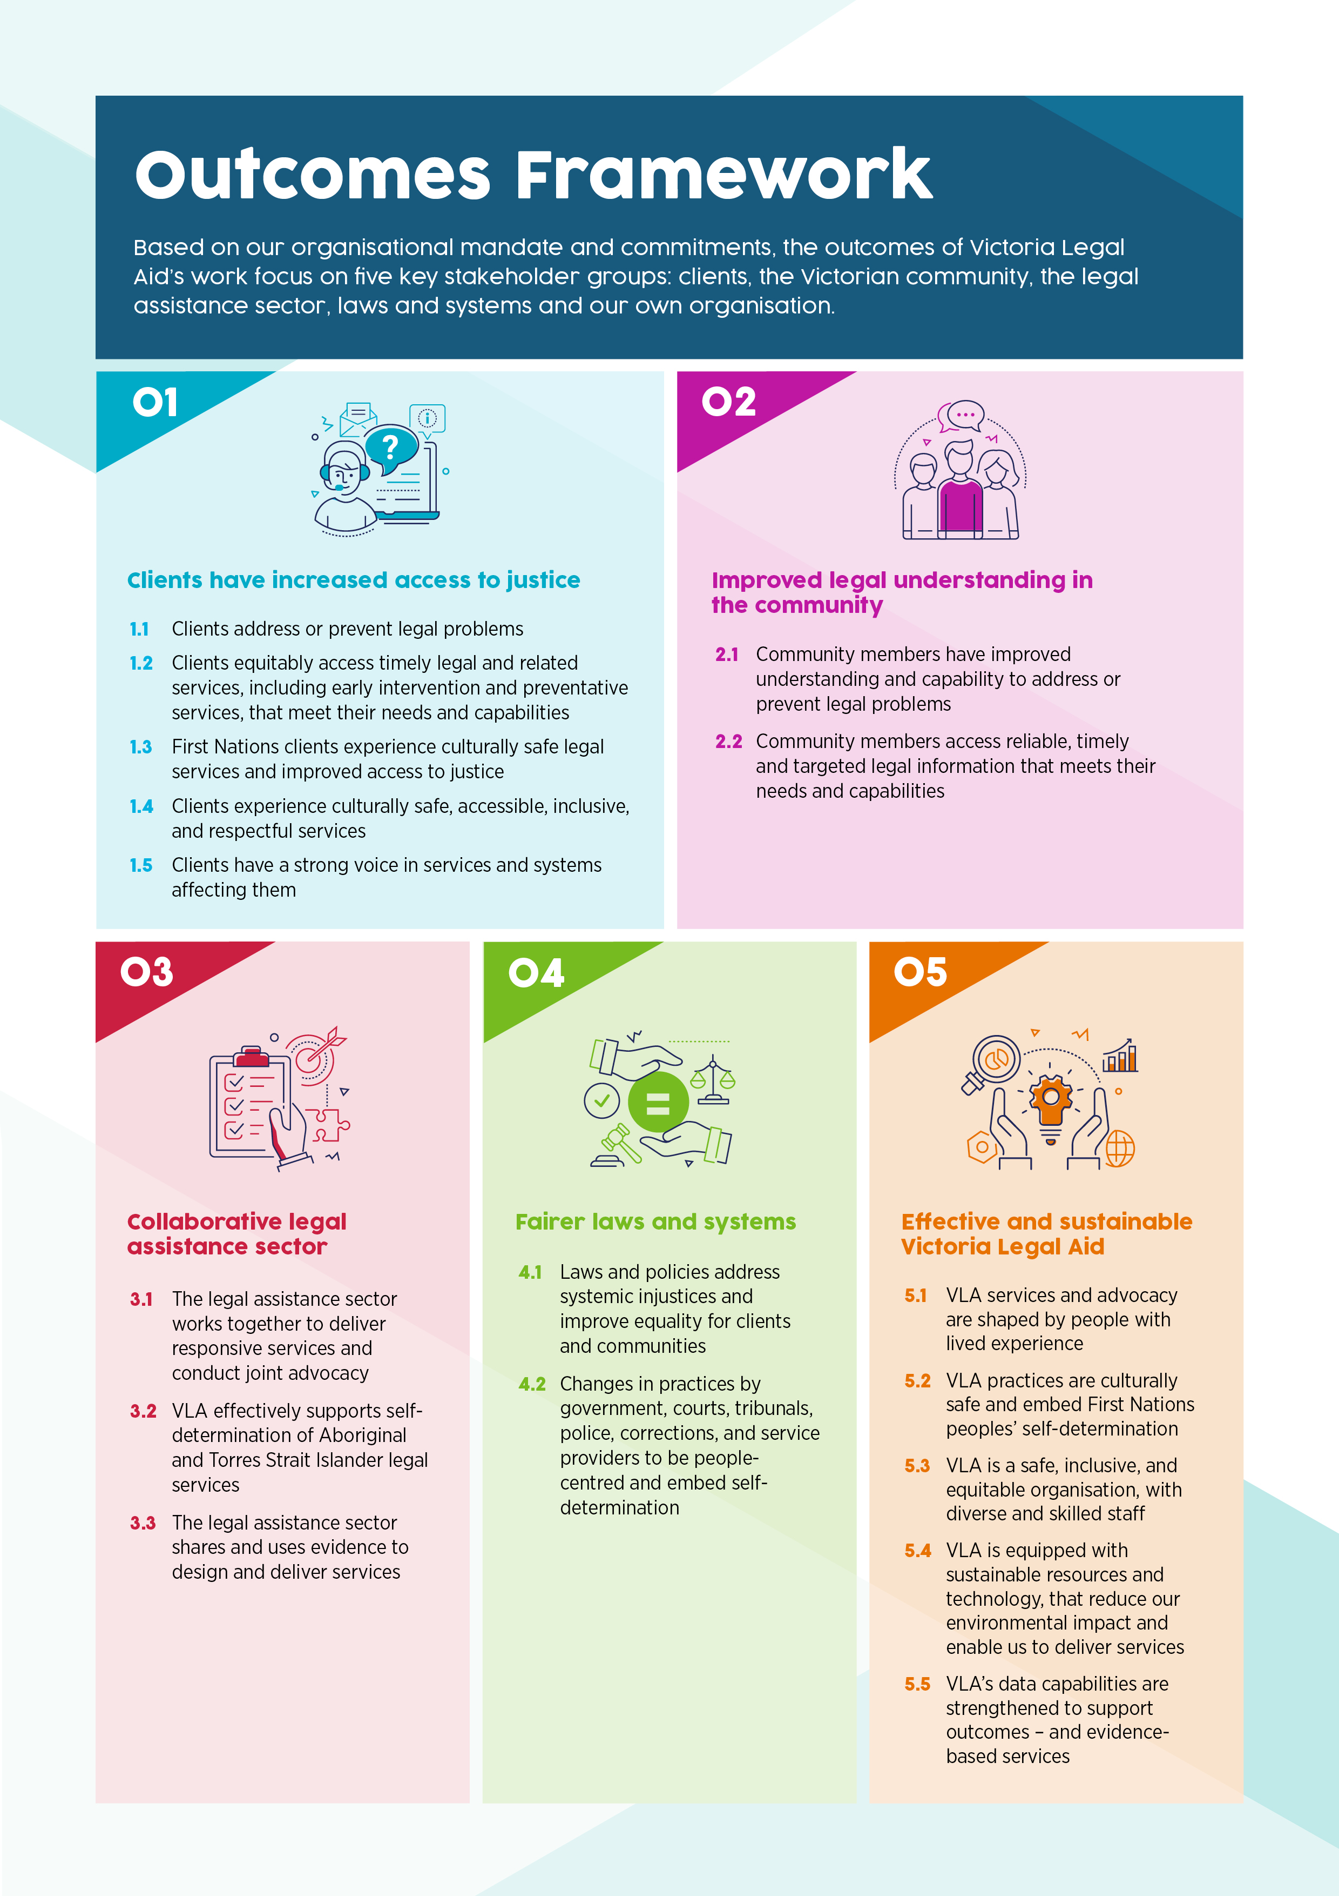

Our outcomes infographic
Our vision: A fair, just and inclusive society.
Based on our organisational mandate and commitments, the outcomes of Victoria Legal Aid’s work focus on five key stakeholder groups: clients, the Victorian community, the legal assistance sector, laws and systems and our own organisation.

Client and community outcomes
Our client and community outcomes are about improving access to justice and supporting people to develop stronger legal capability and a voice in legal problems they face. The outcomes include how people equitably access and experience our legal and related services and information across Victoria, and how this assists them to prevent or minimise the impact of legal problems, or to resolve them and move forward with their lives.
- Clients have increased access to justice
  - Clients are assisted to address or prevent legal problems
  - Clients equitably access timely legal and related services, including early intervention and preventative services, that meet their needs and capabilities
  - First Nations clients experience culturally safe legal services and increased access to justice
  - Clients experience culturally safe, accessible, inclusive, and respectful services
  - Clients have a strong voice in services and systems affecting them
- Improved legal understanding in the community
  - Community members have improved understanding and capability to address or prevent legal problems
  - Community members access reliable, timely and targeted legal information that meets their needs and capabilities

Sector and system outcomes
The sector and system outcomes are about improving our capability and practices, and how we support and work together with community legal centres, Aboriginal and Torres Strait Islander legal services, and private practitioners. They include our work to elevate the voices of people who have experienced legal and justice services and advocate jointly with the sector to improve and reform laws and systems, so they are more people-centred, culturally safe, support First Nations peoples’ self-determination, address systemic injustices, and improve equality for clients and the Victorian community.
- Collaborative legal assistance sector
  - The legal assistance sector works together to deliver coordinated and responsive services and advocacy
  - VLA effectively supports self-determination of Aboriginal and Torres Strait Islander legal services
  - The legal assistance sector shares and uses evidence to design and deliver services
- Fairer laws and systems
  - Laws and policies address systemic injustices and improve equality for clients and communities
  - Changes in practices by government, courts, tribunals, police, corrections, and service providers to be people-centred and embed self-determination
- Effective and sustainable Victoria Legal Aid
  - VLA services and advocacy are shaped by people with lived experience
  - VLA practices are culturally safe and embed First Nations peoples’ self-determination
  - VLA is a safe, inclusive, and equitable organisation, with diverse and skilled staff
  - VLA is equipped with sustainable resources and technology, that reduce our environmental impact and enable us to deliver services
  - VLA’s data capabilities are strengthened to support outcomes and evidence-based services

Totals are preliminary and may be altered prior to publishing. Performance was lower in 2021–22 compared to our 2022-23 targets due to the impacts of COVID on court operations.
The 2022–23 targets reflect historical demand levels, based on modelled assumptions that the courts will resume operations more aligned to pre-pandemic operations.
During 2020-21, a modified survey was piloted during COVID-19. Results are statistically unreliable due to a small sample size arising from the inability to access clients.

