Measuring our outcomes – Strategy 26 outcome measures
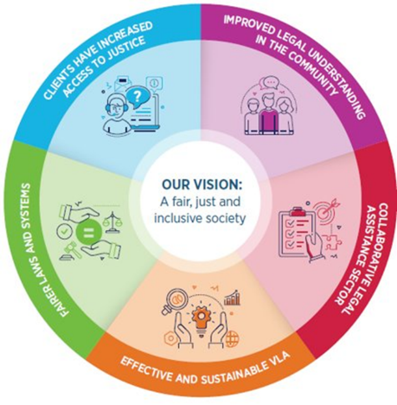
Victoria Legal Aid’s (VLA) Outcomes Framework 2022–30 defines the difference we make for our clients and the Victorian community.
Our five outcomes to 2030 are:
- Clients have increased access to justice
- Improved legal understanding in the community
- Collaborative legal assistance sector
- Fairer laws and systems
- Effective and sustainable VLA
VLA is committed to an outcomes and evidence-based approach to our services. This means we will:
- design and deliver services based on what works for clients and the community
- measure the difference our services make for our clients and the community
- align our efforts with the community legal sector and government to achieve shared access to justice outcomes.
Our outcomes guide our strategic plans: Strategy 26 and Strategy 30, and all our planning, design, reporting, data analysis, reporting, research, and evaluation.

Strategy 26 outcome measures

Purpose
The purpose of these high-level, priority measures is to guide simple and standard measurement of outcomes against VLA’s Strategy 26, and be accountable to improve outcomes for clients, the community, and our partners.

Reporting and analysis
Results on the measures will be drawn from annual client and community surveys, as well as available research and reports where relevant. The measures will guide our public reporting, including annual reports. The outcome measures complement our service performance measures for the National Legal Assistance Partnership and State Budget measures, which cover the number and type of services we deliver, and the people we reach each year.

Legal needs analysis, research, and evaluations will provide further analysis and insights, to understand what works for different client groups and contexts.

Outcome 1. Clients have increased access to justice
First Nations clients
Analysis of all the client measures (below), for First Nations clients
Access to legal and related services
Who accesses VLA services, by demographic factors
Clients who have three or more indicators of disadvantage
Experience of services
Clients report that services meet their needs
Clients experience services as accessible, respectful, and easy to navigate
Clients experience services as culturally safe and responsive
Clients are satisfied with VLA services
Legal capability
Clients better understand how to deal with their legal problems
Clients feel confident to seek help in future
Help to prevent and address legal problems and uphold rights
Clients report that the service had a positive impact on their legal problem
Clients’ legal problem/s are resolved
Wellbeing
Clients feel less stressed
Client-first services
Clients and people with lived experience shape VLA services and advocacy

Sources: Client Experience Surveys (note client feedback is analysed to identify experiences and outcomes of diverse client groups), reporting on VLA Client First Strategy.

Outcome 2. Improved legal understanding in the community
Access to legal information and education
Community members report that legal information or education meets their needs
Legal capability, and help to prevent and address legal problems and uphold rights
Community members better understand how to deal with legal problems

Sources: Legal Help phone call and webchat surveys, Community Legal Education reports.

Outcome 3. Collaborative legal assistance sector
Coordination and integrated services
Private Practitioners, Community Legal Centres, and Stakeholders report that VLA has contributed to effective service coordination and strategic advocacy
Collaborative planning and integrated service initiatives contribute to improved accessibility and outcomes for clients and communities

Sources: CLC feedback surveys, Panel Practitioner and Stakeholder surveys, Evaluations of integrated services.

Outcome 4. Fairer laws and systems
Systems change
VLA and sector partners contribute to changes in practices, laws, and policies to address inequality, uphold rights, and improve access to justice in line with our strategic advocacy priorities:
- First Nations justice, and reducing the over-representation of First Nations people in child protection, youth, and criminal justice systems
- Justice for culturally and linguistically diverse communities in child protection, youth and criminal justice systems
- Rights, accountability and consumer leadership for people experiencing mental health issues and people with disability
- Safety, accessibility and inclusivity in family law, family violence, and child protection
- Gender equality and improved responses for victim-survivors of gender-based violence

Sources: Examples and reports from practice areas, Stakeholder Surveys.

Outcome 5. Effective and sustainable Victoria Legal Aid
Sustainability
Sustainable resourcing to meet forecast service demand
Improved data and digital capability to improve the accessibility of our services
Improved environmental impact and sustainability
Our people and workplace
VLA is a safe, diverse, and inclusive organisation
VLA meets our Workplace Gender Equality and First Nations employment targets

Sources: Financial and Corporate reporting.

We tailor our services to people’s diverse needs and capabilities and recognise that many people and communities experience barriers in accessing justice due to disadvantage and discrimination for their gender, sexuality, age, disability, mental health, First Nations identity, where they live, their cultures, languages spoken, citizenship status, experiences of trauma and violence, and socio-economic status. In the design, delivery, and evaluation of our services, we are committed to addressing these barriers and prioritising outcomes for these groups.

