Suggested social media posts
Please feel free to use these on your social channels, and modify as needed to suit your channels and audiences.
For assistance please contact: media@vla.vic.gov.au

Facebook posts

General Facebook audience

Copy:
Sexual harassment can include touching, brushing up against you, sending photos, or offensive ‘jokes’.
It can happen in person, on social media, via text or phone and on work trips.
If you’ve experienced sexual harassment, Victoria Legal Aid’s specialist sexual harassment and discrimination law services can help.
Visit https://www.legalaid.vic.gov.au/specialist-sexual-harassment-and-discrimination-law-services or call Victoria Legal Aid’s legal help team on 1300 792 387.

Image files (to be used as a carousel):
vla-elp-sex-harass-aud-1-ad-a-1.png
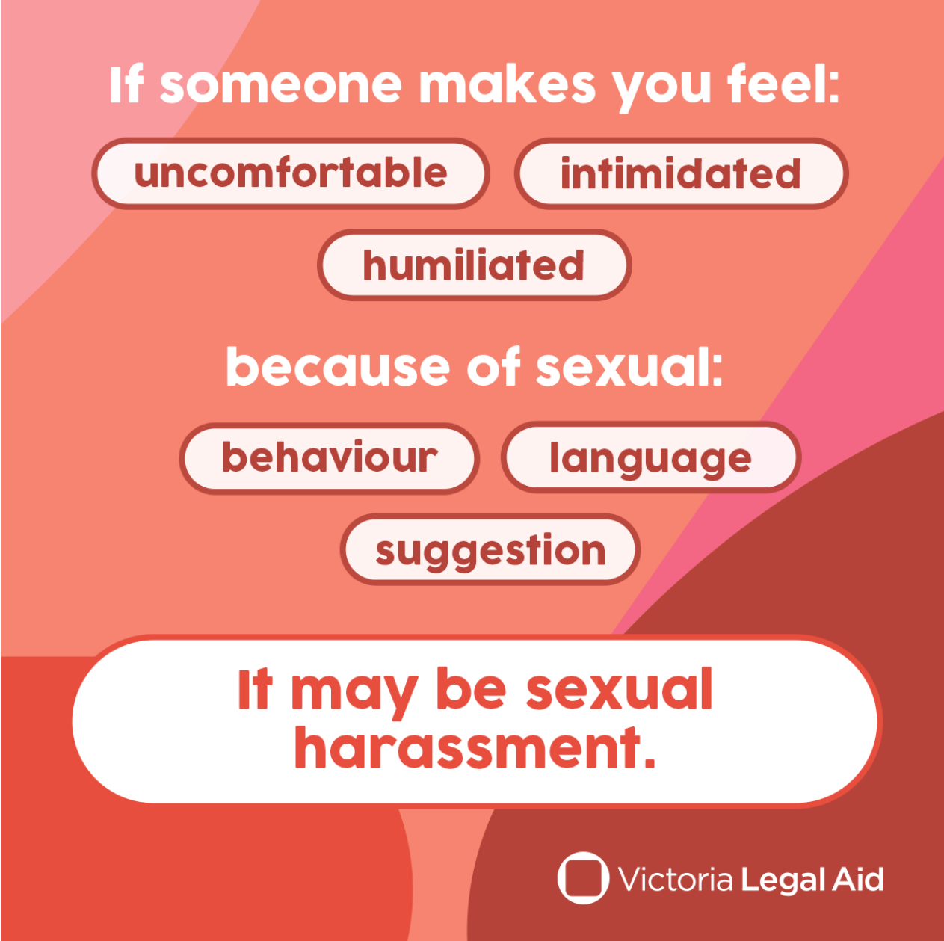
vla-elp-sex-harass-aud-1-ad-a-2.png
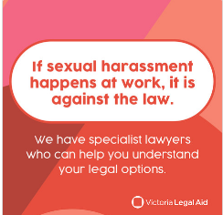

Young Victorians aged 18-25

Copy:
Safe workplaces treat everyone equally. Sexual harassment can affect your confidence, mental health, and work.
If you are experiencing harassment, let Victoria Legal Aid’s Equality Law team know. They can help you figure out the legal option that best suits your needs. It is a free service.
Email equalitylaw@vla.vic.gov.au or call Victoria Legal Aid’s Legal Help team on 1300 792 387.

Image files (to be used as a carousel):
vla-elp-sex-harass-aud-2-ad-b-1.png
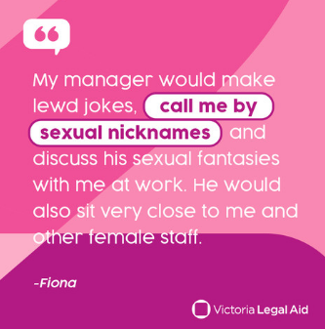
vla-elp-sex-harass-aud-2-ad-a-2.png
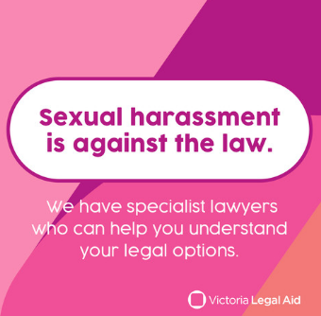

Victorian-based Women, non-binary and gender diverse people under 40

Copy:
Discrimination is unacceptable. Everyone deserves to be safe and treated with respect at work. If you have been sexually harassed, we can help you enforce your rights.

Contact Victoria Legal Aid for more information about your legal options. Email equalitylaw@vla.vic.gov.au or call Victoria Legal Aid’s Legal Help team on 1300 792 387.

Image files (to be used as a carousel):
vla-elp-sex-harass-aud-4-ad-b-1.jpg
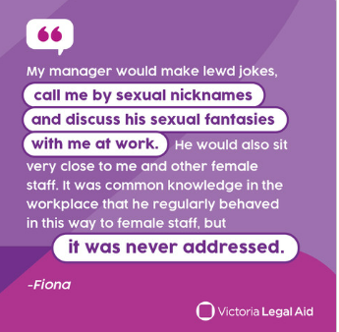
vla-elp-sex-harass-aud-4-ad-b-2.png
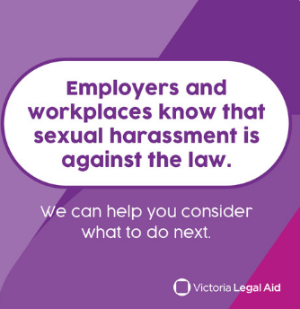

Twitter posts

Tweet 1

Copy:
Everyone should feel safe at work. If you’ve experienced sexual harassment at work, Victoria Legal Aid’s specialist sexual harassment and discrimination law services can help.
To learn more, visit https://www.legalaid.vic.gov.au/specialist-sexual-harassment-and-discrimination-law-services

Image file:
vla-elp-sex-harass-aud-1-ad-a-1.png

Tweet 2

Copy:
Sexual harassment can include touching, sending photos, or offensive ‘jokes’. It can happen in person, or on social media, via text or phone and on work trips.
If you are experiencing sexual harassment, Victoria Legal Aid’s specialist services can help.
To learn more, visit https://www.legalaid.vic.gov.au/specialist-sexual-harassment-and-discrimination-law-services

Image file:
vla-elp-sex-harass-aud-1-ad-a-2.png

Tweet 3

Copy:
Safe workplaces treat everyone equally. Sexual harassment can affect your confidence, mental health, and work.
To learn more, visit https://www.legalaid.vic.gov.au/specialist-sexual-harassment-and-discrimination-law-services

Image file:
vla-elp-sex-harass-aud-2-ad-b-1.png

Tweet 4

Copy:
Discrimination is unacceptable. Everyone deserves to be safe and treated with respect at work. If you have been sexually harassed, we can help you enforce your rights.

To learn more, visit https://www.legalaid.vic.gov.au/specialist-sexual-harassment-and-discrimination-law-services

Image file:
vla-elp-sex-harass-aud-4-ad-b-2.png

