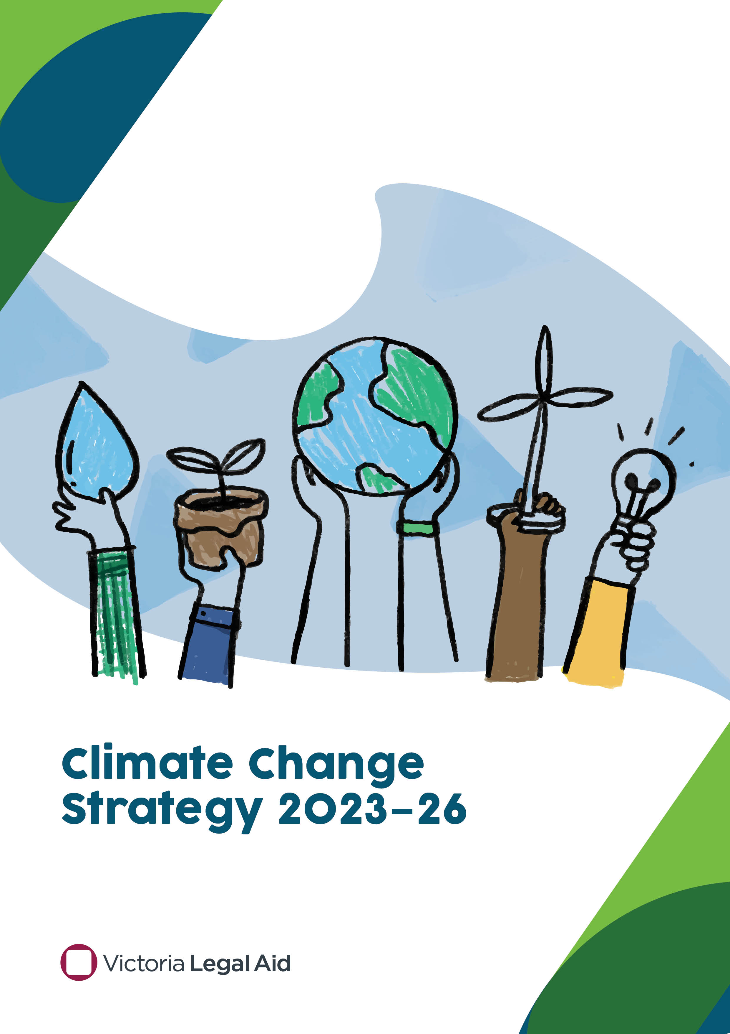

Climate Change Strategy 2023–26

Acknowledgement of Country
This document was written on the land of the Wurundjeri people of the Kulin Nation. We acknowledge the Traditional Custodians of the lands across Victoria and pays respect to their Elders past and present. We recognise their continuing connection to country, culture and identity and the leadership being taken by First Nations people to manage and protect against the impacts of climate change on the environment.
© 2023 Victoria Legal Aid. Reproduction without express written permission is prohibited.
Written requests should be directed to Victoria Legal Aid, Community Legal Information and Corporate Services,
GPO Box 4380, Melbourne VIC 3001.
Disclaimer. The material in this publication is intended as a general guide only. It has been prepared for Victoria Legal Aid staff and community legal centre staff and volunteers for study purposes only. The information contained should not be relied upon as legal advice, and should be checked carefully before being relied upon in any context. Victoria Legal Aid expressly disclaims any liability howsoever caused to any person in respect of any legal advice given or any action taken in reliance on the contents of the publication.

Contents
Acknowledgement of Country ii
Contents iii
Chairperson message 1
About Victoria Legal Aid 2
Our vision 2
Our purpose 2
Our values 2
Our outcomes 2
Introduction 3
Aim and climate goals 5
Governance 6

Chairperson message
I am pleased to present Victoria Legal Aid’s climate change strategy. At Victoria Legal Aid (VLA), our purpose is to make meaningful difference for our clients and the community. Climate change is one of, if not the most, pressing challenge that our planet is facing, and we recognise the importance of caring for the environment by reducing our own impact. We are committing to ambitious carbon emission reductions and aim to certify as a carbon neutral agency by 2026 through the Australian Governments Climate Active Program.
As an independent government agency, we are also committed to supporting the ambition of the Victorian Government to reach net-zero greenhouse gas emissions by 2045. The best outcomes for our clients and communities also include the responsible management of our carbon emissions. This strategy lays out our commitment to climate action and the beginnings of how we will get there by:
- looking at ways to reduce our emissions
- considering the environmental impact of our operations
- continuously measuring and improving how we capture and report our environmental data.
The climate has already changed, and we are increasingly facing disasters caused by extreme weather. VLA receives funding from the Australian Government to support individuals, small businesses, and producers through the public and private legal sector partnership Disaster Legal Help Victoria. It is crucial that the legal assistance sector comes together to build knowledge, relationships, and processes to ensure that we do our best to support communities to not only respond to extreme weather events but to prepare for them too.
The clients and communities who most need our support in accessing justice are also those who are likely to be disproportionately impacted by climate change. Disadvantaged communities tend to live in areas more affected by extreme weather and have fewer resources to change their circumstances. Internationally and in Australia there has been efforts to review climate change’s impact on access to justice, and there is evidence that it exacerbates disadvantage disproportionately affecting those who are least able to cope and recover from its effects.
Bill Jaboor
Chairperson, Board

About Victoria Legal Aid
Victoria Legal Aid is a statutory authority that serves the broader community by providing information, legal advice, and education with a focus on the prevention and early resolution of legal problems. We prioritise more intensive legal services, such as legal advice and representation, to those who need it the most. We recognise the intersections between legal and social issues in the way we do our work and advocate for change. We also work to address the barriers that prevent people from accessing the justice system by participating in systemic reforms and strategic advocacy.

Our vision
A fair, just, and inclusive society where people can get help with their legal problems and have a stronger voice in how laws and legal processes affect them.

Our purpose
To make a difference for clients and the community by helping to effectively address legal problems, supporting the coordination of a strong and dynamic legal assistance sector and working with partners to create fairer laws and systems.

Our values

Fairness
We are committed to fairness in society and facilitating fair and equitable access to legal support.

Care
We care about our clients and the community and approach our work informed by the effects that trauma and discrimination can have. We learn from people affected about what matters most. We treat each other with kindness and respect.

Courage
We approach our work with strength and confidence. We are guided by our values and what matters most to our clients and society.

Inclusion
We work to provide an inclusive environment for clients, staff, and referral partners.

Our outcomes
Victoria Legal Aid has five outcomes that it will focus on over the next four years (2022–26):
- Clients: Clients have increased access to justice
- Community: Improved legal understanding in the community
- Legal assistance sector: The legal assistance sector is collaborative and coordinated
- Laws and systems: Laws and systems are fairer
- Victoria Legal Aid: Victoria Legal Aid is effective and sustainable.

Introduction

Our target
The aim of this strategy is to reach carbon neutral by 2026 through the Australian Government’s Climate Active Program. The impacts of climate change are becoming more obvious and have already been felt by the Victorian community and our clients. This strategy will assist us to review and reduce our sources of greenhouse gas emissions and to encourage the consideration of environmental sustainability and the impacts of our built environment.
Over recent years, damaging floods and bushfires have become more frequent. In 2022 thousands of Australians were impacted by severe flooding and the 2019–20 Eastern Victorian bushfires caused far-reaching devastation for local communities, ecosystems, businesses, and infrastructure. Climate change science has shown that to stop these impacts from growing, and to ensure our planet remains healthy and liveable, global temperature increases need to be limited to 1.5°C above the pre-industrial levels of the late 1800’s. Currently, we are at about 1.1°C above those levels and drastic actions need to be taken to limit continued warming.
The Victorian Government introduced the Climate Change Act in 2017, a commitment to carbon emissions reduction actions and targets with the aim of net-zero emissions by 2045. The government is aiming to have all government-owned buildings, such as schools and hospitals, powered by 100 per cent renewable energy by 2026, and to incrementally decarbonise Victoria’s electricity grid so that 65 per cent of electricity is generated by renewable sources by 2030.

Our communities
Climate change is introducing complex and changing demands across the legal landscape. We are already partnering with others in the legal assistance sector to support clients affected by these extreme weather events through Disaster Legal Help Victoria (DLHV). DLHV works collaboratively with others in the legal assistance sector to provide free legal advice and ongoing casework to communities affected by extreme weather events. The magnitude and intensity of recent events have brought home the real threat of climate change-driven disasters already here.
While we support our clients and communities in the face of disaster, we need to ensure that we too are a climate resilient organisation able to continue to provide much needed legal services. This strategy aligns with the strategic direction in our latest four-year strategy, Strategy 26, to ‘Enhance our commitment to environmental sustainability and carbon neutral targets’.

Our emissions
We measured our emissions between April 2021 and March 2022 to establish a baseline year and estimated that they were approximately 1411.63 tCO2e,. The sources of carbon emissions we measured included our hybrid car fleet, energy consumption in our offices and an estimate of the emissions resulting from working from home.

Our timeline – carbon neutral by 2026
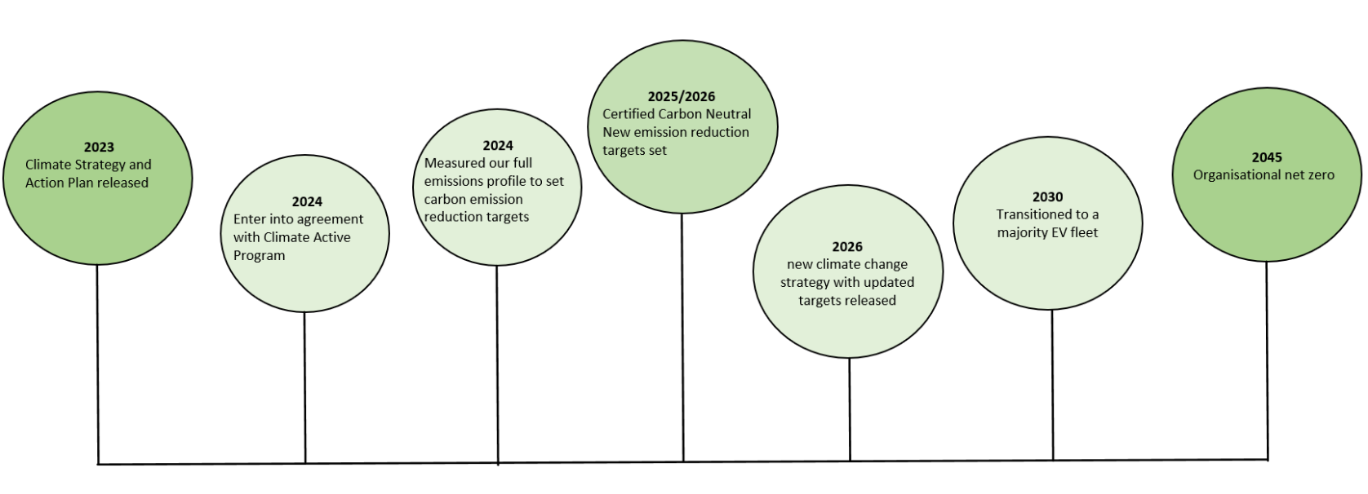
Tackling climate change requires action from individuals, business and industries, and all levels of government. This is why VLA has decided to commit to being carbon neutral by 2026. This means that we have reduced, or are reducing, our emissions where possible and are compensating for the those that we have not yet, or cannot, reduce through the purchase of carbon offsets.
Becoming carbon neutral by 2026 is ambitious, yet the nature of our office-based operations and hybrid car fleet means that it is achievable. Our initial measurement of our emissions between April 2021 and March 2022 highlighted areas where there needs to be more work done to ensure we are measuring as best as possible all sources of emissions. We will manage the emissions we have already measured whilst taking steps to capture and measure all sources of emissions that we can.
Our milestones are 2023-climate change strategy and Action plan released; 2024 Enter into agreement with the climate Action Program; 2024 Measured our full emissions profile to set carbon emission reduction targets; 2025/2026-Certified Carbon Neutral and New emission reduction targets set; 2026-New climate change strategy with updated targets released; 2030-Transitioned to a majority EV fleet; 2045-Organisational net zero.

Aim and climate goals

Aim
Our aim is to do everything we can to ensure our environmental impact is as small as possible by reducing our emissions footprint, working towards carbon neutral certification by 2026 and taking the environment into consideration in our decision making. This timing also aligns with in the end of our current strategic plan, Strategy 26. The development of the next four-year strategy will give us an opportunity to review our actions and set new targets.

Climate goals
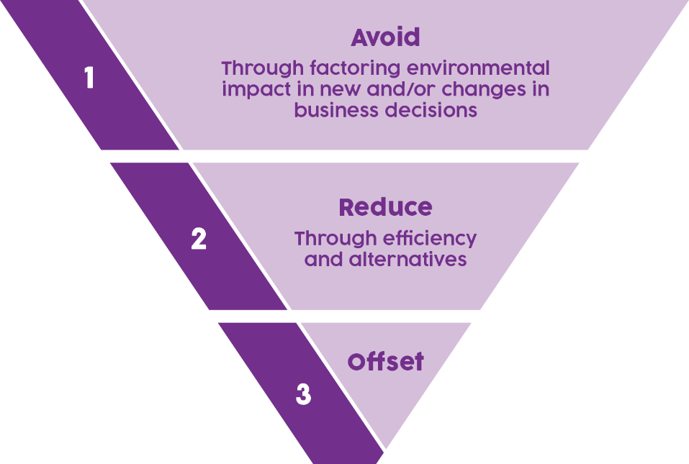
A mitigation hierarchy has been used to guide the development of our Climate Change Strategy. The hierarchy prioritises emissions avoidance and reduction first and uses offsets as a last resort, or interim measure, on the path towards carbon neutrality. While we have not set a target for overall emissions reduction, we will still aim to reduce them as action on climate change cannot wait. Once we have calculated and estimated our full scope of emissions then we will be able to make informed reduction targets.
This strategy has three main goals.

Carbon emissions reduction
Goal: To reduce our greenhouse gas emissions and offset what we cannot reduce.
Priorities:
- Switching to green power—as part of our contract for the State Purchasing Contract for electricity, VLA has already switched to 100 per cent Green Power from 1 July 2023.
- Committing to electric vehicles—VLA will replace its fleet with electric vehicles (EV) long-term, subject to availability and cost (including supporting infrastructure).
- Purchasing offsets—VLA will purchase offsets for emissions that we can’t yet eliminate or reduce further.
Measuring our success by 2026:
- A reduction of emissions compared to our baseline year, with targets reviewed and reset on a regular basis.
- Our remaining emissions are offset through the purchase of offsets from Australian reforestation and biodiversity projects.

Environmental management
Goal: To lead a resilient and sustainable agency where our environmental impact is considered in decision making.
Priorities:
- Environmental Management Policy—VLA will introduce an environmental management policy that will establish climate change considerations into our built environment, procurement, and business decision-making.
- Staff Network—to support our environmental management, VLA will introduce a staff network to encourage a culture of environmental responsibility.
Measuring our success by 2026:
- Environmental Management Policy is introduced.
- Staff are engaged in reducing VLA’s environmental impact through internal environmental education and promotion.

Understanding and monitoring our impact
Goal: Continue to collect data to understand all sources of emissions, and to take a leadership role in the legal assistance sector’s response to extreme weather events.
Priorities:
- Data improvements to understand our full emissions profile—VLA will expand our environmental reporting to include optional reporting of environmental data by government entities (FRD24) indicators in anticipation of Victorian Government changes and to support Climate Active certification.
- Advocacy—VLA has a potential role to play in climate change advocacy given our involvement with climate-related disaster response through DLHV, and to advocate for disaster preparedness, especially for our client demographic groups who are likely to be disproportionately affected.
Measuring our success by 2026:
- Data capture process have been put in place to regularly review and report on the emissions of our organisational value chain.
- Increased engagement with stakeholders and government on planning for and responses to extreme weather events.

Governance
All staff have a role to play in reducing our emissions ‘footprint’. A staff network that focuses on green and sustainable choices and education will be set up to support the delivery of this strategy. This network will assist in implementing actions for us to reduce our emissions, ‘green’ our leases and achieve carbon neutrality.
As part of our obligations as a government agency, we will be reporting our resource consumption and greenhouse gas emissions, and our progress against this strategy in our annual reports from 2022–23 onwards.

Carbon dioxide equivalent, CO₂e, means the number of metric tons of CO2 emissions with the same global warming potential as one metric ton of another greenhouse gas.
As we expand our emissions data collection and reporting we anticipate that this figure is likely to initially increase.

