Aboriginal and Torres Strait Islander Employment Strategy 2020–25

Acknowledgement of Country
Victoria Legal Aid acknowledges the Traditional Custodians of the land where we work, and pays respect to their Elders past, present and emerging. We recognise their continuing connection to Country and the resilience, diversity and strength of Victoria’s Aboriginal Communities.

Contents
Acknowledgement of Country 1
Foreword 3
First Nations Staff Network supporting statement 3
Introduction 4
Building on our achievements 4
Where we are at 4
Career pathway programs 5
Aboriginal and Torres Strait Island Legal Clerkship Program 5
New Lawyers Program 5
Aboriginal Services 6
Aboriginal and Torres Strait Islander Employment Strategy 2020–25 7
Priority areas 7
Implementation of this strategy 9
Monitoring and reporting 9
First Nations Staff Network 10

Foreword
On behalf of Victoria Legal Aid (VLA), we are pleased to present our Aboriginal and Torres Strait Islander Employment Strategy 2020–25.
The strategy reflects VLA’s genuine commitment to the principles of reconciliation and self-determination under our Innovate Reconciliation Action Plan 2019–21 (RAP2) by committing us to significantly increasing the proportion of First Nations staff in our workforce. We want to create a culturally safe and inclusive workplace for all First Nations staff that values their unique knowledge, skills and expertise.
Currently, five per cent of our clients identify as Aboriginal and/or Torres Strait Islander. We want to build a workforce that understands the needs and interests of the clients we serve. First Nations staff contribute to influencing culturally safe practice and bring valuable perspectives to the design and delivery of services across our organisation.
This strategy is a five-year roadmap for VLA with ambitious commitments to identify and remove systematic barriers that discourage and disadvantage First Nations peoples who want to join our organisation. To achieve the strategy’s outcomes, all staff will play an active role in making the organisation a safe and inclusive place to work.
We thank our First Nations Staff Network for its leadership in this strategy, which supports strong professional development and career progression for current and future employees.
Bill Jaboor, Chairperson, Board, Victoria Legal Aid
Louise Glanville, Chief Executive Officer, Victoria Legal Aid

First Nations Staff Network supporting statement
The First Nations Staff Network welcomes Victoria Legal Aid’s Aboriginal and Torres Strait Islander Employment Strategy 2020–25 and applauds our organisation’s continued commitment to supporting self-determination, and to building a culturally safe workplace that values and seeks the unique knowledge, skills, and expertise of First Nations staff. The Network is pleased to have played a consultative role in the development of the strategy and believe that its implementation will ensure First Nations staff will feel a sense of inclusion and support in our workplace and their careers.

Introduction
Our Aboriginal and Torres Strait Islander Employment Strategy 2020–25 (the strategy) is intended to contribute to VLA being viewed as an employer of choice for First Nations peoples through effective recruitment processes, a culturally safe and supportive work culture, opportunities for professional development and mentoring, and demonstrated respect for the skills, expertise, and perspectives of First Nations staff.
The strategy builds on the successes and learnings of VLA’s previous and first Aboriginal and Torres Strait Islander Employment Strategy (2016–18). It provided the foundation for a more ambitious strategy. This strategy aims to significantly increase the number of First Nations staff employed at VLA, improve access to professional development and mentoring opportunities, and ensure our workplaces are safe and inclusive. The strategy reflects and supports the key commitments of our second Innovate Reconciliation Action Plan 2019–21, particularly Actions 12, 16, and 18, which focus on increased recruitment, retention, and professional support for First Nations people.
We acknowledge that increased employment of First Nations people within our organisation supports principles of self-determination and recognises that having a diverse workforce is crucial to achieving services that are culturally safe and responsive to our clients. First Nations people bring unique knowledge, skills, and expertise to our workforce and understand the needs and aspirations of the Aboriginal and Torres Strait Islander community.
This strategy has three priority areas:
- Increase the proportion of First Nations staff at VLA from 2.3 per cent to 5 per cent
- Ensure that VLA is a culturally safe and inclusive workplace
- Improve the retention and professional development of First Nations staff at VLA
The development and implementation of this strategy is priority in our Corporate Plan 2019–20 and sits alongside the following organisational plans and initiatives that support diversity and inclusion:
- Our vision and values
- Strategy 22
- Innovate Reconciliation Action Plan 2019–21
- Client-first strategy 2020–23
- Cultural Diversity and Inclusion Strategy 2020–23
- Workplace Wellbeing Plan
- Gender, Diversity and Inclusion Survey

Building on our achievements

Where we are at
One of the key achievements of our Aboriginal and Torres Strait Islander Employment Strategy 2016–18 was the introduction of increased employment opportunities for First Nations people. The creation of an Aboriginal Services team and the strengthening of legal pathway programs for law students and graduates generated the most significant contribution to an increase in our First Nations staff, who currently represent 2.3 per cent of our workforce. This progress was strengthened by the appointment of First Nations staff to non-designated roles in areas of VLA such as legal administration, non-legal service delivery, and a newly created role of Associate Director, Data Services.

Career pathway programs
Our previous strategy strengthened VLA’s legal pathway programs. There are numerous benefits to these structured pathways, which are designed to train, support, and guide participants as they progress in their legal careers. The 2020–25 strategy will continue to consolidate and grow participation in these programs.
We acknowledge that our organisation is more than a legal service and that there are a multitude of opportunities for recruitment and development in non-legal role across the organisation. Under this strategy, over the next five years we will leverage off the success of our legal pathway programs to implement ways of better supporting non-legal careers for current and prospective First Nations staff members.

Aboriginal and Torres Strait Island Legal Clerkship Program
This program is designed to support law students to obtain practical skills, knowledge and a comprehensive understanding of the work undertaken by lawyers and support staff at VLA through actual experience. Clerks have the option to complete the program either part time or full time, depending on other commitments. Placements can be undertaken at any of our 15 office locations, in any area of law.
A total of 23 law students have participated in the program with many completing multiple placements.
We also implemented our Graduate Law Program which is available to candidates who have completed a Bachelor of Law (LLB) and are eligible to enrol in Practical Legal Training (PLT). This was a crucial step in addressing a previous barrier for law students – a structured pathway between law studies and admission as lawyer. The program pays for PLT which is provided by Leo Cussen and undertaken mostly online. Our graduates undertake three days of study while in the office and two days of practical work tasks while still being paid a full-time wage. Three participants have successfully completed placements in this program.

New Lawyers Program
Our New Lawyers Program (NLP) is our most competitive recruitment campaign each year and provides two designated positions for Aboriginal and Torres Strait Islander candidates. The two-year program, consisting of six-month rotating placements, is available to lawyers with less than 18 months post admission experience. It provides participants with the opportunity to regularly appear before courts and tribunals to consistently strengthen their advocacy skills, as well as undertake case work and advice clinics with a diverse range of clients. They also receive hands on experience in different regional and metropolitan locations across a variety of areas of law, while being supported by a structed training program.
We have had eight participants undertake VLA’s New Lawyers Program in designated positions, including one participant who successfully completed all three pathway programs, once again highlighting the significant value of having specialised programs at all different stages.

John Cattanach, New Lawyers Program
Currently undertaking his final rotation of VLA’s New Lawyers Program, John will be the first staff member to complete all three of VLA’s legal pathway programs.
John commenced in 2016 through our Aboriginal and Torres Strait Islander Clerkship Program, undertaking placements in Geelong’s criminal law practice while completing his law studies. After graduating, John commenced our Aboriginal and Torres Strait Islander Graduate Law Program in January 2018, where he balanced his PLT with legal work in Melbourne’s Summary Crime team. In September 2018, John was accepted into the New Lawyers Program, completing his first two rotations in the Summary Crime team in Sunshine before moving home to undertake his final two rotations in Geelong.
‘VLA has supported me in going from law student to lawyer. These programs have offered valuable knowledge, confidence and mentorship that has lasted beyond the programs. My time at VLA has been insightful and culturally safe. I am proud to work in an organisation that supports Aboriginal people.’

Aboriginal Services
Our Aboriginal Services team was established to facilitate and lead VLA’s reconciliation journey. The team is made up of an associate director, a project officer, and three Aboriginal community engagement (ACE) officers.
The ACE officers are specialist non-legal roles that focus on client support, community engagement, and empowering First Nations peoples. The ACE officers support First Nations peoples to access our legal assistance services, contribute to building and supporting relationships with community-controlled organisations and other service providers, and build greater knowledge of legal problems and assistance available through community legal education and other community engagement activities.
The Aboriginal Services team coordinates and lead all Aboriginal-specific initiatives across VLA. This includes leadership and guidance in legal service design, reforms and outcomes, with the objective of providing culturally safe and responsive services for Aboriginal and Torres Strait Islander people. Another area of responsibility is aligning VLA’s objectives with the Victorian Aboriginal Affairs Framework 2018–23, to enable the principles of self-determination in VLA’s practices, procedures and policies. While applying these principles to ensure guidance is grounded in evidence-based practices, Aboriginal Services also provides ongoing support to all program areas and regional offices to build our capacity to provide culturally safe and responsive services for Aboriginal and Torres Strait Islander people.
The Associate Director, Aboriginal Services is a member of our Senior Executive Team (SET) and provides Aboriginal expertise across VLA’s leadership. The Associate Director, Aboriginal Services also provide strategic leadership advice to our Chief Executive Officer and Board on the Aboriginal Services portfolio including policies, programs, financial and operational.

Alan Dewis, Associate Director, Aboriginal Services
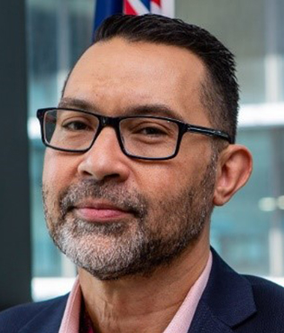
Having previously been part of the New Lawyers Program, Alan returned to VLA in the role of Associate Director, Aboriginal Services in 2018. Alan plays a significant role in leading VLA’s reconciliation journey through coordinating implementation of our Innovate Reconciliation Action Plan 2019–21 which aims to improve and embed cultural safety for Aboriginal and Torres Strait Islander clients and our First Nations staff.
‘I’m immensely proud to have the opportunity to provide my leadership to Victoria Legal Aid’s Aboriginal and Torres Strait Islander Employment Strategy 2020–25. The importance of continuing to grow our First Nations staff across all areas of our organisation is an essential element to achieving our RAP2 objective of being able to provide culturally safe and responsive services.’

Aboriginal and Torres Strait Islander Employment Strategy 2020–25
The strategy outlines specific goals that will see our current legal career pathway programs continued and enhanced, while expanding these initiatives to non-legal pathways. The actions outlined in this document will also ensure we are developing a culturally safe workplace, maintaining and strengthening our existing programs and practices, and optimising our opportunities to retain and develop First Nations staff within VLA and the broader legal services sector.
These actions will be carried out in collaboration with our justice sector partners and Aboriginal Community Controlled Organisation partners in the legal, education, and the broader social and community sectors. Together we aim to increase employment opportunities for the Aboriginal and Torres Strait Islander community in legal service delivery in Victoria.

Priority areas

1. Increase the proportion of First Nations staff at VLA from 2.3 per cent to 5 per cent
A target of five per cent was established to acknowledge the importance of a workforce that is reflective of the community we serve – five per cent of our clients identify as Aboriginal and/or Torres Strait Islander. To achieve this target, we will need to attract and recruit more Aboriginal and Torres Strait Islander people in a range of roles across the organisation.
To increase the recruitment of First Nations staff we will:
- Consult the First Nations Staff Network on culturally safe recruitment practices.
- Provide support and guidance to hiring managers by developing guidelines on attracting and recruiting Aboriginal and Torres Strait Islander people.
- Ensure all Aboriginal and Torres Strait Islander candidates and new recruits receive information about the cultural supports available to them within the organisation.
- Establish and maintain partnerships with Tarwirri Indigenous Law Students and Lawyers Association, universities, and other Aboriginal and Torres Strait Islander organisations and employment programs.
- Establish and maintain networks across Aboriginal Community Controlled Organisations and government to promote VLA’s inclusive work culture.
- Improve coordination and support for all Aboriginal and Torres Strait Islander applicants to maximise VLA’s ability to recruit suitable candidates to roles across the organisation.

2. Ensure that VLA is a culturally safe and inclusive workplace for First Nations peoples
An inclusive workplace enables staff to feel valued and increases job satisfaction. Through our commitment to inclusion, VLA is respecting and giving effect to the principles of self-determination within the design and delivery of specific services and policies across the organisation. To achieve this, we will embed First Nations staff voices in our everyday work, including actively consulting and seeking input from commencement and through all stages of design, development and implementation, rather than as a ‘tick of approval’. The enabling of inclusion should not occur in isolation, but across all of our offices and programs, to ensure that the workplace is culturally safe for all First Nations staff.
To ensure that VLA is a culturally safe and inclusive workplace we will:
- Support and encourage all First Nations staff to participate in First Nations Staff Network activities.
- Ensure that First Nations Staff Network’s perspectives are actively considered and incorporated in First Nations specific policies and programs or other policies and procedures which may create barriers for First Nations peoples.
- Strengthen the Employee Assistance Program (EAP) to be culturally inclusive and accessible to First Nations staff.
- Ensure that all VLA staff are undertaking activities as part of the Aboriginal and Torres Strait Islander Cultural Learning Strategy 2020–25.
- Continue to ensure that all VLA staff have undertaken Respectful Workplace Behaviour training.

3. Improve the retention and professional development of First Nations staff
Retention of staff is strongly linked to how safe and valued they feel in the workplace, and increasing their awareness and access to career development opportunities to embrace their strengths and achieve their full potential.
To ensure that VLA improves the retention and development of Aboriginal and Torres Strait Islander staff we will:
- Establish an Aboriginal Employment Coordinator position in our People and Culture team.
- Develop Aboriginal and Torres Strait Islander Employment Toolkits to support managers to induct and support new First Nations staff in a culturally safe way.
- Ensure that departing First Nations staff are supported to have a voluntary exit interview with a member of staff with whom they feel culturally safe to identify and rectify any organisational shortcomings that may have contributed to their departure.
- Establish a professional development program for both legal and non-legal First Nations staff, including access to career mentors.
- Support First Nations staff career opportunities and secondments to and from other organisations.

Implementation of this strategy
In consultation with the First Nations Staff Network, the implementation of this strategy will be phased. Rolling implementation plans will be developed that are strategic, realistic and achievable within the resources available. The rolling implementation plans will enable us to be agile and adjust to meet all priorities by 2025. The rolling implementation plans will be over two phases, the first phase is 2020–22 and the second phase is 2022–25.

Monitoring and reporting

Measuring our progress and performance measures
The Aboriginal and Torres Strait Islander Employment Strategy 2020–25 supports our commitment to First Nations staff and increasing Aboriginal and Torres Strait Islander employment across a range of roles.
VLA is committed to making reconciliation everyday business and this strategy is a call to action for all staff to play an active role in making the organisation a safe and inclusive place to work.
Over the next five years we will use a range of measures to monitor our progress towards achieving our goals.
These measures will enable us to:
- monitor performance to track our progress towards our goals.
- know if our First Nations staff experience VLA as culturally safe workplace.
- take action to improve performance or to make adjustments if needed.
These measures sit alongside and have interdependencies within the governance framework being driven by the RAP Working Group during the first two years of the strategy.
Our annual corporate plan and relevant business unit planning will include measures that will link back to this strategy and help us to assess what we have achieved over the shorter term and the difference we have made.

Performance measures
- The proportion of First Nations staff has increased to 3 per cent by 2021 and to 5 per cent by 2025.
- Increased engagement by practice and policy areas with the First Nations Staff Network meetings and forums.
- Introduction of a designated role within People and Culture to coordinate and support the employment of First Nations staff and applicants
- Expansion of our legal pathway programs for First Nations staff and introduction of non-legal pathway programs for First Nations staff
- Improved results for First Nations staff in relevant VLA staff surveys
- Creation and implementation of career planning and professional development program in consultation with First Nations staff
- Increased engagement by First Nations Staff in self-identification, secondment opportunities and staff retention.
- Increased staff participation in completing cultural awareness training and other elements within the Aboriginal and Torres Strait Islander Cultural Learning Strategy 2020-25.

First Nations Staff Network
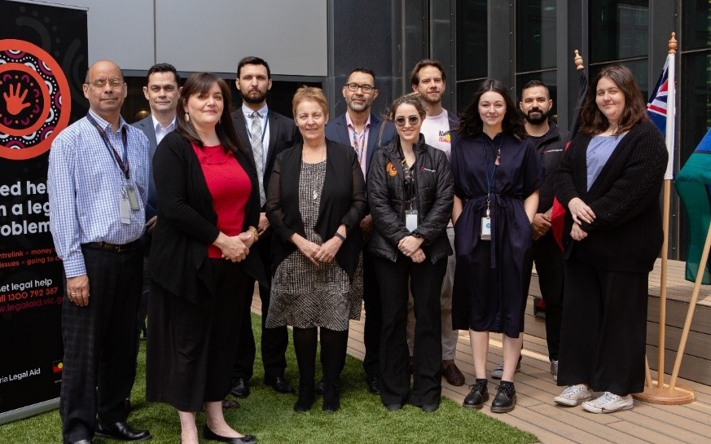
On 23 January 2019, our First Nations Staff Network was established. The network was instrumental in the development of this strategy, providing essential reflections, feedback, and consultation. The Network will continue to contribute to the implementation and evaluation of the strategy, in partnership with our Aboriginal Services and People and Culture teams. However, all our staff have a role to play in the successful implementation of this strategy. It is ultimately the commitment, actions and behaviours of all our people that will determine how successful we are in creating a work culture that is inclusive and culturally safe.

Alethea Belford, Associate Director, Data Services
Alethea started at VLA in late 2018 as part of our digital transformation program. She leads our Data Services function which includes the Reporting, Governance and Records and Architecture and Integration teams.
‘VLA is the first place I have worked where I feel free (and proud) to be myself.’

Craig Cairney, Senior Legal Help Lawyer
A senior lawyer in our Legal Help team, Craig’s relationship with VLA started while he was still a law student, before commencing as an articled clerk in 2005. Since then, Craig has experienced multiple areas of our legal practice, and has also completed policy and project work.
‘Given the commitments toward resourcing recruitment, cultural safety, career development and accountability measures, the implementation of the Aboriginal and Torres Strait Islander Employment Strategy 2020–25 should deliver improvements in attracting and retaining First Nations staff. A tangible example of VLA’s broader strategy to respond to the legal needs of First Nations peoples in partnership with Aboriginal controlled organisations.’

Jayde Lee Schmidt, Legal Assistant
Jayde commenced with VLA in 2019 as a legal assistant working in the Civil Justice program. Jayde is currently working within the Mental Health and Disability Advocacy team and works on a wide range of administrative tasks across Civil Justice.
‘As a legal assistant, I have the opportunity to be exposed to las in a practical setting and it provides great experience that complement my studies. Victoria Legal Aid also provides great training opportunities to help you develop in your role.’

Courtney McGann, Project Officer, Aboriginal Services
Courtney commenced with VLA in 2018 as part of the Aboriginal and Torres Strait Islander Clerkship program. She has since worked in a Project Officer role in the Civil Justice program and, more recently, in the Aboriginal Services team. In her role, Courtney provides overarching support to the Associate Director, Aboriginal services, the RAP Working Group and RAP Champions Network, as well as leadership and coordination within our First Nations Staff Network.
‘My time with VLA has been immensely beneficial to my personal and professional development. I have gained experience in legal research, strategic advocacy and policy work, and project coordination in a supportive and encouraging environment.’

Simone Lim, New Lawyers Program
Simone commenced with VLA in 2018 as part of the New Lawyers Program working in our Frankston office’s Civil Justice program. Simone currently works across a variety of civil law areas including Commonwealth Entitlements, Child Support, Mental Health Tribunal, Guardianship and Administration matters at the VCAT, and Centrelink appeals at the AAT.
‘In the New Lawyers Program, I have the opportunity to manage my own files while receiving support from senior lawyers and mentoring from and executive staff member while continually learning a range of new areas of law.’

Kye Hardie, Aboriginal Community Engagement Officer, Aboriginal Services
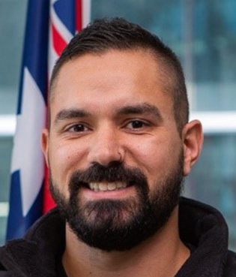
Kye has been an Aboriginal Community Engagement (ACE) Officer in VLA’s Shepparton office since September 2019. The ACE officers are specialist non-legal roles that focus on client support and community engagement. Kye supports the local community to access VLA’s legal assistance services in a culturally safe way, builds relationships with community-controlled organisations and other service providers, and raises awareness of legal problems and assistance available through community legal education and other community engagement activities.
‘Working at VLA has provided me with many unique opportunities to build on my career. At the same time, I’m able to work with people from all walks of life and provide a platform to advocate for change.’

https://www.content.vic.gov.au/sites/default/files/2019-09/Self-Determination-Reform-Framework-August-2019.PDF

