Victoria Legal Aid
Research and Evaluation Agenda
2018–22

Victoria Legal Aid. Reproduction without express written permission is prohibited. Written requests should be directed to Victoria Legal Aid, Corporate Affairs, Level 9, 570 Bourke Street, Melbourne Vic 3000.

Contents
VLA Research and Evaluation Agenda 2
VLA Vision and purpose 2
Objectives of research and evaluation at VLA 3
Developing the agenda 3
Themes 4
Identifying what works 5
Focus areas 5
Reconciliation Action Plan (RAP) Final Evaluation 5
The effectiveness of legal information 5
Evaluating the impact of major reforms 6
Means Test Review and Implementation 6
Online Referrals and Booking Tool 6
Other major reforms 7
Innovations and opportunities for system change 8
Focus areas 8
IMHA evaluation 8
Sunraysia Health Justice Partnership (SHJP) 8
Using non-legal professionals in preventing escalation of legal problems and supporting clients – evaluating early intervention pilots at VLA 9
Proposed early intervention pilot evaluations 10
Increased client voice 12
Focus areas 12
Client feedback tools 12
Client survey 12
Move towards outcomes 13
Focus areas 13
Development of an Outcomes Framework 13
Program logics and Monitoring and Evaluation (M&E) plans 13
Demonstrating value 15
Focus areas 15
Social return on investment study on timely access to legal support- measuring the broader social and economic impact 15
Supporting business cases for further investment 15
Role of the Research, Library and Evaluation Team 16
Priorities for 2018/19 18

VLA Research and Evaluation Agenda
The purpose of the agenda is to coordinate and guide the priority evaluation and research activities undertaken across Victoria Legal Aid (VLA) over the next four years. The agenda aims to establish a more strategic and collaborative evidence-based approach to our practice. The agenda will also promote the generation of evidence to support us to meet current and emerging needs. The agenda sets out the objectives, themes and enablers for quality research and evaluation activity across VLA.

VLA Vision and purpose
A fair and just society where rights and responsibilities are upheld. To make a difference to clients and the community through;
- The provision of effective legal services
- Collaborative leadership of a strong and dynamic legal assistance sector
The Agenda supports our corporate priorities relating to;
- Listening to our clients and making their diverse needs a priority (CLIENTS)
- Designing effective services using evidence and feedback when making decisions about how and where they are delivered (IMPACT)
- Leading and acting in ways that build trust and deepen relationships with colleagues, partners and the community. (TOGETHER)
A research and evaluation agenda at VLA will support this vision, purpose and corporate directions by increasing our understanding of the needs and experiences of our clients. The agenda will add to the existing evidence base in the legal assistance sector and help build a culture of inquiry and capacity to undertake and act on research and evaluation findings. It will enable us to collaborate better with our legal assistance partners, and share our learnings with colleagues, partners and the Victorian community.
VLA has a unique role in promoting research and evaluation. We are a provider of high volume legal services to the Victorian community, with frontline staff having considerable expertise in the delivery of legal services, and firsthand knowledge of the ways in which legal problems are experienced by the community. VLA is also seen as having a system manager and co-ordinator role within the legal assistance sector, with a role in resource allocation, legal needs identification and the promotion of innovative legal service delivery – all of which needs to be underpinned by robust research and evaluation.

Objectives of research and evaluation at VLA
Research and evaluation will aim to help VLA;
- Understand and respond to emerging needs and trends - understand the justice and policy environment, our clients, how legal problems are experienced and how legal need manifests in the community. (CLIENTS)
- Provide appropriate, sustainable and quality services - understand what works, in what context and for which clients. Identify innovations and services that are effective, sustainable, and of high quality and ultimately will improve outcomes for clients. (IMPACT)
- Be more transparent, strategic and effective in decision making - be accountable to our funders, service partners, stakeholders, clients and the community, by being prepared to evaluate our services and communicate the findings. (TOGETHER)
- Become an authority to influence policy and sector reform - support advocacy, inform government/administrative decision making, law reform and systemic change. (TOGETHER)
- Attract increased investment - provide evidence to demonstrate the value of legal aid and support government investment in legal aid services. (IMPACT)
- Become a sector leader and valued partner in research and evaluation - actively collaborate and support our partners in the legal assistance sector and in universities who are undertaking research and evaluation and share our expertise and knowledge with them. We will encourage relationships and research alliances that stimulate a focus on access to justice and best practice service delivery. (TOGETHER)

Developing the agenda

In developing the themes and focus areas we referenced the VLA strategy planning and corporate plan. Key teams and individuals both from within and outside of VLA, were also consulted to help us develop the themes and focus areas.

Development of the agenda will contribute to our response to both the Victorian government and Productivity Commission Access to Justice inquiries. Both reports called for improving data, research and evaluation capability across the legal assistance and justice sector.

The agenda will be reviewed annually.

Themes

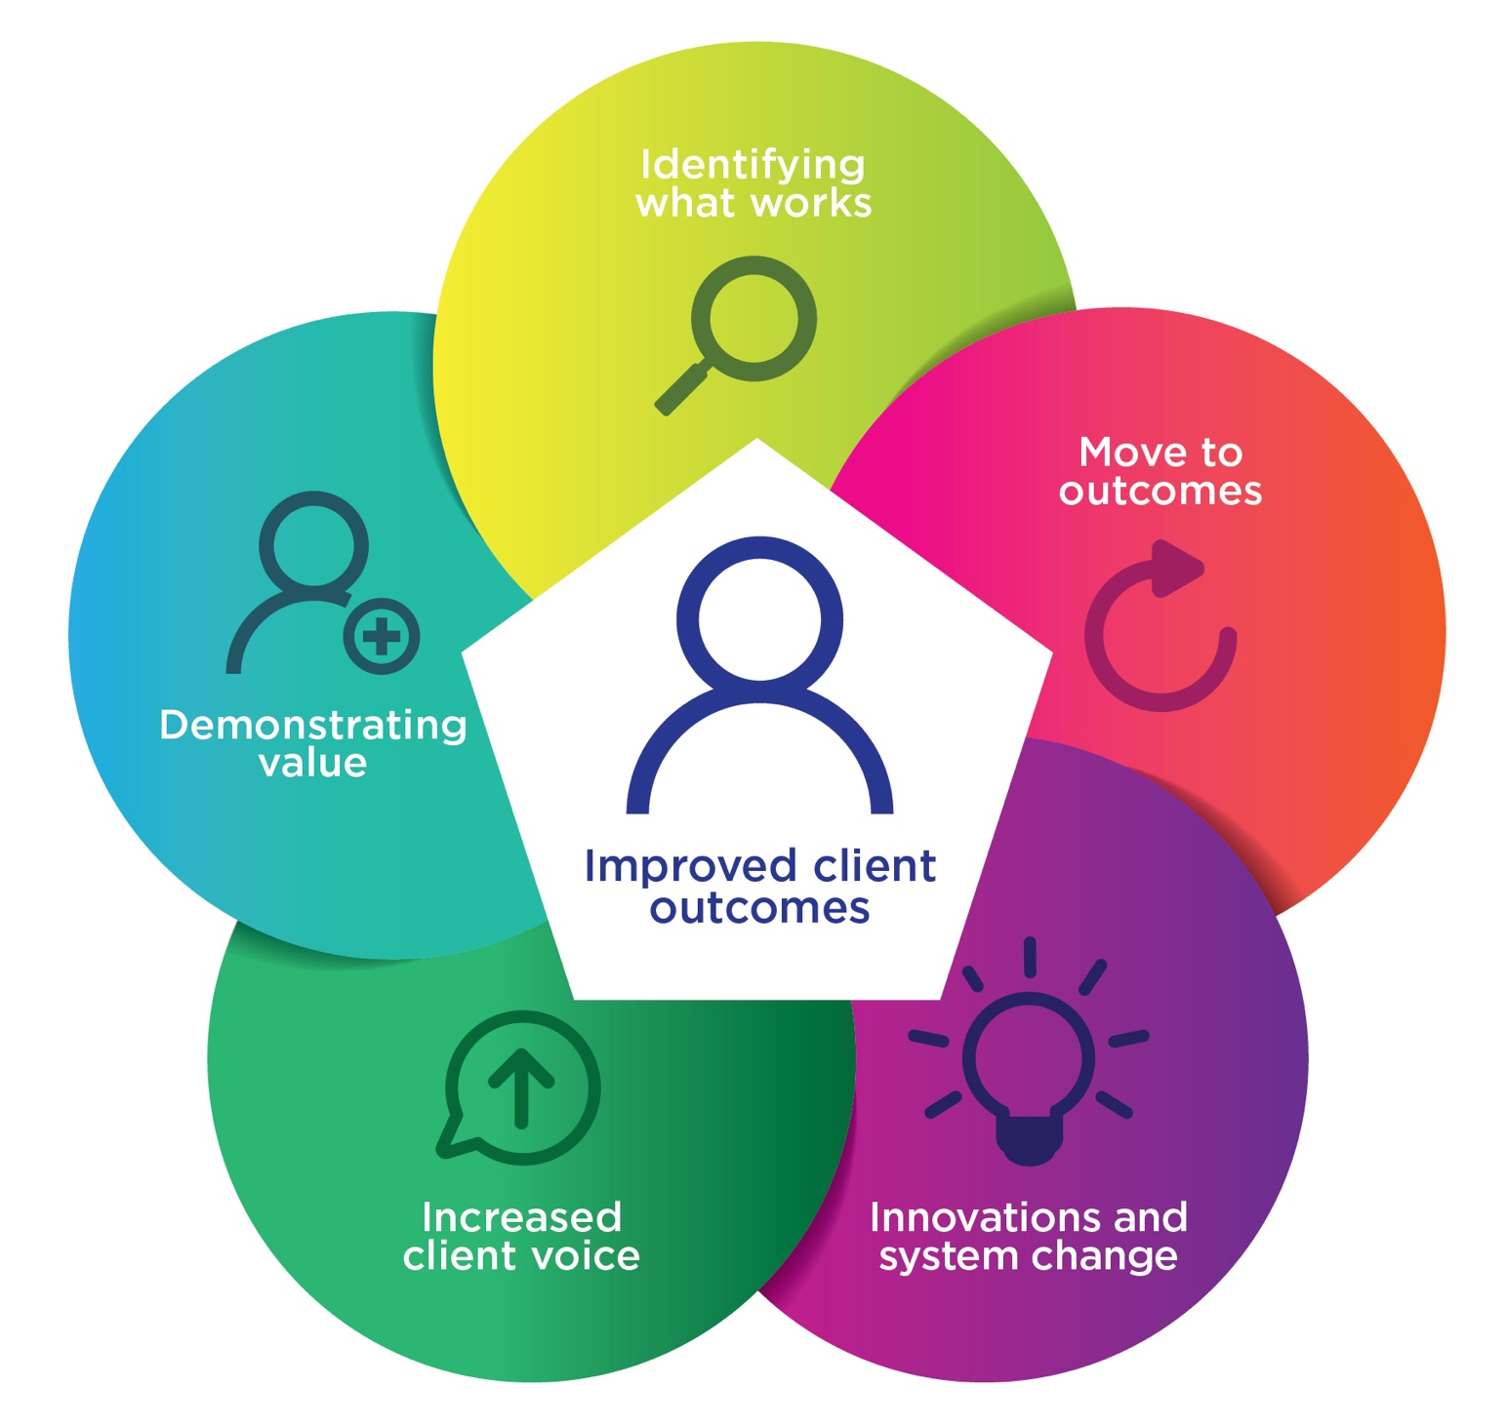

Identifying what works
To enable VLA to design and target services using data, evidence and collaborative planning we will;
- Adopt an evidence-based approach to find out what works, in what context and for which clients
- Identify effective engagement and practice for working with our priority client groups
- Better understand and identify client capabilities, and factors that contribute to better client outcomes

Focus areas

Reconciliation Action Plan (RAP) Final Evaluation

Who: The Institute for Public Policy and Governance, University of Technology Sydney and Karen Milward Consulting

Directorate/Program area: Office of Managing Director, Aboriginal Services

Victoria Legal Aid's (VLA's) Reconciliation Action Plan 2015–18 (RAP) was launched in May 2015 and is due to expire in 2018. VLA’s RAP identifies key areas and actions where we can increase access to justice for Aboriginal and Torres Strait Islanders.
The evaluation will measure the overall impact of the RAP and the extent to which the aims of the plan were achieved. The evaluation report will provide a clear assessment of the performance of the current RAP, and recommendations for improving and implementing the next RAP.

The effectiveness of legal information

Who: Law and Justice Foundation NSW.

Directorate/Program area: Access and Equity, Corporate Affairs

Legal information is the lowest intensity service but is the most common form of legal service provided by VLA. Legal information is provided to the community through our website, telephone line, duty lawyer service and community legal education publications and workshops. With limited resources, it is also frequently relied upon, sometimes instead of, or in addition to more intensive forms of legal assistance such as advice or representation. However, little is known about how effective our legal information services are, for which clients, and under what circumstances. Understanding more about client capability and how legal information can be tailored to match different capabilities will be a focus of the project.

Evaluating the impact of major reforms

Reviews of services and priority projects should be supported by sound research before commencement and evaluation at completion, in line with the complexity of the project, and its impact on the organisation. Large scale reviews are usually undertaken after acknowledging a perceived problem and coming up with an intervention, often in the form of a service solution and new models of working. Research helps us understand the problem and what has been done before to address it. Evaluation can help us assess if the objectives of the project were achieved and help determine whether the intervention we’ve chosen resulted in the intended benefits outlined as part of the project plan.

Proposed reform evaluations

Means Test Review and Implementation
Directorate/Program area: Legal Practice

The purpose of the Means Test Review was to expand access to justice by increasing eligibility for grants of legal assistance.
The Mid-Term review will be a process evaluation, assessing the process of undertaking the Review, including assessing the effectiveness of consultation and stakeholder engagement processes used. The evaluation will support continuous improvement, through capturing lessons learned and recommendations for any improvements to undertaking reviews at VLA.

Online Referrals and Booking Tool
Directorate/Program area: Access and Equity, Client Access

The -Online Referral, Booking and Information Tool project aims to make it easier for clients to obtain legal assistance from VLA and participating Community Legal Centres (CLCs), as well as for VLA and CLC staff to refer and/or book clients into services, by:
- improving the usefulness and availability of service information across the legal assistance sector
- simplifying the referral and booking process for VLA appointment services
- reducing the time required for VLA staff to make appointment bookings
- providing VLA and CLC staff with accurate and user-friendly information about VLA and participating CLC services.
The evaluation will enable us to consistently improve our referrals processes and improve the client experience of our intake and referrals.

Other major reforms
The implementation of key recent reviews, including the Summary Crime evaluation, the Child Protection Review, and the Youth Crime Service Review, will include critical monitoring and evaluation of any new pilots, funded areas of work and other reforms and initiatives falling out of the reviews to assess to what extent they have worked and made a difference to the lives of our clients and the wider community.

Innovations and opportunities for system change
To ensure clients have more access to user friendly services, through innovative technologies, and to work with partners and allies to reform and fix systemic problems that undermine fairness and erode legal rights, we will
- Evaluate innovations and new service delivery models that better support our priority clients
- Evaluate early intervention and prevention service shifts, and opportunities to increase service reach
- Evidence to drive funding requests, and support implementation of pilots to full scale, or support decisions regarding continuation/amendment of pilots.
- Respond to emerging justice issues, using program evidence to contribute to a distinctive advocacy voice

Focus areas

IMHA evaluation
Directorate/Program area: Civil Justice, Independent Mental Health Advocacy
Who? Social and Global Studies Centre, RMIT

Independent Mental Health Advocacy (IMHA) is a service delivered by Victoria Legal Aid, funded by the Victorian Department of Health and Human Services. Victoria Legal Aid and Independent Mental Health Advocacy work alongside each other to provide comprehensive and holistic support to people who are being detained because of their mental illness.
The overarching aim of this evaluation is to detail the extent to which IMHA is providing effective, efficient, sustainable independent advocacy services to people subject to, or at risk of being subject to, compulsory treatment under the Mental Health Act 2014.

Sunraysia Health Justice Partnership (SHJP)
Directorate/Program area: Services and Innovation, Mallee Legal Impact
Who? Clear Horizons and Storyscape
The SHJP is a partnership between Victorian Legal Aid (VLA) and the Sunraysia Community Health Services (SCHS), commencing operations in 2017. This is the first VLA office co-located in a community health service.
As a new service model (for VLA and SCHS), we have established a rigorous monitoring and evaluation framework to measure achievements. The evaluation activities will be used to explore whether this mode of service, in comparison with other VLA services, has a greater impact on client outcomes and addresses unmet legal needs, along with assessing the effectiveness of the partnership. The evaluation will provide a strong evidence base to guide decision-making through the implementation and operation of the service. Additionally, the results and deliverables will help inform the way we design and deliver similar services in other parts of Victoria.

Using non-legal professionals in preventing escalation of legal problems and supporting clients – evaluating early intervention pilots at VLA

Directorate/Program area: Family, Youth and Children, Child Protection, Family Violence and Criminal Law, Youth Crime

Who? External provider- TBD
VLA has undertaken recent reviews of its Child Protection and Youth Crime services, along with an evaluation of its Summary Crime Program. These reviews identified the need to think outside the traditional legal delivery framework to provide more therapeutic, client-centred services, which would aid in preventing the escalation of legal problems and support earlier resolution. Making provision for a more multidisciplinary approach to meeting the non-legal needs of more complex clients would improve the experience of some of our more vulnerable clients.
The Summary Crime Evaluation recommended VLA investigate integrating social workers into our legal practice, and the Child Protection Review recommendations included piloting an Early Intervention Unit featuring non-legal advocates.
The Youth Crime Service Review identified similar themes, and discusses the need to adopt a more therapeutic, preventative frame of reference in day to day practice.
An evaluation of implemented pilot projects will help us determine their effectiveness, and the associated benefits/costs of the model, which, if favorable, can be used to attract further funding and support for embedding these services long-term.
Evaluation will ensure lessons are learnt about the establishment of such a service and can provide a best practice model for integrating non-legal professionals, such as social workers or advocates, into the delivery of legal services in the future.

Proposed early intervention pilot evaluations

Independent Family Advocacy and Support (IFAS) Pilot

Directorate/Program area: Child Protection

Who? Incus (preparatory work), Mid and final evaluation (TBD)
IFAS responds to recommendations from the Child Protection review which are focused on providing non-legal advocacy services to families involved in the child protection system. It builds on the advocacy model developed by VLA’s Independent Mental Health Advocacy service.

IFAS is designed as a small 3-year pilot project, in two geographic areas of Victoria. The goal of the pilot is to improve access to effective prevention and early intervention services for families involved in the child protection system, that support a better experience for clients and a reduction in some matters proceeding to court. The service is planned to provide representational advocacy services to families involved in the child protection system who have not been to court. The service will focus on key population groups which we know to be over-represented in the child protection system, primarily Aboriginal and Torres Strait Islander families; and families where one or both parents have an intellectual disability. The evaluation will assess the efficiency, effectiveness and appropriateness of the interventions. Tools, frameworks and learning developed during the pilot can be used to inform other early intervention models using non-legal professionals.

Youth Crime Multidisciplinary Pilot – Delivering an Enhanced Legal Service

Directorate/Program area: Youth Crime

Who? Research & Evaluation team (preliminary program logic & M&E framework) Evaluation TBD
A model pilot currently being developed is the integration of social work capacity into the youth crime practice. This model will support vulnerable young people being more effectively linked into specialist support services, building on an improved identification of risk and protective factors at client intake, along with better supporting and building the capacity of youth crime lawyers. It would additionally support VLA to take on a more proactive approach in identifying and advocating for changes in the youth justice and supporting service system to drive innovation, strengthen service delivery and, most importantly, improve outcomes for children and young people involved in the justice system. Evaluation will be critical to assessing the effectiveness of the pilot, and the extent to which positive outcomes for lawyers and young people are achieved.

Night Court
Directorate/Program area: Criminal Law, Summary Crime
Who? Research and Evaluation team

The Night Court duty lawyer service commenced on 30 April to provide a duty lawyer service for bail and remand matters. The service is an interim service that will operate until the establishment of the permanent Bail and Remand Court. The evaluation will examine if the Night Court duty lawyer service has been implemented as intended, and review its operation to date, including the type of clients assisted and experience of staff with the out of hours staffing model. Learnings from the evaluation can help inform future out of hours service models and help prepare VLA for servicing the Bail and Remand Court in the future.

Evaluation of other innovations, service models and practice pilots
The Research and Evaluation team will also support innovations in service delivery that may involve an innovative use of technology to solve a legal issue – for example, the Streamline Fines project (a collaboration between VLA and three CLCs with established Health Justice Partnerships. The project will develop a digital tool and processes aimed at simplifying the flow of information between health, legal services and enforcement agencies, so that people experiencing disadvantage have their applications processed more efficiently). Or a new service model (e.g. Geelong Lawyer in School program, where a VLA lawyer is located at Newcomb Secondary College to engage students and provide ready access to legal information, education and advice in a familiar environment).

Increased client voice
To meet our objective of listening to our clients and make meeting their diverse needs our priority, we will;
- Increase direct engagement with our clients to understand our effectiveness and value, and identify opportunities to improve the justice experience
- Explore opportunities for participatory research involving clients
- Develop a suite of adaptable tools and approaches to more regularly listen to and engage with our clients, and follow up on experiences and outcomes

Focus areas

Client feedback tools
Directorate/Program area: Corporate Affairs, Access & Equity.
Who? Research and Evaluation Team; Access & Equity team

An integral part of being able to understand if our interventions add value is to engage directly with our clients. Information from clients, whether through surveys, case studies, focus groups, client/consumer advisory groups or social media platforms, is an important way we can measure whether our interventions are effective and is useful for service design and improvement.
Providing tools and skilling up staff to enable them to seek client feedback for evaluative purposes will be a key focus. This will also support our movement from outputs to outcomes-based performance monitoring, as client outcomes will be a key focus of the framework.

Client survey
Directorate/Program area: Corporate Affairs, Research Evaluation and Library
Who? External provider (TBD)
As part of the National Partnership Agreement, VLA is required to conduct a biennial survey of clients (next due 2018-19).

The project will design and deliver a telephone and online survey to assess client satisfaction with our services across all program areas and service types. We will produce a report outlining key survey results against specific quality and satisfaction measures, with actionable recommendations based on client feedback.

Move towards outcomes
To help us design effective services and assess whether they are having the desired impact we will;
- Adopt a VLA wide outcomes approach, identifying desired outcomes to drive strategy, planning and performance
- Use as a scaffold to develop and embed program logics at program level, supported by monitoring and evaluation frameworks

Focus areas

Development of an Outcomes Framework
Who? Research and Evaluation team
Directorate/Program area: Corporate Affairs, Research Evaluation and Library

State governments and community service providers are increasingly seeking to measure and report on the outcomes they achieve for clients and the community. To align with our broader strategy of making a difference, and to be able to demonstrate our value, we need to be clear about what difference we want to make so we can evaluate and communicate to what extent we have made this difference. An outcomes framework for the whole of VLA can inform strategy, planning, performance monitoring and reporting. The development of the framework can provide the foundation for the development of outcomes for specific programs and services and focus the organisation on medium and long-term goals. Consensus on long term desired outcomes will provide the direction for specific programs to focus on activities to progress these outcomes without over-prescribing what these activities should be. The outcomes framework can also influence the VLA data strategy, as we can better identify the data we need to collect to demonstrate our progress towards outcomes.
The final product will be an accepted VLA wide outcomes framework, that will help us design, deliver and demonstrate the impact of our services.

Program logics and Monitoring and Evaluation (M&E) plans
Who? Research and Evaluation team, External providers (TBD)
Directorate/Program area: Various

We will work directly with our programs to help them identify the “so what” – what are we hoping to change – for clients, the community and the wider justice sector when we are delivering our services. Once we do that, we can then help teams identify what information they may need to find out if they are achieving their outcomes. This process of developing program logics and Monitoring and Evaluation plans will help teams plan their services, identify gaps in service delivery or information and allow them to think strategically about what activities are worth pursuing, and what activities may not be adding value. Program logics have been used by teams within VLA to help address demand issues by focusing on the purpose of the program, and the tangible outcomes and benefits the program is trying to achieve.
Summary Crime, Legal Help, Youth Crime, Child Protection Transformation and Family Violence have been selected as priority areas for developing program logics as they have all;
- been the focus of recent reviews, and need to revisit their purpose and future directions following review recommendations and;
- experienced high volume and/or increasing demand on their services.

Demonstrating value
To help us build trust and show that we are making a difference for clients and the community we will;
- Evaluate our services to ascertain their value and to demonstrate the difference they are making
- Increase community and stakeholder understanding and recognition of the function and value of VLA
- Provide evidence to inform future, sustainable investment in legal aid.

Focus areas

Social return on investment study on timely access to legal support- measuring the broader social and economic impact
Who? External provider (TBD)
Child protection and family violence are areas of high and ever-increasing demand for VLA services. Reviews of these programs, including examining our own data have indicated there may be benefits and potential system cost savings if we provide legal help earlier.
Using a social return on investment model we can assess what value and difference having a lawyer available early in a matter can provide for clients in either family violence or child protection matters. This project could potentially build on the evaluation of the CLC Child Protection pilots to establish ways to better track and measure the social and economic impact of appropriate legal and non-legal support. The study result would be a monetary indication of the broader savings and benefits that have flowed to individual clients, the broader community and the wider system from having a lawyer intervening earlier in child protection and/or family violence matters. It can also be used as a model to demonstrate the value of legal support for other services.

Supporting business cases for further investment
Who? Research and Evaluation Team, External provider (TBD)
Research and evaluation can support the development of new business cases for government budget proposals, and the evaluation of projects where funding is lapsing. Support provided would be in the form of providing evidence-based solutions or interventions, advice on evaluation questions or measures for success, and demonstrating evidence of positive impact

Role of the Research, Library and Evaluation Team
Research and Evaluation initiatives occur across VLA.
A central resource (REaL) coordinates and supports these activities, providing advice, support and guidance, building in-house capacity, and leading and undertaking some discrete pieces of work.
While the priorities of the team will be to support the projects outlined in the agenda, it is worth acknowledging that research and evaluation projects are still undertaken throughout the organisation, with some support from the team.

The Research, Library and Evaluation team will;
- Build a culture of critical thinking and evaluation practice – providing direction and guidance.
- Increase staff capabilities to undertake and use research and evaluation – providing personalised support and oversight to ensure research and evaluation is done to a high standard.
- Provide the support, systems and resources to enable quality research and evaluation – providing access to tools and platforms to enable staff to undertake research and evaluation.
- Promote strategic partnerships to build our capacity to undertake and use research – develop and manage external relationships with researchers and evaluators.

In addition to supporting the priority projects identified in this research and evaluation agenda, the REaL team will be responsive to emerging new priorities and research and evaluation that supports core business activities.
The success of the Research and Evaluation program is also dependent on the input, skills and work of other teams at VLA. We will work closely with Finance and Reporting, Strategic Planning and Investment, Internal Legal Services, Services and Innovation and program managers and policy officers across VLA.
We will also cultivate relationships and alliances with external organisations that will help us achieve our research and evaluation objectives. These include;
- Law and Justice Foundation of NSW,
- Victoria Law Foundation,
- RMIT, Centre for Innovative Justice
- Health Justice Australia
- Monash University Criminal Justice Consortia
- Crime Statistics Agency

We are also open to collaborating with other universities, organisations, individual researchers or evaluators on projects of mutual benefit.

Priorities for 2018/19
The agenda provides an overview of priority evaluation activity across VLA.

The priorities listed below will be the areas of focused effort for the VLA in 2018-19. While the list below doesn’t reflect all the research and evaluation currently undertaken by VLA, it does highlight our priority projects.

We will prioritise and support the following areas of work;
- Client satisfaction survey
- Client feedback tools
- Outcomes framework
- Effectiveness of legal information (Stage 1)
- Reconciliation Action Plan (RAP) final evaluation
- Sunraysia Health Justice Partnership
- Independent Family Advocacy and Support Pilot
- Youth Crime Multi-Disciplinary Pilot
- Night Court

