Reconciliation Action Plan – Report card on the first year
May 2016

Introduction
‘One year ago we launched our first Reconciliation Action Plan with the commitment to do more and better for Aboriginal and Torres Strait Islander clients. Today that commitment is stronger than ever. This report card provides a snapshot on progress toward our four main areas of activity – access to services, building cultural awareness of staff, improving employment pathways and strategic advocacy – and future areas of focus.
Of note, I am pleased that a significant proportion of Victoria Legal Aid staff have participated and gained great value from cultural awareness training. We have also recently welcomed our first Associate Director Aboriginal Services, Meena Singh, and put in place protocols to respect and acknowledge Aboriginal history and culture. We continue to work closely with Victorian Aboriginal Legal Service and the Aboriginal Family Violence Prevention and Legal Service to support the important work that they do.
Our Reconciliation Action Plan sets out a way forward for Victoria Legal Aid to play its part in responding to justice issues impacting Aboriginal people. Significant work lies ahead though if we are to realise our goals and it will be personal change as well as organisational leadership that will see it happen. But I am encouraged by the depth of engagement from staff and our partners, the small and larger changes taking place and the lessons learnt so far.’
Bevan Warner, Managing Director

Our work
- We helped over 1800 Aboriginal and/or Torres Strait Islander people with their criminal, child protection, family violence or civil law issues.

Relationships
- Funding assistance to Aboriginal Family Violence and Prevention Legal Service for Sisters Day Out and a Koori Women’s Hub.
- Supported the Victorian Aboriginal Legal Service with a Melbourne lecture from the Aboriginal Legal Services of Toronto.
- Celebrated Reconciliation Week at our Shepparton launch and some regional offices in 2015, and in events across the state in 2016, including visits to the Melbourne Museum First Nations exhibition and unveiling acknowledgment plaques.
- We participated in six Sisters Day Out events and held community legal education events in Geelong, Ringwood, Ballarat, Sunshine and Melbourne.
- We prepared for the future recruitment of Aboriginal Field Officers.
The development of the AFO program is the most significant positive step towards improved access for Aboriginal Victorians that I have seen in my time here at VLA.
Monica Ferrari, Manager of Community Legal Education

Respect
- 177 staff attended an Aboriginal cultural awareness half day workshop, over three times the number of staff who attended the previous year.
- Most staff in practice or management roles also attended a lecture or panel session featuring Aboriginal lawyers and leaders in late 2015.
- Aboriginal and Torres Strait Islander flags and acknowledgement plaques in all our offices.
- Acknowledgement of country and elders before significant events and in our email signatures.
- Strengthening our practices to ensure we always ask about Aboriginal and Torres Strait Islander status.
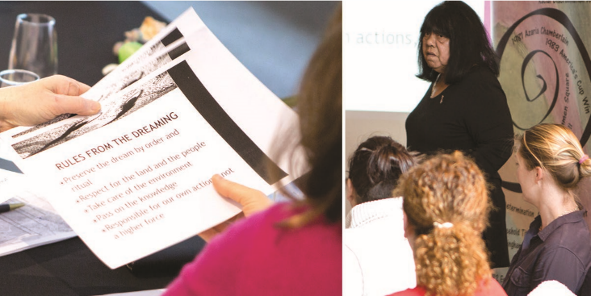
I was deeply moved by the session and think it is imperative for all VLA staff, not just lawyers, particularly given our RAP.
Lauren Galvin, Deputy Managing Lawyer Family Law
The cultural awareness training was excellent – informative, moving and inspiring. It’s an essential grounding in culture and the history of our country that everyone working at VLA should attend.
Dan Nicholson, Executive Director Civil Justice Access and Equity

Opportunities
First Associate Director, Aboriginal Services started in May 2016. She says:
‘It’s important that organisations such as VLA work holistically to address not only legal issues, but also the broader social challenges that lead to these issues. So many of the legal issues that Aboriginal and Torres Strait Islander people face are entrenched in historical and social factors that need to be understood.’
- Our Board and senior managers held one of their regular meetings in Mildura and heard directly from local Aboriginal service providers.
- New Sector Innovation Planning Committee includes two Aboriginal representatives.

A steering committee has met every 2–3 months to oversee the RAP. Here is what some of them said about what the RAP means to them:
Having a RAP has encouraged me to engage in events throughout the year which in the past I have let happen around me. It has also lead me to read more about local Aboriginal history and Angus McMillian who ‘discovered Gippsland’ and lead the slaughter of hundreds of Gunaikurnai people.
Ana Talko-Nicholas, VLA Lawyer

In high school I read Women of the Sun written by Hyllus Maris. This was the beginning of my reconciliation journey, including reflection on my own privilege and power and how I use this in my work and personal life. VLA having a RAP is significant to me because the reconciliation journey is a process that is not just about the individual but organisations, communities and policy and law makers.
Helen Makregiorgos, Manager of Independent Mental Health Advocacy

‘Being of Aboriginal background, the Reconciliation Action Plan is not just work, it is personal.’
Craig Cairney, VLA lawyer

‘Being involved in the RAP steering committee has been really important for me and encouraged me to think actively about how we can better engage with the Koori community as well as thinking more intimately about how we can continue to create and strengthen our partnerships and collaborations with Koori agencies. ‘
Laura Chipp, Manager of Youth Crime

‘I am very proud that VLA has taken this step and for me personally, one measure of success will be in seeing increasing numbers of Indigenous employees throughout the organisation.’
Kimberley Ison, VLA Lawyer

What we want to do next
- Promoting and simplifying employment pathways
- Strengthening our community legal education work
- Improving access to civil and family law services
- Working with our partner organisations to identify and address systemic injustices
- Recruiting Aboriginal Field Officers

