Costs indemnified
When an Appeals Cost Fund (ACF) Certificate is issued in a matter or an order for costs is obtained, complete the Costs Indemnified section when submitting a claim.

The number of units claimed for the indemnified work type will be added back to the Invoice so that no hearing days are ‘lost’. They are available to be claimed for the next service or adjourned court date.

Practitioners are required to submit an application with the certificate to the Appeals Cost Board quoting the VLA reference number to ensure that VLA is reimbursed for the payment.

Costs Indemnified or Appeals Cost Fund entry

- Select Submit New Claim from the left hand menu.

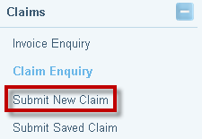

- The Search for a Proforma Invoice screen will display. Enter the File ID and click on Search to find the pro forma invoice.

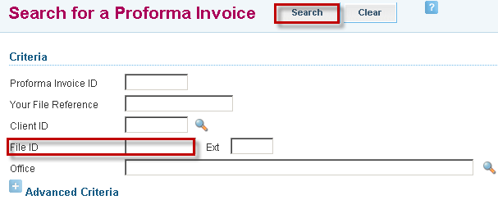

- Search results will be displayed.

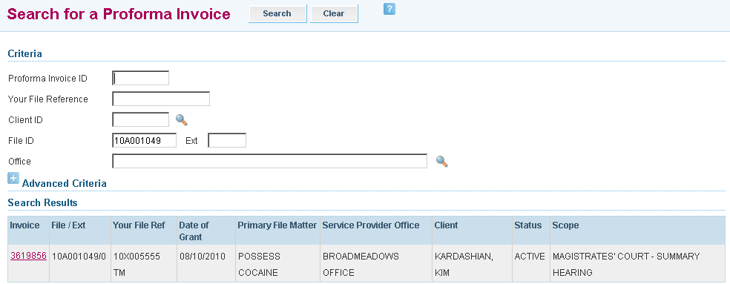

- Select the relevant invoice by clicking on the Invoice hyperlink
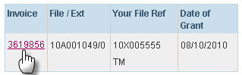

- The Submit Payment Claim screen will display. In the Work Items section, complete the following fields, if required: 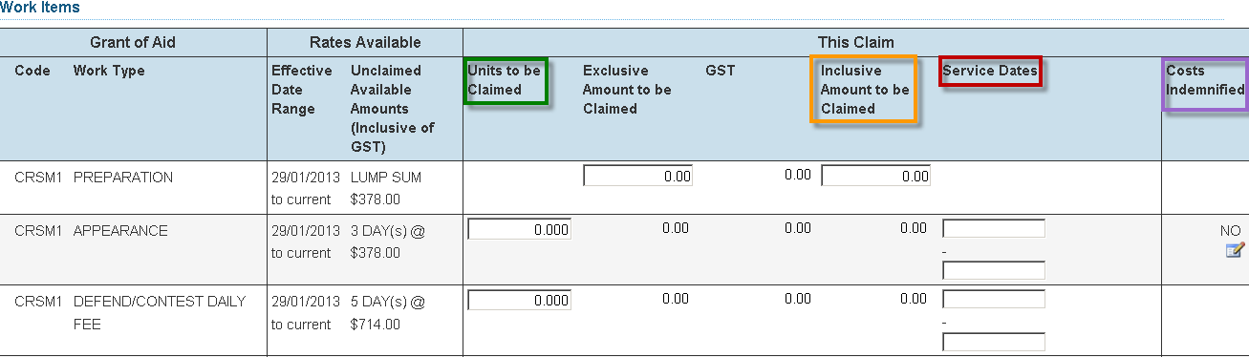

- Units are entered in the relevant Units to be Claimed field, where multiple days are available to claim against

- Work types that are not unit based (i.e. a Stage of Matter Limit) are entered as a $ value in the Inclusive Amount to be Claimed field. GST will be automatically calculated and the amount exclusive of GST will be automatically populated

- Service Dates are the dates of the court appearances and must be entered as start and end dates
  - If the appearance is for one day, the start and end dates are the same.
  - If the appearance is for more than one day or for non consecutive days, enter the first and last day of service. You will need to manually override the end date populated by ATLAS.

- Costs Indemnified (eg. if an Appeals Costs Fund (ACF) Certificate is issued in a matter), click on the icon for the relevant Work Item to record relevant details of the costs indemnified.

- Complete the following fields:
- Units to be Claimed (i.e. the number of days for which the certificate was issued)
- Your Reference Number
- Agency (i.e. the agency responsible for meeting the cost of the day
- 3rd Party Details (optional)

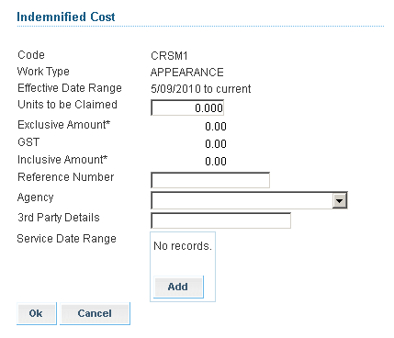

- Click on Add within the Service Date Range field
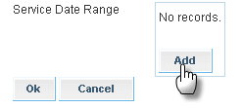

- Enter the date within the Service Date field

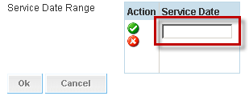

- Click on the icon to add this date and select Ok.

The date entered is now within the Service Date table

to edit the date
to delete the incorrect date.
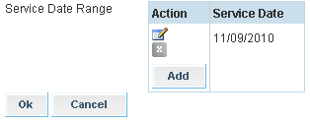

- The Certification statement will be automatically populated with the practitioner’s name. Select Save if not yet ready to submit for payment, or click Submit Claim to send to VLA to process for payment.

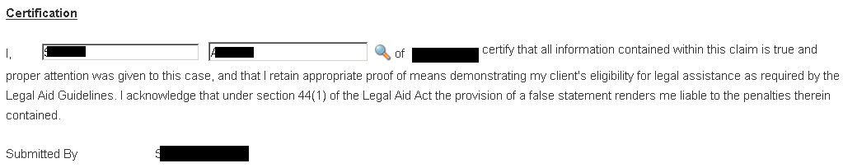
Invoices and documentary proof must be retained on the file for compliance and audit purposes

- A message will display to confirm the claim has been submitted successfully.
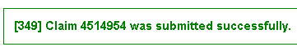

- A pdf copy of the claim that has been submitted will be sent to your Inbox.

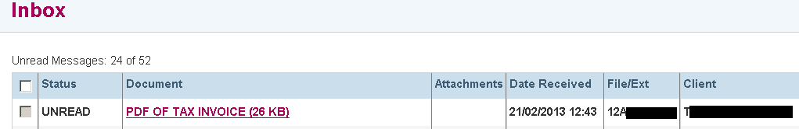
If an error has been made on a submitted claim, use the ‘Submit Correspondence’ function in ATLAS to notify VLA of details of the adjustment required. The claim will be adjusted by VLA. Claims cannot be increased, they can only be adjusted down.

