Having support at mediation

About mediation
Victoria Legal Aid has a mediation service, called Family Dispute Resolution Service (FDRS). We help families going through separation. At a mediation, a trained mediator sits down with you and the other parent or carers, and helps you to all talk about family arrangements, to see if you can agree on a plan together, with the help of lawyers, instead of going to court.
Lots of families use mediation to help them sort out arrangements for children. Separation is very difficult for everyone in a family. It can be hard to talk about personal family issues, but we will try to make it easier for you. Mediation is also confidential.
We offer a culturally appropriate service for Aboriginal and Torres Strait Islander people. We work closely with other services who work with Aboriginal and Torres Strait Islander people, too.

Asking about your needs

For mediation to work best, everyone involved in making decisions needs to feel they can talk about what is going on, and be willing to listen and have a say.

When we are helping families prepare for mediation, as well as asking about your family situation we will ask you about what you need so that you feel you can participate. We will ask about your cultural needs, as well as whether you have a lawyer to help you, whether there is anyone in your family or community who should also be involved in discussions, or come along to a mediation to support you. We call this last type ‘support people’. It might be a worker from a service you are using, or it might be a friend or family member.

Support people at mediation
FDRS must set up mediation in a way that puts safety and children first, while allowing everyone who should have a say about family decisions to be involved.
Professional support people – like disability advocates or family service workers – should always be able to be involved, if they are clear about their role in mediation.
Other support people, like friends or family members, are encouraged, as we understand that Aboriginal and Torres Strait Islander families have unique needs, and that many factors, including intergenerational experiences, can affect the way Aboriginal and Torres Strait Islander clients may engage with and participate in mediation, particularly family dispute resolution.

Asking for a support person
You can ask for a support person to help you during the preparation for mediation (such as at assessment conversations with our case managers) and at the mediation conference. You can ask at any time before the conference or a case manager may suggest it.
A case manager can approve a support person attending at any time, if they have enough information to make this decision. They do not have to seek consent from the other person in the dispute. They may need to get more information.
The case manager will write to all parties to advise when a support person will be attending, and will provide information about the role and responsibilities of support people.
If a person brings a support person to a conference without prior approval from FDRS it is unlikely they will be able to stay, unless the mediator decides they can.
If you want someone at mediation with you, please ask us.
We listen, to work out how we can help and so we can learn to do things better.

Other ways we can help set up mediation
We will always ask you about what can be done to help you feel safe and encouraged to participate in discussions about your family. We can help you to find a lawyer and let you know about other places (like health services) that could also help, depending on what you need.

Ask your case manager.

Find out more
See our information sheet ‘Separated? Need to talk about the kids? Try mediation’
Call 1800 136 832 (toll free) or (03) 9269 0500
Email fdrs@vla.vic.gov.au
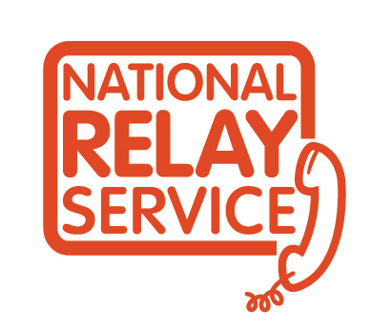
www.legalaid.vic.gov.au/fdrs
If you find it hard to hear or speak you can use the National Relay Service to call us

