Acknowledgement of country
This agenda was written on the land of the Wurundjeri and Boon Wurrung people of the Kulin Nation. We acknowledge and pay our respects to Aboriginal and Torres Strait Islander peoples and Traditional Custodians throughout Victoria, including Elders past and present. We acknowledge the strength and resilience of all First Nations people fighting for justice.

Contents
Outcomes and Evidence Agenda 2022-26 1
How we will use the agenda 1
Aims of the agenda 1
Improving our evidence base 2
Our outcomes 2
Our priorities 3
Clients​ 4
Community​ 5
Legal assistance sector​ 5
Laws and systems​ 6
VLA 6

© 2023 Victoria Legal Aid. Reproduction without express written permission is prohibited.
Written requests should be directed to Victoria Legal Aid, Outcomes and Evidence, Community Legal Information and Corporate Services, GPO Box 4380, Melbourne VIC 3001.
Disclaimer. The material in this publication is intended as a general guide only. The information contained should not be relied upon as legal advice and should be checked carefully before being relied upon in any context. Victoria Legal Aid expressly disclaims any liability howsoever caused to any person in respect of any legal advice given or any action taken in reliance on the contents of the publication.

Outcomes and Evidence Agenda 2022–26
The Outcomes and Evidence Agenda sets out VLA’s priorities in legal needs analysis, service design, data, evaluation, and research for the period of our Strategy 26. ​These key activities support us to deliver client-centered, effective, and evidence-based services.
Legal needs analysis guides our service design and evidence-based planning. We regularly analyse and report our client and service data to measure how our services and programs are going, and at key points we conduct research and evaluation to identify what outcomes we are achieving, what’s working for different client groups and contexts, and to identify improvements that we can apply in planning, design, and implementation.
The agenda includes our capability building priorities within VLA and in support of our sector partners. ​ Further detail of our priorities and plans for how we strengthen and use our client and service data at VLA and with sector partners are outlined in our Data and Digital Information Strategy 2022–26.

How we will use the agenda
We will use the Outcomes and Evidence Agenda to:
- Invest in strengthening and using our evidence base for learning what works across our programs and services​
- Work with our sector partners on common priorities for strengthening outcomes and evidence-based services
- Guide partnerships with research, evaluation and design organisations in our sector.

Aims of the agenda

Our aims are to use legal needs analysis, service design, data analysis, research, and evaluation to:
​
- Identify what works for different client groups​
- Focus on outcomes
- Demonstrate the value​ of legal and related assistance
- Increase client voices and leadership in our services and in system reform​
- Learn from and promote innovations and systems change​.

Improving our evidence base
Our services are supported by evidence from research in the legal assistance sector, as well as our own work in engaging with clients, lived experience groups and partners to conduct legal needs analysis, service design, data analysis, and research and evaluation.
The Incus Group and VLA Research and Evaluation team conducted a review and synthesis of VLA evaluations, surveys, and key reports from 2019–2022. ​The review made two recommendations for strengthening and better using our evidence base for legal assistance outcomes:
- Align research, evaluation, client and partner feedback, and service designs with the VLA Outcomes Framework; and gather consistent data that can be used to track progress towards our outcomes. Combine routine outcome measures with evaluations and research to learn how and why different services contribute to the outcomes.
- Continue to strengthen how we use our available evidence (including client and lived experience expertise, previous evaluations, reports, and research) to shape service design and improvements.

Our outcomes
The priorities in the outcomes and evidence agenda are focused on the five outcomes in our Outcomes Framework 2022–30, which defines the difference we make for our clients and the Victorian community.
​Our five outcomes to 2030 are:
- Clients have increased access to justice​
- Improved legal understanding in the community​
- Collaborative legal assistance sector​
- Fairer laws and systems​
- Effective and sustainable VLA​
The five outcomes guide our strategies: Strategy 26 and Strategy 30, and all our planning, service design, reporting, data, research and evaluation.
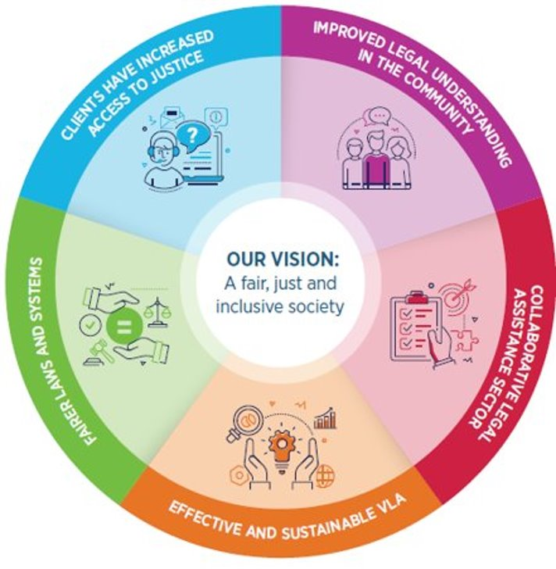

Our priorities
The outcomes and evidence priorities that we will invest in over the period of Strategy 26 are:

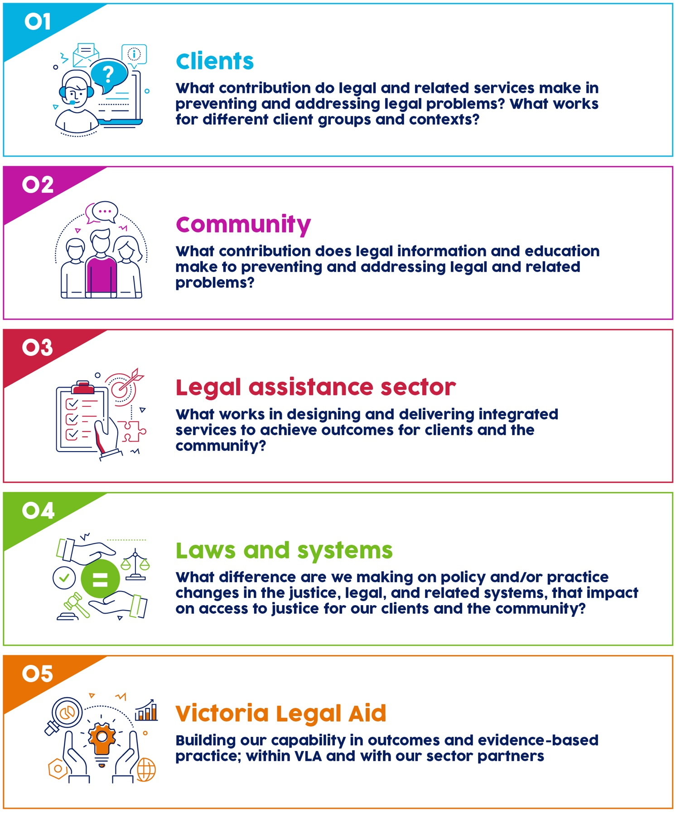

Clients
Our focus areas to 2026 are:
Services and outcomes for clients; focusing on:
  - First Nations people
  - People with disabilities
  - Children and young people.
We are expanding our civil justice services, and will work on service design, research and evaluation in the Victims Legal Service, Sexual Harassment Legal Service, and Mental Health Legal Services, to best respond to clients’ needs and improve access to justice.
We also have ongoing work in our criminal justice, and family youth and children’s law programs and services; where we are investing in client and lived experience leadership, legal needs analysis, service design and evaluations. For example, we are evaluating our Specialist Family Violence Courts legal practice model, and the regional expansion of Drug Court services.
Resolving legal problems; how does legal assistance help?
We are re-designing our client experience surveys, and planning longitudinal research into how legal assistance contributes to resolving legal problems and improving access to justice for our clients. We especially welcome partnerships in this area.
How do early intervention and resolution services, and non-legal and allied services help to resolve legal and related problems?
We are working with client and lived experience leadership to shape service design, service expansions, and research and evaluation in our:
- Early resolution services such as Help Before Court, Family Violence Early Resolution Service, and
- Non-legal services: Independent Mental Health Advocacy (IMHA), Independent Family Advocacy and Support (IFAS), and Family Dispute Resolution Service (FDRS)).
Legal needs and capabilities in Victoria
We are supporting the Victoria Law Foundation’s ‘Public Understanding of Law Survey’ (PULS) to develop a comprehensive understanding of legal capabilities, attitudes, and experiences of the law across Victoria. We will use the findings of this research to inform our service planning across the state.

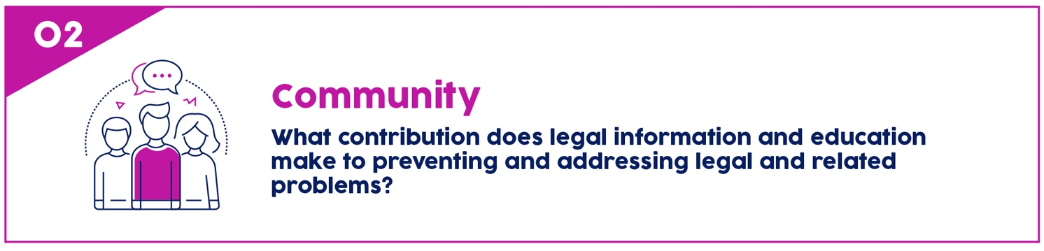Community
Our focus areas to 2026 are:
What impact do Legal Help information and advice services have for help seekers?
We are implementing real-time feedback from help seekers who contact Legal Help webchat and phone lines; to understand whether our help lines are easy to access, and the information and advice we provide helps people know what their options are and what to do next.
How does community legal education and information help people understand, prevent, and address legal problems?
We deliver a range of education and resources for community groups across Victoria. We design these together with community groups and people with lived experience, and evaluate how they help people to understand, prevent, and address legal problems. For example, we are focusing on evaluating our preventative legal education programs with young people.

Legal assistance sector
Our focus areas to 2026 are:
Partnerships and supporting self-determination of Aboriginal and Torres Strait Islander Legal Services
In our partnerships with Aboriginal and Torres Strait Islander Legal Services, we will work jointly on legal needs analysis, service design, data science projects, and research or evaluation activities. For example, we are working with the Victorian Aboriginal Legal Service on the design of the Lotjpa Independent Legal Service for First Nations people participating in the Yoorrook Justice Commission.
Integrated services with legal and non-legal service partners
Throughout our services and programs, we are committed to improving integrated services and referral pathways, and learning jointly with partners about what approaches, and service models work to improve access to justice for different client groups. We are improving our intake, triage, and referral practices at VLA in the Access and Intake project. We also work in partnership to design, deliver, evaluate, and conduct research into our integrated services with partners and consortia, such as Disaster Legal Help Victoria and the Mildura Health Justice Partnership.
Improving the mixed model of legal aid services with panel practitioners and community legal centres
To continually improve the supply of legal aid services we have a range of work underway to review the mixed model of legal services, via regular feedback and joint planning with panel practitioners and community legal centres.
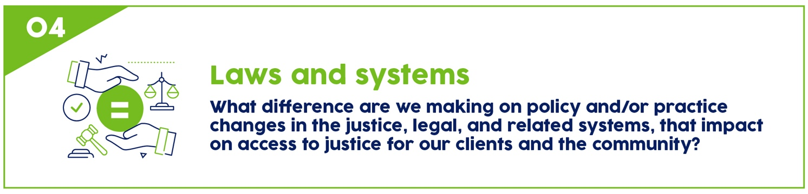

Laws and systems
Our focus areas to 2026 are:
We use client-led and evidence-based research and analysis to inform our advocacy. Throughout our programs and services, we will focus on the difference our work is making towards changing the systemic factors that impact on access to justice.
We welcome opportunities to partner with other organisations advocating or conducting research in relation to our strategic advocacy priorities:
- Justice for First Nations peoples​, and addressing the over-representation of First Nations people in the criminal and child protection systems
- Justice for culturally and linguistically diverse communities​, and addressing the over-representation of marginalised people in the criminal and child protection systems
- Reducing entry into, and harms of the criminal justice system​
- Rights of people experiencing mental health issues and people with disability​
- Safety and trauma informed practices in the family violence, family law and child protection systems​
- Gender equality and gendered and sexual violence

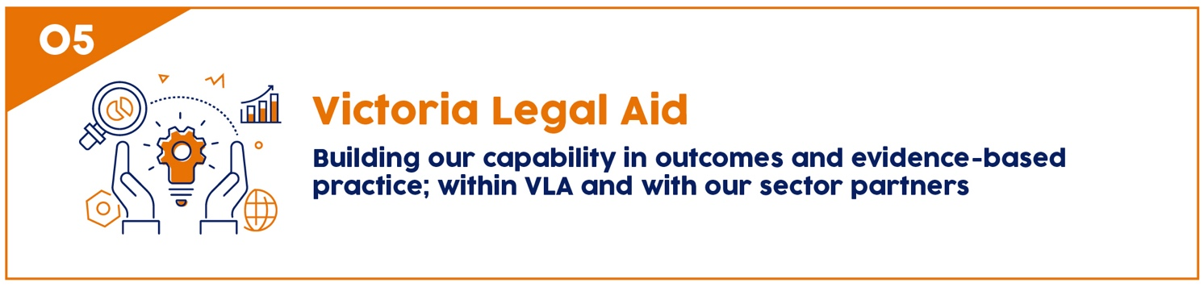

Victoria Legal Aid
As we move towards a stronger focus on outcomes, and building the evidence-base for legal and related services, we are supporting improvements in VLA’s capability in the following areas:
- Embedding outcomes in strategic planning and directorate and program planning
- Outcome measures for strategy and programs
- Service design
- Gender impact assessment
- Client-first practice and strategy
- Ethics and Data Sovereignty
- Data and Digital Information capability, systems, and processes
We are also working with colleagues across the legal assistance sector, aligned with the Victorian Federation of Community Legal Centre’s 10-year plan and commitment to an evidence-informed approach in community legal services.
Key initiatives include:
- Victorian Collaborative Planning Committee Sector Outcomes Pilot– a joint initiative with Victoria Law Foundation, Federation of Community Legal Centres Victoria, Djirra, Victorian Aboriginal Legal Service, Department of Justice, and Health Justice Australia. Fifteen centres across the state are piloting common questions for measuring client outcomes. The pilot will document lessons and recommendations for outcomes and evidence-based practice in our sector.
- Enhancing the Data Discovery Tool to support evidence-based collaborative planning
- Supporting data capability initiatives, data sharing, and sector data alignment and definitions.

Our outcomes and evidence-based practice is guided by the OECD Guidelines for People-Centred Justice Services, as well as Victoria’s Outcomes and Evidence Reform.

