February 2023

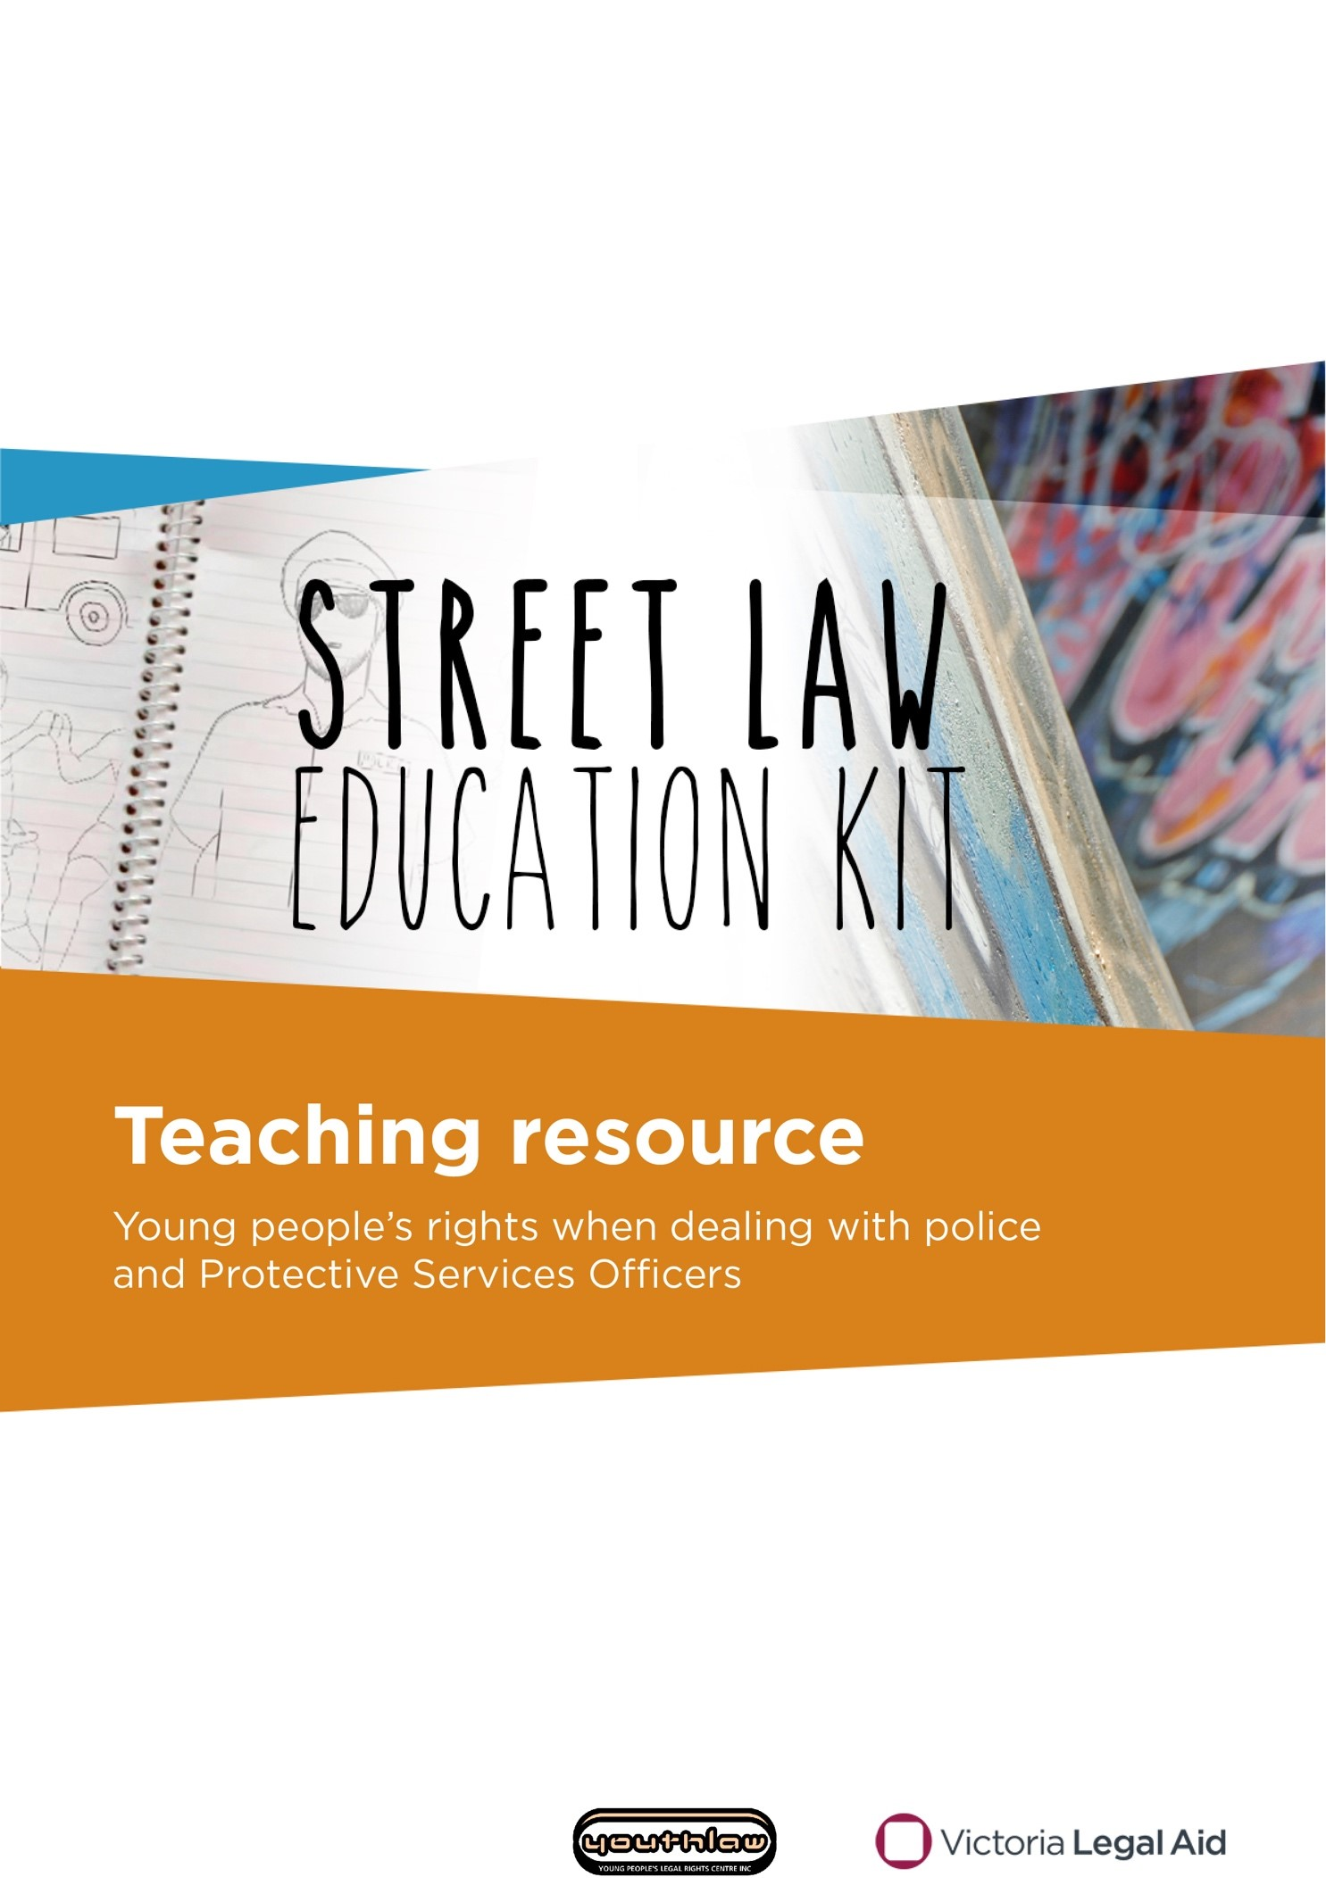

Do you need this kit in a different format?

Please phone us on (03) 9269 0234 and ask for Community Legal Education. We can talk with you about what you need.

Produced by Victoria Legal Aid

Victoria Legal Aid

570 Bourke Street

Melbourne VIC 3000

For free information about the law and how we can help you:

* visit [Victoria Legal Aid’s website](https://www.legalaid.vic.gov.au) (www.legalaid.vic.gov.au)
* call Legal Help on 1300 792 387, Monday to Friday 8 am to 6 pm, excluding public holidays.

For business queries, call (03) 9269 0234

First edition 2016

Second edition 2019

Third edition February 2023

Acknowledgements:The *Street Law* video series and teaching resources were originally produced by Youthlaw with funding from the Victoria Law Foundation. The videos were produced in collaboration with Youthworx Media, Melbourne. We thank Youthlaw and Youthworx for allowing Victoria Legal Aid to adapt and republish this content.

**© 2023 Victoria Legal Aid**

This work is licensed under a Creative Commons Attribution 4.0 licence. You are free to re-use the work under that licence, on the condition that you credit Victoria Legal Aid as author, indicate if changes were made and comply with other licence terms. The licence does not apply to any images, photographs or branding including the Victoria Legal Aid logo.

Changes to the law

The law changes all the time. To check for changes you can visit our website, use our Legal Help Chat or phone us.

**Disclaimer**: The material in this publication is a general guide only. It is not legal advice. If you need to, please get legal advice about your situation.

All stories, examples and case studies in this booklet are fictional and do not relate to cases run by Victoria Legal Aid.

# Contents

About Street Law 5

The *Street Law* program 5

What do these words mean? 7

Giving your name and address 8

Session plan 8

Legal information: speaking to the police 12

Activity cards: at the park role-play 14

Transcript: Sensational salt 15

Being found drunk in public 16

Session plan 16

Legal information: drunk in public 19

Transcript: *Shamed out* 20

Orders to move on and stay away 21

Session plan 21

Legal information: orders to move on and stay away 25

Activity: on the steps role-play cards 27

Transcript: *The magician* 28

Weapons searches 29

Session plan 29

Legal information: weapon searches 33

Activity: at the shopping centre role-play cards 34

Transcript: *Biker baker* 35

Searches on public transport 36

Session plan 36

Legal information: Protective Services Officers (PSOs) 39

Transcript: *The artist* 41

Where to get help 42

Legal information and advice 42

Additional resources 44



# About Street Law

## The *Street Law* program

The *Street Law* program helps youth workers, teachers, lawyers and other professionals educate young people about their rights when dealing with police and Protective Services Officers (PSOs) in Victoria.

The program covers the following topics:

* giving your name and address
* being found drunk in public
* orders to move on and stay away
* weapons searches
* searches on public transport.

The program is based on a series of videos that tell a story about a young person who is approached by a police officer or a PSO. The stories raise questions about young people’s rights in different situations.

The *Street Law* videos and teaching resources were originally produced by Youthlaw in 2012 in collaboration with young people from Youthworx Media. Victoria Legal Aid has adapted and republished those videos and teaching resources with Youthlaw’s permission.

### Who is the *Street Law* program for?

The program can be used with young people aged 12–25. You can deliver it in educational settings (including secondary schools and VCE Vocation Major, formerly Victorian Certificate of Applied Learning or VCAL) and less formal community-based settings.

Ideally, the activities are for groups of 10–40 young people. However, you may be able to adapt activities for smaller or larger groups.

### What is the *Street Law* education kit?

The *Street Law* education kit has:

* five educational videos available on the [Street law education kit](https://www.legalaid.vic.gov.au/street-law-education-kit) webpage (www.legalaid.vic.gov.au/street-law-education-kit)
* session plans
* legal information handouts
* activities.

### How do I use this teaching resource?

This teaching resource includes five session plans covering each of the program’s topics. Each session plan refers to the relevant video. We also include activities that accompany the video.

Sessions should take 20–40 minutes for each topic. You can choose to deliver a session on one topic or a combination of topics in any order.

Session plans are in two stages: the discussion stage and the activity stage. Start with the discussion stage, after the video is screened. The activity stage builds on the group’s understanding of the content from the discussion stage.

Each session plan includes answers to help you check the group’s understanding of the content during the discussion and activity stages.

### What if I do not have access to the internet or a projector?

We have a limited number of DVDs available for order. Please contact Community Legal Education at [cle@vla.vic.gov.au](mailto:cle@vla.vic.gov.au) or call (03) 9269 0234.

### For more information

Please go to Additional resources on page 44.

If you would like more information about the *Street Law* program, please email [cle@vla.vic.gov.au](mailto:cle@vla.vic.gov.au) or call (03) 9269 0234 and ask for Community Legal Education.

### Changes to the law

The law changes all the time. To check for changes you can:

* visit [Victoria Legal Aid’s website](https://www.legalaid.vic.gov.au) at (www.legalaid.vic.gov.au)
* call Victoria Legal Aid’s Legal Help phone line on 1300 792 387.

# What do these words mean?

arrest – when the police or Protective Services Officers think you have broken the law and hold you in custody. You are not free to go

bail – a promise that you will go to court on a certain date. You may have to agree to conditions like reporting to the police or living at a certain place

breaching the peace – causing a disturbance. For example, making a lot of noise

caution – when the police do not charge you if you break the law, but warn you they will charge you if you break the law next time

charge – when police believe you have broken the law and are taking you to court

custody – when you have been arrested and are not allowed to leave

designated area – an area where police can search you for weapons without a warrant

designated place – an area where Protective Services Officers work, such as railway stations

fine – money you have to pay as a punishment for breaking the law

indictable offence – a serious offence, such as robbery

offence – something the law says is wrong. The same as a crime

**penalty –** a punishment for breaking the law

Protective Services Officer – an armed and uniformed officer who can stop, arrest, search and fine people in designated places such as railway stations

warrant – a court document that says what the police can do. For example, arrest you or search you or your house

weapon – a knife, gun or dangerous article. A dangerous article is something that can be used as a weapon. For example, a cricket bat, axe or hammer



# Giving your name and address

## Session plan

### Learning outcomes

At the end of the session, the group should have increased knowledge of:

* when police can ask for a person’s name and address
* consequences if a person breaks the law by failing or refusing to give their name and address
* a person’s rights if police ask them for their name and address
* how to get more information about police powers, a person’s rights or free legal advice.

### You will need:

* an internet connection and facilities to show the video
* *Sensational salt* (giving your name and address) video on the [Street law education kit](https://www.legalaid.vic.gov.au/street-law-education-kit) webpage (www.legalaid.vic.gov.au/street-law-education-kit)
* copies of Legal information: speaking to the police (pages 12-13) for each participant. For more in-depth information on this topic, go to our [speaking to the police](https://www.legalaid.vic.gov.au/speaking-police) webpage (www.legalaid.vic.gov.au/speaking-police)
* role-play cards from Activity cards: at the park role-play cut out (page 14). You may need multiple copies if the group is larger than 12 people
* What do these words mean? (page 7) for your reference
* Where to get help (page 42) or the *Street law* wallet card. You can order free copies of the [Street law wallet card](https://www.legalaid.vic.gov.au/street-law-wallet-card) (www.legalaid.vic.gov.au/street-law-wallet-card).

Note: there is more information about Protective Services Officers’ powers to ask for name and address on pages 39-40. You can include this information if you have time.

### Time allocation

The session will go for approximately 40 minutes.

If you have less time, you can shorten the session by only completing the discussion stage. Note: the activity stage is for the group to complete after the discussion stage. It is not designed to be delivered on its own.

If your session is for longer than 40 minutes, you can deliver a session on another topic or just the discussion stage of another topic. Session plans for each topic can be delivered in any order.

### Discussion: Sensational salt

**Before you begin: personal disclosures**

Ask participants not to discuss personal details and situations in this session. It is important to create an open and safe environment where people feel free to ask questions. However, personal disclosures should be left for private discussion. Encourage participants to say ‘What if this happens?’ instead of ‘This happened.’

**Watch** the *Sensational salt* video from start to finish. A transcript is on page 15 if you have trouble with sound or technology.

**Hand out** and **read** the Legal information: speaking to the police handout (page 12-13).

**Check** if there are any words people do not understand. Use What do these words mean? on page 7.

**Divide** the group into your preferred size (whole class, small groups or pairs).

**Ask** the groups to discuss the following questions and to **report** back when finished.

1. **Why do you think police stopped and asked the person in the video for his name and address?** Police probably thought he was dealing illegal drugs or in possession of illegal drugs.
2. **Did police have the power to get that person’s name and address in that situation?** Yes. Police had the power to get his name and address because they believed he had committed an offence (dealing drugs).
3. **What rights did that person have when police asked for his name and address?** He had the right to ask the police officers: why they wanted his name and address, for their name, rank and station and to write their details down for him.
4. **What would have happened if he refused to give police his name and address or if he gave police a false name or address?** Police had a lawful reason to ask for his name and address. If he refused, or gave a false name or address, he would have broken the law. Police could have charged him.
5. **If the police had asked him more questions would he have to answer?** No. He only has to give his name and address. He does not have to answer any more police questions. He can say ‘No comment’ to any questions the police ask.
6. **Which services could that person contact for more information about the law or free legal advice?** He could contact Victoria Legal Aid, a local community legal centre or the Victorian Aboriginal Legal Service if he identifies as Aboriginal or Torres Strait Islander. He could also contact Youthlaw, a free legal service for young people under 25. Go to Where to get help on page 42 for contact details.

### Activity: at the park role-play

**Ask** the group to imagine they are at a local park.

**Remind** them to think about what rights they have if a police officer stops them and asks them for their details.

**Divide** the group in half and nominate one half tobe the police officers.

**Hand out** an activity card from the Activity cards: at the park role-play (page 14) to each police officer.

**Explain** to the group of police officers:

* they are about to stop a person in the park and ask them for their name and address
* the reason why they want to stop the person is on their card.

**Explain** to the other half of the group:

* they are about to be stopped by a police officer in the local park
* they have no idea why the police officer has stopped them
* they have a right to ask the officer questions, such as why they are asking for their name and address.

**Direct** the police officers to read their cards and to ask you for help if they do not understand the information on their card.

**Ask** the police officers to find another person in the group who does not have a card and ask them for their name and address.

**Allow** 2–3 minutes for the role-play. Repeat the activity if there is time.

**Reconvene** the group. Ask some or all the police officers to read out their card to the group and report back on whether they were able to get the names and addresses they needed.

**Ask** members of the group who were stopped by the police officers to put their hand up then ask them the following questions:

1. **What questions did they have the right to ask the police officer in that situation? Did they ask any of those questions?** Everyone stopped by the police officers in this activity had the right to ask: why the police officer wanted their name and address; for the police officer’s name; rank and station, and for the officer to write their details down for them.
2. **Did they find out why the police officer stopped them? Did they think the officer had a lawful reason to get their details in that situation?** This depends on the scenario. The table on the next page has information about each scenario.

If someone is unsure about their answer, ask the rest of the group if they can answer the question or share their views.

|  |  |
| --- | --- |
| **At the park activity card description** | **Do the police have the power to get this person’s name and address?** |
| **Sergeant Brown**  Someone just robbed a shop. Robbery is an indictable offence.  You need to question everyone you see to find out if they saw or heard the robbery. | Yes.  They had reason to believe people in the area may have witnessed a robbery, which is a serious crime and an indictable offence. |
| **Senior Constable Myer**  You saw this person driving a car and swerving all over the road.  You need their name and address to check their licence details on your database. | Yes. They saw the person driving and asked them to stop. |
| **Constable Abdi**  A person called Sam Smith just assaulted someone.  A witness told you what Sam Smith looks like. This person looks like Sam Smith. You want to know their name and address so you can arrest them if they are Sam Smith. | Yes. The officer had reason to believe that the person had committed a serious crime. |
| **Constable Sims**  You saw this person jump a fence and walk across train tracks nearby.  You need their name and address so you can give them a fine. | Yes. The officer saw the person commit an offence. |
| **Constable Gibb**  This person looks like they are from the same family as a big troublemaker called Benny Raskal.  You want to know their name so you can tell them to leave the area if they are related to Benny Raskal. | No. They had no lawful reason to ask for the person’s details. They had no reason to believe that the person had committed an offence or is about to commit an offence or that the person had witnessed a serious crime. Just being related to someone police know is a criminal or a troublemaker is not enough reason for police to ask for a person’s details. |
| **Senior Constable Tran**  You just heard glass smashing and you can see a bus shelter with a broken window.  This person has blood and pieces of glass on their hands. You want their name and address so you can ask questions about the bus shelter. | Yes. The person had blood and glass on their hands so it looks like they may have caused the damage. |

## Legal information: speaking to the police

### Do you have to give your name and address to the police?

A police officer must have a reason to ask for your name and address. Generally, a police officer can only ask for your name and address if they believe you:

* have committed a crime
* are about to commit a crime.

For example, if a police officer believes you bought alcohol and you are under 18, they can ask for your name and address.

The police officer must tell you why they want your name and address. If they don’t give you a reason, you should ask for it.

A police officer can also ask for your name and address if:

* you are driving a car or motorbike and a police officer signals for you to stop
* you are on the tram, train, bus or at a stop or station. Public transport inspectors and Protective Services Officers (PSOs) can also ask for your name and address
* you are in a bar, club or somewhere that sells alcohol. Staff can also ask how old you are
* the police think you know something about a serious crime (they might call it an indictable offence). The police must tell you what crime they think you can help with.

If you are at a police station, police can ask you why you are there. This is because they have a responsibility to keep the area around the station safe and peaceful. They can then ask for your name and address if they do not think you have a legitimate reason to be there. Legitimate reasons include reporting a crime or asking for help.

### What happens if I don’t give my name and address to the police?

It is an offence (breaking the law) if:

* a police officer does have reason to ask for your name and address and you do not tell them
* you give a fake name or address.

### What can I ask the police?

If you feel safe to do so, you can ask the police officer for their name, rank and what police station they work at. You can ask the police officer to write this down.

Police officers do not have to give you their details automatically. You have to ask for them. This information may be useful later on. You can use this information to complain about a police officer or report them. The police officer can be fined if they refuse to give you their name, rank and police station.

### Do I have to answer any other questions by the police?

No. Once you have said your name and address, you do not have to answer any other questions. You can say ‘No comment’ if the police start questioning you. You can also ask for a lawyer.

### I’m under 18. Can police question me?

Yes, but not on your own. If the police want to question you as a suspect you must have a parent, guardian or an independent person with you if you are under 18.

### Can I complain about the police?

Yes. You can get more information or free legal advice from:

* Victoria Legal Aid
* Youthlaw, a free legal service for people under 25
* Victorian Aboriginal Legal Service if you identify as Aboriginal or Torres Strait Islander
* your local community legal centre.

Ask your facilitator for these services’ contact details.

## Activity cards: at the park role-play

|  |  |
| --- | --- |
| **You are:**  **Sergeant Brown**  **Southside Police Station**  Someone just robbed a shop. Robbery is an indictable offence.  You need to question everyone you see to find out if they saw or heard the robbery. | **You are:**  **Senior Constable Myer**  **Highway Patrol**  You saw this person driving a car and swerving all over the road. You pull them over next to the park.  You need their name and address to check their licence details on your database. |
| **You are:**  **Constable Abdi**  **Sunnydale Police Station**  A person called Sam Smith just assaulted someone.  A witness told you what Sam Smith looks like. This person looks like Sam Smith. You want to know their name and address so you can arrest them if they are Sam Smith. | **You are:**  **Constable Sims**  **Transit Safety Division**  You saw this person jump a fence and walk across train tracks nearby.  You need their name and address so you can give them a fine. |
| **You are:**  **Constable Gibb**  **Northside Police Station**  This person looks like they’re from the same family as a big troublemaker called Benny Raskal.  You want to know their name so you can tell them to leave the area if they are related to Benny Raskal. | **You are:**  **Senior Constable Tran**  **Metropolitan Police Station**  You just heard glass smashing and you can see a bus shelter with a broken window.  This person has blood and pieces of glass on their hands. You want their name and address so you can ask questions about the bus shelter. |

## Transcript: Sensational salt

*A cartoon figure of a policeman holding and looking down at an identification card
*It was a morning so sunny, that you needed to not wear a sweater.

Jimmy and I were sitting there at the bus stop, eating our delicious chips. And I said to Jimmy, “Oooh, I could use some sensational salt, to go on my chips. It just explodes when you have that sensational salt.”

So he’s like, “Sure.”

And I’m like, “Do you see those cops over there?” Because it’s kind of a shady area, kind of not where two little school kids should be sitting alone without any supervision.

He’s like, “That’s right, I see ’em too. All right, let’s do it.”

And we did this awesome handshake that was so unmoist that our hands didn’t get sweaty for some reason. And he passed the salt to my hand.

These two officers get out of their car, officers Spence and Cheryl. They were holding hands when they came up to us, but they were just friends, nothing more than friends.

He comes up and says, “Son, I’m going to need your name and address.” And I said, “Daaad!” And he’s like, “Son, I got no time to play games.” And I said, “All right.”

So I gave him my address and I said, “Umm, oh it’s just salt, sensational salt.”

And he’s like, “Oh, well that’s, that’s really good ’cause for a moment I thought you were doing something very illegal. I feel a bit like an idiot, like.”

I’m like, “Don’t worry, we all get like that.”

And then they walked off, holding hands like they were friends. With… benefits.



# Being found drunk in public

## Session plan

### Learning outcomes

At the end of the session, the group should have increased knowledge of:

* police powers to arrest a person if they are drunk in public
* consequences if a person breaks the law by being drunk in public
* how to get more information about police powers, a person’s rights or free legal advice.

### You will need:

* internet connection and facilities to show the video
* *Shamed out* (being found drunk in public) video on the [Street law (education kit) website](https://www.legalaid.vic.gov.au/street-law-education-kit) (www.legalaid.vic.gov.au/street-law-education-kit)
* copies of Legal information: drunk in public (page 19) for each participant. For more in-depth information on this topic, go to our [drugs and alcohol](https://www.legalaid.vic.gov.au/drugs-and-alcohol) webpage (www.legalaid.vic.gov.au/drugs-and-alcohol)
* What do these words mean (page 7) for your reference
* Where to get help (page 42) or the *Street law* wallet card. You can order free copies of the [Street Law wallet card](https://www.legalaid.vic.gov.au/street-law-wallet-card) (www.legalaid.vic.gov.au/street-law-wallet-card).

### Time allocation

The session will go for approximately 40 minutes.

If you have less time you can shorten the session by only completing the discussion stage. Note: the activity stage is for the group to complete after the discussion stage. It is not designed to be delivered on its own.

### Discussion: *Shamed out*

**Before you begin: personal disclosures**

Ask participants not to discuss personal details and situations in this session. It is important to create an open and safe environment where people feel free to ask questions. However, personal disclosures should be left for private discussion. Encourage participants to say ‘What if this happens?’ instead of ‘this happened.’

**Watch** the *Shamed out* video from start to finish. A transcript is on page 20 if you have trouble with sound or technology.

**Hand out** and **read** the Legal information: drunk in public handout on page 19.

**Check** if there are any words people in the group do not understand. Use What do these words mean? on page 7.

**Divide** the group into your preferred size (whole class, small groups or pairs).

**Ask** the groups to discuss the following questions and to **report** back when finished.

1. **Why did the police officer arrest the person in the video and put her in a lockup?** Police can put someone into safe custody if they find them drunk in a public place. They can put them into custody at a sobering-up centre or in a cell at a police station or a court.
2. **Do you think it was fair she got locked up?** **Why or why not?** There are no right or wrong answers. You can prompt discussion by asking questions like: do you think she needed to be locked up in a police cell for her own safety? Do you think police could have dealt with the situation differently?
3. **What are the penalties or other consequences she could face for being drunk in public?** She could have been:

* released with a caution or a fine (also called an infringement notice)
* sent to a sobering up centre if there is one in her local area
* bailed to go to court.

Use What do these words mean? on page 7 of this resource to check the group’s understanding of the words caution and bail in this context.

1. **Which services could she contact for more information about the law or free legal advice?** She could contact Victoria Legal Aid, a local community legal centre or the Victorian Aboriginal Legal Service if she identifies as Aboriginal or Torres Strait Islander. She could also contact Youthlaw, a free legal service for young people under 25. Go to Where to get help on page 42 for these services’ contact details.

### Activity: cracking down on teen drinking debate

**Divide** the group in half to create two teams and name one ‘For’, the other ‘Against’.

**Ask** the group to consider the following statement:

*Police should lock more young people up for being drunk in public.*

**Direct** each team to work together and brainstorm arguments to support their position for or against.

**Ask** each team to nominate one person as a scribe to make a list of the group’s arguments on a piece of large paper.

**Ask** each group to research information or commentary about underage drinking and police strategies to tackle public drunkenness or youth crime, for example, by searching online. Suggest that teams collect media articles, statistics or ideas to support their position either for or against.

**Allow** each team 10–15 minutes to discuss and brainstorm their points for or against.

There are no right or wrong answers. You can help each team come up with arguments for or against by asking them questions like:

* Do you think there are too many teenagers getting drunk in public?
* Do you think the risk of being locked up will stop young people from being drunk in public?
* What are the reasons for people to be drunk in public?
* Do you think it’s more of a problem for people under 18 or is it a problem for adults as well?
* Are there other things police could do to reduce or discourage public drunkenness?
* Are there things other services or people in the community could do to reduce or discourage public drunkenness?

**Reconvene** the group and ask a volunteer from each team to outline their arguments for or against. If the teams collected any articles or statistics, ask them to report those back to the group.

**Award** the team with the strongest arguments by announcing them as winners of the debate.

## Legal information: drunk in public

### Is it against the law to be drunk in public?

In Victoria, police can charge you with being:

* drunk in a public place. Police can arrest you and put you in custody if they think you are not safe
* drunk and disorderly in a public place. This is acting in a way that disturbs the peace or interferes with the comfort of other people. Police can charge you even if nobody else is around
* drunk and behaving in a riotous or disorderly manner. This is acting in a way that frightens other people.

### Where can the police take me?

Police can arrest you and take you to a police station. You will normally be kept in custody until the police think you are sober enough to leave – usually around four hours. While you are in custody, police must check on you regularly to make sure you’re okay. The police must call for medical help if they think you need it.

Police can also take you to a sobering-up centers. You will not be charged. A sobering-up centre is a safe place for people to sober up. The centers also have services that can help people with problems with alcohol.

### I’m under 18. Can police question me?

Yes, but not on your own. If you are under 18 and the police interview you (ask you questions) at the police station, you must have a parent, guardian or independent person with you when police question you.

You have the right to speak to a lawyer.

### Will I get charged with an offence?

This is up to the police. They might charge you. If they charge you they will usually release you on bail. If you are on bail, you must go to court on a certain day.

The police might give you a fine or a cautioninstead.

### Where can I get help?

You can get information or free legal advice from:

* Victoria Legal Aid
* Youthlaw, a free legal service for people under 25
* Victorian Aboriginal Legal Service if you identify as Aboriginal or Torres Strait Islander
* your local community legal centre.

Ask your facilitator for these services’ contact details.

## Transcript: *Shamed out*

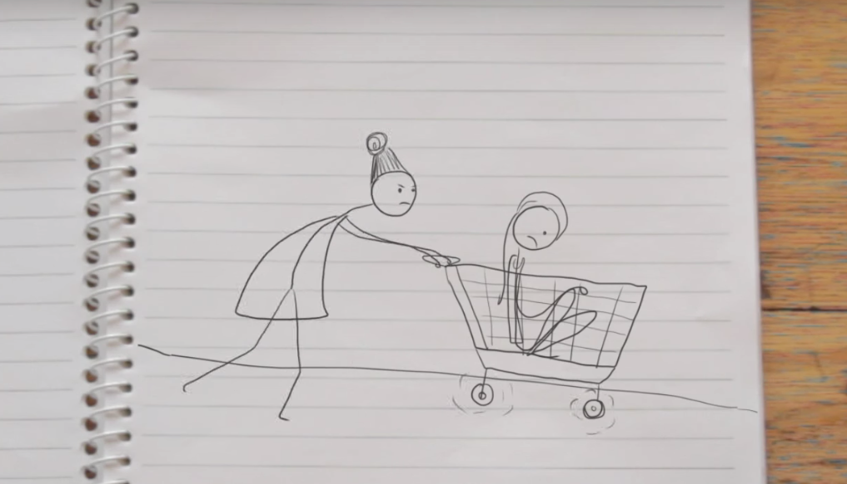

A few weeks back I had a mass’ night with my mates. We went from pub to pub and we were just smashing those drinks. We had drink, after drink, after drink.

We went to this karaoke bar, I was on a mad rage, I was singin’, I was jammin’. Oh yeah, I’m cruisin’! I was lovin’ life.

At the end of the night I ended up alone and had to find my own way home.

I fell asleep and I had this great dream.

I felt someone, like, tapping me on the shoulder. And I was like “Mum, can you make me some bacon and eggs. I’m like, sooo hungover.”

But it was a cop and he was asking me if I was alright. And I was like, “Yep!” He said I was too drunk so he took me back to the station.

Mum had to pick me up. I was so shamed out*.*



# Orders to move on and stay away

## Session plan

### Learning outcomes

At the end of the session, the group should have increased knowledge of:

* police powers to order a person to move on and stay away from a public place
* consequences if a person breaks the law by disobeying an order to move on and stay away
* how to get more information about police powers, a person’s rights or free legal advice.

### You will need:

* an internet connection and facilities to show the video
* *The magician (orders to move on and stay away)* video on the Street law education kit webpage (www.legalaid.vic.gov.au/street-law-education-kit)
* copies of Legal information: orders to move on and stay away (pages 25-6) for each participant. For more in-depth information on this topic, go to our [police powers and my rights](https://www.legalaid.vic.gov.au/police-powers-and-my-rights) webpage (www.legalaid.vic.gov.au/police-powers-and-my-rights)
* role-play cards from Activity: on the steps role-play cards cut out (page 27). You may need to duplicate the cards depending on the number of people in the group
* What do these words mean? (page 7) for your reference
* Where to get help (page 42) or the *Street Law* wallet card. You can order free copies of the [Street law wallet card](https://www.legalaid.vic.gov.au/street-law-wallet-card) (www.legalaid.vic.gov.au/street-law-wallet-card).

### Time allocation

The session will go for approximately 40 minutes.

If there is less time, you can shorten the session by only completing the discussion stage. Note: the activity stage is for the group to complete after the discussion stage. It is not designed to be delivered on its own.

### Discussion – *The magician*

**Before you begin: personal disclosures**

Ask participants not to discuss personal details and situations in this session. It is important to create an open and safe environment where people feel free to ask questions. However, personal disclosures should be left for private discussion. Encourage participants to say ‘What if this happens?’ instead of ‘this happened.’

**Watch** *The magician* video from start to finish. A transcript is on page 28 if you have trouble with sound or technology.

**Hand out** and **read** Legal information: orders to move on and stay away handout (pages 25-6).

**Check** if there are any words people in the group do not understand. Use What do these words mean? on page 7.

**Divide** the group into your preferred size (whole class, small groups or pairs.)

**Ask** the groups to discuss the following questions and to **report** back when finished.

1. **Why do you think the police officer ordered the magician to move on?** The police officer may have ordered the magician to move on because he thought the magician was:

* disrupting or likely to disrupt the peace
* behaving in a way that may be dangerous to public safety
* likely to cause injury or damage to property.

1. **Why did the magician end up getting a fine?** The magician got a fine because he came back to the area. The police ordered him to move on and stay away so it was illegal for the magician to go back to that area straight away.
2. **Do you think it was fair that the police officer ordered the magician to move on? Why or why not?** There are no right or wrong answers to this question. You can prompt discussion with questions like:

* Was the magician a danger to anyone or was there a risk he might damage property?
* Was the magician getting in the way of other people or traffic?
* Do you think the magician was disrupting the peace?

1. **Which services could the magician contact for more information about the law or free legal advice?** The magician could contact Victoria Legal Aid, a local community legal centre or the Victorian Aboriginal Legal Service if he identifies as Aboriginal or Torres Strait Islander. The magician could also contact Youthlaw, a free legal service for young people under 25. Go to Where to get help on page 42 for these services’ contact details.

### Activity: on the steps role-play

**Divide** the group into pairs or smaller groups of 3–4 people.

**Hand out** an activity card from: Activity: on the steps role-play cards on page 27 to each pair or small group.

**Ask** each pair or small group to imagine they are police officers patrolling a train station. They come across a number of different people on the steps of the station, as described in their activity card.

**Allow** each pair or small group 5–10 minutes to discuss the situations on their cards and reach a decision together on what their answer is to the following question:

*Do you think police have the power to order a person or group of people to move on in the situation described on your card?*

**Reconvene** the group and ask each pair or small group to report back. Ask each pair or smaller group if they agreed police had the power to order a person or people to move on in the situation described in their card. Ask them to explain why they did or did not issue a move on notice. If they were not sure, ask the rest of the group to discuss the situation and share their views.

**Card 1: A group of high school students listening to really loud music with speakers attached to their phones.** Police could order the group to move on if they believe the group are disrupting the peace.

To prompt further discussion, ask:

* Is listening to music enough to ‘disrupt the peace’?
* What else might change their answer to this question? For example, would it depend on the volume or type of music?
* Do you think different people might have different ideas on what is ‘disrupting the peace’?
* How do you balance young people’s rights to use public space with the needs of other people in the area?
* What limits should there be on young people’s behaviour in public spaces? What do you think is fair?

**Card 2: Two guys who keep play-fighting and nearly hit other people by accident.** Police could order the two guys to move on if they believe the group are disrupting the peace, may be dangerous to public safety or they likely to cause injury to someone else or damage property.

To prompt further discussion, ask:

* Is play-fighting like that a risk to public safety?
* Were they likely to cause injury to someone?
* Were they likely to damage property?
* Were they ‘disrupting the peace’ or ‘likely to disrupt the peace’?

**Card 3: A man who is acting strangely and staring at people passing by.** Just making people feel uncomfortable is not enough reason for police to order this man to move on. Police can only order the man to move on if he is disrupting the peace, behaving in a way that might be dangerous to public safety or is likely to cause injury to someone else or damage property.

To prompt further discussion, ask the pair or group to consider if there are other things the man could do that would give police a reason to order him to move on. For example, what if he started shouting or threatening people?

**Card 4: A group of breakdancers who are practising right out the front of the ticket gates.** Police could order the breakdancers to move on if the police believe the breakdancers are disrupting the peace, behaving in a way that might be dangerous to public safety or is likely to cause injury to someone else or damage property. If they are very close to the ticket gates, there may be a risk to public safety so police could order the group to move on.

To prompt further discussion, ask:

* If the group weren’t a danger to safety, were they ‘disrupting the peace’ or likely to ‘disrupt the peace’?
* Do you think different people might have different ideas on what ‘disrupting the peace’ means?
* How do you balance young people’s rights to use public space with the needs of other people in the area?
* What limits should there be on young people’s behaviour in public spaces? What do you think is fair?

## Legal information: orders to move on and stay away

Police can ask you to move on and stay away from public places and from in or around police stations.

### Public places

#### When can police make me leave a public place?

Police can order you to move on (leave) a public place if they think you are:

* disrupting the peace
* behaving in a way that may be dangerous to public safety
* likely to cause injury to someone or damage property.

You will usually have to stay away from the area for a certain amount of time. This can be up to 24 hours. It can be shorter.

#### What happens if I don’t leave?

If you don’t move on or stay away from a public place, the police can give you a fine.

If you have to go to court, the court can give you a bigger fine.

#### What is a public place?

A public place means that anyone is allowed to be there. Public places include:

* bars and clubs
* beaches
* churches and places of worship
* movie theatres and other places for entertainment
* parks, sports ovals and gardens
* public schools
* roads, bridges and footpaths
* train stations and on public transport.

### Can police ask me to leave and stay away from a police station?

Yes. Police can ask you to leave and stay away, but only if they think two things:

* you don’t have a legitimate reason to be there
* this is necessary to preserve the peace or maintain the security of the police station.

Legitimate reasons include:

* asking the police for help
* reporting a crime
* giving information to the police
* being required to be at a police station. For example, it is part of your bail conditions.

Police can ask you to stay away for up to seven days.

Police can arrest you or give you a fine if you do not leave or stay away when they ask you. They can also arrest you or give you a fine if you try to stop them asking you or someone else to leave or stay away.

### Where can I get help?

You can get information or free legal advice from:

* Victoria Legal Aid
* Youthlaw, a free legal service for people under 25
* Victorian Aboriginal Legal Service if you identify as Aboriginal or Torres Strait Islander
* your local community legal centre.

Ask your facilitator for these services’ contact details.

## Activity: on the steps role-play cards

|  |  |
| --- | --- |
| A group of high school students are listening to really loud music with speakers attached to their phones. | Two guys are play-fighting and nearly hit other people by accident. |
| A man is acting strangely and staring at people passing by. | A group of breakdancers are dancing right in front of the ticket gates. |

## Transcript: *The magician*

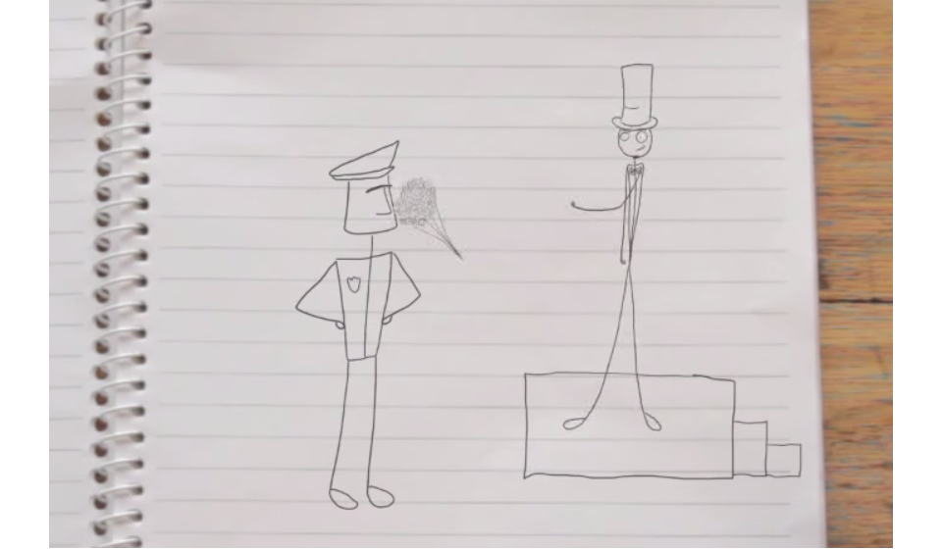

My name’s Daniel and I am a magician.

So I was trying out some tricks the other day on the street and a police officer asks me to move on. Yeah, he said I was disturbing the peace. I guess I took it a bit personally.

I have a bit of a reputation to uphold so I had to get back to my stage, to my audience. So I threw a smoke bomb and shazam! I was back there.

So in the end I got a fine but, er, it was a great show.



# Weapons searches

## Session plan

### Learning outcomes

At the end of the session, the group should have increased knowledge of:

* police powers to search a person for weapons in a public place
* when it is illegal to carry knives and other weapons or dangerous articles in public
* consequences if a person resists a police search or if they are found with an illegal weapon or dangerous article
* a person’s rights if they are searched by police
* how to get more information about police powers, a person’s rights or free legal advice.

### You will need:

* an internet connection and facilities to show the video during the session
* *Biker baker* *(weapons searches)* video on the Street law (education kit) webpage (www.legalaid.vic.gov.au/street-law-education-kit)
* copies of Legal information: weapons searches on page 33 for each participant. For more in-depth information on this topic, go to our [guns and other weapons](https://www.legalaid.vic.gov.au/guns-and-other-weapons) webpage (www.legalaid.vic.gov.au/guns-and-other-weapons)
* activity cards from Activity cards: at the shopping centre role-play on page 34. You may need to duplicate the cards depending on the number of people in the group
* What do these words mean? (page 7) for your reference
* Where to get help (page 42) or the *Street law* wallet card. You can order free copies of the [Street law wallet card](https://www.legalaid.vic.gov.au/street-law-wallet-card) (www.legalaid.vic.gov.au/street-law-wallet-card).

### Time allocation

The session will go for 40 minutes.

If you have less time you can shorten the session by only completing the discussion stage. Note: the activity stage is for the group to complete after the discussion stage. It is not designed to be delivered on its own.

### Discussion – *Biker baker*

**Before you begin: personal disclosures**

Ask participants not to discuss personal details and situations in this session. It is important to create an open and safe environment where people feel free to ask questions. However, personal disclosures should be left for private discussion. Encourage participants to say ‘What if this happens?’ instead of ‘this happened.’

**Watch** the *Biker baker* video from start to finish. A transcript is on page 35 if you have trouble with sound or technology.

**Hand out** and **read** the Legal information: weapons searches handout (page 33).

**Check** if there are any words people in the group do not understand. Use What do these words mean? on page 7.

**Ask** the group to discuss the following questions and to **report** back when finished.

1. **Did the police officer need a reason to search the biker baker for weapons?** Yes. The police officer did not show the biker baker a warrant or a special notice to say he was in a ‘designated area’ for weapons searches. So we can assume that the police officer needed a reason to suspect the biker baker was carrying a weapon in order to search him.
2. **What do you think the police officer’s reasons for searching the biker baker might have been? Do you think those reasons were fair and legal?** We do not know what the police officer’s reasons were but if he searched the biker baker just because of how he looks or what he is wearing, that is not a fair or lawful reason to stop and search him. The biker baker may, however, be in an area where there is lots of violent crime. This can be a lawful reason for police to stop and search him.
3. **What would happen if the biker baker resisted the search?** It is an offence to resist or refuse a lawful search by police. The biker baker could be charged if he resisted a lawful search.
4. **Why did the biker baker get a fine?** The biker baker got a fine because he was carrying a kitchen knife in a public place and the police officer did not believe he had a lawful excuse.
5. **Do you think the biker baker had a lawful excuse for carrying the weapon?** Yes. He was carrying the knife because he was going on a picnic. Having the knife for recreational purposes is a lawful excuse.
6. **Where could the biker baker go for more information or legal advice about how he should deal with the fine?** The biker baker could get more information or free legal advice from Victoria Legal Aid or a local community legal centre. He could also contact Youthlaw, if he is under 25 or the Victorian Aboriginal Legal Service if he identifies as Aboriginal and/or Torres Strait Islander. Go to Where to get help on page 42 for contact details.

### Activity: at the shopping centre role-play

**Hand out** a card from Activity cards: at the shopping centre role-play on page 34 to each person.

**Divide** the group into pairs or smaller groups of 3–4 people.

**Ask** each pair or small group to imagine they are standing in the carpark of their local shopping centre and they are carrying the item on their card either in their bag or in their pocket.

**Explain** to each pair or small group that they are just about to be approached by a police officer. They are not in a ‘designated area’ but the police officer wants to stop and search them because there have been a lot of violent incidents involving weapons in the area lately.

**Direct** each pair or small group to reveal to each other the items each of them has in their bag or their pocket, as described on the cards. Alloweach pair or small group 5–10 minutes to discuss the items described on their cards and reach a consensus on the questions below.

**Reconvene** to report back, and if a pair or group are unsure of their answers, ask the rest of the group to share their answers if they had the same items or to share their views.

1. **Would you break the law by carrying the item for the reasons described on the card?**

| **Activity card description** | **Model answer** |
| --- | --- |
| **Box cutter knife (also known as a Stanley knife)** | No. It can be illegal to carry a Stanley knife or a box cutter knife around in public without a lawful excuse but if you need to carry one for work, then you have a lawful excuse. However, it can be a good idea to avoid carrying these items in public. You can avoid hassles with the police if you are searched. If you have to carry a knife like this for work, it is a good idea to get a letter from your employer. Keep it with you to prove you need it for your work. |
| **Fishing knife** | No. It can be illegal to carry a fishing knife around in public without a lawful excuse but if you need to carry one that day for a recreational reason, such as fishing, then you have a lawful excuse. However, it can be a good idea to avoid carrying these items in public. You can avoid hassles with police if you are searched. |
| **Fake gun** | Yes. It is illegal to carry an imitation firearm around in public. |
| **Pocket knife** | Yes. It is illegal to carry a pocket knife around in public without a lawful excuse. Self-defence is not a lawful excuse. |
| **Swiss army knife** | No. It can be illegal to carry a Swiss army knife around in public without a lawful excuse but if you need to carry one that day for a recreational reason, such as camping, then you have a lawful excuse. However, it can be a good idea to avoid carrying these items in public. You can avoid hassles with police if you are searched. |
| **Baseball bat** | Yes. A baseball bat is not usually a weapon but it is illegal to carry any object around in public if you are going to use it as a weapon. Carrying the bat for self-defence is not a lawful excuse. |

1. **Can the police officer search you for weapons in this situation?** For all cards: Yes. Police can search a person for weapons in a public place if the police officer has a reason to believe they are carrying a weapon. Being in an area where there has been a lot of violent crime lately can be enough of a reason for a police officer to search a person for weapons. If there have been a lot of violent incidents involving weapons at or near the shopping centre lately then that can be enough reason for police to search you without a warrant just for being in the area.
2. **What do you have the right to ask police if they search you?** For all cards: Anybody who is searched by police for weapons in these situations has the right to ask police why they want to search them and to give them a written record of the search.

## Legal information: weapon searches

There are laws about owning and carrying weapons.

### Guns

You can't own or buy a gun until you turn 18. If you have a gun, you must register it and have a licence. Some people will not be allowed to have a gun if they have committed certain crimes. The same law applies to fake (imitation) guns.

### Knives

Knives include kitchen knives, Swiss army knives, Stanley knives (box cutters), batons, cattle prods and bayonets. If you want to carry a knife, you must have a lawful excuse. You have a lawful excuse if you need a knife for work, sport, recreation or a weapons collection. Self-defence is not a lawful excuse. You must store weapons safely if you are carrying them.

### Dangerous articles

A dangerous article is an object that can be used as a weapon. This can be an axe, a cricket bat, a baseball bat or a hammer.

You can't carry a dangerous article in the street unless you have a lawful excuse. You can't change a dangerous article to make it a weapon unless you have a lawful excuse. You have a lawful excuse if you need the dangerous article for work, sport, recreation or a weapons collection. Self-defence is not a lawful excuse.

### Can police search me for weapons?

Police can search you if they reasonably think you have a weapon illegally. They do not need a warrant. Police can also search your car and your bag. Being in an area where there is a lot of violent crime is enough for police to search you without a warrant.

Police can also search you in a 'designated area' for weapons searches. Police can make any area a designated area, and usually tell people about it. In a designated area, police do not need a reason to search you, but they have to show you a search notice first.

### What is a designated area?

A place where:

* two or more violent incidents with weapons happened in the last 12 months
* an event is going to happen and there were violent incidents with weapons when the event was on before (even if the event was somewhere else)
* the police think that an incident with weapons is about to happen.

### What happens if I don’t let police search me?

If the police have the right to search you, you must let them do their job. If you refuse to be searched, police can charge you.

### Where can I get help?

You can get information or free legal advice from Victoria Legal Aid, Youthlaw, a free legal service for people under 25, Victorian Aboriginal Legal Service if you identify as Aboriginal or Torres Strait Islander or your local community legal centre. Ask your facilitator for these services’ contact details.

## Activity: at the shopping centre role-play cards

|  |  |
| --- | --- |
| Scissors  You have a Stanley knife (also known as a box cutter).  You need it to open boxes at work. You are on your way to work right now. | You have a fishing knife.  You are on your way to the beach right now to go fishing. |
| You have a fake gun that looks just like a real gun.  You don’t have a licence for it. You just carry it around for fun. | You have a pocket knife.  You carry it for self-defence. You never know when you might need it. |
| You have a Swiss army knife.  You need it for a camping trip and you’re waiting for a friend to pick you up and drive you to the camp site right now. | You have a baseball bat.  You don’t play baseball but you carry it around for self-defence because you’re scared of people around here. |

## Transcript: *Biker baker*

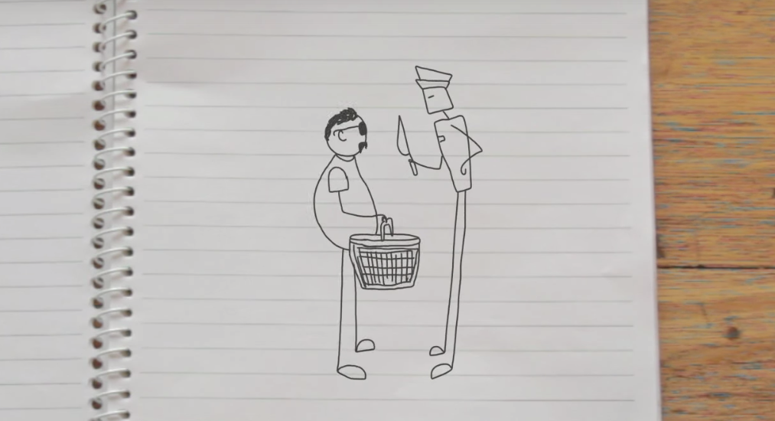

People think I am a pretty tough guy. And I am. But it’s just that I really like baking. It’s just something that I really like doing. And I’m really good at it. I like to cook in my own style though, you know?

So it was my girlfriend’s birthday the other day, and I baked her this giant, amazing birthday cupcake. All pink with icing and everything.

I told her to meet me at the park for a picnic. My plan was to bring a rug and some wine, and make it all nice and surprise her with the cake.

So I packed the cake, and all the picnic stuff in the basket, and I was walking down the street. But then this cop stops me, giving me all this attitude, he said he wanted to search the basket so I let him.

And then he pulled out a cake knife and said it was a controlled weapon. I explained it was just to cut the cake. But he kind of laughed at me and didn’t believe it. And he ended up giving me a fine.

So I finally got to the park and found my girlfriend. Gave her the cake and she was stoked. But we had to cut it with a spoon.



# Searches on public transport

## Session plan

### Learning outcomes

At the end of the session, the group should have increased knowledge of:

* Protective Services Officers (PSOs) and their powers
* when it is illegal to carry spray paint cans or other graffiti tools at or near train stations
* PSO’s powers to search people for illegal graffiti tools at or near train stations
* consequences if a person resists a search or if they are found carrying graffiti tools illegally
* a person’s rights if they are searched by PSOs for graffiti tools
* how to get more information about PSO powers, a person’s rights or free legal advice.

### You will need:

* an internet connection and facilities to show the video
* *The artist* (searches on public transport) video on our [Street law education kit](https://www.legalaid.vic.gov.au/street-law-education-kit) webpage (www.legalaid.vic.gov.au/street-law-education-kit)
* copies of Legal information: Protective Services Officers for each participant (pages 39-40). For more in-depth information on this topic, go to our [public transport offences](https://www.legalaid.vic.gov.au/public-transport-offences) webpage (www.legalaid.vic.gov.au/public-transport-offences)
* What do these words mean? (page 7) for your reference
* Where to get help (page 42) or the *Street law* wallet card. You can order free copies of the [Street law wallet card](https://www.legalaid.vic.gov.au/street-law-wallet-card) (www.legalaid.vic.gov.au/street-law-wallet-card).

### Time allocation

The session will go for approximately 40 minutes.

If you have less time you can shorten the session by only completing the discussion stage. Note: the activity stage is for the group to complete after the discussion stage. It is not designed to be delivered on its own.

### Discussion – *The artist*

**Before you begin: personal disclosures**

Ask participants not to discuss personal details and situations in this session. It is important to create an open and safe environment where people feel free to ask questions. However, personal disclosures should be left for private discussion. Encourage participants to say ‘What if this happens?’ instead of ‘This happened.’

**Watch** *The artist* video from start to finish. A transcript is on page 41 if you have trouble with sound or technology.

**Hand out** and **read** the Legal information: Protective Services Officers handout on pages 39-40.

**Check** if there are any words people do not understand. Use What do these words mean? on page 7.

**Discuss** the following questions as a group or break the group into pairs or small groups and **report** back when finished.

1. **Did the PSO have the power to search that person for graffiti tools? Why or why not?** Yes, as long as she was 14 or over. The PSO had the power to search her for spray paint cans because she is in a ‘designated place’ (a train station) and the PSO had a reason to believe she was carrying a spray paint can because she had paint on her hands. Being in an area with lots of graffiti around can be enough reason for a PSO to believe a person is carrying a spray paint can.
2. **What would have happened to her if she resisted the search?** It is an offence to resist a lawful search by a PSO. She would have been charged if she refused or resisted the search.
3. **Why did she get a fine?** She got a fine because it is illegal to carry a spray paint can at a train station or near a train station. She is breaking the law unless she can prove she needed to carry it for her job. Carrying it just to make art for fun or even for a volunteer community project is not a lawful excuse.
4. **Would it make any difference if she was not going to use the spray paint can for illegal graffiti?** No. It is still illegal to carry a spray paint can at or near a train station without a lawful excuse, even if you have no intention of using it for illegal graffiti.
5. **Which services could she contact for more information about the law or free legal advice?** She could get more information or free legal advice from Victoria Legal Aid or a local community legal centre. She could also contact Youthlaw, if she is under 25 or the Victorian Aboriginal Legal Service if she identifies as Aboriginal and/or Torres Strait Islander. Go to Where to get help on page 42 for these services’ contact details.

### Activity: how to stop graffiti crime debate

**Divide** the group in half to create two teams and name one ‘For’, the other ‘Against’.

**Ask** the group to consider the following statement:

*Getting PSOs to search and fine more young people for carrying spray cans on public transport is the best way to reduce graffiti crime.*

**Direct** each team to work together and brainstorm arguments to support their position for or against.

**Ask** each team to nominate one person as a scribe to make a list of the group’s arguments on a piece of large paper.

**Ask** each group to research information or commentary about graffiti crime and about PSOs, for example, by searching online. Suggest that teams collect media articles, statistics or ideas to support their position either for or against.

**Allow** each team 10–15 minutes to discuss and brainstorm their points for or against.

There are no right or wrong answers but you can help each team come up with arguments for or against by asking them questions like:

* Are people less likely to graffiti if they can’t carry a spray paint can around at places like train stations?
* Are searches and fines likely to stop young people who do illegal graffiti?
* Is it fair to charge or fine people for carrying a spray can if they weren’t planning on doing anything illegal with the spray paint can?
* Should graffiti be a crime at all or should some graffiti be legal and not others?
* Has the introduction of PSOs at train stations decreased the amount of graffiti crime?
* Should PSOs have powers to search people for spray paint cans?
* Are there other ways of reducing graffiti crime?

**Reconvene** the group and ask a volunteer from each team to outline their arguments for or against. If the teams collected any articles or statistics, ask them to report those back to the group.

**Award** the team with the strongest arguments by announcing them as winners of the debate.

## Legal information: Protective Services Officers (PSOs)

### Who are PSOs?

Protective Services Officers (PSOs) have weapons and wear uniforms like the police. They look like police, and have powers like the police, but they can only use those powers inand around certain areas. For example, designated places and police stations.

Designated places include: railway stations and carparks; bus stops; and taxi ranks and paths next to railway stations.

### Can a PSO search me?

A PSO can search you and your car for spray paint, markers and other graffiti tools if you are 14 years old or older or look over 14, and they reasonably think you are carrying those items. Being at a train station with lots of other graffiti may be enough of a reason. Carry ID if you are under 14.

PSOs can also search you for drugs or weapons if they reasonably suspect you have them.

PSOs can only carry out these searches in designated places.

### What if I don’t let a PSO search me?

You may be charged with a crime if a PSO has the right to search you and you don’t let them.

### Do I have to give PSOs my name and address?

If you are at or near a train station, PSOs can ask for your name and address. You must give them your name and address if they:

* think you have committed a crime
* think you are about to commit a crime
* reasonably believe you’re under 18 and have drunk, are drinking or about to drink alcohol
* think you’ve witnessed a crime.

### If you are in or near a police station

If you are in or near a police station, PSOs can ask you why you are there. They can then ask you your name and address if they do not think you have a legitimate reason for being there, such as reporting a crime.

PSOs can also ask you to leave and stay away from around or near a police station. They can only do this if they do not think you have a legitimate reason to be there and that you are disturbing the peace. PSOs can also fine or arrest you if you do not leave, or answer questions about why you are there.

### What else can PSOs do?

PSOs can:

* arrest you if they think you broke the law or are drunk and disorderly
* take alcohol from you if you’re under 18
* fine you if you’re over 18 and gave alcohol to a young person
* take you to a safe place if you’re under 18 and they believe you’ve been chroming (inhaling fumes from spray can) and might harm yourself
* tell you to move on if you’re disturbing, annoying or making other people unsafe
* stop a person who appears to have mental health issues and is believed to have recently tried to seriously hurt themselves or someone else (or is likely to do so)
* ask you to leave from a police station and stay away for up to seven days if they do not think you have a legitimate reason for being there.

### Where can I get help?

You can get information or free legal advice from:

* Victoria Legal Aid
* Youthlaw, a free legal service for people under 25
* Victorian Aboriginal Legal Service if you identify as Aboriginal or Torres Strait Islander
* your local community legal centre

Ask your facilitator for the contact details of these services.

## Transcript: *The artist*

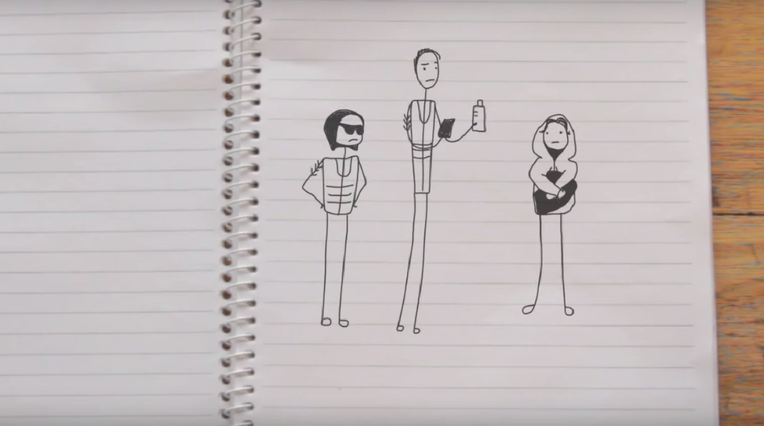

I was at a train station the other day just waiting for my train, and then one of those Protective Services Officers came up to me, you know the ones, they kind of look like police but they’re not.

Well, he came up to me and he was like, “What’s that paint on your hands? I’m going to need to search your backpack.”

And then I was like, “Aren’t you just a ticket inspector? You can check my ticket but forget about the bag, mate.”

This PSO, he must have been a trainee or something ’cause this transit cop was standing behind him and he was all quoting the book like, “You are on railway premises and I have the power to search you under the Graffiti Prevention Act.”

And I said, “Search me for what?” And he said, “For this.”

And I was like, “Well oh that. I need that for my work.” And he was like, “Oh really, you need that for your work? What kind of work do you do then?” And I said, “Well, mostly giant tags, but some murals, like that one.”

So I got fined for carrying a spray can on public transport property. Of all the things to get done for I get done for that.

# Where to get help

## Legal information and advice

### Victoria Legal Aid

For free information about the law and how we can help you:

* visit [Victoria Legal Aid’s website](https://www.legalaid.vic.gov.au) (www.legalaid.vic.gov.au) to use our Legal Help Chat or for information on many legal topics
* call Legal Help on 1300 792 387, 8 am to 6 pm, Monday to Friday excluding public holidays.

#### Do you need help phoning us?

Translating and Interpreting Service

Phone: 131 450

[www.tisnational.gov.au](http://www.tisnational.gov.au)

National Relay Service

TTY: phone 133 677

Speak and Listen: phone 1300 555 727

Internet Relay users: visit the [National Relay Service](https://nrschat.nrscall.gov.au/nrs/internetrelay)   
(https://nrschat.nrscall.gov.au/nrs/internetrelay)

SMS relay: text 0423 677 767

Video Relay: use Skype or the National Relay Service app

### Youthlaw

A free, youth-friendly legal service for young people under 25 in Victoria. The service can also provide legal information to adults assisting young people. ‘Ask a lawyer’ legal information service is available by phone Monday to Friday, 9.00 am to 5.00 pm, by email via the Youthlaw website. Youthlaw also have drop-in legal clinics at Frontyard Youth Services 19 King Street, Melbourne.

Phone: (03) 9113 9500

Visit [Youthlaw’s website](https://youthlaw.asn.au/) (http://youthlaw.asn.au)

### Local community legal centre

Community legal centres give free legal advice. Use the Federation of Community Legal Centres’ website to find your nearest community legal centre.

Visit the [Federation of Community Legal Centres’ website](https://www.fclc.org.au/) (www.fclc.org.au)

### Victorian Aboriginal Legal Service

A free legal service for Aboriginal and/or Torres Strait Islander people in Victoria.

Phone: 1800 064 865

Visit the Victorian Aboriginal Legal Service’s website (www.vals.org.au)

### Youth Referral and Independent Person’s Program.

To speak to a lawyer or organise an independent person to be with you in custody. Available 24 hours a day, seven days a week.

Phone: 1300 791 189

## Additional resources

### Online resources

#### StreetSmart

An online guide produced by Youthlaw about young people’s rights in Victoria when dealing with authorities on public transport and on the street.

Go to the [StreetSmart website](https://streetsmartvic.com.au/) (www.streetsmartvic.com.au)

#### Youthlaw

Youthlaw has online fact sheets for young people on a number of different legal issues.

Go to [Youthlaw’s fact sheets](https://youthlaw.asn.au/learn-about-the-law/) (youthlaw.asn.au/learn-about-the-law/)

#### Youth Law Australia

The National Children’s and Youth Law Centre’s legal information and email advice service for children and young people.

Go to [Youth Law Australia’s website](https://yla.org.au/): (yla.org.au)

### Publications

You can order the following publications by visiting [Publications](https://www.legalaid.vic.gov.au/publications) on Victoria Legal Aid’s website (www.legalaid.vic.gov.au/publications)

#### Am I old enough? Common legal issues for young people

A booklet for young people about what you can and cannot do because of your age.

Go to [Am I old enough? Common legal issues for young people](https://www.legalaid.vic.gov.au/am-i-old-enough-common-legal-issues-young-people) (www.legalaid.vic.gov.au/am-i-old-enough-common-legal-issues-young-people)

#### Fines: the law, your options

A booklet for anyone who has been fined in Victoria, with options for dealing with fines.

Go to [Fines: the law, your options](https://www.legalaid.vic.gov.au/fines-law-your-options) (www.legalaid.vic.gov.au/fines-law-your-options)

#### Legal Help card

A wallet-sized brochure about our services, available in English and other languages.

Go to [Victoria Legal Aid help card (English)](https://www.legalaid.vic.gov.au/victoria-legal-aid-help-card-english) (www.legalaid.vic.gov.au/victoria-legal-aid-help-card-english)

#### Police powers: your rights in Victoria

A general guide to help you when you deal with the police. It includes information for young people under the age of 18 and people with a cognitive disability.

Go to [Police powers: your rights in Victoria](https://www.legalaid.vic.gov.au/police-powers-your-rights-victoria) (www.legalaid.vic.gov.au/police-powers-your-rights-victoria)

#### Street law help card

A wallet-sized card made for this kit.

Go to [Street law wallet card](https://www.legalaid.vic.gov.au/street-law-wallet-card) (www.legalaid.vic.gov.au/street-law-wallet-card)