Specialist sexual harassment and discrimination law services
Everyone deserves to feel safe and respected at work. Our Equality Law Program delivers specialist services to help people who have experienced discrimination, including sexual harassment.

We can help with
- providing legal advice and assistance
- representation at conciliation, mediations and hearings
- conducting direct negotiations.

We cannot help with
- general employment advice
- workers’ compensation claims
- defending complaints of discrimination, sexual harassment or victimisation made against you.

Eligibility for assistance

We have expanded our service to be able to help more workers experiencing sexual harassment. There are eligibility requirements for more intensive, ongoing legal services. We will discuss with you what information or assistance we can provide.

Contact us
You can contact us by phone, online webchat or email.

Phone
Call our Legal Help line 1300 792 387 (8 am and 6 pm, Monday to Friday)
Help in another language
Phone the Translating and Interpreting Service on 131 450 and ask to be put through to Victoria Legal Aid.
Help for people who are deaf or have a hearing or speech impairment
Use the National Relay Service to phone Victoria Legal Aid on 1300 792 387. This is a free service.

Webchat
Go to https://www.legalaid.vic.gov.au
A Legal Help Chat window will appear at the bottom of the page (8 am and 6 pm, Monday to Friday)

Email
Please send an email to equalitylaw@vla.vic.gov.au including your name, contact number, email address, date of birth, address and a description of your legal problem.

Dedicated referral pathway for Aboriginal and Torres Strait Islander people
Our lawyers have received training in cultural safety for Aboriginal and Torres Strait Islander people and work to provide services that are informed by your lived experiences.
Please email kali.wischmann@vla.vic.gov.au and cc equalitylaw@vla.vic.gov.au

More information
If you want to know more about our services, please get in touch:
equalitylaw@vla.vic.gov.au or (03) 9269 0416.
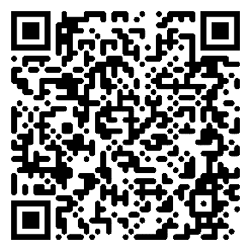
https://www.legalaid.vic.gov.au

