Victoria Legal Aid (VLA)
Client Experience Survey 2023
Summary report

Quality and Compliance Statement
This project was conducted in accordance with the international quality standard ISO 20252, the international information security standard ISO 27001, as well as the Australian Privacy Principles contained in the Privacy Act 1988 (Cth). ORIMA Research also adheres to the Privacy (Market and Social Research) Code 2021 administered by the Australian Data and Insights Association (ADIA).
Acknowledgments
ORIMA pays respect to Aboriginal and Torres Strait Islander Peoples past and present, their cultures and traditions and acknowledges their continuing connection to land, sea and community.
We would also like to acknowledge and thank all the participants who were involved in our research for their valuable contribution.
Contents
Project overview 1
Background 1
Research approach 1
Respondent profile 2
Summary of key results 4
Access 6
Experience 7
Expertise 7
Communication 8
Person-centred 9
Support needs and considerations 9
Suggestions for assisting clients with support needs/considerations 12
Impact of COVID-19 13
Legal capability 14
Resolution 15
Resolution – fully resolved matter 15
Resolution – unresolved matter 16
Wellbeing 17
Wellbeing – fully resolved matter 18
Wellbeing – partly resolved or unresolved matter 19
Overall client satisfaction 20
Overall satisfaction comparisons by cohorts 21
Overall satisfaction trends 22

Project overview

Background
Victoria Legal Aid (VLA) is an independent statutory authority established under the Legal Aid Act 1978. VLA provides legal information, advice and representation to members of the Victorian community who are most disadvantaged and in need of support. Services provided by VLA, including through its external partner agencies, are intended to be accessible and appropriate to the person’s need. While access to legal information is provided free (online information, resources, access to telephone advice including connection with other organisations to assist), access to VLA advice and representation for certain legal matters must meet an eligibility criterion.
As a publicly funded authority with a high demand for legal services, it is important that VLA operate efficiently and at a high quality for the clients it serves. This client-centric focus of VLA extends to ensuring improvements to its services are directly driven by the voice of its clients. The service areas that VLA aimed to collect client feedback on in 2023 were:
- Legal advice services (including minor work files) for clients of its Legal Help, criminal, family, and civil law programs
- Legal representation on a grant of aid (casework) for clients of its criminal, family, and civil law programs, and
- Duty lawyer services for clients of its criminal, family, and civil law programs.
The primary objective of the survey was to engage with clients to inform tangible service improvement actions that directly respond to client experience, and to measure the outcomes clients experience as a result of VLA services.

Research approach
The research approach had four stages:
- Project establishment, which included:
  - Project inception and planning
  - Ethics review
- Establishment of survey tools and processes
  - Questionnaire refinement and finalisation
  - Survey translations
  - Sample preparation and validation
  - Online survey programming
- Fieldwork (16 May – 14 June 2023)
  - Online survey invitations and reminders distributed via email and SMS
  - Computer Assisted Telephone Interviewing (CATI)
- Data analysis and reporting
  - Data cleaning and analysis
  - Survey data weighted by service offering, service type and law type
  - Preparation of a summary and comprehensive report

Respondent profile

Sampling approach
The survey was sent to a stratified random sample of n=16,475 VLA clients who received services between 1 July – 31 December 2022. The sampling strata were based on service offering, service type and law type (see Table 1). Certain groups were oversampled to allow for more robust analysis and reporting. Survey data was then weighted by known population proportions.

Response rate
6% of clients responded in 2023, which was 926 clients out of 16,475 clients.

Profile of responding sample compared to the in-scope population
A summary of the responding sample compared to the in-scope population is provided in Table 1.
Table 1: Profile of responding sample compared to the in-scope population
Overall | Population count | Population proportion | Responding sample count | Responding sample proportion (unweighted)
Total | 27,222 | 100% | 926 | 100%
Service offering
In-house practitioner | 23,433 | 86% | 810 | 87%
Private practitioner | 3,814 | 14% | 116 | 13%
Service type
Duty Lawyer | 15,360 | 56% | 402 | 43%
Legal Advice | 7,761 | 29% | 390 | 42%
Casework | 4,291 | 16% | 142 | 15%
Law type
Criminal law | 15,894 | 58% | 324 | 35%
Family law | 8,179 | 30% | 384 | 41%
Civil law | 3,226 | 12% | 220 | 24%

Demographic profile
Just over half of the sample were middle-aged: 35-44 years (28%) and 45-54 years (27%). Two in five were female (41%) and just over half were male (56%). One in seven respondents spoke a language other than English (14%) and 6% were of Aboriginal and / or Torres Strait Islander descent. Two in three respondents had a disability or an ongoing condition or impairment (65%) and the most common conditions were mental health issues (50% overall), chronic illnesses (12%) and neurodiverse or learning difficulties (11%). 38% of respondents’ highest level of education was high school or below.

Summary of key results

Access
- 81% of respondents agreed it was easy to contact VLA when they first needed help.

Wellbeing
- 59% of respondents agreed they were less stressed after talking to the lawyer.
- 67% of the respondents with a fully resolved matter agreed that their overall wellbeing were improved.
- 34% of the respondents with an unresolved matter agreed that their overall wellbeing were improved.

Experience
- 80% of respondents agreed that the lawyer treated them with respect.
- 76% of respondents agreed that the lawyer listened to their legal problem.
- 70% of respondents agreed that the lawyer took their circumstances into account.

Legal capability
- 80% of respondents agreed they know where to get help for future legal problems.
- 76% of respondents agreed that they feel more confident to get legal help in the future.
- 70% of respondents agreed that the lawyer helped them understand how to deal with their legal problems.

Resolution
- 76% of respondents (whose legal problem had been fully resolved) agreed that VLA’s help had a positive impact on their legal outcome.
- 75% of respondents (whose legal problem had been fully resolved) agreed that VLA helped fix their legal problem.

Satisfaction
- 76% of respondents agreed that they would recommend VLA to others.
- 62% of respondents were satisfied with the help they got from VLA.

Service dimensions with the greatest positive impact on overall satisfaction
A regression model was developed to determine the key drivers of overall satisfaction with VLA’s services from the 2023 survey. The model identified seven service dimensions that explained 85% of the variation in VLA’s overall satisfaction rating among survey respondents.
The regression model indicated that sustaining and/or improving performance on the following seven service dimensions is likely to have the greatest positive impact on overall satisfaction (in decreasing order of importance):
- Client perceptions that VLA has provided them with enough help (broader theme: perceived impact of VLA on the outcomes of respondents’ legal problems)
- Client confidence to get legal help in the future (broader theme: degree to which respondents’ feel capable of dealing with legal problems in the future as a result of receiving VLA services)
- Clients feeling that their Legal Aid lawyer wanted the best result for them (broader theme: respondents’ experiences using VLA’s services)
- Legal Aid lawyers taking clients’ circumstances into account (broader theme: respondents’ experiences using VLA’s services)
- Clients being able to ask all the questions they want (broader theme: respondents’ experiences using VLA’s services)
- VLA’s assistance having a positive impact on the outcome of clients’ legal problems (broader theme: perceived impact of VLA on the outcomes of respondents’ legal problems)
- VLA’s assistance improving clients’ mental health (broader theme: perceived impact of VLA’s services on the respondents’ wellbeing)

Key takeouts for the 2023 survey
Resolution status and outcome of legal problems has a significant influence on perceptions of VLA’s services.
  - The resolution status and outcome of respondents’ legal matters had a large influence on their overall satisfaction as well as most other survey measures.
Client perceptions as to whether VLA has provided them with enough help has an important influence on overall client satisfaction regardless of resolution status or the outcome of their legal problem.
  - The majority of respondents with a fully resolved matter agreed that VLA provided enough help for their legal problem (80%). However, just under half (46%) with an unresolved matter agreed with this same measure. Enabling staff to dedicate more time to cases would be likely to improve their interactions with clients and, in turn, improve client satisfaction – this may reassure clients that they have been provided with an appropriate level of assistance regardless of their legal outcome.
Addressing the unique challenges of clients will improve overall client experience, particularly among those with support needs or considerations.
  - Just over one-third (37%) of respondents indicated they had support needs or considerations. Respondents who had support needs and considerations were significantly less satisfied overall with VLA’s services compared to those who did not have support needs. Additionally, only around half or less of respondents who said they have a disability, mental health, other health concerns or previous experience with violence felt that their support needs and considerations were fully met. Feedback highlighted the need for VLA to identify means to address the unique challenges of these clients so that they can be effectively supported through the legal process. A key suggestion from respondents with support needs and considerations was for VLA staff to listen more in order to understand their challenges and needs.
Clients have an improved understanding and capability to deal with future legal problems.
  - Survey results suggest that respondents have an improved capability on how to deal with future legal problems following their experiences with VLA – eight in ten (80%) respondents agreed they know where to get help for their legal matters in the future and just over three-quarters (76%) agreed they feel more confident to get legal help in the future.

Access
This section of the report focuses on clients’ initial contact with VLA and any difficulties they had when contacting VLA when they first needed help.
Accessing VLA’s service was straightforward.
Four-fifths of respondents (81%) agreed it was easy to contact VLA when they first needed help (shown in Figure 1).
Figure 1: Ease of accessing Victoria Legal Aid
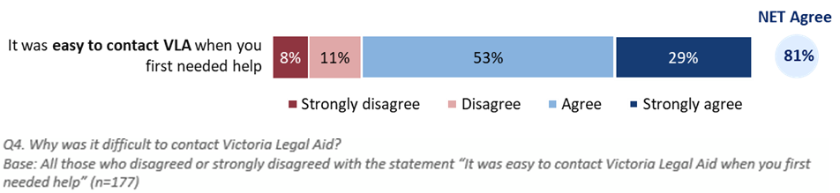

Experience
This section of the report focuses on the various factors influencing the quality of the experience clients have while interacting with VLA. These can be summarised as:
perceived expertise of the legal advisors
quality of communication between clients and legal advisors
the extent to which services are person-centered and tailored to individual circumstances, and
support needs and considerations of clients, and whether these were adequately met.

Expertise
Respondents generally felt assured about the expertise of the lawyer.
Three-quarters (73%) agreed the lawyer understood their problem and two-thirds (65%) had been confident the advice provided would help them.
One-quarter (25%) had not been confident that the lawyer’s advice would help them, disagreeing or strongly disagreeing with the statement.
More details can be found in Figure 2.
Figure 2: Expertise of Legal Aid lawyer
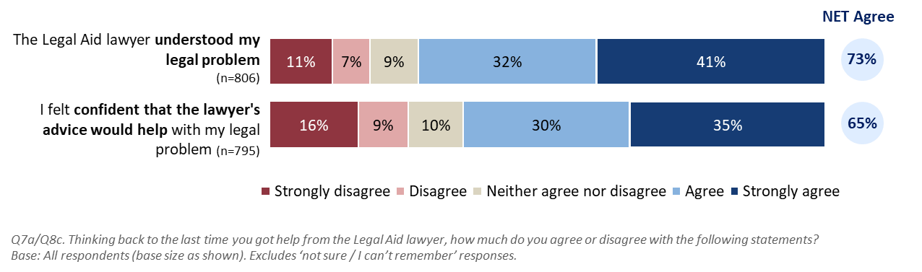
Some respondents praised the knowledge of their lawyer, and the suitability of their advice. Some also highlighted that a positive outcome came from their lawyer’s legal expertise.
“The lawyer listened and understood the circumstances leading to what happened. Very knowledgeable in life circumstances.”
“Because my lawyer was knowledgeable, and I received a lesser charge.”
Some respondents also highlighted some areas of improvement regarding client confidence in the expertise of Legal Aid lawyers.
“Ensure that the choice of Legal Aid lawyer has appropriate experience for the case.”

Communication
Communication was generally good, although some respondents felt they were not listened to properly.
Although more than three-quarters (77%) agreed it was easy to understand the lawyer, slightly fewer found it easy to explain their problem (72%) or ask all the questions they needed to (71%).
More information can be found in Figure 3.
Figure 3: Communication between lawyers and clients
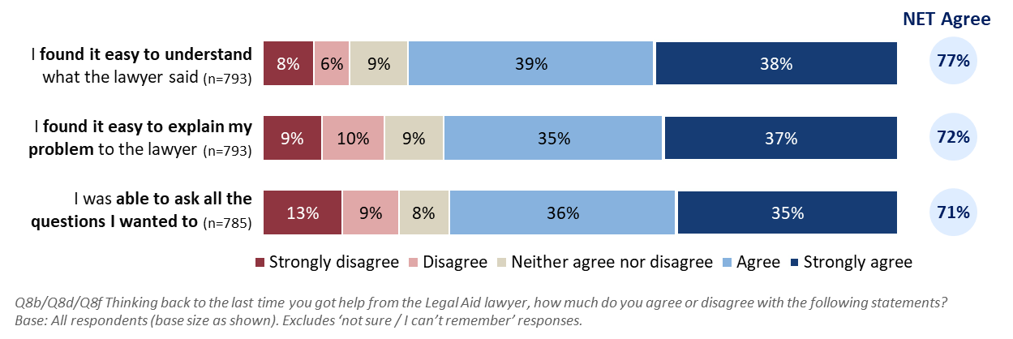
Some respondents praised the positive impact of VLA’s good communication skills:
“[Name] was a saving grace, listened to me, is calm and warm, clear kind explanations and expressed my view to magistrate and facilitated an amazing outcome for me and my life.”
“They were very welcoming and forthcoming, and the lawyer was helpful and relaxed and knowledgeable I couldn’t thank him and her enough highly grateful.”
Poor communication often seemed to stem from what clients viewed as VLA personnel being rushed or holding dismissive attitudes. Some respondents also highlighted that due to these behaviours, they could not ask the questions they wanted.
“My questions were not answered, I was rushed…”
“The Legal Aid lawyer spoke to the other party’s lawyer first before speaking to me, then made up her mind before asking me a single question that I would not win the case.”

Person-centred
Respondents differed in their assessment of VLA engaging with them in a person-centred manner.
The results showed that lawyers generally displayed a person-centred approach towards their clients. At least three-quarters agreed or strongly agreed that their lawyer treated them with respect (80%) and listened to their legal problem (76%).
More information can be found in Figure 4.
Figure 4: VLA engaging in a person-centred manner
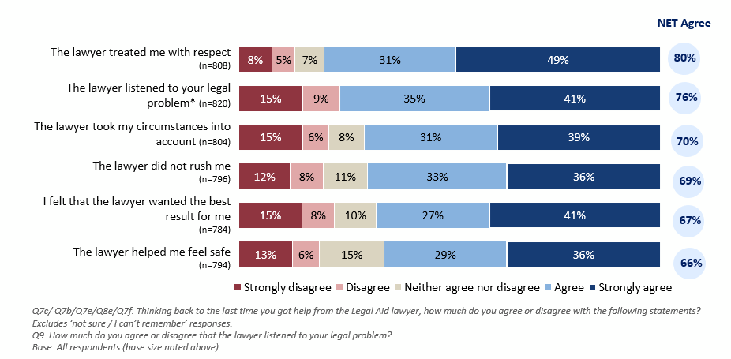
Some respondents noted in their comments that their lawyer seemed rushed, which was also reflected above in the relatively lower ratings about not feeling rushed by the lawyer (69%). This was associated with perceptions that their lawyer did not want the best result for them (23% disagreed that they wanted the best for them).
“They only get your case moments before, don’t have enough time to get all over your case, and truly want to win for you.”
Some comments showed that respondents’ perception of VLA’s service as personal and tailored to individual circumstances impacted their level of satisfaction. For example:
“Could not have asked for a better insight into supporting my personal circumstances and the relevance to the accused charges.”
“Customise your service next time for the legal issue.”

Support needs and considerations
Overall, VLA fully met the needs for around half of those with support needs, but this varied depending on the type of request.

Support needs and considerations
Among 809 respondents, 37% of respondents had specific support needs or considerations when using VLA’s services (see Figure 5). 21% of respondents had a disability, mental health issue, or other health concern. 11% of respondents had experienced violence at home, school, or work.
The respondents who had caring responsibilities, who had difficulty reading or writing, and who needed an interpreter (including Auslan) accounted for 5%, 5%, and 4% respectively.
For the respondents needing cultural support from elders, community leaders, or family, for those with needs related to their gender or sexual orientation, and for the respondents who had needs related to their religious or cultural beliefs, the numbers were 2%, 2%, and 1% respectively.
There were 5% of respondents who chose the answer of “other”.
Figure 5: Support needs and considerations
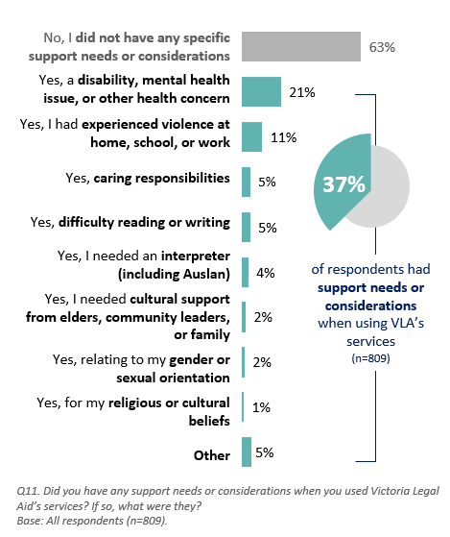

Extent to which support needs and considerations were met
Feedback from respondents on whether their support needs or considerations were met were mixed (as illustrated in Figure 6). Respondents requiring interpreter services were the most likely to say that their needs were fully met (75%). Although respondents’ disability, mental health, other health concerns or previous experience with violence were the most commonly identified areas for supports, only around half or less of the needs of these respondents were fully met (53% and 35% respectively).
Figure 6: Extent to which support needs and considerations were met
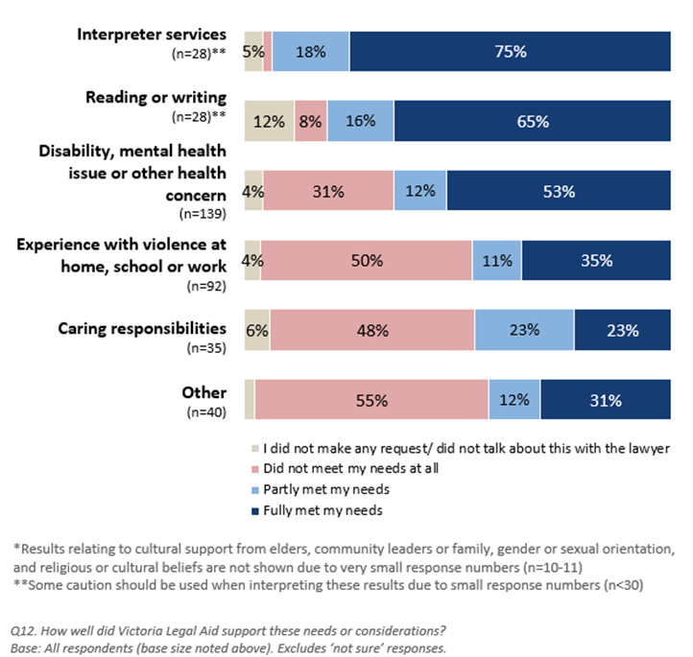

Suggestions for assisting clients with support needs/ considerations
When respondents were asked why their support needs/ considerations were not fully or only partially met, many felt it was because VLA did not listen to them or take the time to understand their situation:
“Legal Aid didn't listen to anything and kept cutting me off. When I asked to be [listened] to, she said and I quote “nope, you can deal with it yourself” then she stormed out of the room, so I had a private cry before composing myself and speaking with the judge completely unsupported.”
“The lawyer did not even give me any time to mention my needs to the full extent, so she would actually understand the depth of my situation.”
“I was basically ignored and left to fend for myself.”
“Spoke over the phone and was rushed saying its 30 minutes and ended abruptly not taking into consideration my situation to leave a [domestic violence] situation.”
When respondents whose support needs were not fully met were asked how VLA could better meet their needs, many suggested that VLA could improve their communication and their quality of assistance (e.g. taking the time to listen to clients to understand their circumstances):
“Hire people who understand how to listen and empathise with domestic violence victims.”
“Just listen to me better when I was on the phone.”
“Understand the full picture before providing advice. I was provided general information which I already had from other sources.”
“Allocate A LOT more time for each client, actually have experience and get to know the client and their situation a lot better so you can represent them FAIRLY and speak with terms they can understand.”
Improving the attitudes of VLA staff was also another suggestion offered by respondents, including having more empathy, respect and kindness towards them:
“Respect people [with] disability and not discriminate my faith.”
“Listen without assumption on initial contact. Treat each request individually.”
“Assume that the person seeking advice is genuine, give proper weight to the support and other service.”
A small proportion of respondents indicated that although they had support needs, they did not make any requests. A few explained that they were not aware that they could make requests or did not know how they could make these requests.
“They did not ask. Very little communication, if any. I was disappointed.”
“I wasn't aware I could.”
“I was not aware that this was something I could do. I made the lawyer aware of my disability at the start of the conversation (for the demographic questions).”
“I didn't know I could ask for help on those areas.”

Impact of COVID-19
Few respondents felt VLA’s service had been impacted by COVID-19.
When respondents were asked what impact COVID-19 had on the service they received from Legal Aid, 72% thought the service they got was the same. 11% of respondents thought the service took longer to get. 8% believed that they has trouble contacting VLA. 6% reported that they had trouble getting the service using a phone, video call, mobile, or internet. 6% though it was harder for them to explain their problem.
The respondents who thought they could not ask all the questions they wanted to, who believed that they could not share their paperwork easily, who reported it was harder for them to understand the lawyer, and who reported other impacts of COVID-19 accounted for 5%, 4%, 2%, and 11% respectively (Figure 7).
Figure 7. Impact of COVID-19
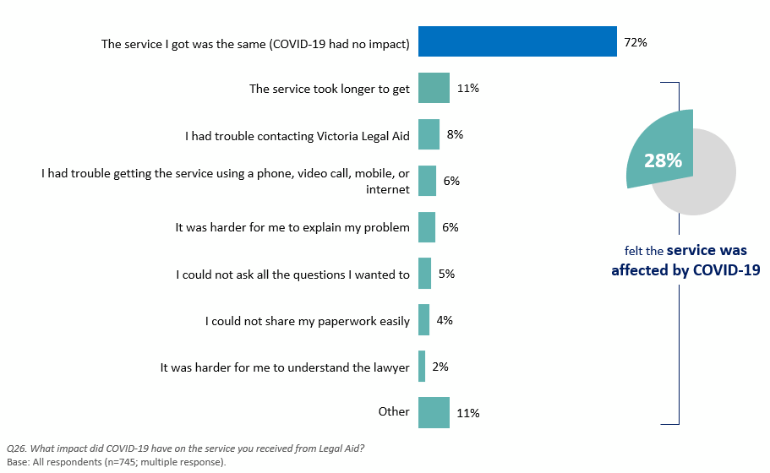

Legal capability
This section describes the impact of VLA’s assistance on clients’ ability to understand their most recent legal problem, how to deal with it, as well as their impact on building client capability in dealing with future legal problems.
The experience of interacting with VLA left most respondents feeling more capable of dealing with legal problems in the future.
Eight in ten (80%) agreed they would know where to get help with future legal problems, and three-quarters (76%) felt more confident in getting legal help should they need to do so in the future. Respondents also agreed the lawyer was instrumental in helping them to understand (70%) and deal (70%) with their legal problems, but to a slightly lesser extent (Figure 8).
Figure 8. Capability of respondents
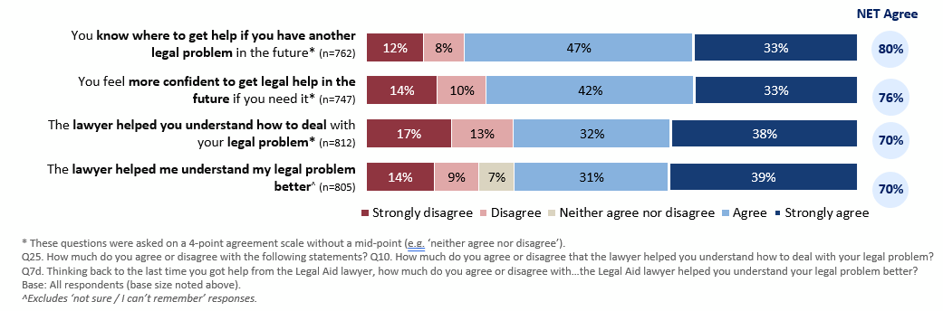
When respondents commented on their satisfaction with VLA’s service, they often referred to the value of the lawyer helping them understand the legal problem, and providing them with confidence to address it, rather than simply resolving it for them:
“I felt more confident about resolving my legal issue and I had more knowledge so I wasn't as worried about what would happen as I had a clear idea and understanding of what could happen and how.”
“They helped me in so many ways, made me understand more better as well.”
Some respondents, however, did not feel so empowered following their experience with VLA:
“I am going through some stuff at the moment, so I might need to reach out to Legal Aid again. I don't know. I have no idea. I am not very smart. I don't know how they could help you. They would have to tell me how they could help me.”
“Just explain how the process works.”
“I find I get different information on how l apply for a grant each time I try. It would be easier and less stressful if someone could step me through over the phone.”

Resolution
This section focuses on client perceptions of VLA’s impact on their legal matters. In the survey there was a separate set of questions for those who had a fully resolved legal matter to those whose legal matter was yet to be resolved. The former focused on the perceived impact of VLA assistance on the outcome, and the latter focused on the perceived impact of VLA assistance on the progress of their case or anticipated outcome.

Resolution – fully resolved matter
VLA’s involvement was generally perceived to have had a positive impact on the outcomes of respondents’ legal problems where the legal matter had been resolved.
For the respondents with a fully resolved legal matter, 81% reported they were satisfied with the outcome of their legal problem. 80% thought Legal Aid gave them enough help for their problem. 76% of respondents reported that the help they got from VLA had a positive impact on the outcome of their legal problem. The outcome of their legal problem was fair for 75% of respondents. 75% of respondents thought VLA helped them fix their legal problem (Figure 9).
Figure 9. Resolution - Fully resolved matter
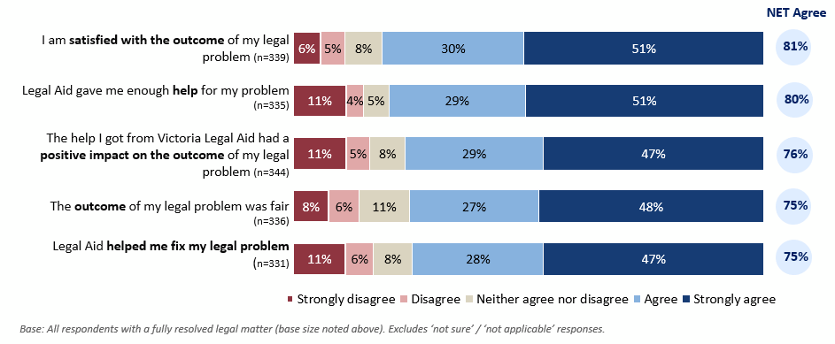
Respondents who perceived VLA to have a positive impact on their legal matter praised VLA’s communication and support which helped them to achieve their outcome:
“I'm very happy with the help I received and the outcome.”
“Outcome was in my favour and they were very understanding and supportive.”
“They helped me prove my [innocence].”

Resolution – unresolved matter
Clients were generally less positive if their matter had not been fully resolved.
For the respondents with an unresolved legal matter, 53% reported that the help from Legal Aid helped them to get to the next step(s) in their legal problem. 46% thought Legal Aid gave them enough help for their problem. 46% of respondents reported that the help they have got from VLA so far will have a positive impact on the outcome of their legal problem. 38% of respondents thought they were satisfied with how their case was going (Figure 10).
Figure 10. Resolution - unresolved matter
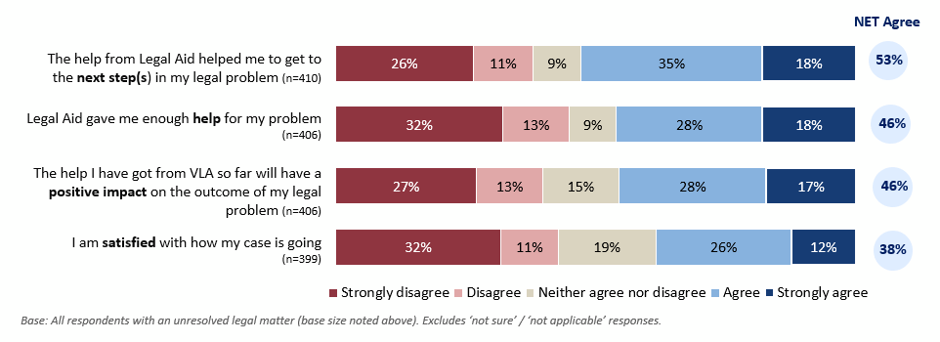
Respondents who were not satisfied with their overall experience and whose legal problem had not been resolved described concerns about the level of communication, support and advice from VLA:
“I have been left in the dark, I'm unsure of the plan by my lawyer, I have made 5 attempts to contact my lawyer they didn't return my phone calls.”
“No result or progress with them, they contradict what they initially say.”
Although most clients were generally less positive if their matter had not been fully resolved, a few expressed satisfaction with VLA despite their case not being resolved due to the assistance they had received with their legal problem.
“My case is still ongoing, but I'm still getting the help I need and I'm happy with how things are going.”
“In some ways I'm unhappy as there's no resolution but I'm satisfied that the lawyer tried and that's all I can ask for.”

Wellbeing
This section discusses VLA’s impact on the wellbeing of clients. In the survey there was a separate set of questions for those who had a fully resolved legal matter to those whose legal matter was yet to be resolved.
VLA’s services had a positive impact on wellbeing where the legal matter was resolved, and less so where it was partially or unresolved.
Three-quarters (74%) of those with a resolved legal matter agreed they were less stressed after talking to the lawyer, but this was less than half (46%) for those without a resolved matter (Figure 11).
Figure 11. Wellbeing
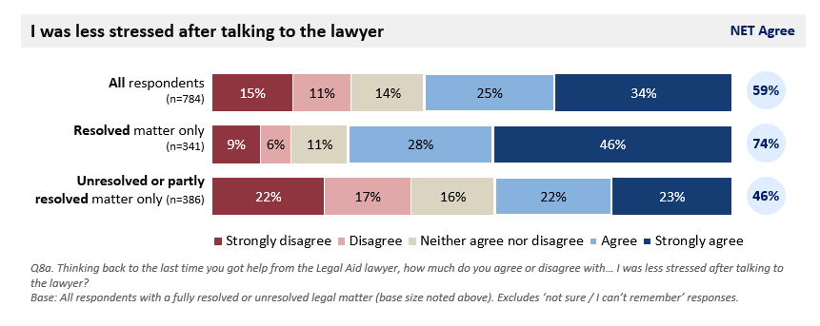

Wellbeing – fully resolved matter
Regarding their wellbeing, 67% of respondents with a fully resolved matter agreed that the help they got from VLA improved their overall wellbeing. 60% of respondents thought the help improved their mental health, and 59% of them agreed that the help made them safer. The percentages of respondents believed that the help from VLA made their financial situation better and made their housing situation better were 53% and 39% respectively (Figure 12).
Figure 12. The help I got from VLA (resolved matter)
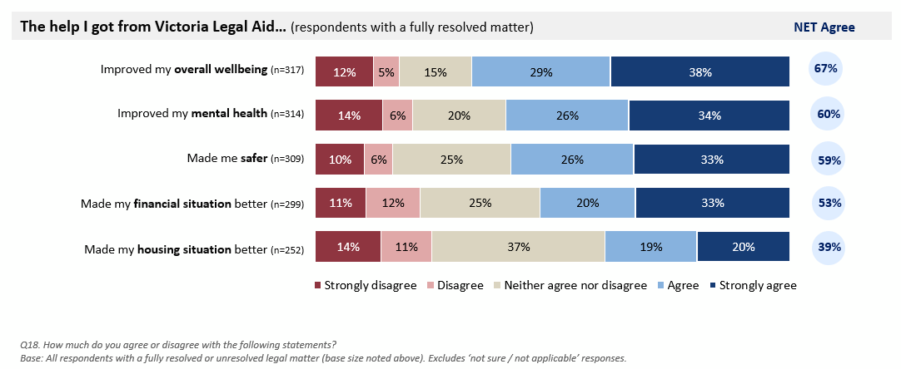
Respondents who felt that they had good mental health outcomes, praised VLA’s assistance:
“I feel blessed that my experience was as good as it was and that my mental health has improved and feel I have a second chance for a better life. Thank you VLA for the support! So much gratitude.”
“The service I got was fantastic. It really made a difference to my mental and emotional wellbeing.”
“That dark cloud floating over my head was gone. There was only sunshine left. Anyone with very little legal training deserves this level of support I received.”

Wellbeing – partly resolved or unresolved matter
34% of respondents with an unresolved or partly resolved matter agreed that the help they got from VLA improved their overall wellbeing. 30% of respondents thought the help improved their mental health, and 38% of them agreed that the help made them safer. The percentages of respondents believed that the help from VLA made their financial situation better and made their housing situation better were 32% and 23% respectively (Figure 13).
Figure 13. The help I have got from VLA so far (unresolved or partly resolved matter)
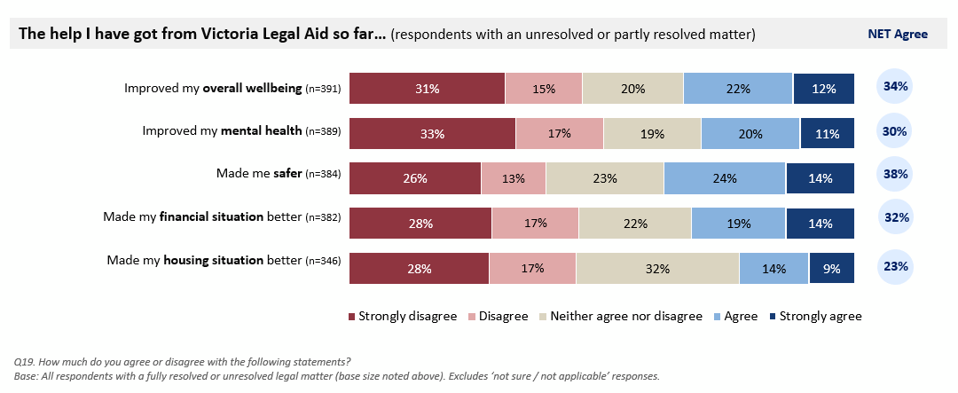
Some felt their poorer mental wellbeing was related to the attitude that the lawyer had towards them and their case, with some feeling that their lawyer had limited time to help, had a limited understanding of their personal circumstances or did not follow through with the legal assistance discussed.
“More time to speak with duty lawyer, more understanding of my anxiety and the stress that the process creates.”
“…Actually provide the assistance you say you offer. Because all I got was stress and upset. I was not listened to or offered any real legal advice. Just provided a list of lawyers that I could not afford.”

Overall client satisfaction
Many respondents were satisfied with the help they received from VLA, although there has been a declining trend since 2015.
Six in ten (62%) respondents were either very satisfied or satisfied with the service they received. This is lower than all previous years since 2013. From 2013 to 2023, the rate of respondents who were satisfied with the help they received from VLA had dropped from 73% to 62%, while the rate of dissatisfaction had increased from 18% to 27% (Figure 14).
Figure 14. Overall satisfaction and time series comparison
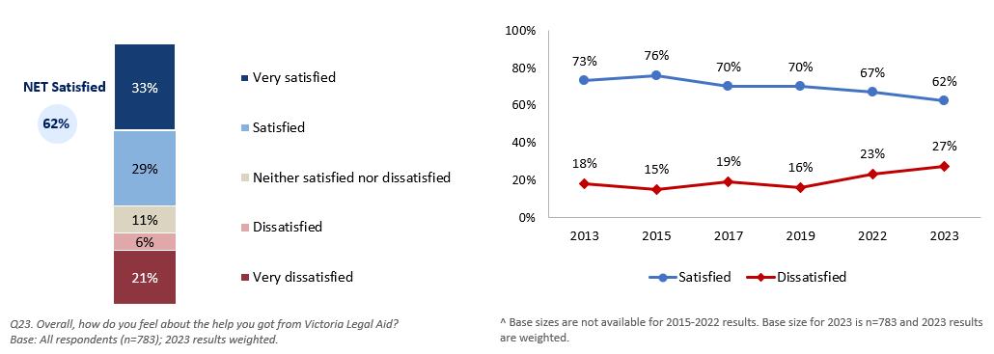
Respondents were asked the reason for their level of satisfaction. The top reason among those satisfied with the help they received from VLA was to note that their request for services was fulfilled (i.e., they felt VLA helped) and/or were satisfied due to the outcome of their legal problem:
“Outcome was in my favour, and they were very understanding and supportive.”
“The outcome was better than expected.”
Among respondents who were dissatisfied with VLA’s services, some explained that this was due to the lack of access to legal assistance from VLA, including not being able to access a lawyer in court, being referred to private/ fee-paying services, or not qualifying for legal support or being refused services:
“Limited on what they can do.”
“I was told that they cannot help me and [sent] me to a private lawyer.”

Overall satisfaction comparisons by cohorts
Regarding the rate of overall satisfaction by the outcome of respondents’ legal problem, the rates of satisfaction for “completely in your favour”, “partly in your favour”, and “not at all in your favour” were 90%, 74%, and 34% respectively.
Regarding the rate of overall satisfaction by resolution status of legal problem, 77% of respondents with a fully resolved matter were satisfied, 71% of respondents with a partially resolved matter were satisfied, 32% of respondents with an unresolved matter were satisfied, and 54% of respondents who were not sure or did not know the outcome of their legal problem were satisfied.
Of the clients who did not need support or considerations, 67% were satisfied with the service they received. Of the clients who did need support or considerations, 54% were satisfied with the service they received.
The information is shown in Figure 15.
Figure 15. Overall satisfaction comparisons by cohorts

Overall satisfaction by outcome of legal problem

Overall satisfaction by resolution status of legal problem

Overall satisfaction by clients who needed support or considerations

Overall satisfaction trends
From 2015 to 2023, the satisfaction rates in the criminal law area dropped from 81% to 69%, the satisfaction rates in the civil law area decreased from 73% to 56%, and in the family law area, the satisfaction rate also decreased, dropping from 72% in 2015 to 52% in 2023 (Figure 16).
Figure 16. Overall satisfaction by program area and time series comparison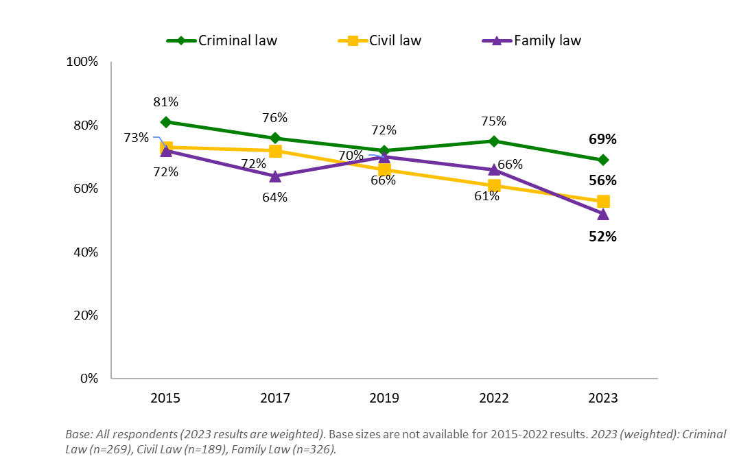
From 2015 to 2023, the satisfaction rates for those who received case work services dropped from 85% to 76%, the satisfaction rates for those who received support from a duty lawyer decreased from 75% to 64%, and for legal advice services, the satisfaction rate also decreased, dropping from 72% in 2015 to 52% in 2023 (Figure 17).
Figure 17: Overall satisfaction by service area and time-series comparison
