November 2023
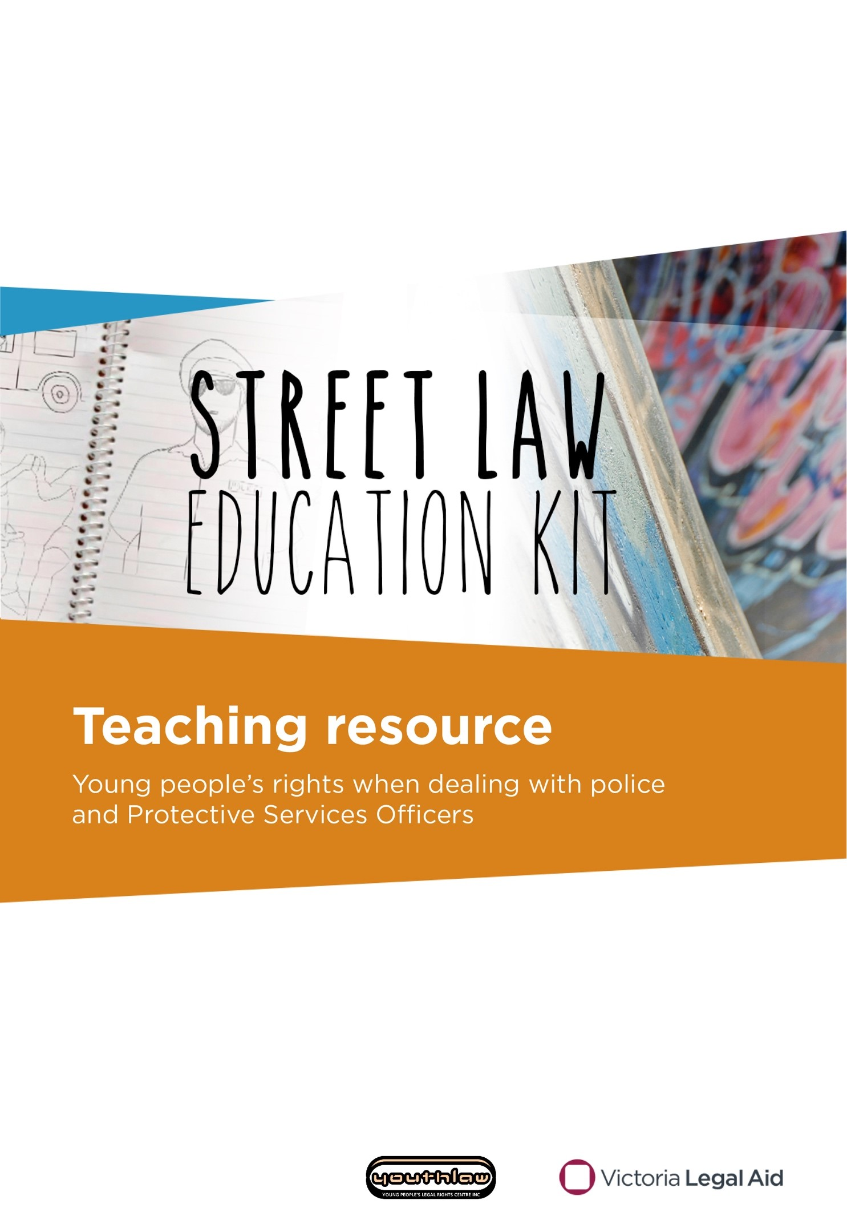

Do you need this kit in a different format?
Please phone us on (03) 9269 0234 and ask for Community Legal Education. We can talk with you about what you need.
Produced by Victoria Legal Aid
Victoria Legal Aid
570 Bourke Street
Melbourne VIC 3000
For free information about the law and how we can help you:
- visit Victoria Legal Aid’s website (www.legalaid.vic.gov.au)
- call Legal Help on 1300 792 387, Monday to Friday 8 am to 6 pm, excluding public holidays.
For business queries, call (03) 9269 0234.
Fourth edition, November 2023
Acknowledgements: The Street law video series and teaching resources were originally produced by Youthlaw with funding from the Victoria Law Foundation. The videos were produced in collaboration with Youthworx Media, Melbourne. We thank Youthlaw and Youthworx for allowing Victoria Legal Aid to adapt and republish this content.
© 2023 Victoria Legal Aid
This work is licensed under a Creative Commons Attribution 4.0 licence. You are free to re-use the work under that licence, on the condition that you credit Victoria Legal Aid as author, indicate if changes were made and comply with other licence terms. The licence does not apply to any images, photographs or branding including the Victoria Legal Aid logo.
Changes to the law
The law changes all the time. To check for changes you can visit our website, use our Legal Help Chat or phone us.
Disclaimer: The material in this publication is a general guide only. It is not legal advice. If you need to, please get legal advice about your situation.
All stories, examples and case studies in this booklet are fictional and do not relate to cases run by Victoria Legal Aid.

Contents
Contents 3
About the Street law education kit 4
What do these words mean? 6
Giving your name and address 7
Orders to move on and stay away 15
Weapons searches 23
Searches on public transport 30
More information and where to get help 36

About the Street law education kit

Who is this kit for?
The Street law education kit helps youth workers, teachers, lawyers and other professionals educate young people about their rights when dealing with police and protective services officers (PSOs) in Victoria.

What is in this kit?
The Street law education kit is made up of:
- this teaching resource
- four videos that tell a story about a young person who is approached by a police officer or a PSO. The stories raise questions about young people’s rights in different situations.
The videos can be found on our Street law education kit webpage (www.legalaid.vic.gov.au/street-law-education-kit).
Each video corresponds with a topic in this teaching resource. The topics are:
- giving your name and address
- orders to move on and stay away
- weapons searches
- searches on public transport.
Each topic has:
- a session plan
- legal information handouts
- activities with answers.

Who can this kit be used with?
This kit can be used with young people aged 12–25. You can deliver the kit in community-based or educational settings. For example, secondary schools and VCE Vocation Major, formally Victorian Certificate of Applied Learning (VCAL).

How to use this teaching resource
Follow the session plan for each topic.

Delivery
Each session plan has three stages:
- video
- discussion
- activity.
It is important to deliver the stages in this order. The activity stage is for the group to complete after the discussion stage. It is not designed to be delivered on its own.
Each session plan includes answers to help you check the group’s understanding of the content.

Time allocation
Sessions should take approximately 40 minutes for each topic. If you have less time, you can shorten the session by only completing the video discussion stages.
If you have longer than 40 minutes, you can deliver a session on another topic or just the video and discussion stages of another topic. Topics can be delivered in any order.

The Street law wallet card
You can order the Street law wallet card to support the delivery of this kit. The wallet card has information on legal rights and contacts for more help. Orders normally take three to five business days. For more information go to Street law wallet card on our website (www.legalaid.vic.gov.au/street-law-wallet-card).

Changes to the law
The law changes all the time. To check for changes you can:
- visit our website (www.legalaid.vic.gov.au)
- message us on our Legal Help Chat
- call our Legal Help phone line on 1300 792 387.

Who created the Street law education kit?
The Street law videos and teaching resource were originally produced by Youthlaw in 2012 in collaboration with young people from Youthworx Media. Victoria Legal Aid has adapted and republished those videos and teaching resources with Youthlaw’s permission. Victoria Legal Aid regularly reviews and updates the kit.

What if I have more questions?
If you do not have access to the internet, we have a limited number of DVDs available for order. If you would like more information about the Street law education kit, please email cle@vla.vic.gov.au or call (03) 9269 0234 and ask for Community Legal Education.

What do these words mean?
arrest – when the police or protective services officers think you have broken the law and hold you in custody. You are not free to go
bail – a promise that you will go to court on a certain date. You may have to agree to conditions like reporting to the police or living at a certain place
breaching the peace – causing a disturbance. For example, making a lot of noise
caution – when the police do not charge you for breaking the law, but warn you they will charge you if you break the law again
charge – an action by police when they think you broke the law. For example, ‘the police have charged you with a crime’. The crime the police think you did is also known as the charge. For example, ‘your charge is assault’
custody – when the police detain you. You are not free to leave
designated area – an area where police have extra powers, like searching you without a warrant
designated place – an area where protective services officers have powers. For example, in and around train stations
fine – money you have to pay as a punishment for breaking the law
indictable offence – a serious offence. For example, armed robbery
offence – something the law says is wrong. The same as a crime
penalty – a punishment for breaking the law
protective services officer (PSO) – an armed and uniformed officer who can stop, arrest, search and fine people in designated places
summary offence – an offence that is considered less serious than an indictable offence. For example, speeding or careless driving
warrant – a court document that says what the police can do. For example, arrest you or search you or your house
weapon – a knife, gun or other item that can be used as a weapon. For example, a cricket bat, axe or hammer

Giving your name and address

Session plan

Learning outcomes
At the end of the session, the group should have increased knowledge of:
- when police can ask for your name and address
- consequences if you refuse to give your name and address
- your rights if police ask for your name and address
- how to get free information and legal advice about police powers and your rights.

You will need:
- an internet connection and a way to show the video
- Sensational salt (giving your name and address) video on the Street law education kit webpage (www.legalaid.vic.gov.au/street-law-education-kit)
- copies of Legal information: speaking to the police (pages 11–12) for each participant. For more in-depth information on this topic, go to our speaking to the police webpage (www.legalaid.vic.gov.au/speaking-police)
- role-play cards from Activity cards: at the park role-play cut out (page 13). You may need multiple copies if the group is larger than 12 people
- What do these words mean? (page 6) for your reference
- More information and where to get help (page 36) or order the Street law wallet card (www.legalaid.vic.gov.au/street-law-wallet-card).

Time allocation
The session will go for approximately 40 minutes.
If you have less time, you can shorten the session by only completing the video and discussion stages.
If you have more time, you can include extra information about protective services officers’ powers from pages 33–34.

Before you begin: personal disclosures
Ask participants not to discuss personal details and situations in this session. It is important to create an open and safe environment where people feel free to ask questions. However, personal disclosures should be left for private discussion. Encourage participants to ask, ‘What if this happens?’ instead of saying, ‘This happened.’

Video: Sensational salt
Watch the Sensational salt video from start to finish. A transcript is on page 14 if you have trouble with sound or technology.

Discussion
Hand out and read the Legal information: speaking to the police handout (page 11–12).
Check if there are any words people do not understand. Use What do these words mean? on page 6.
Divide the group into your preferred size (whole class, small groups or pairs).
Ask the groups to discuss the following questions and to report back when finished.
- Why do you think police stopped and asked the person in the video for his name and address? Police probably thought he was dealing illegal drugs or in possession of illegal drugs.
- Did police have the power to get that person’s name and address in that situation? Yes. Police had the power to get his name and address because they believed he had committed an offence (dealing drugs).
- What rights did that person have when police asked for his name and address? He had the right to ask the police officers: why they wanted his name and address, for their name, rank and station and to write their details down for him.
- What would have happened if he refused to give police his name and address or if he gave police a false name or address? Police had a lawful reason to ask for his name and address. If he refused, or gave a false name or address, he would have broken the law. Police could have charged him.
- If the police had asked him more questions would he have to answer? No. He only has to give his name and address. He does not have to answer any more police questions. He can say ‘No comment’ to any questions the police ask.
- Which services could that person contact for more information about the law or free legal advice? He could contact Victoria Legal Aid, a local community legal centre or the Victorian Aboriginal Legal Service if he identifies as Aboriginal and/or Torres Strait Islander. He could also contact Youthlaw, a free legal service for young people under 25. Go to More information and where to get help on page 36 for contact details.

Activity: at the park role-play
Ask the group to imagine they are at a local park.
Remind them to think about what rights they have if a police officer stops them and asks them for their details.
Divide the group in half and nominate one half to be the police officers.
Hand out an activity card from the Activity cards: at the park role-play (page 13) to each police officer.
Explain to the group of police officers:
- they are about to stop a person in the park and ask them for their name and address
- the reason why they want to stop the person is on their card.
Explain to the other half of the group:
- they are about to be stopped by a police officer in the local park
- they have no idea why the police officer has stopped them
- they have a right to ask the officer questions, such as why they are asking for their name and address.
Direct the police officers to read their cards and to ask you for help if they do not understand the information on their card.
Ask the police officers to find another person in the group who does not have a card and ask them for their name and address.
Allow 2–3 minutes for the role-play. Repeat the activity if there is time.

Activity answers: group discussion
Get the group back together. Ask the police officers to read out their card to the group and report back on whether they were able to get the names and addresses they needed.
Ask members of the group who were stopped by the police officers the following questions:
- What questions did they have the right to ask the police officer in that situation? Did they ask any of those questions? Everyone stopped by the police officers in this activity had the right to ask: why the police officer wanted their name and address; for the police officer’s name, rank and station, and for the officer to write their details down for them.
- Did they find out why the police officer stopped them? Did they think the officer had a lawful reason to get their details in that situation? This depends on the scenario. The table on the next page has information about each scenario.
If someone is unsure about their answer, ask the rest of the group if they can answer the question or share their views.

At the park activity card description | Do the police have the power to get this person’s name and address?
Sergeant Brown  Someone just robbed a shop. Robbery is an indictable offence.  You need to question everyone you see to find out if they saw or heard the robbery. | Yes.  They had reason to believe people in the area may have witnessed a robbery, which is a serious crime and an indictable offence.
Senior Constable Myer  You saw this person driving a car and swerving all over the road.  You need their name and address to check their licence details on your database. | Yes. They saw the person driving and asked them to stop.
Constable Abdi  A person called Sam Smith just assaulted someone.  A witness told you what Sam Smith looks like. This person looks like Sam Smith. You want to know their name and address so you can arrest them if they are Sam Smith. | Yes. The officer had reason to believe that the person had committed a serious crime.
Constable Sims  You saw this person jump a fence and walk across train tracks nearby.  You need their name and address so you can give them a fine. | Yes. The officer saw the person commit an offence.
Constable Gibb  This person looks like they are from the same family as a big troublemaker called Benny Raskal.  You want to know their name so you can tell them to leave the area if they are related to Benny Raskal. | No. They had no lawful reason to ask for the person’s details. They had no reason to believe that the person had committed an offence or is about to commit an offence or that the person had witnessed a serious crime. Just being related to someone police know is a criminal or a troublemaker is not enough reason for police to ask for a person’s details.
Senior Constable Tran  You just heard glass smashing and you can see a bus shelter with a broken window.  This person has blood and pieces of glass on their hands. You want their name and address so you can ask questions about the bus shelter. | Yes. The person had blood and glass on their hands so it looks like they may have caused the damage.

Legal information: speaking to the police

Do you have to give your name and address to the police?
A police officer must have a reason to ask for your name and address. Generally, a police officer can only ask for your name and address if they believe you:
- have committed a crime
- are about to commit a crime.
For example, if a police officer believes you bought alcohol and you are under 18, they can ask for your name and address.
The police officer must tell you why they want your name and address. If they don’t give you a reason, you should ask for it.
A police officer can also ask for your name and address if:
- you are driving a car or motorbike and a police officer signals for you to stop
- you are on public transport or at a stop or station. Public transport inspectors and protective services officers (PSOs) can also ask for your name and address
- you are somewhere that sells alcohol. Staff can also ask how old you are
- the police think you know something about a serious crime (an indictable offence). The police must tell you what crime they think you can help with.
If you are at a police station, police and PSOs can ask you why you are there. They can then ask for your name and address if they do not think you have a legitimate reason to be there. Legitimate reasons include reporting a crime or asking for help.

What happens if I don’t give my name and address to the police?
It is an offence (breaking the law) if:
- a police officer does have reason to ask for your name and address and you do not tell them
- you give a fake name or address.

What can I ask the police?
You have the right to ask the police officer for their name, rank and what police station they work at. You can ask the police officer to write this down.
Police officers do not have to give you their details automatically. You have to ask for them. This information may be useful later on. You can use this information to make a complaint or report a police officer. The police officer can be fined if they refuse to give you their name, rank and police station.

Do I have to answer any other questions by the police?
No. Once you have said your name and address, you do not have to answer any other questions. You can say ‘No comment’ if the police start questioning you. You can also ask for a lawyer.

I’m under 18. Can police interview me at a police station?
If the police want to question you as a suspect you must have a parent, guardian or an independent person with you. You have the right to speak with your parent, guardian or the independent person alone before you speak to police.

Where can I get help?
You can get more information or free legal advice from:
- Victoria Legal Aid
- Youthlaw, a free legal service for people under 25
- Victorian Aboriginal Legal Service if you identify as Aboriginal and/or Torres Strait Islander
- your local community legal centre.
Ask your facilitator for these services’ contact details.

Activity cards: at the park role-play
You are:  Sergeant Brown  Southside Police Station  Someone just robbed a shop. Robbery is an indictable offence.  You need to question everyone you see to find out if they saw or heard the robbery. | You are:  Senior Constable Myer  Highway Patrol  You saw this person driving a car and swerving all over the road. You pull them over next to the park.  You need their name and address to check their licence details on your database.
You are:  Constable Abdi  Sunnydale Police Station  A person called Sam Smith just assaulted someone.  A witness told you what Sam Smith looks like. This person looks like Sam Smith. You want to know their name and address so you can arrest them if they are Sam Smith. | You are:  Constable Sims  Transit Safety Division  You saw this person jump a fence and walk across train tracks nearby.  You need their name and address so you can give them a fine.
You are:  Constable Gibb  Northside Police Station  This person looks like they’re from the same family as a big troublemaker called Benny Raskal.  You want to know their name so you can tell them to leave the area if they are related to Benny Raskal. | You are:  Senior Constable Tran  Metropolitan Police Station  You just heard glass smashing and you can see a bus shelter with a broken window.  This person has blood and pieces of glass on their hands. You want their name and address so you can ask questions about the bus shelter.

Transcript: Sensational salt
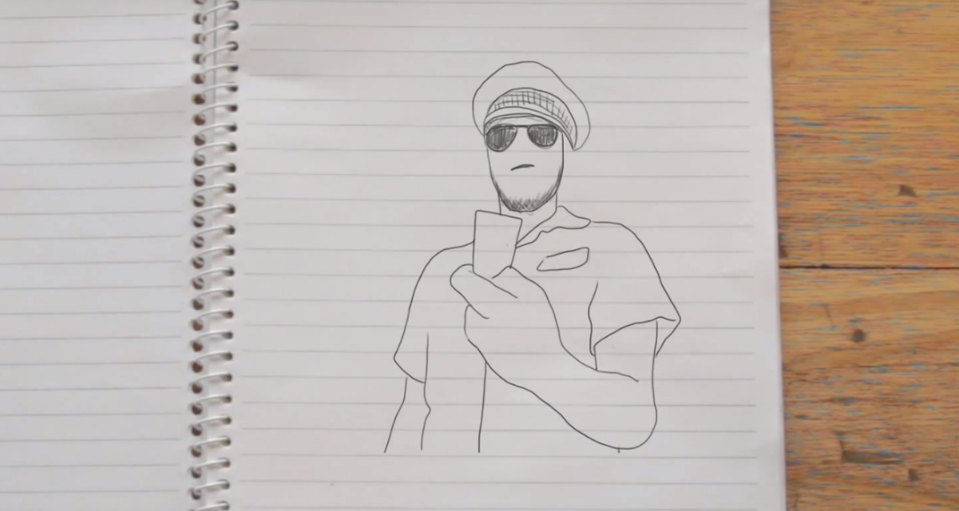
It was a morning so sunny, that you needed to not wear a sweater.
Jimmy and I were sitting there at the bus stop, eating our delicious chips. And I said to Jimmy, “Oooh, I could use some sensational salt, to go on my chips. It just explodes when you have that sensational salt.”
So he’s like, “Sure.”
And I’m like, “Do you see those cops over there?” Because it’s kind of a shady area, kind of not where two little school kids should be sitting alone without any supervision.
He’s like, “That’s right, I see ’em too. All right, let’s do it.”
And we did this awesome handshake that was so unmoist that our hands didn’t get sweaty for some reason. And he passed the salt to my hand.
These two officers get out of their car, officers Spence and Cheryl. They were holding hands when they came up to us, but they were just friends, nothing more than friends.
He comes up and says, “Son, I’m going to need your name and address.” And I said, “Daaad!” And he’s like, “Son, I got no time to play games.” And I said, “All right.”
So I gave him my address and I said, “Umm, oh it’s just salt, sensational salt.”
And he’s like, “Oh, well that’s, that’s really good ’cause for a moment I thought you were doing something very illegal. I feel a bit like an idiot, like.”
I’m like, “Don’t worry, we all get like that.”
And then they walked off, holding hands like they were friends. With… benefits.

Orders to move on and stay away

Session plan

Learning outcomes
At the end of the session, the group should have increased knowledge of:
- when police can order you to move on and stay away from a public place
- consequences if you do not follow an order to move on and stay away
- how to get free information and legal advice about police powers and your rights.

You will need:
- an internet connection and a way to show the video
- The magician (orders to move on and stay away) video on the Street law education kit webpage (www.legalaid.vic.gov.au/street-law-education-kit)
- copies of Legal information: orders to move on and stay away (pages 19–20) for each participant. For more in-depth information on this topic, go to our speaking to the police webpage (www.legalaid.vic.gov.au/speaking-police)
- role-play cards from Activity: on the steps role-play cards cut out (page 21). You may need to duplicate the cards depending on the number of people in the group
- What do these words mean? (page 6) for your reference
- More information and where to get help (page 36) or order the Street law wallet card (www.legalaid.vic.gov.au/street-law-wallet-card).

Time allocation
The session will go for approximately 40 minutes.
If you have less time, you can shorten the session by only completing the video and discussion stages.

Before you begin: personal disclosures
Ask participants not to discuss personal details and situations in this session. It is important to create an open and safe environment where people feel free to ask questions. However, personal disclosures should be left for private discussion. Encourage participants to ask, ‘What if this happens?’ instead of saying, ‘This happened.’

Video: The magician
Watch The magician video from start to finish. A transcript is on page 22 if you have trouble with sound or technology.

Discussion
Hand out and read Legal information: orders to move on and stay away handout (pages 19–20).
Check if there are any words people in the group do not understand. Use What do these words mean? on page 6.
Divide the group into your preferred size (whole class, small groups or pairs).
Ask the groups to discuss the following questions and to report back when finished.
- Why do you think the police officer ordered the magician to move on? The police officer may have ordered the magician to move on because he thought the magician was:
- disrupting or likely to disrupt the peace
- behaving in a way that may be dangerous to public safety
- likely to cause injury or damage to property.
- Why did the magician end up getting a fine? The magician got a fine because he came back to the area. The police ordered him to move on and stay away so it was illegal for the magician to go back to that area straight away.
- Do you think it was fair that the police officer ordered the magician to move on? Why or why not? There are no right or wrong answers to this question. You can prompt discussion with questions like:
- Was the magician a danger to anyone or was there a risk he might damage property?
- Was the magician getting in the way of other people or traffic?
- Do you think the magician was disrupting the peace?
- Which services could the magician contact for more information about the law or free legal advice? The magician could contact Victoria Legal Aid, a local community legal centre or the Victorian Aboriginal Legal Service if he identifies as Aboriginal and/or Torres Strait Islander. The magician could also contact Youthlaw, a free legal service for young people under 25. Go to More information and where to get help on page 36 for these services’ contact details.

Activity: on the steps role-play
Divide the group into pairs or small groups.
Hand out an activity card from: Activity: on the steps role-play cards on page 21 to each pair or small group.
Ask each group to imagine they are police officers patrolling a train station. They come across different people on the steps of the station, as described in their activity card.
Allow each pair or small group 5–10 minutes to discuss the situations on their cards and reach a decision together on what their answer is to the following question:
Do you think police have the power to order a person or group of people to move on in the situation described on your card?

Activity answers: group discussion
Get the whole group back together. Ask each small group to report back on whether they agreed that police had the move on powers in the situation described in their card. Ask them to explain why they did or did not issue a move on notice. If they were not sure, ask the rest of the group to discuss the situation and share their views.
Card 1: A group of high school students listening to really loud music with speakers attached to their phones. Police could order the group to move on if they believe the group are disrupting the peace.
To prompt further discussion, ask:
- Is listening to music enough to ‘disrupt the peace’?
- What else might change their answer to this question? For example, would it depend on the volume or type of music?
- Do you think different people might have different ideas on what is ‘disrupting the peace’?
- How do you balance young people’s rights to use public space with the needs of other people in the area?
- What limits should there be on young people’s behaviour in public spaces? What do you think is fair?
Card 2: Two guys who keep play-fighting and nearly hit other people by accident. Police could order the two guys to move on if they believe the group are disrupting the peace, being dangerous to public safety or they are likely to cause injury to someone else or damage property.
To prompt further discussion, ask:
- Is play-fighting like that a risk to public safety?
- Were they likely to cause injury to someone?
- Were they likely to damage property?
- Were they ‘disrupting the peace’ or ‘likely to disrupt the peace’?
Card 3: A man who is acting strangely and staring at people passing by. Just making people feel uncomfortable is not enough reason for police to order this man to move on. Police can only order the man to move on if he is disrupting the peace, behaving in a way that might be dangerous to public safety or is likely to cause injury to someone else or damage property.
To prompt further discussion, ask the group to consider if there are other things the man could do that would give police a reason to order him to move on. For example, what if he started shouting or threatening people?
Card 4: A group of breakdancers who are practising right out the front of the ticket gates. Police could order the breakdancers to move on if the police believe the breakdancers are disrupting the peace, behaving in a way that might be dangerous to public safety or is likely to cause injury to someone else or damage property. If they are very close to the ticket gates, there may be a risk to public safety so police could order the group to move on.
To prompt further discussion, ask:
- If the group weren’t a danger to safety, were they ‘disrupting the peace’ or likely to ‘disrupt the peace’?
- Do you think different people might have different ideas on what ‘disrupting the peace’ means?
- How do you balance young people’s rights to use public space with the needs of other people in the area?
- What limits should there be on young people’s behaviour in public spaces? What do you think is fair?

Legal information: orders to move on and stay away
Police can ask you to move on and stay away from public places and from in or around police stations.

Public places

When can police make me leave a public place?
Police can order you to move on (leave) a public place if they think you are:
- disrupting the peace
- behaving in a way that may be dangerous to public safety
- likely to cause injury to someone or damage property.
You will usually have to stay away from the area for a certain amount of time. This can be up to 24 hours.

What happens if I don’t leave?
If you don’t move on or stay away from a public place, the police can give you a fine.
If you have to go to court, the court can give you a bigger fine.

What is a public place?
A public place means that anyone is allowed to be there. Public places include:
- bars and clubs
- beaches
- places of worship
- movie theatres and other places for entertainment
- parks, sports ovals and gardens
- public schools
- roads, bridges and footpaths
- train stations and on public transport.

Can police ask me to leave and stay away from a police station?
Police can ask you to leave and stay away, but only if they think two things:
- you don’t have a legitimate reason to be there
- this is necessary to preserve the peace or maintain the security of the police station.
Legitimate reasons include:
- asking the police for help
- reporting a crime
- giving information to the police
- being required to be at a police station. For example, it is part of your bail conditions.
Police can ask you to stay away for up to seven days.
Police can arrest you or give you a fine if you do not leave or stay away when they ask you. They can also arrest you or give you a fine if you try to stop them asking you or someone else to leave or stay away.

Where can I get help?
You can get information or free legal advice from:
- Victoria Legal Aid
- Youthlaw, a free legal service for people under 25
- Victorian Aboriginal Legal Service if you identify as Aboriginal and/or Torres Strait Islander
- your local community legal centre.
Ask your facilitator for these services’ contact details.

Activity: on the steps role-play cards
A group of high school students are listening to really loud music with speakers attached to their phones. | Two guys are play-fighting and nearly hit other people by accident.
A man is acting strangely and staring at people passing by. | A group of breakdancers are dancing right in front of the ticket gates.

Transcript: The magician
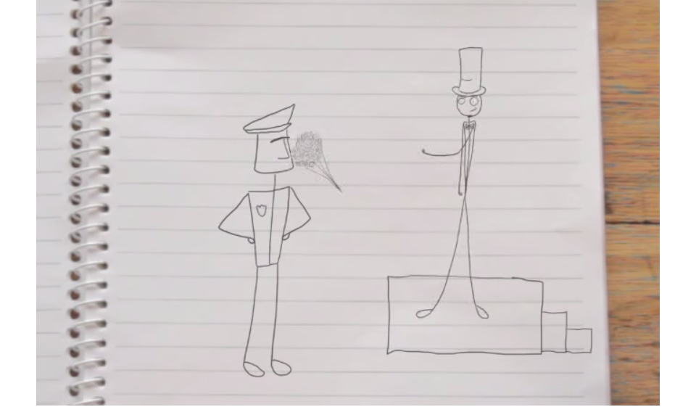
My name’s Daniel and I am a magician.
So I was trying out some tricks the other day on the street and a police officer asks me to move on. Yeah, he said I was disturbing the peace. I guess I took it a bit personally.
I have a bit of a reputation to uphold so I had to get back to my stage, to my audience. So I threw a smoke bomb and shazam! I was back there.
So in the end I got a fine but, er, it was a great show.

Weapons searches

Session plan

Learning outcomes
At the end of the session, the group should have increased knowledge of:
- when police can search you for weapons in a public place
- when it is illegal to carry weapons or dangerous articles in public
- consequences if you resist a police search or if you are found with an illegal weapon or a dangerous article
- your rights if you are searched by police
- how to get free information and legal advice about police powers and your rights.

You will need:
- an internet connection and a way to show the video
- Biker baker (weapons searches) video on the Street law education kit webpage (www.legalaid.vic.gov.au/street-law-education-kit)
- copies of Legal information: weapons searches on page 27 for each participant. For more in-depth information on this topic, go to our guns and other weapons webpage (www.legalaid.vic.gov.au/guns-and-other-weapons)
- activity cards from Activity cards: at the shopping centre role-play on page 28 cut up. You may need to duplicate the cards depending on the number of people in the group
- What do these words mean? (page 6) for your reference
- More information and where to get help (page 36) or order the Street law wallet card (www.legalaid.vic.gov.au/street-law-wallet-card).

Time allocation
The session will go for approximately 40 minutes.
If you have less time, you can shorten the session by only completing the video and discussion stages.

Before you begin: personal disclosures
Ask participants not to discuss personal details and situations in this session. It is important to create an open and safe environment where people feel free to ask questions. However, personal disclosures should be left for private discussion. Encourage participants to ask, ‘What if this happens?’ instead of saying, ‘This happened.’

Video: Biker baker
Watch the Biker baker video from start to finish. A transcript is on page 29 if you have trouble with sound or technology.

Discussion
Hand out and read the Legal information: weapons searches handout (page 27).
Check if there are any words people in the group do not understand. Use What do these words mean? on page 6.
Ask the group to discuss the following questions and to report back when finished.
- Did the police officer need a reason to search the biker baker for weapons? Yes. The police officer did not show the biker baker a warrant or a special notice to say he was in a ‘designated area’ for weapons searches. So we can assume that the police officer needed a reason to suspect the biker baker was carrying a weapon in order to search him.
- What do you think the police officer’s reasons for searching the biker baker might have been? Do you think those reasons were fair and legal? We do not know what the police officer’s reasons were but if he searched the biker baker just because of how he looks or what he is wearing, that is not a fair or lawful reason to stop and search him. The biker baker may, however, be in an area where there is lots of violent crime. This can be a lawful reason for police to stop and search him.
- What would happen if the biker baker resisted the search? It is an offence to resist or refuse a lawful search by police. The biker baker could be charged if he resisted a lawful search.
- Why did the biker baker get a fine? The biker baker got a fine because he was carrying a kitchen knife in a public place and the police officer did not believe he had a lawful excuse.
- Do you think the biker baker had a lawful excuse for carrying the weapon? Yes. He was carrying the knife because he was going on a picnic. Having the knife for recreational purposes is a lawful excuse.
- Where could the biker baker go for more information or legal advice about how he should deal with the fine? The biker baker could get more information or free legal advice from Victoria Legal Aid or a local community legal centre. He could also contact Youthlaw, if he is under 25 or the Victorian Aboriginal Legal Service if he identifies as Aboriginal and/or Torres Strait Islander. Go to More information and where to get help on page 36 for more details.

Activity: at the shopping centre role-play
Hand out a card from Activity cards: at the shopping centre role-play on page 28 to each person.
Divide the group into pairs or small groups.
Ask each group to imagine they are standing in the carpark of their local shopping centre. They are carrying the item on their card either in their bag or in their pocket.
Explain to each group that they are just about to be approached by a police officer. They are not in a ‘designated area’. But the police officer wants to stop and search them because there have been a lot of violent incidents involving weapons in the area lately.
Direct each small group to show each other their card. Allow each group 5–10 minutes to discuss the items described on their cards and reach a consensus on the questions below. The table below has information about each scenario.

Activity answers: group discussion
Get the whole group back together to report back. If anyone is unsure of their answers, ask the rest of the group to share their answers if they had the same items or to share their views.
- Would you break the law by carrying the item for the reasons described on the card?
Activity card description | Model answer
Box cutter knife (also known as a Stanley knife) | No. It can be illegal to carry a Stanley knife or a box cutter knife around in public without a lawful excuse. If you need to carry one for work, then you have a lawful excuse. However, it can be a good idea to avoid carrying these items in public. You can avoid hassles with the police if you are searched. If you have to carry a knife like this for work, it is a good idea to get a letter from your employer. Keep it with you to prove you need it for your work.
Fishing knife | No. It can be illegal to carry a fishing knife around in public without a lawful excuse. If you need to carry one that day for a recreational reason, such as fishing, then you have a lawful excuse. However, it can be a good idea to avoid carrying these items in public. You can avoid hassles with police if you are searched.
Fake gun | Yes. It is illegal to carry an imitation firearm around in public.
Pocketknife | Yes. It is illegal to carry a pocketknife around in public without a lawful excuse. Self-defence is not a lawful excuse.
Swiss army knife | No. It can be illegal to carry a Swiss army knife around in public without a lawful excuse. If you need to carry one that day for a recreational reason, such as camping, then you have a lawful excuse. However, it can be a good idea to avoid carrying these items in public. You can avoid hassles with police if you are searched.
Baseball bat | Yes. A baseball bat is not usually a weapon but it is illegal to carry any object around in public if you are going to use it as a weapon. Carrying the bat for self-defence is not a lawful excuse.

- Can the police officer search you for weapons in this situation? For all cards: Yes. Police can search a person for weapons in a public place if the police officer has a reason to believe they are carrying a weapon. Being in an area where there has been a lot of violent crime lately can be enough of a reason for a police officer to search a person for weapons. If there have been a lot of violent incidents involving weapons at or near the shopping centre lately then that can be enough reason for police to search you without a warrant just for being in the area.
- What do you have the right to ask police if they search you? For all cards: Anybody who is searched by police for weapons in these situations has the right to ask police why they want to search them and to give them a written record of the search.

Legal information: weapon searches
There are laws about owning and carrying weapons.

Guns
You can't own or buy a gun until you turn 18. If you have a gun, you must register it and have a licence. Some people will not be allowed to have a gun. For example, if they have committed certain crimes or there is an intervention order against them for violence. The same law applies to fake (imitation) guns.

Knives
Knives include kitchen knives, Swiss army knives, Stanley knives (box cutters), batons, cattle prods and bayonets. If you want to carry a knife, you must have a lawful excuse. You have a lawful excuse if you need a knife for work, sport, recreation or a weapons collection. Self-defence is not a lawful excuse. You must store weapons safely if you are carrying them.

Dangerous articles
A dangerous article is an object that can be used as a weapon. This can be an axe, a cricket bat, a baseball bat or a hammer.
You can't carry a dangerous article in the street unless you have a lawful excuse. You can't change a dangerous article to make it a weapon unless you have a lawful excuse. You have a lawful excuse if you need the dangerous article for work, sport, recreation or a weapons collection. Self-defence is not a lawful excuse.

Can police search me for weapons?
Police can search you if they reasonably think you have a weapon illegally. They do not need a warrant. Police can also search your car and your bag. Being in an area where there is a lot of violent crime is enough for police to search you without a warrant.
Police can also search you in a 'designated area' for weapons searches. Police can make any area a designated area, and usually tell people about it. In a designated area, police do not need a reason to search you, but they have to show you a search notice first.

What makes a designated area?
To make a designated area police must think an incident with a weapon is about to happen and one of two things:
- two or more violent incidents with weapons happened there in the last 12 months
- an event is going to happen and there were violent incidents with weapons at the event in the past. A designated area can still be declared even if the event was held somewhere else in the past.

What happens if I don’t let police search me?
If the police have the right to search you, you must let them do their job. If you refuse to be searched, police can charge you.

Where can I get help?
You can get information or free legal advice from Victoria Legal Aid, Youthlaw, a free legal service for people under 25, Victorian Aboriginal Legal Service if you identify as Aboriginal and/or Torres Strait Islander or your local community legal centre. Ask your facilitator for these services’ contact details.

Activity: at the shopping centre role-play cards
You have a Stanley knife (also known as a box cutter).  You need it to open boxes at work. You are on your way to work right now. | You have a fishing knife.  You are on your way to the beach right now to go fishing.
You have a fake gun that looks just like a real gun.  You don’t have a licence for it. You just carry it around for fun. | You have a pocketknife.  You carry it for self-defence. You never know when you might need it.
You have a Swiss army knife.  You need it for a camping trip and you’re waiting for a friend to pick you up and drive you to the camp site right now. | You have a baseball bat.  You don’t play baseball but you carry it around for self-defence because you’re scared of people around here.

Transcript: Biker baker
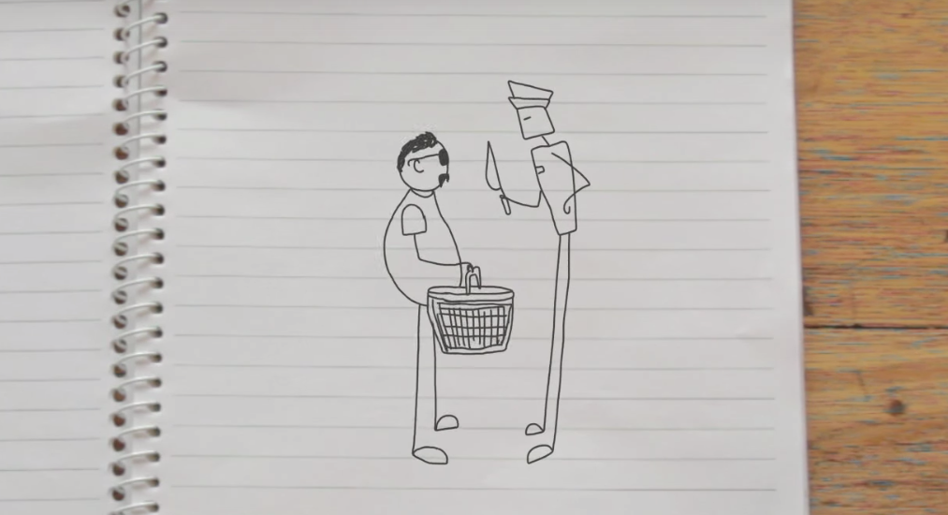
People think I am a pretty tough guy. And I am. But it’s just that I really like baking. It’s just something that I really like doing. And I’m really good at it. I like to cook in my own style though, you know?
So it was my girlfriend’s birthday the other day, and I baked her this giant, amazing birthday cupcake. All pink with icing and everything.
I told her to meet me at the park for a picnic. My plan was to bring a rug and some wine, and make it all nice and surprise her with the cake.
So I packed the cake, and all the picnic stuff in the basket, and I was walking down the street. But then this cop stops me, giving me all this attitude, he said he wanted to search the basket so I let him.
And then he pulled out a cake knife and said it was a controlled weapon. I explained it was just to cut the cake. But he kind of laughed at me and didn’t believe it. And he ended up giving me a fine.
So I finally got to the park and found my girlfriend. Gave her the cake and she was stoked. But we had to cut it with a spoon.

Searches on public transport

Session plan

Learning outcomes
At the end of the session, the group should have increased knowledge of:
- protective services officers (PSOs) and their powers
- when it is illegal to carry spray paint cans or other graffiti tools around train stations
- when PSOs can search you for illegal graffiti tools around train stations
- consequences if you resist a search or if you are found carrying graffiti tools illegally
- your rights if you are searched by PSOs for graffiti tools
- how to get free information and legal advice about PSO powers and your rights.

You will need:
- an internet connection and a way to show the video
- The artist (searches on public transport) video on our Street law education kit webpage (www.legalaid.vic.gov.au/street-law-education-kit)
- copies of Legal information: protective services officers for each participant (pages 33–34). For more in-depth information on this topic, go to our public transport offences webpage (www.legalaid.vic.gov.au/public-transport-offences)
- What do these words mean? (page 6) for your reference
- More information and where to get help (page 36) or order the Street law wallet card (www.legalaid.vic.gov.au/street-law-wallet-card).

Time allocation
The session will go for approximately 40 minutes.
If you have less time, you can shorten the session by only completing the video and discussion stages.

Before you begin: personal disclosures
Ask participants not to discuss personal details and situations in this session. It is important to create an open and safe environment where people feel free to ask questions. However, personal disclosures should be left for private discussion. Encourage participants to ask, ‘What if this happens?’ instead of saying, ‘This happened.’

Video: The artist
Watch The artist video from start to finish. A transcript is on page 35 if you have trouble with sound or technology.

Discussion
Hand out and read the Legal information: protective services officers handout on pages 33-34.
Check if there are any words people do not understand. Use What do these words mean? on page 6.
Discuss the following questions as a group or break the group into pairs or small groups and report back when finished.
- Did the PSO have the power to search that person for graffiti tools? Why or why not? Yes, as long as she was 14 or over. The PSO had the power to search her for spray paint cans for these two reasons:
- she is in a ‘designated place’ (a train station)
- the PSO had a reason to believe she was carrying a spray paint can because she had paint on her hands. Being in an area with lots of graffiti around can be enough reason for a PSO to believe a person is carrying a spray paint can.
- What would have happened to her if she resisted the search? It is an offence to resist a lawful search by a PSO. She would have been charged if she refused or resisted the search.
- Why did she get a fine? She got a fine because it is illegal to carry a spray paint can at a train station or near a train station. She is breaking the law unless she can prove she needed to carry it for her job. Carrying it just to make art for fun or even for a volunteer community project is not a lawful excuse.
- Would it make any difference if she was not going to use the spray paint can for illegal graffiti? No. It is still illegal to carry a spray paint can at or near a train station without a lawful excuse, even if you have no intention of using it for illegal graffiti.
- Which services could she contact for more information about the law or free legal advice? She could get more information or free legal advice from Victoria Legal Aid or a local community legal centre. She could also contact Youthlaw, if she is under 25 or the Victorian Aboriginal Legal Service if she identifies as Aboriginal and/or Torres Strait Islander. Go to More information and where to get help on page 36 for these services’ contact details.

Activity: how to stop graffiti crime debate
Divide the group in half to create two teams and name one ‘For’, the other ‘Against’.
Ask the group to consider the following statement:
Getting PSOs to search and fine more young people for carrying spray cans on public transport is the best way to reduce graffiti crime.
Direct each team to work together and brainstorm arguments to support their position for or against.
Ask each team to nominate one person as a scribe to make a list of the group’s arguments on a piece of large paper.
Ask each group to research information or commentary about graffiti crime and about PSOs, for example, by searching online. Suggest that teams collect media articles, statistics or ideas to support their position either for or against.
Allow each team 10–15 minutes to discuss and brainstorm their points for or against.

Activity answers
There are no right or wrong answers but you can help each team come up with arguments for or against by asking them questions like:
- Are people less likely to graffiti if they can’t carry a spray paint can around at places like train stations?
- Are searches and fines likely to stop young people who do illegal graffiti?
- Is it fair to charge or fine people for carrying a spray can if they weren’t planning on doing anything illegal with the spray paint can?
- Should graffiti be a crime at all or should some graffiti be legal and not others?
- Has the introduction of PSOs at train stations decreased the amount of graffiti crime?
- Should PSOs have powers to search people for spray paint cans?
- Are there other ways of reducing graffiti crime?
Get the whole group back together and ask a volunteer from each team to outline their arguments for or against. If the teams collected any articles or statistics, ask them to report those back to the group.
Award the team with the strongest arguments the winners of the debate.

Legal information: protective services officers

Who are PSOs?
Protective services officers (PSOs) have weapons and wear uniforms like the police. They look like police, and have powers like the police, but they can only use those powers in and around certain areas. For example, designated places and police stations.
Designated places include: railway stations, bus stops, and places next to railway stations like taxi ranks, carparks and paths.

Can a PSO search me?
A PSO can search you and your car for spray paint, markers and other graffiti tools if you are 14 years old or older or look over 14, and they reasonably think you are carrying those items. Being at a train station with lots of graffiti may be enough of a reason. Carry ID if you are under 14.
PSOs can also search you for drugs or weapons if they reasonably suspect you have them.
PSOs can only carry out these searches in designated places.

What if I don’t let a PSO search me?
You may be charged with a crime if a PSO has the right to search you and you don’t let them.

Do I have to give PSOs my name and address?
If you are at or near a train station, PSOs can ask for your name and address. You must give them your name and address if they:
- think you have committed a crime
- think you are about to commit a crime
- reasonably believe you’re under 18 and are drinking or about to drink alcohol
- think you’ve witnessed a crime.

If you are in or near a police station
If you are in or near a police station, PSOs can ask you why you are there. They can then ask you your name and address if they do not think you have a legitimate reason for being there. A legitimate reason includes reporting a crime.
PSOs can also ask you to leave and stay away from around or near a police station. They can only do this if they do not think you have a legitimate reason to be there and that you are disturbing the peace or security of the station. PSOs can also fine or arrest you if you do not leave, or answer questions about why you are there.

What else can PSOs do?
PSOs can:
- arrest you if they think you broke the law
- take alcohol from you if you’re under 18
- fine you if you’re over 18 and gave alcohol to a young person
- take you to a safe place if you’re under 18 and they believe you’ve been chroming (inhaling fumes from spray can) and might harm yourself
- tell you to move on if you’re disrupting the peace, making other people unsafe or may damage property
- stop a person who appears to have a mental health condition and is believed to have recently tried to seriously hurt themselves or someone else (or is likely to do so)
- ask you to leave from a police station and stay away for up to seven days if they do not think you have a legitimate reason for being there.

Where can I get help?
You can get information or free legal advice from:
- Victoria Legal Aid
- Youthlaw, a free legal service for people under 25
- Victorian Aboriginal Legal Service if you identify as Aboriginal and/or Torres Strait Islander
- your local community legal centre
Ask your facilitator for the contact details of these services.

Transcript: The artist
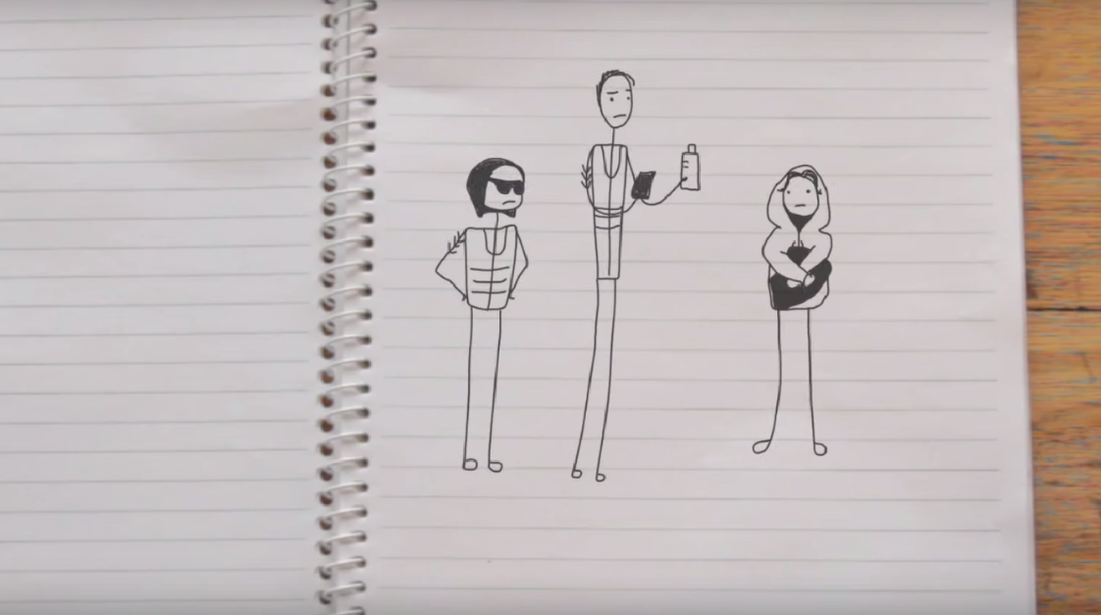
I was at a train station the other day just waiting for my train, and then one of those protective services officers came up to me, you know the ones, they kind of look like police but they’re not.
Well, he came up to me and he was like, “What’s that paint on your hands? I’m going to need to search your backpack.”
And then I was like, “Aren’t you just a ticket inspector? You can check my ticket but forget about the bag, mate.”
This PSO, he must have been a trainee or something ’cause this transit cop was standing behind him and he was all quoting the book like, “You are on railway premises and I have the power to search you under the Graffiti Prevention Act.”
And I said, “Search me for what?” And he said, “For this.”
And I was like, “Well oh that. I need that for my work.” And he was like, “Oh really, you need that for your work? What kind of work do you do then?” And I said, “Well, mostly giant tags, but some murals, like that one.”
So I got fined for carrying a spray can on public transport property. Of all the things to get done for I get done for that.

More information and where to get help

Legal information and advice

Victoria Legal Aid
For free information about the law and how we can help you:
- visit Victoria Legal Aid’s website (www.legalaid.vic.gov.au) to use our Legal Help Chat or for information on many legal topics
- call Legal Help on 1300 792 387, 8 am to 6 pm, Monday to Friday excluding public holidays.

Do you need help phoning us?

Translating and Interpreting Service
Phone: 131 450
www.tisnational.gov.au

National Relay Service
TTY: phone 133 677
Speak and Listen: phone 1300 555 727
Internet Relay users: visit the National Relay Service
(https://nrschat.nrscall.gov.au/nrs/internetrelay)
SMS relay: text 0423 677 767
Video Relay: use Skype or the National Relay Service app

Local community legal centre
Community legal centres give free legal advice. Use the Federation of Community Legal Centres’ website to find your nearest community legal centre.
Visit the Federation of Community Legal Centres’ website (www.fclc.org.au)

Victorian Aboriginal Legal Service
A free legal service for Aboriginal and/or Torres Strait Islander people in Victoria.
Phone: 1800 064 865
Visit the Victorian Aboriginal Legal Service’s website (www.vals.org.au)

Youthlaw
A free, youth-friendly legal service for young people under 25 in Victoria. They can provide legal advice by phone, email or Skype. They also have a drop-in clinic at Frontyard Youth Services in Melbourne.
Phone: (03) 9113 9500
Visit Youthlaw’s website (www.youthlaw.asn.au)

Youth Referral and Independent Person’s Program (YRIPP)
Contact YRIPP to speak to a lawyer or organise an independent person to be with you in custody. Available 24 hours a day, seven days a week.
Phone: 1300 791 189

Additional resources

Online resources

StreetSmart
An online guide produced by Youthlaw about young people’s rights in Victoria when dealing with authorities on public transport and on the street.
Go to the StreetSmart website (www.streetsmartvic.com.au)

Youthlaw
Youthlaw has online fact sheets for young people on a number of different legal issues.
Go to Youthlaw’s fact sheets (www.youthlaw.asn.au/learn-about-the-law/)

Youth Law Australia
The National Children’s and Youth Law Centre’s legal information and email advice service for children and young people.
Go to Youth Law Australia’s website (www.yla.org.au)

Publications
You can order the following publications by visiting Publications on Victoria Legal Aid’s website (www.legalaid.vic.gov.au/publications).

Am I old enough? Common legal issues for young people
A booklet for young people about what you can and cannot do because of your age.
Go to Am I old enough? Common legal issues for young people (www.legalaid.vic.gov.au/am-i-old-enough-common-legal-issues-young-people)

Legal help card
A wallet-sized brochure about our services, available in English and other languages.
Go to Victoria Legal Aid help card (English) (www.legalaid.vic.gov.au/victoria-legal-aid-help-card-english)

Police powers: your rights in Victoria
A general guide to help you when you deal with the police. It includes information for young people.
Go to Police powers: your rights in Victoria (www.legalaid.vic.gov.au/police-powers-your-rights-victoria)

Street law wallet card
A wallet-sized card made for this kit.
Go to Street law wallet card (www.legalaid.vic.gov.au/street-law-wallet-card)

