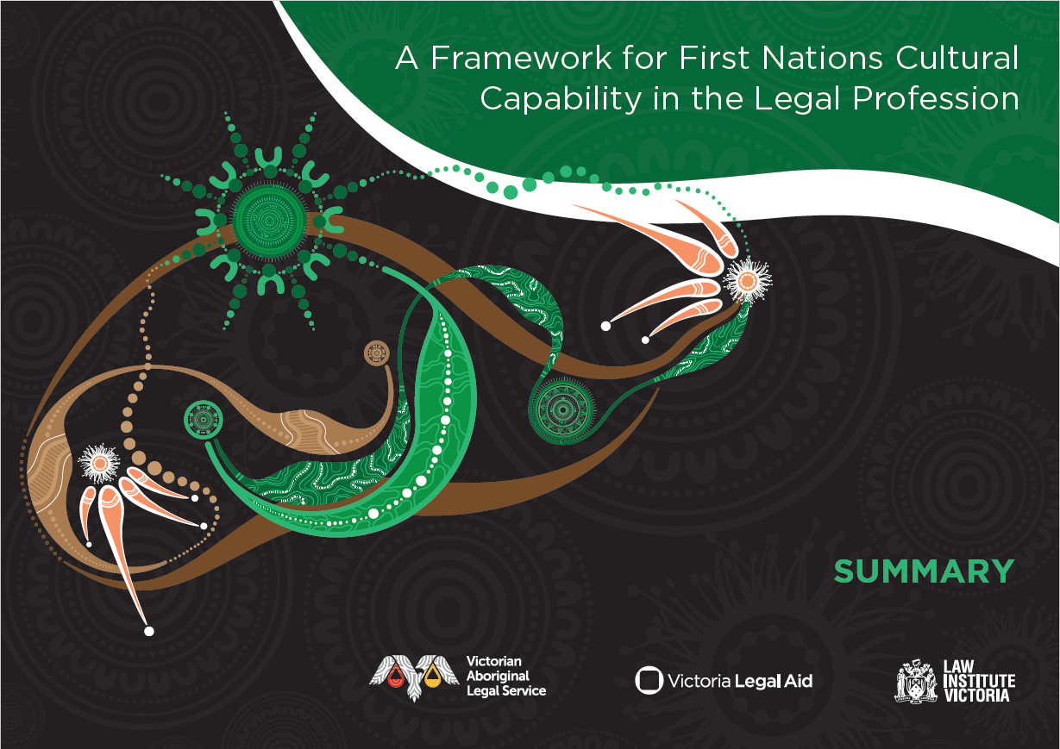

Summary
The First Nations Cultural Capability Framework is an Australia-first, First Nations-led initiative to improve the experiences of First Nations peoples seeking legal support and assistance in Victoria and for strengthening the likelihood of better justice outcomes.
Developed through a partnership between VALS, LIV and VLA, the Framework identifies the knowledge, skills and attitudes needed by individual practitioners to perform their duties in a culturally responsive and appropriate way.
It is well established that First Nations peoples in Victoria frequently experience inadequate interactions with legal practitioners, organisations and the justice system, often translating to poorer outcomes. The stark overrepresentation of First Nations peoples being incarcerated continues to grow, as does the number of First Nations children in out of home care. The need for this Framework was made stark by the tragic and preventable death of Aboriginal woman, Veronica Marie Nelson, with the subsequent Coronial Inquest recommending that cultural awareness training be made mandatory.
This Framework is just one part of a larger call to action for the legal profession to elevate cultural capability as best practice legal support.
[Text appearing within four circles:]
The Framework is directed at the Victorian legal profession in its entirety.
Practitioners can use the Framework to identify how they can grow their cultural capability.
A foundational pilot training based on the Framework is in development and will be piloted in 2025.
Implementation supports, compliance and advocacy measures will be needed to ensure change is sustained.

How the Framework is organised
This Framework is structured according to a set of capability domains and underpinning principles. The capability domains are unpacked in terms of requisite knowledge, attitudes and skills that are applicable for each. The underpinning principles provide the essential, conceptual grounding for understanding each of the capability domains. Given their interdependency, for most capability domains, many principles are applicable.

Capability domains
- Understand the history of First Nations peoples and the continuing impact of dispossession, oppression and intergenerational trauma on First Nations peoples and communities
- Understand the specific ways in which Australian law has been and continues to be central to colonisation, dispossession, and intergenerational trauma, and continues to adversely impact First Nations peoples
- Understand and reflect upon settler norms, ideas and practices
- Understand First Nations peoples’ world belief systems and ways of knowing, being and doing
- Understand intersectionality and its implications for practice
- Enable access and engagement
- Create a culturally safe, welcoming, and affirming service environment
- Understand and consider First Nations peoples’ non-legal needs
- Take a trauma-informed approach
- Uphold client rights in decision making
- Understand and apply specific laws, policies and programs relating
- to legal practice specialisations
- Establish meaningful relationships with First Nations practitioners
- and First Nations-led legal and other support services
- Contribute to the advancement

Underpinning principles
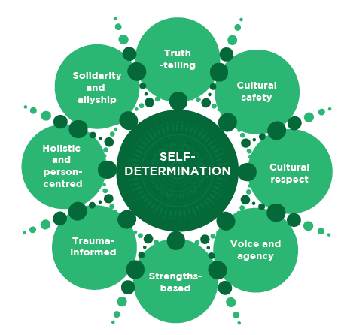

Acknowledgements
We, the partners of the First Nations Cultural Capability Uplift project, acknowledge the Aboriginal and Torres Strait Islander people as the First Peoples and Traditional Owners and custodians of the land, skies and waterways upon which our lives depend. We acknowledge and pay our respects to ancestors of this country, Elders, knowledge holders and leaders – past, present, and emerging. We recognise that First Nations peoples frequently experience inadequate interactions with legal practitioners, organisations, and the justice system, and that this lack of culturally appropriate and responsive advocacy and support often translates to poor outcomes. We acknowledge the ongoing leadership of Aboriginal communities and ACCOs in striving to improve justice outcomes and address these perpetual and ongoing inequalities.

Note on terminology
The term ‘First Nations people’ is used throughout this document to describe Aboriginal and Torres Strait Islander peoples. This is a collective term used in Australia to refer to the First Nations peoples of the continent and surrounding islands. It encompasses two distinct cultural groups: Aboriginal peoples and Torres Strait Islander peoples. It is acknowledged that while some people use this term to describe themselves, others prefer nation- or Country-specific identifiers such as Wiradjuri or Meriam Mir, or regional terms like Koori or Murri.

Note on artwork
The artwork for the First Nations Cultural Capability Uplift Project was designed by Reanna Bono (Wemba Wemba and Wiradjuri). In Reanna’s words, the artwork reflects the gum leaves used in a smoking ceremony and how those around are welcomed into the ceremony by the symbolic giving of a gum leaf. The leaves themselves all carry history and culture in their markings, while the smoke heals and cleanses. The gumnuts are representative of building the cultural capability of non-Indigenous practitioners, in that all essential elements needed to form a flower are cradled in the gumnut. After the practitioners have completed the cultural capability training, the skills, knowledge, behaviours and systems enable them to continue to work in a culturally responsive way and is instilled in them and will always remain, the same way a gumnut is left after the flower is gone.
© All artwork copyrights are reserved to artist, Reanna Bono (Wemba Wemba and Wiradjuri).

Victorian Aboriginal Legal Service 2025
For further information about this publication contact Nerita Waight, CEO, VALS.
ISBN 978-1-7640652-0-7

