Client-first strategy 2020–23
Improving how we listen to and assist people with legal needs
February 2020
© 2020 Victoria Legal Aid. Reproduction without express written permission is prohibited. Written requests should be directed to Victoria Legal Aid, Corporate Affairs, Level 9, 570 Bourke Street, Melbourne Vic 3000.
Disclaimer. The material in this publication is intended as a general guide only. The information contained should not be relied upon as legal advice, and should be checked carefully before being relied upon in any context. Victoria Legal Aid expressly disclaims any liability howsoever caused to any person in respect of any legal advice given or any action taken in reliance on the contents of the publication.

Acknowledgement of Country
Victoria Legal Aid acknowledges the Traditional Custodians of the land where we work and pays respect to their Elders both past and present. We recognise their continuing connection to country and the resilience and strength of Victoria’s Aboriginal communities.

Contents
Acknowledgement of Country i
Message from our leaders 1
Message from our client advisors 2
Understanding the need for client-first work 3
What does client-first or client-centric mean? 3
Why be client-first? 3
Our activities 4
What we know about people who use our services 4
What is important to people who use our services? 6
What are we doing already? 7
Our journey towards a client-first strategy 8
Our strategy – changing how we assist people 10
Vision 10
What this strategy applies to 10
Objectives 10
How we will change 11
Different ways clients can be involved 12
The strategic shifts needed to embrace client-first 14
How we will monitor and evaluate progress 15
Appendix – client-first terms 16

Message from our leaders
At Victoria Legal Aid (VLA), our purpose is to make a meaningful difference for clients and the community through effective legal services and collaborative leadership in a strong and dynamic legal assistance sector. To do this, we need to put people with legal needs at the centre of all our work and thinking. We need to understand and better meet their needs and preferences and work with them to make improvements to our services. The increasing demand for legal assistance in the diverse Victorian community makes this particularly important.
Our Client-first strategy will help us take strong steps towards improving client experience through many of our current service reforms, in our everyday activities and in our future planning. It builds on our existing work and supports a strong focus on understanding and responding to the needs of service users in many other government and community services.
We looked closely at what people told us they value and find difficult about engaging with and receiving legal services. We thought about the gaps in the way we work now, and how we can design our future work with a greater emphasis on client participation and leadership. As a result, we identified four objectives for our Client-first strategy:
- Create and nurture a client-first work culture
- Enable clients to participate in decisions that affect them
- Strengthen and better connect entry points to improve navigation and access
- Reimagine service models, including more holistic approaches and stronger partnerships.

How will we do this?
We will achieve these objectives in three ways:
- Involving client voices in our improvement projects in criminal law, family violence, online services and other areas we work in.
- Authorising leaders, managers and staff to do things differently to improve the experience of clients.
- Building our skills and confidence to listen to and involve people affected by our services and programs.
To achieve this, we will:
- change how we think about our work and what is important
- make use of new digital technology
- co-operate with other organisations
- support a work culture that values what is important to people who use our services and maintains the wellbeing of people working in legal assistance services.
We look forward to the opportunities and possibilities provided by our Client-first strategy to better listen to people who use or need our services, assist them to make their own decisions and use their feedback to design more impactful services.
Bill Jaboor, Chairperson, VLA Board and Louise Glanville, Chief Executive Officer, VLA

Message from our client advisors
In developing a strategy to improve how we help people with legal needs, it was important to involve people who have used legal services. Three client advisors contributed to the development of the Client-first strategy as members of our steering committee. This is what they had to say about the strategy:
‘The Client-first strategy is so important for organisations such as VLA as the legal process is so systematic that people who are not trained or experts within that system quite often feel lost or alienated and have no real decision-making capacity. A strategy that focuses on putting clients first brings the process much closer to engaging with and supporting the people whose lives are affected by decisions made during those processes.’
Sherie Thomas, Client Advisor, Client-first strategy Steering Committee
‘I believe the strategy builds on and enhances Strategy 22 and has listened to the voices of the lived experience clients/consumers like myself, who were consulted. For example, it incorporates concepts of co-design and aspirations for client advisory mechanisms that were advanced in the consultations and will form the basis of renewed client-centred practice for VLA.’
Chris MacBean, Client Advisor, Client-first strategy Steering Committee
‘The experience for those seeking legal assistance has always been a daunting one, but it is hoped that through the Client-first strategy, combined with Strategy 22, consumers/clients are able to navigate and be fully supported. The development of the Client-first strategy has been thorough, with a diverse range of input from past consumers, professionals and external input opportunities. I’m hoping the system takes note and looks very strongly on this model of client engagement and support through to professional development.’
Alfie Bamblett, Client Advisor, Client-first strategy Steering Committee

Understanding the need for client-first work
In this strategy we use a range of terms to refer to clients, including consumers, users and people with legal needs. For the purpose of this strategy, clients are people in Victoria who have a legal need. This recognises the broad scope of our objectives and the reach of our activities in:
- providing legal aid in the most effective, economic and efficient way
- ensuring co-ordination of legal aid, community legal information and education
- providing improved access to justice
- pursuing innovative means of providing legal aid.

What does client-first or client-centric mean?
In the context of our work, client-first or client-centric includes:
- recognising and valuing the diverse perspectives and experiences of people with legal needs
- listening to and involving people with legal needs in designing improved access to justice
- using different ways to gain insight into client experience and using this to design more impactful services
- addressing the way we organise or structure our services to improve the client experience as a whole.

Why be client-first?
We want to know more about our clients and respond to what is important to them. We will provide more ways for people with legal needs to tell us what is important to them. We will use their feedback to create new ways of providing legal assistance and other help that is linked with their legal needs so that our services:
- are easier to use and understand
- are reliable, dependable and predictable
- are designed to reflect what is important to people who need assistance
- provide people with ways to assist themselves and connect with other services and supports
- are more likely to produce better outcomes and experiences for people with legal needs.
Our Strategy 22 commits us to:
- assisting people to make their own decisions about how to resolve their legal issues
- meeting clients’ broader needs through triage, referrals and service delivery
- improving access to user-friendly services through innovative technologies, partnering and outreach
- ensuring clients feel safe, understood and respected when dealing with us.
The Client-first strategy will help us do these things.

Our activities
We serve the broader community by providing information, legal advice and education with a focus on the prevention and early resolution of legal problems. This includes community legal education and engagement.
We prioritise providing more intensive legal services, such as legal advice and representation, to those who need it the most, using evidence to inform what we do. We also recognise the connections between legal and social issues in the way we do our work.
We work to address the barriers that prevent people from accessing the justice system by being involved in system-wide reforms.

What we know about people who use our services
During 2018–19, 100,061 unique clients received legal advice and representation services provided by legal aid staff and private practitioners doing legal aid work. This is an increase of 6 per cent on the previous year. You can find out more about who we helped in this diagram on the following page.

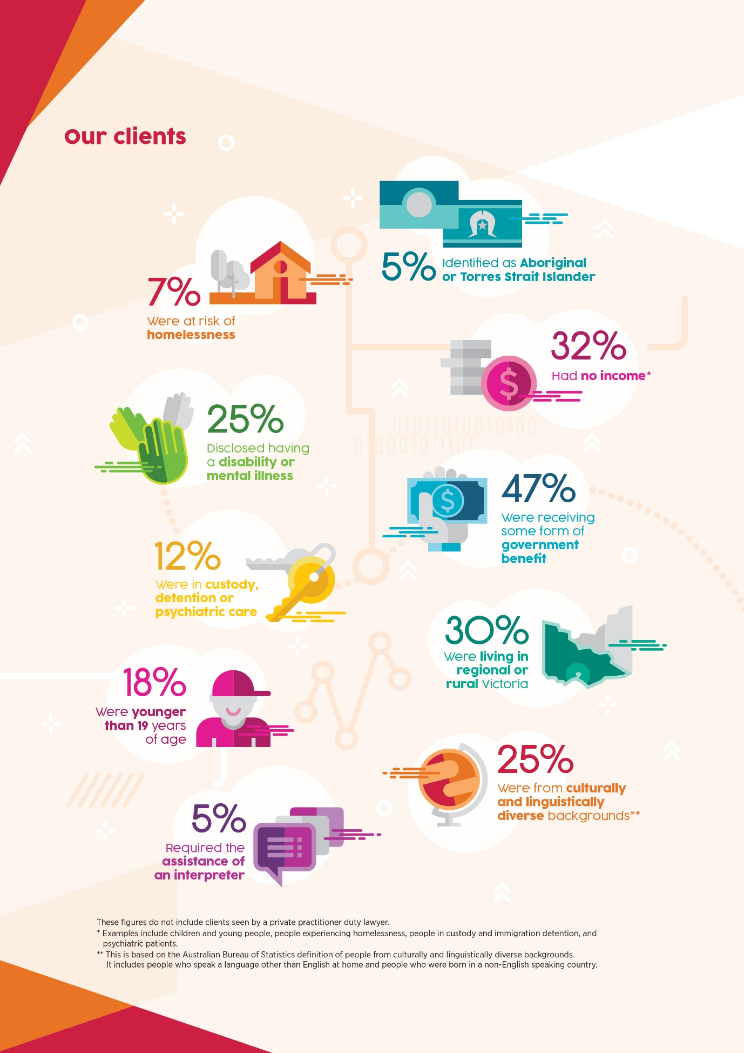

What is important to people who use our services?
Every two years since 2011, we have surveyed a large sample of people who have received legal aid services to measure their satisfaction with our intake and information, advice and casework services. This is known as our client satisfaction survey. While overall satisfaction levels are good, feedback from this survey and other consultations shows us that:
- many clients say the design and delivery of our services and products makes it difficult for them to find and get assistance
- clients do not always understand or feel involved in how we respond to their needs
- clients who received lower intensity services, such as one-off legal advice, were more likely to be dissatisfied than clients who received higher intensity services, such as representation in court
- many clients, who had received all types of services we offer, said that the extent or type of service provided did not meet their expectations.
‘Have the client's best interest at heart. Show that your client is not just a number.’
Client response from the Client Satisfaction Survey 2019
‘I called and I called and I called. The answer was always the same. He is too busy. He has other clients. He is in court. I couldn’t talk to anyone.’
Client response from the Client Satisfaction Survey 2019
‘I got to choose my own path forward, I felt involved in decision making.’
Client focus group 2019 participant
‘My lawyer got me help for my alcohol problem, this helped my case with the judge and I got the help I needed to break the cycle and not reoffend.’
Client focus group 2019 participant
‘Weren't clear with communication, too much legal jargon.’
Client focus group 2019 participant
Based on our interviews with people who have used our services and client satisfaction survey feedback, we identified four key areas where clients would like us to improve.
What clients want | This means
Support us to understand what to expect | - A clear explanation of who can help and how  - We get helpful, consistent and reliable assistance  - Information about the law and how it applies to our situation is easy to find and understand
Take the time to talk to us and use technology we already have access to | - Provide us with relevant information including while we are waiting for assistance and to help prepare for the next stage  - It is easy to find and get help, including by phone and online  - Talk to services we already know and are using, with our consent
Give us time to understand and be part of decisions on legal options | - Help that is quick and fit for purpose  - More time to understand the process and choices and shorter wait times to get assistance
Make your services accessible, culturally safe and sensitive to our needs | - Understand and respond to the impact of physical, psychological and social issues, for example, trauma, inequality, poverty, colonisation, health, disability and mental health needs  - Provide help that responds to us as people rather than looking at one legal issue or process to be resolved at a time

What are we doing already?
Our staff and practice partners address high-volume demand for legal assistance in criminal, family and civil law through a range of services. Some of VLA's programs have already embraced client-first ways of working, including through human-centred design, involving clients in advisory groups or providing ways for clients to give feedback.
Some examples of how VLA informs, engages and listens to people with legal needs are:
- explaining eligibility and providing legal information by phone, online live chat, email and through our website, or printed materials or face-to-face at courts, tribunals and regional centres
- conducting client satisfaction surveys for all legal aid services, and in more detail for some programs
- conducting research and undertaking client journey mapping to inform service design
- trialling new approaches to summary crime and family violence legal services
- the Speaking from Experience group that is made up of people with a lived experience of mental health issues, informs our Independent Mental Health Advocacy service. Their work includes co-designing self-help advocacy tools, training in mental health issues for staff and policy work, including contributing to submissions
- the Shared Experience and Support lived experience group, which advises our Independent Family Advocacy and Support service
- a young person’s advisory group that informed a review of our child protection services
- inviting people with a lived experience to present at training events for legal assistance staff
- including three client members on the Steering Committee overseeing the creation of this Client-first strategy.
There are also examples of community legal centres and our other service delivery partners involving people with legal needs and experiences in their work, including programs funded through the Victorian Legal Services Board and Commissioner grants program Designing Justice Differently: Using human-centred design and technology.
These initiatives and activities show that client-centred work is already being undertaken by VLA and its practice partners. This strategy will help us to incorporate client-first work into service design more consistently and will help us to keep improving our services and programs. In particular, the strategy guides our work to:
- address issues in the way our services have been designed; and
- raise awareness and increase use of client-first methods and approaches like client engagement and collaboration, human-centred design and service improvement methods.

Our journey towards a client-first strategy
Legal aid services including specialist Aboriginal legal services and community legal centres have, since the early 1970s, been focused on improving access to legal assistance for people who would otherwise not be able to afford or know how to find legal help. The legal profession and legal reformers led this work, alongside communities affected by social and economic inequality.
There has been a growing awareness of the need for more client feedback, engagement and participation in service design and delivery, led by non-legal advocacy, community education, human-centred design and lived experience initiatives.
Legal services must continue to change to better meet the needs and expectations of clients. This includes making legal information and assistance more accessible, timely and helpful and more importantly, recognising and responding to people as a whole rather than through the narrow lens of single legal challenges.
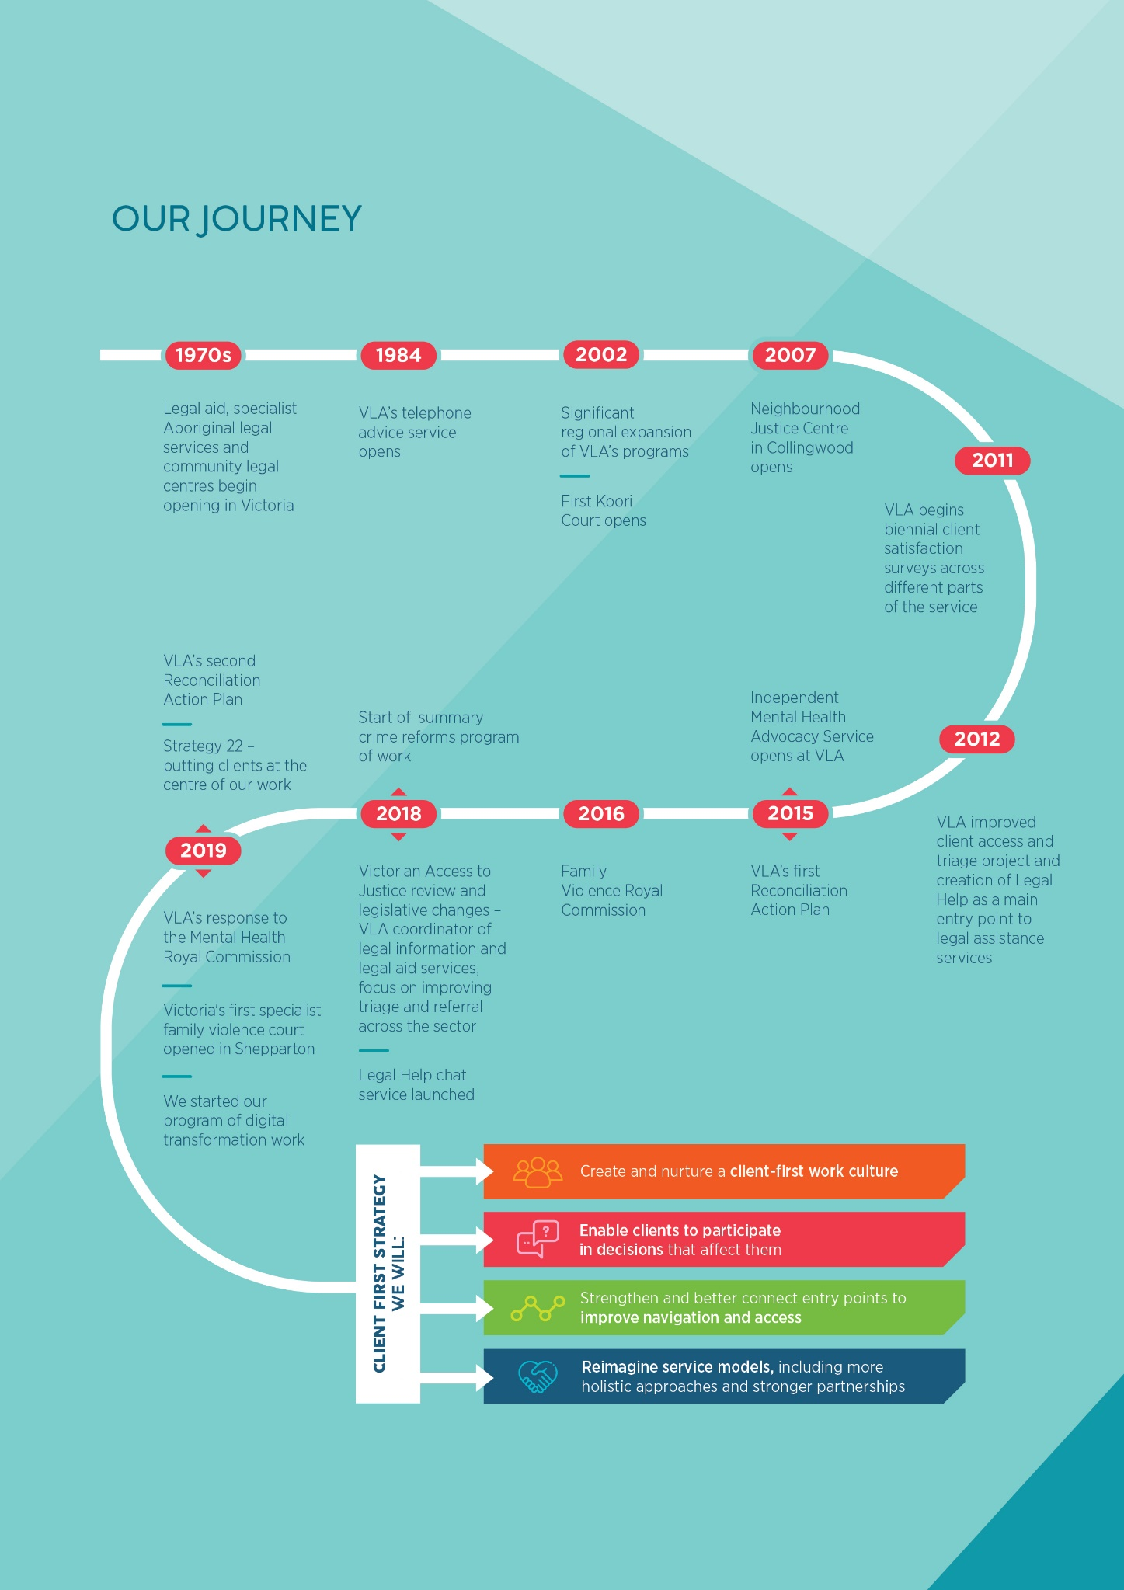

Our strategy – changing how we assist people

Vision
Our aim is for people in Victoria to get the legal and related assistance they need and have a say in how it’s provided.

What this strategy applies to
This strategy focuses on people with legal needs and our roles as service provider, co-ordinator, funding manager and advocate for improving access to justice. We commit to becoming more client-first in all our activities, including:
- prevention-based law reform, and strategic advocacy
- community legal education and engagement
- development and delivery of information and referral and self-advocacy support
- phone and pre-court legal advice ¥ ongoing legal casework
- advice and advocacy at courts and tribunals
- non-legal support and advocacy
- family dispute resolution, and
- therapeutic and health justice programs.

Objectives
We will:

1. Create and nurture a client-first work culture
We will build the skills and confidence of our workforce, including when working with our partners, to recognise and value the diverse views and experiences of people with legal needs, and to include these views and experiences in the way we design and deliver our services.

2. Enable clients to participate in decisions that affect them
We will improve information and support for people to better understand and participate in legal processes and decisions about them. We will also aim to involve more people with legal needs in decisions about service priorities and ways of working in the long term.

3. Strengthen and better connect entry points to improve navigation and access
We will keep improving our intake, information and referral processes and make eligibility and service options clearer. We will focus on providing high-quality and connected digital and real-time reception services at metropolitan and regional locations. We will collaborate with community legal centres, private practitioners and other justice and related services to improve intake and referral experiences for clients. This will include ensuring that Aboriginal and Torres Strait Islander people can choose to be referred to an Aboriginal and Torres Strait Islander community-controlled service.

4. Reimagine service models, including more holistic approaches and stronger partnerships
We will look for ways to recognise and better respond to people’s multiple legal and other needs. We will work with our staff, practice partners, external agencies such as the courts and police, and with health and community programs, to offer more connected and trauma-informed services.

How we will change
This strategy aims to support our staff and to collaborate with our practice partners to improve the way people find and experience legal assistance. We will focus our efforts on improving client participation and leadership in our current and future work. We will support a change in mindset and approach to improve client experience and engagement with legal assistance.
We will use and align existing projects to improve our services and systems, including:
- reforming summary crime services to better respond to clients’ needs including through the Better justice, every day project
- designing and delivering new specialist family violence services
- our digital transformation program, Digital Legal Aid, which will improve our intake processes and online services and information
- providing more meaningful ways for clients to give feedback
- creating more consistent and user-friendly processes, tools and approaches for intake, information, referral and communication with clients
- re-developing our website so people can better understand their legal needs, options and find relevant resources and services with ease
- improving the reliability, currency and accessibility of legal information products and resources in print, online and other formats
- continuing to implement our Reconciliation Action Plan.
We will authorise leaders, managers and staff to do things differently to improve client experience, including through:
- incorporating client-first approaches into new projects and initiatives
- creating opportunities for learning and developing our ability to quickly adapt to client feedback and make improvements
- including client first approaches in our management and leadership programs
- working with others to address some of the challenges to improving client experience including:
  - many services being focussed on responding to one legal issue at a time rather than addressing people's multiple legal needs
  - high demand for legal services and resource and funding limits
  - changing needs and circumstances of people with legal needs.
We will build our skills, tools and capacity to listen to and respond to clients, including by:
- involving people with experience of legal assistance services in the design of new processes and programs and building lessons learnt from client feedback and complaints into service improvement activities
- providing staff and stakeholders with opportunities to participate in client-first projects and access client-first training, support and tools
- include client-first skills and attitudes in recruitment, support and staff development
- where possible, creating more client advisory processes and roles
- supporting staff with ways they can involve client voices in design and delivery of services.
We will use a range of ways to engage people with legal needs in our future work. We recognise that building in best practice standards such as website accessibility guidelines and becoming a more culturally safe organisation are important foundations to improving client experience. We will also take opportunities to re-design services or programs and provide ways for clients or former clients to directly contribute to improvements.

Different ways clients can be involved
There are lots of ways to involve clients in designing and improving legal services. Below are some examples of the main types of activity adapted from the International Association for Public Participation (IAP2) public participation spectrum.

Informing
To provide people with balanced and objective information. For example:
- Media releases
- Social media posts
- Website materials
- Displays and stands at community events

Consulting
To obtain feedback from people affected by issues or services on analysis, alternatives and/or decisions. For example:
- Focus groups or interviews and observations of client experience
- Satisfaction surveys and other surveys
- Discussion papers

Involving
To work directly with the people affected by issues or services throughout the process of delivering or designing them. For example:
- Workshops
- Roundtables
- Conferences
- Working parties

Collaborating
To partner with people affected by services or changes to develop joint solutions and alternatives. For example:
- Citizen jury
- Participatory decision-making processes
- Advisory groups
- Working parties

Sharing control
To place final decision-making in the hands of people affected by decisions. For example:
- Citizen jury
- Decision making bodies where people affected by the work share equal decision making with professional members
- Co-design products or services
- Co-production

The strategic shifts needed to embrace client-first
We intend to make the following changes to embed a client-first approach in our work:
Objective | Shift from | Shift to
Create and nurture a client-first work culture | - Service design decisions based on historical practice or service capacity with limited input by clients  - Emphasis on legal expertise and direction. | - An organisation-wide strategy that gives staff the authority to do more client centric work more consistently.  - Staff mindset, behaviour and ways of working reflect a deep commitment to understanding and responding to the views and priorities of clients.  - Emphasis on partnership approach between professionals and clients.  - An organisation that provides culturally safe services that reflect our clients needs.
Enable clients to participate in decisions that affect them | - Lots of legal and related information that is hard to find and some of it is difficult to understand.  - Verbal advice delivered in time-restricted and stressful contexts.  - A lot of legal information and support is only available from a legal professional. | - Information that is easy to find, tailored, timely, connected to other legal assistance services and provided in a range of different formats.  - Follow up processes to assist with understanding and engagement.  - An emphasis on helping people to find assistance or participate in legal processes independently as much as possible.  - Moving to supported decision-making models where possible.
Strengthen and better connect entry points to improve navigation and access | - People are unclear where to find help or try several times before reaching the right help.  - Concerns about digital divide and preference for face-to-face assistance stops services from modernising to improve the availability and relevance of legal assistance. | - Standardised and client-centred information, intake and referral or booking processes with digital, face-to-face and telephone options.  - It is clear who is eligible for the different kinds of assistance and how people can take steps to address their own legal needs where possible.  - We use technology to improve access to justice and use information about legal needs and service experience to design new ways of meeting legal needs.
Reimagine service models, including more holistic approaches and stronger partnerships | - Siloed, adversarial, legal issue-based, and court-based services | - Legal services are trauma-informed  - We work more holistically both within our programs and with partners to respond better to a person’s connected social and legal needs.  - We work with other organisations to provide connected and suitable help.

How we will monitor and evaluate progress
- We will include client-first measures in the evaluation of our programs and projects.
- We will establish a Client-first strategy oversight group that will include client advisors and be sponsored by a VLA senior executive. The group will meet at least quarterly to monitor progress against this strategy and report annually to our Board.
- We will include data and client stories about their experiences as well as progress against the priority areas of action.
- We will consider where client-first approaches have influenced service design and delivery.

Appendix – client-first terms
These terms include some of the different ways a client-first approach has been used at VLA and some examples of techniques we could use for future work.
Agile – a set of values and principles that guide how to respond to change, deal with uncertainty, and figure out how to build and adapt a solution as you go along by getting user feedback and make adjustments as required.
Behavioural insights – a method used to help understand how people make decisions and choices to better design, develop and create public policies. It recognises that humans are not always rational and don’t always follow through on intentions. It draws on psychology, behavioural economics, user-centred design and systems thinking. This approach focuses on the social, cognitive and emotional behaviour of individuals and institutions. It suggests that subtle changes to the way decisions are framed and delivered can have big impacts on behaviour.
Citizen jury – a tool for engaging citizens on a range of issues. Developed by the Jefferson Centre, this type of participatory action research draws on the symbolism and practices of a legal trial by jury. A group of 12-24 people that represent local community demographics are randomly selected. They work on an issue, generally one core question. Their small size allows for effective discussion and decision making, but they are sufficiently diverse to expose participants to a wide range of views.
Client – in the context of VLAÕs Client-first strategy, this refers to people in Victoria who have a legal need.
Client voice – all expressions of the views, opinions, needs and experiences of individuals that seek, need or use legal services.
Client voice groups – ways for clients to communicate their views and influence matters that affect them. For instance: Speaking from Experience (Independent Mental Health Advocacy group) and Shared Experience and Support (Independent Family Advocacy and Support group).
Co-create/co-design – activities and processes that involve people who are affected by an issue, to inform and improve the design of services and products. This approach helps to ensure that the results meet peoples’ needs and are fit for purpose.
Collaborative planning committee – in the context of this strategy, this refers to an existing advisory committee made up of the Federation of Community Legal Centres, Djirra, Law Institute of Victoria, Victoria Law Foundation, Victorian Aboriginal Legal Service, Department of Justice and Community Safety, Victoria Legal Aid and the Victorian Bar. The committee provides strategic, evidence-based advice to the VLA Board about legal and related community needs, the provision of legal aid, and VLA's co-ordination functions.
Co-production – involves people who use services being consulted, included and working together from the start to the end of any project that affects them.
Community legal education – training and resources that equip people in the community with legal awareness, knowledge and information. Community legal education assists people to identify legal matters, know where to seek help, avoid unknowingly committing offences and avoid legal problems escalating. This can take many forms including presentations or workshops, self-help manuals and teaching kits.
Community legal information – information that helps people understand the law, address their legal issues and find legal assistance. It can be in a variety of formats such as: printed materials (brochures, booklets, fact sheets, cards and educator kits), audio visual, online (websites, learning modules or apps), or delivered through a community legal education session.
Consumer/client engagement – the level of a client’s cognitive, emotional and behavioural investment in interactions with an organisation. Consumer engagement can take place online and offline. It can be captured through various channels such as feedback forms, surveys, in-depth interviews, focus groups and active listening.
Consumer participation and leadership – consumers are encouraged to take part in decision-making around planning, policy development, setting priorities and quality issues in service delivery. This involvement can vary in levels of responsibility from providing feedback and advice to full partnership.
Customer experience – a customer's perceptions and feelings from the one-off or cumulative effect of interactions with an organisation. These interactions can be with an organisation’s employees, systems, channels or service provision.
Holistic – addressing the complex needs of a client that are connected to their legal issue. Research has established links between legal and health needs and between social exclusion and legal need. Understanding legal issues in the context of a client’s mental, social and health needs can result in more effective outcomes for them.
Human-centred design – an approach to problem-solving that focuses on the needs, experiences and expertise of the people using a product, service or system. Human-centred design can be used when starting new initiatives, reviewing existing programs or services and finding opportunities to improve services and experiences.
Independent Family Advocacy and Support (IFAS) – a non-legal advocacy and support service for parents and primary carers involved in the early stages of the child protection system. Advocates work with clients to identify needs, help locate available supports and to increase understanding of their rights and responsibilities.
Independent Mental Health Advocacy (IMHA) – a non-legal advocacy and support service for people who are receiving compulsory mental health treatment, Advocates support consumers to make decisions and have as much say as possible about their assessment, treatment and recovery.
Integrated services – internal teams and external agencies with common clients work together to provide services that holistically support client needs. Working together can include partnerships, networking, co-ordinating, co-operating or collaborating to broaden understanding, decide common goals, agree on protocols and co-ordinate services.
Legal Help Online – a Victorian online tool used by legal aid and community legal centre staff to send people legal information or refer them to a legal service via email or SMS.
Lived experience roles – roles in an organisation that are dedicated to people who have a lived experience of service use and are employed to work specifically from that perspective. Roles vary and include systemic leadership, direct peer support, education and research roles.
Net promoter score – a metric used in customer experience programs to determine the loyalty of customers and their likelihood of recommending a service or product.
Participatory Action Research – an approach to research in communities that emphasises participation and action. It seeks to understand the world through collective inquiry and using experiments grounded in experience. Ideas are put into practice, tested in the field, then adjusted as required.
Reconciliation Action Plan – sets out the steps and commitments VLA or any another organisation will make to improve service responses to Aboriginal and Torres Strait Islander peoples in Victoria.
Supported decision making – an approach with a set of values and principles designed to support people living with mental health and co-existing conditions including cognitive difficulties to make important decisions, exercise legal capacity and exert greater choice and control.
Systemic problems – a local problem caused by issues that exist in the overall system, rather than due to a specific, individual, isolated factor. Systemic problems may be related to an organisation’s structure, policies or processes. They can also occur more widely in a ‘system’ of related or connected organisations, social conditions and human experiences.
Systems thinking – an end-to-end service improvement method that focuses on designing the work to meet purpose from the perspective of the end user.
Tailored – adapting services to meet clients’ individual capabilities, cultural and personal needs.
Therapeutic Courts – a legal practice model that fosters trauma-informed, culturally safe and holistic response to a person's needs and not just their legal issue. For example, this model focuses on collaboration with services that supports the clients non-legal needs in a less adversarial courtroom with increased interaction between judges and offenders.
Trauma-informed – an approach that considers past trauma, the resulting coping mechanisms and the influence of these on behaviour.
VLA practice partners – this includes private legal practitioners who are funded to provide specific legal aid services including duty lawyer work, legal advice and legal casework through a grant of legal aid and community legal centres who provide a range of specialist and general legal assistance.
VLA practice partners – this includes private legal practitioners who are funded to provide specific legal aid services including duty lawyer work, legal advice and legal casework through a grant of legal aid and community legal centres who provide a range of specialist and general legal assistance.

Other organisations that offer help with legal issues.
Strategy 22 is our commitment to putting clients first, delivering services with impact and acting as a collaborative leader within a strong and dynamic legal assistance sector. More information is available here: https://www.legalaid.vic.gov.au/about-us/our-organisation/strategy-2018-22
A unique client is an individual who accessed one or more of our legal services. This does not include people for whom a client lawyer relationship was not formed, who received information via the telephone, website or in-person at court or at a public counter, who participated in community legal education sessions, or clients from community legal centres. Neither does this client count include people assisted by our Independent Mental Health Advocacy service or Independent Family Advocacy and Support service.
VLA practice partners include private lawyers who provide legal aid advice and representation services, Aboriginal community controlled legal centres and community legal centres.
A journey map shows the steps people take to interact with a product or service, and helps the organisation to better understand where there are difficulties and look for ways to make the experience a better one.
One example of CLCs’ work in this space is Women Transforming Justice – a collaboration between Darebin CLC, Flat Out and the Law & Advocacy Centre for Women. More information is available here: https://lsbc.vic.gov.au/documents/ReportKeeping_Women_Out_of_the_Justice_System_Review_of_Year_One-2019.pdf
More information about this is available at https://lsbc.vic.gov.au/?p=6519
Human-centred design is an approach to problem solving, commonly used in design and management frameworks, that develops solutions to problems by involving the human perspective in all steps of the problem solving process using tools such as client journey maps, client personas and creative approaches to designing, testing and refining solutions.
Trauma-informed is an approach that considers past trauma, the resulting coping mechanisms and the influence of these on behaviour
More information about how to build the capacity of an organization through consumer participation and leadership is available at https://recoverylibrary.unimelb.edu.au/__data/assets/pdf_file/0005/1391513/consumer_participation_framework.pdf
An international association which seeks to promote and improve the practice of public engagement, with organisations that affect the public interest
A tool for engaging citizens on a range of issues. Developed by the Jefferson Centre, this type of participatory action research that draws on the symbolism and practices of a legal trial by jury. A small group of 12-24 people that represent local demographics are randomly selected. They deliberate on an issue, generally one core question. Their small size allows for effective deliberation, but they are sufficiently diverse to expose participants to a wide range of perspectives.
An approach to research in communities that emphasises participation and action. It seeks to understand the world through collective inquiry and experimentation grounded in experience.
Co-production involves people who use services being consulted, included and working together from the start to the end of any project that affects them. More information about this is available at https://www.scie.org.uk/publications/guides/guide51/references.asp#a
An approach to research in communities that emphasises participation and action. It seeks to understand the world through collective inquiry and experimentation grounded in experience.
Supported decision making is an approach with a set of values and principles designed to support people living with mental health and co-existing conditions including cognitive difficulties to make important decisions, exercise legal capacity and exert greater choice and control
An approach that considers past trauma, the resulting coping mechanisms and the influence of these on behaviour

