Client Priority and Capability Policy 2019

Purpose
Victoria Legal Aid (VLA) provides legal information, education, advice and representation services in criminal, family and civil law, combined with other services such as Independent Mental Health Advocacy. We administer grants of legal aid that fund services provided by VLA lawyers and private practitioners across Victoria. To extend the reach of these services to as many people as possible within our limited resources, particularly for high volume or complex legal problems, we prioritise services based on a range of factors.
This policy articulates our approach to prioritizing services based on personal circumstances and legal capability in the context of particular legal issues and service capacity.
Much of the funding VLA receives must be targeted to people who are experiencing particular disadvantage or vulnerability. Since it was created in 2013, VLA’s priority client framework has strongly influenced the way we prioritise services like telephone advice from our Legal Help call centre, new appointments with lawyers and duty lawyer assistance in Magistrates’ courts.
VLA has a statutory obligation to provide effective, economic and efficient legal services. Under the National Partnership Agreement on Legal Assistance Services, which applies to Commonwealth funding for family, criminal and civil law services by the Commonwealth government, VLA has agreed to improve the way we target legal assistance services to people facing disadvantage who have the greatest legal need.The Victorian Government Access to Justice Review also agreed that additional funding for legal assistance be targeted to services for priority groups.
This policy will help us improve the ways we design and provide services to those who need them most.
The policy is intended over time to become a lens that we apply to eligibility and design of all levels of service from legal information resources, to one off legal advice, to legal education activities, to one off or more extensive representation in courts and tribunals. Where it changes eligibility processes or guidelines over time, this policy will also affect private practitioners and community legal centre lawyers directly delivering legal aid services including duty lawyering or legal advice as part of a broader legal aid program and services under a grant of legal aid. It is not intended that for every service or guideline, every “priority” group must be included in a blanket fashion, but rather that this way of prioritizing according to legal need and capability

Our approach to prioritising services
Under this policy, VLA outlines its approach to prioritizing services by considering three main factors:
- the priority characteristics relevant to the individual (in three tiers);
- their capability to understand and address the legal problem, including their ability to access or pay for alternative legal services; and
- the context and characteristics of the legal problem the individual presents with and considerations related to a possible service response to the problem.
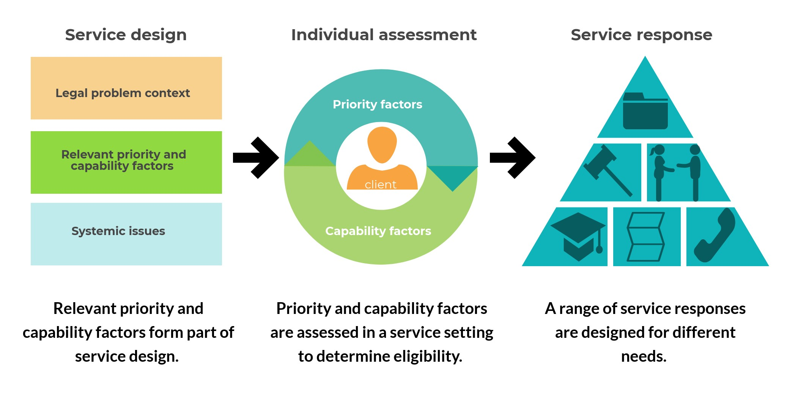
An example of the priority and capability model and how it applies to the design and delivery of services is illustrated here. As noted in the service design section below, consideration of the context of the legal problem and the potential impact it has on individuals, particularly where no legal assistance is provided, forms part of VLA’s decision making on both a systemic and an individual level.
Example: the policy supports the design of services that help priority groups, like the Aboriginal Community Engagement Officers program
Example: When grant of aid guidelines are reviewed, prioritisation based on characteristics and capability as defined in this policy will be incorporated.
Example: priority and capability factors are used to triage new enquiries for duty lawyer services at Magistrate’s Courts.
Aboriginal Community Engagement Officers support Aboriginal and Torres Strait Islander people to access legal assistance from VLA and work to strengthen relationships and raise awareness of circumstances that give rise to legal problems.

Priority characteristics
We know from legal needs research that there are life experiences and circumstances which tend to make people more vulnerable to legal problems and also less likely to seek legal help to address them. Indeed, inequality, poverty, trauma and disadvantage drive many of the behaviours, situations and conflicts which have legal repercussions for people. To help make decisions about who we can assist, we have articulated broad groups of people who we will prioritise services for. In some settings we may require that a person meets one or more of these criteria in order to qualify for assistance (for instance financial hardship and living with a disability). More detailed definitions or criteria may also be applied for some services. Service guidelines and grant of aid guidelines explain which of these characteristics are relevant for different types of assistance.
The three tiers of priority
This policy groups the characteristics in order of priority. The position of characteristics in the tiers is based on research and consultation about the needs and experience of different priority groups. Many people are likely to meet criteria in more than one tier.
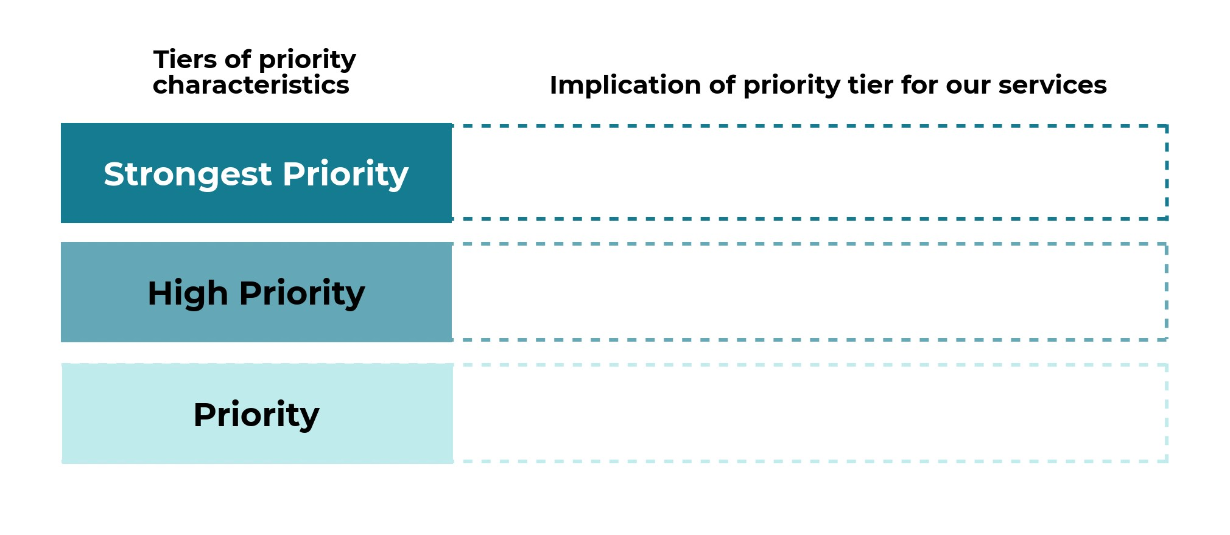

Strongest priority
This is the highest tier of priority. The experience of these characteristics may indicate a very high level of legal need and that the person will require more intensive assistance to address their legal problem(s). Design and delivery of services to people who experience these factors should be a key organisational focus. For instance, financial hardship is a criterion in almost all grant of legal assistance guidelines (applied through VLA’s means test). Depending on the legal situation and context, people with these characteristics are likely to be a priority for direct assistance at entry points, may receive extra assistance before a court event, and may be eligible for further casework assistance through a grant of legal aid:
- Children and young people.
- Aboriginal and Torres Strait Islander people.
- People living with a cognitive impairment (such as an intellectual disability, acquired brain injury or other serious cognitive condition).
- People who experience a mental health issue that significantly affects their ability to engage in everyday activities.
- People experiencing financial hardship (as assessed under VLA’s means tests for grants of legal assistance or income tests for other services). This will include people who are unemployed or relying on government benefits as their main source of income or otherwise living on a low income.

High priority
We will aim to provide direct assistance at courts and other entry points and provide high quality (including warm) referrals to alternative legal services where we cannot assist directly or completely for people with following characteristics:
- People who have experienced family violence, including non-partner violence such as elder abuse, or a recent serious trauma including being a victim of violent crime.
- People who are detained by the state, for instance people in police custody, court cells, prison or immigration detention, or people involuntarily held in a mental health facility or other closed environment.
- People who have nowhere to live or who live in crisis or temporary accommodation.
- People who have finished school before completing year 10 level or have difficulty with reading and writing in daily life.
- People who have recently arrived in Australia who experience significant challenges interacting with Australian legal and government systems, including refugees/humanitarian entrants and asylum seekers.

Priority
People with these characteristics should be recognised in the way we deliver our services or may lead to targeted services to address the particular needs of these groups:
- People who are elderly and have limited family support.
- Single parents or carers (of children or people living with a disability).
- People experiencing a drug or alcohol dependency or a gambling dependency.
- People with a chronic illness or significant physical disability.

Capability assessment
In many situations, the seriousness of the legal problem and a person’s personal characteristics will be enough to determine how much legal aid should assist. We also know from the research that social disadvantage is linked to lower capability to address legal problems.
When determining how VLA can assist people who are a priority for our services, where possible we will also consider their individual capability; that is, their ability to understand that they have a legal problem, to access legal information and to take appropriate steps or actions to resolve the legal problem.
For instance, while being on a low income and having a particular disability is a strong indicator of both legal need and potential difficulty in making sense of or addressing a legal problem, we should not assume that all people in this situation have the same capacity to take part in legal processes affecting them. Giving separate consideration to indicators of capability gives help-seekers more agency and recognises that some people can address their legal issues with limited professional support, while others will find legal processes difficult and alienating even with extensive legal assistance. Many people will be somewhere in between these two experiences.

Consideration of capability factors may include:
- the person’s financial circumstances and their ability to purchase alternative legal services, if such services exist
- the person’s experience of cultural or community practices, traditions or ideas that create a power imbalance, mistrust of government or authorities and/or lack of English language proficiency
- the person’s previous experiences with court, tribunal or other legal processes
- the number of legal problems facing the person that require resolution
- how confident they are about the legal process they are engaged with and the nature and formality of the related legal proceedings
- the person’s language and literacy skills and how well they understand written material or diagrams
- their level of stress or anxiety about the next part of the process or the legal problem generally, and other supports available to them
- whether they live in a place that makes it difficult for them to access appropriate and affordable services.

Legal issue and impact
Determining who to prioritise for assistance takes place in the context of legal aid expertise, funding and service capacity and is also closely connected to a determination of the nature of the legal problem and the likely impact of providing assistance. This takes place at both the systems level during service design and then at an individual level when making decisions about who we can assist and how. Consideration of legal issue and impact or
potential impact may include the impact on the individual, and the potential benefit to the broader community or others affected by the same legal problem.

The impact on the individual
An assessment of the likely impact of the proposed service for the individual will also generally involve a range of considerations, including:
- which parts of the problem we can help with and how much assistance we should provide in this context
- the likely consequences for the individual of providing, or not providing assistance: what is the harm that the assistance is likely to prevent, or the likely benefit to the person? For instance, is the person facing a potential jail sentence? Is assisting a person likely to result in a safer outcome for someone they are accused of harming in a family violence context? Is the person likely to be removed to the country from which they fled persecution? Is the person being detained for the first time or facing indefinite detention?
- whether the outcome and experience of receiving assistance for the person is proportionate to the cost of providing the services and is an appropriate and effective use of limited public resources
- the likelihood of obtaining a successful outcome for the person.
Many of these factors are explained further in service and grant of legal assistance guidelines within particular VLA programs.
The potential benefit to the broader community or other people affected by the legal problem
In some areas of legal practice, particularly where there are insufficient resources to assist many people, we may decide to help some people or in some circumstances where this could potentially benefit a group of people or help to improve unfair systems or processes.

How this policy will be used in practice
This policy will come into effect immediately and will be implemented over time as VLA reviews existing services and practices and designs new services and approaches. It is an important lens that we will apply at both the systems or service design and review level and at an individual level. In order to do this, priority and capability considerations will be integrated into eligibility for different types and intensity of services, such as those in the diagram below.

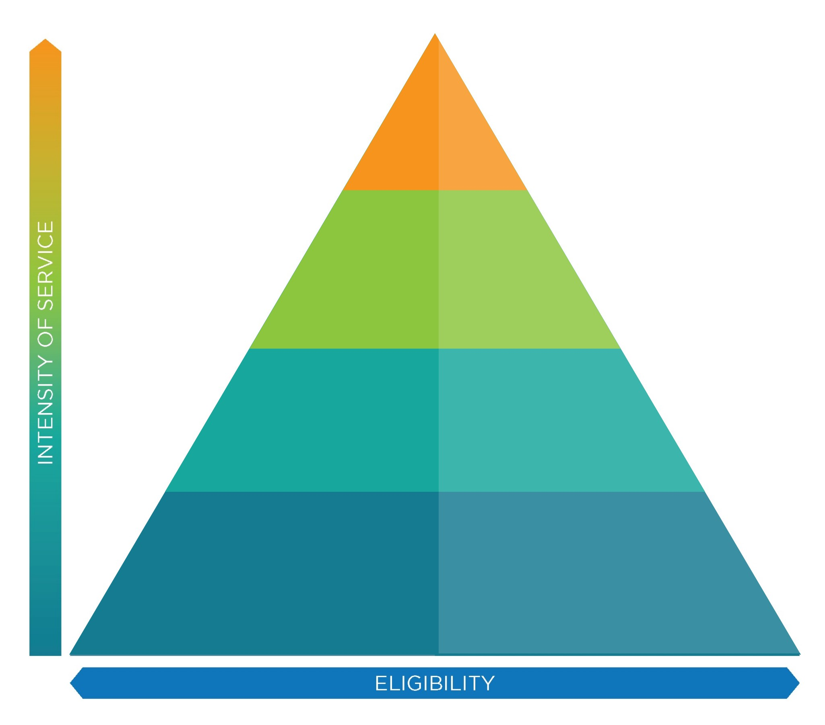

GRANTS
OF LEGAL
ASSISTANCE

MINOR WORK SERVICES
(e.g. drafting a letter, written legal advice, one-off court appearance)

DUTY LAWYER SERVICES
NEW CLIENT APPOINTMENTS

ADVICE
(advice tailored to the person’s specific circumstances)

COMMUNITY LEGAL EDUCATION

LEGAL INFORMATION
(information provided by phone or online that explains the law and legal system in general terms and provides resources to enable people to take further action)

The policy will be applied in the following ways:
- incorporating priority and capability factors into triage tools and practices at VLA entry points and for determining eligibility for individual services
- informing development and review of appointment, duty lawyer and grant of legal assistance guidelines, including any income test (as these are reviewed over time)
- guiding community legal education activities and approaches
- informing service design, innovation and review processes, including client focused project design, evaluation of programs and activities
- as a resource to assist discretionary funding decisions or help explain to an applicant for legal services why they do not qualify for certain types of assistance.
This policy is a public document because we want to inform community members and potential clients about our services, establish realistic expectations about provision of
services and help to address misconceptions about eligibility for legal aid services. Other materials such as information about VLA’s means test will also help with this.

Commencement
This policy commences on 1 March 2019.
We intend to review the impact of this policy two years after commencement and report findings to the VLA Board.

Owner
The Executive Director, Civil Justice Access and Equity, is responsible for this policy.

The Commonwealth’s principles and service priorities are set out in Schedule B of the National Partnership Agreement.
Section 4 of the Legal Aid Act 1978 (Vic)
Section 3(a) of the National Partnership Agreement on Legal Assistance Services
Access to Justice Report (2016) recommendation 6.21 and Government Response
For instance, some community legal centres receive funding to provide family law and child protection services directly from Victoria Legal Aid.
McDonald, HM & Wei, Z 2015, How people solve legal problems: level of disadvantage and legal capability, Justice issues paper 23, Law and Justice Foundation of NSW, Sydney and Pleasance, P. 2014, Reshaping legal assistance services: building on the evidence base, a discussion paper. Law and Justice Foundation of NSW.
A warm referral is made when, with a client’s consent, details of their legal problem and characteristics are passed on from an entry point service to another part of the system, such as a duty lawyer or legal advice appointment. This may be complimented with a direct booking process in same situations, reducing the need for a client to contact a second service to arrange an appointment. It also takes away the need to repeat essential details and to focus the interaction between the client and the lawyer on the substantive problem.
Law and Justice Foundation. Op cit.
Ibid.

