Part A: How do we measure eligibility?
This section will provide an overview of:
- Unmet legal need
  - Why can’t people afford legal representation?
  - Disadvantaged people missing out on legal help
  - Disadvantaged people have complex legal needs
- What happens when people miss out on legal help and why it matters
  - The impact of missing out on legal assistance
  - How lack of access to legal help impacts our community
- Looking beyond the means test
  - Priority client framework
  - Who is missing out on legal assistance?
  - How can we consider factors of disadvantage when assessing relative need?
- What financial criteria do other agencies assess?
  - Other legal aid commissions
  - Government agencies
  - International organisations

Unmet Legal Need
Unmet legal need in Australia
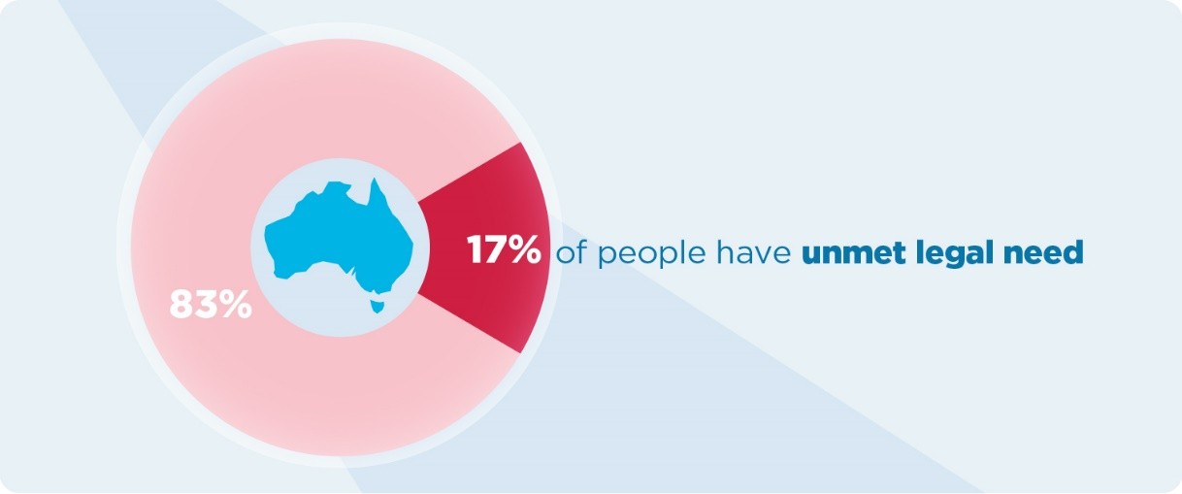
Many people may not realise that some of the problems they are experiencing are of a legal nature. Even if they do know that they have a legal problem, they may struggle to know where help is available to assist them with their problems. This is a widespread problem that exists across Australia and in other nations, including in the United States that has found that for every person assisted with their legal problem, there is another person turned away.
People most likely to encounter a legal problem
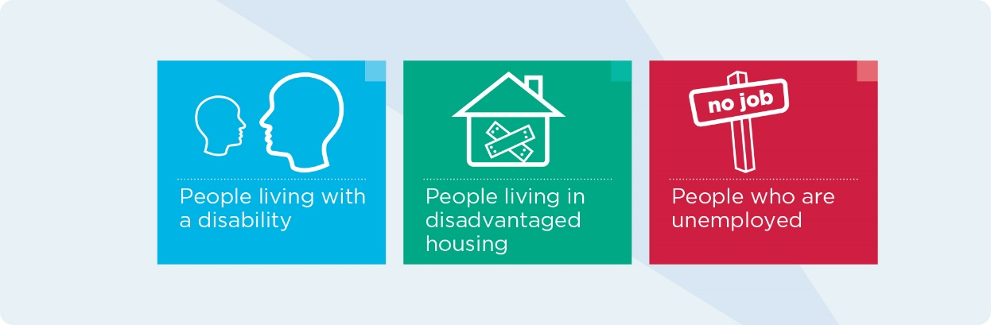
We know that there are many people who do not qualify for legal assistance from services like VLA, but also do not have enough money to pay for lawyer on a private basis. This is also referred to as the ‘missing middle’.
Many people that fall into this gap of not qualifying for legal assistance have been deemed as living below the ‘poverty line’.
Eligibility for publicly funded legal assistance
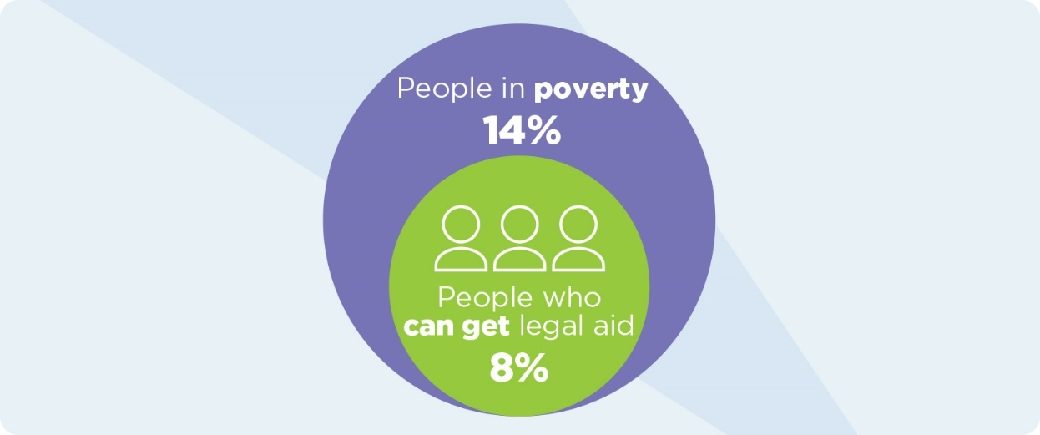
The Henderson Poverty Line (HPL) provides an assessment of poverty based on income, but does not take into account assets. The HPL is the benchmark that VLA measures its own means test against.
Another commonly used poverty line is the OECD Relative Poverty Line (RPL). The RPL is defined as household income below 50% of the median equivalised household disposable income. It is estimated that 13.8% of Australians live below this poverty line. This means that some people being refused legal assistance are still considered to be living in poverty and may be prevented from accessing a lawyer to help with their legal problem.

Why can’t people afford legal representation?
When the Means Test was first created, we didn’t know enough about what disadvantage and poverty looked like in Australia. The test was based on financial criteria alone and built around the idea of a family model that is no longer as prevalent as it was in the 1990s. The information we have now about household income and expenditure helps build a better picture of some of the challenges experienced by households in meeting the cost of living.

Where households are spending their money
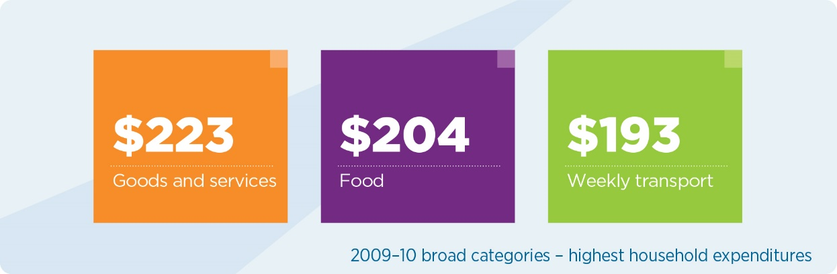
Average annual changes of cost of living since 1984
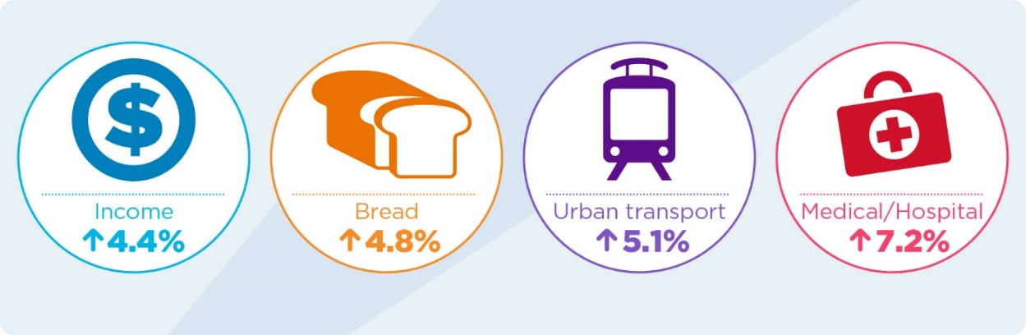
Credit card debt
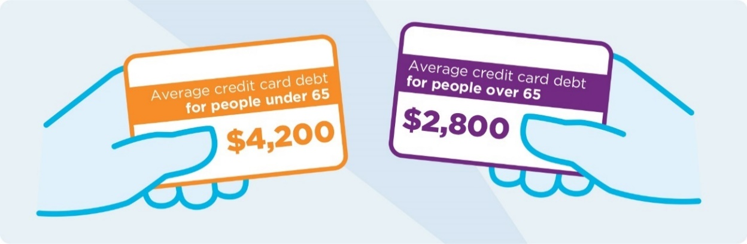
The analysis records a trend where household liabilities and average household disposable income have not increased at the same rate. The top 10% of most indebted low income households now have a ratio of debt to income of 10 compared to just 5.5 in 2004.
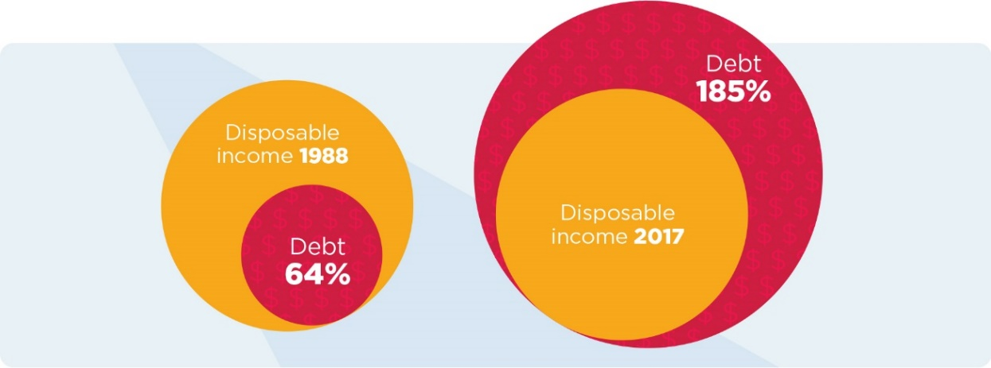
Cost of raising children since 2007
The VLA means test makes some allowance for the cost of raising children through the inclusion of a dependant’s allowance and an allowance for childcare costs necessary because of a person’s work or study. However, these are capped and the figures haven’t changed in many years.

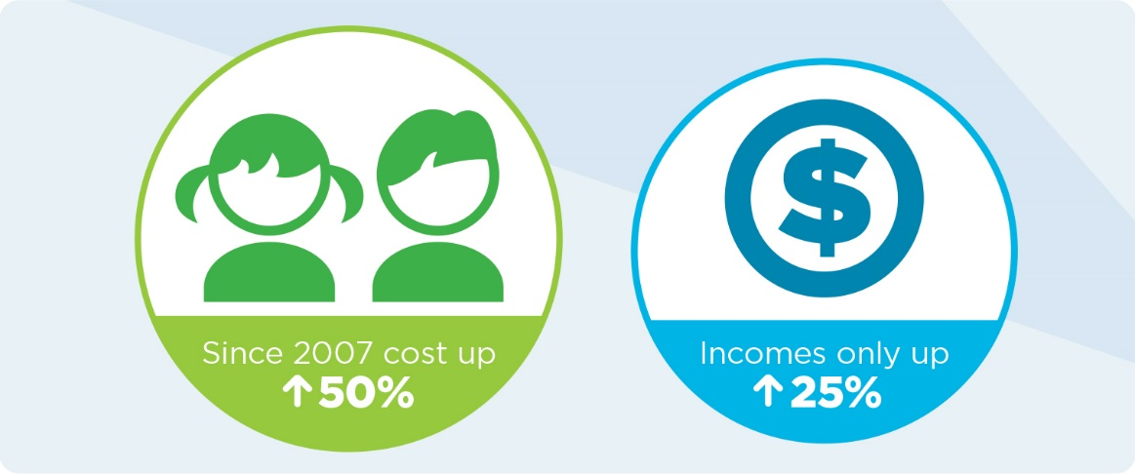
Income is growing at a much slower rate than the cost of raising children, with a significant portion of weekly income being spent on raising a single child.
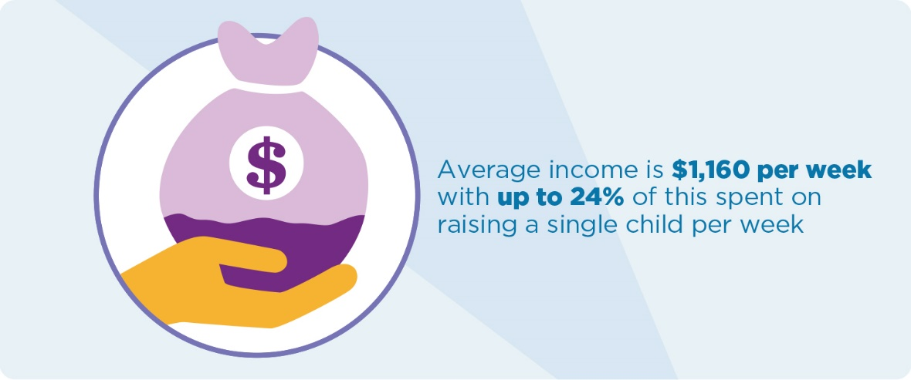
All of these conditions are leading to a significant percentage of families experiencing financial stress.
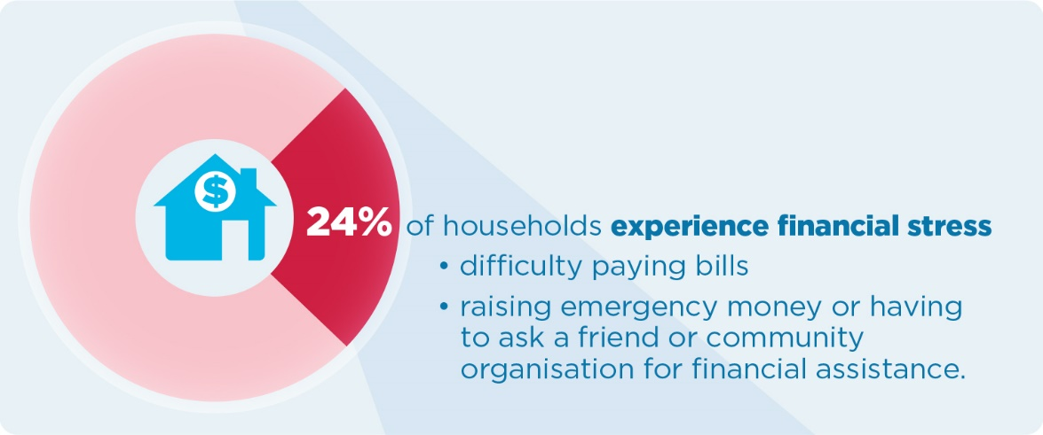
Much of this data does not show whether people are moving in and out of poverty, and does not capture entrenched poverty and disadvantage.
Information about the extent of entrenched disadvantage is provided by the Household Income and Labour Dynamics in Australia (HILDA) Survey.
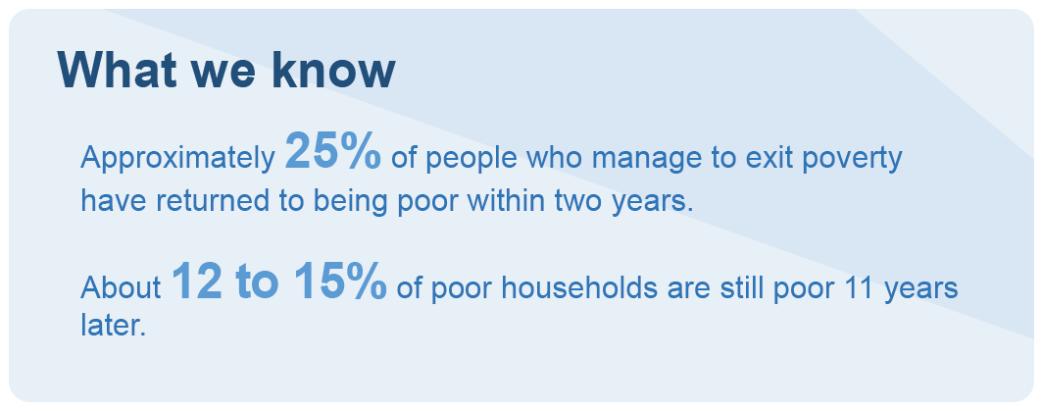
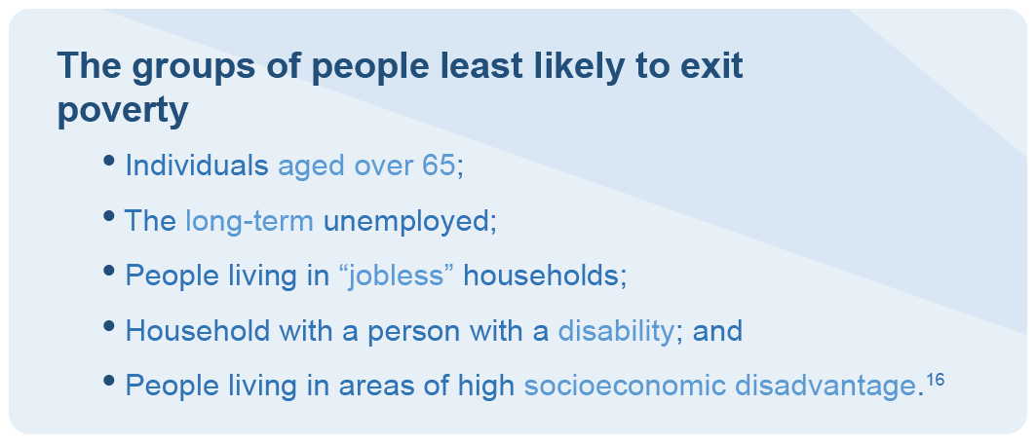

Disadvantaged people have complex legal needs
Disadvantaged people face barriers in accessing the civil justice system, which make them both more susceptible to, and less equipped to deal with, legal disputes. If left unresolved, civil problems can have a big impact on the lives of the most disadvantaged. Simple problems can spiral into complex ones when legal assistance is not provided. Unmet civil problems can also escalate into criminal matters.
While not all people who experience multiple legal problems are disadvantaged, we now know that there is a connection between someone’s level of disadvantage, and the likelihood that they will experience multiple legal problems. There is also evidence that people who experience disadvantage may not take action in response to a legal issue. The Law & Justice Foundation has highlighted the importance of intensive legal assistance being available for some of the most disadvantaged people as early intervention and self-help strategies may not be suitable in these situations.

People who experience disadvantage:
- Are more likely to experience problems related to repaying debts or fines as a result of income deprivation;
- May face issues related to public or private rented housing; and
- Are more likely to have a problem with agencies administering income support.

What happens to the people who miss out on legal help?
When people miss out on a grant of legal assistance, there is no concrete information available about the legal journey that follows. Anecdotally, many of these people may seek assistance from a Community Legal Centre (CLC) or a pro bono legal service. Others will become self-represented litigants. Another group may give up their rights and not take any action.
Percentage of people that have experienced a legal problem in Victoria
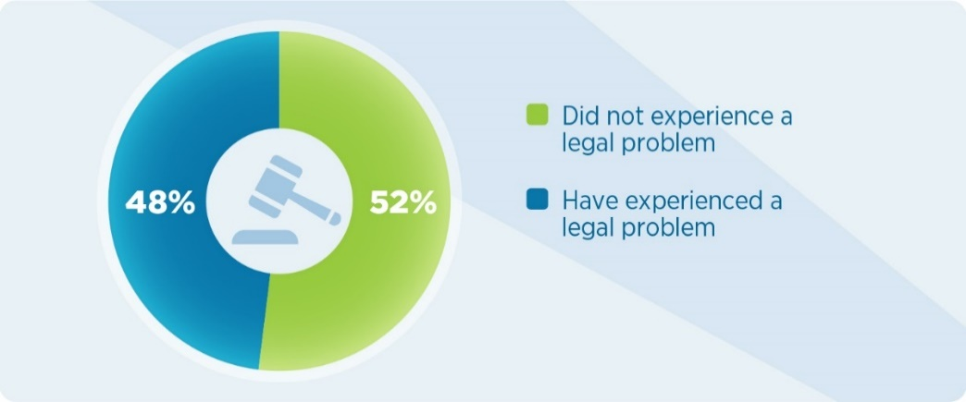
How they dealt with their legal problem
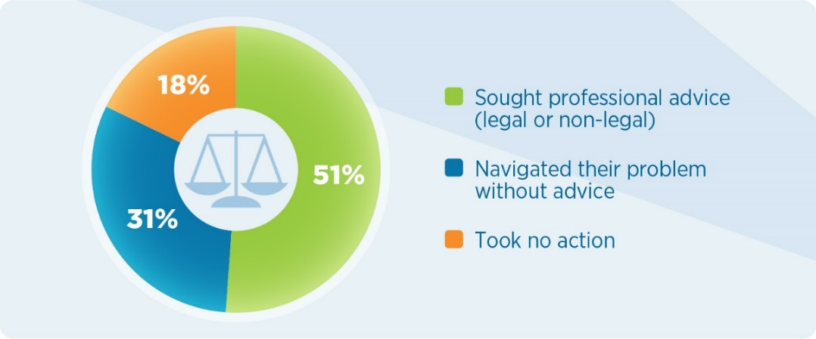
Of the 51% that did seek professional advice, only 30% sought advice from a legal professional.
Of those that took no action, the common reasons were because:
- They said it would take too long;
- It would be too stressful;
- That it would cost too much; and
- They didn’t know what to do.

The impact of missing out on legal assistance
We don’t track what happens to people who are refused a grant of assistance, what services they reach out to, or whether they proceed as a self-represented litigant. As part of our consultation on this review, we released a survey asking for community members to tell us their story if they had been refused assistance. The following common themes were identified.
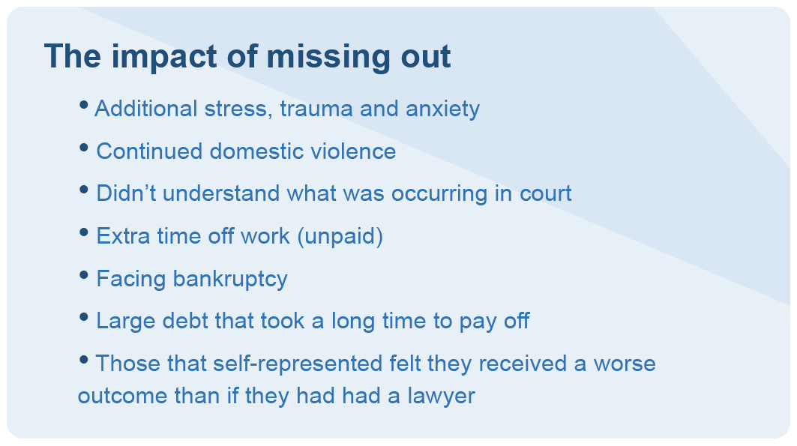

How lack of access to legal help impacts our community
The Productivity Commission noted that ‘numerous studies show that efficient government-funded legal services generate net benefit to the community.’ This has been shown to extend to halting the escalation of issues which can lead to entrenched disadvantage and social exclusion from deteriorating health, employment, relationships and housing stability.
Where a person cannot afford legal representation, or chooses not to proceed with legal representation, they can continue their legal matter as a self-represented litigant. The numbers of self-represented litigants are increasing in some jurisdictions. The High Court has seen a jump from 41% of self-represented litigants in special leave applications to 67% in four years. Appeals in the Family Court have seen an increase in self-representation from 39% to 44% in one year. There is a widespread perception that self-represented litigants are increasing in Australia as a result of increased legal costs and changes to legal aid funding. People that are self-represented in court can result in significant additional costs on the courts and other parties in the proceedings, generally through extending the length of time a legal proceeding must take. Providing people with legal representation would not only benefit a person in their legal matter, but also save costs for the community.
We currently don’t track a person’s journey once they are found to be ineligible for a legal aid service, and so we don’t know whether that person then goes on to become self-represented in a court, tribunal or other process. We know that a person may attempt to access legal help in many ways before ending up as a self-represented litigant. There are legal services available beyond legal aid, including community legal centres, paying privately for a private lawyer or finding someone that will do the work pro bono. Once these options are exhausted, a person is often left with no alternative but to represent themselves. A report commissioned by the National Association of CLCs showed that the benefits and avoided costs as a result of CLC intervention can range from $10,000 to $34,000. The report estimated that for each $1 invested in CLCs, around $100 may be ‘saved’ by CLC clients, governments and/or other affected parties.
Access to effective legal assistance assists with the resolution of many of the problems of everyday life, such as family breakdown, violence, crime, unemployment, debt, health, housing and welfare.
If legal problems can be addressed early, distress and costs are reduced benefiting the individuals, their families, the government and society.

Looking beyond the means test
The Legal Aid Act 1978 requires VLA to consider whether a person has the capacity to pay for a private lawyer, which is the starting point for our assessment of eligibility. Section 24(1) of the Act requires us to consider whether a person ‘is in need of legal assistance by reason that he is unable to afford the full cost of obtaining [private legal services]’. The means test has been established to assess this, as well as to provide legal aid ‘in the most effective, economic and efficient manner’. On this basis alone, it may not be appropriate to consider other factors that interfere with a person’s ability to gain legal assistance. However, the Act also requires us to consider whether it is reasonable to provide the legal assistance having regard to ‘all relevant matters’, which includes considering “any other matters affecting the ability of the person to meet the full cost of obtaining services from private legal practitioners”. It is from here that we can start to consider other factors that might impact a person’s ability to get a lawyer.

Could our priority client framework work with the means test?

The fact that the means test is the first threshold for eligibility is significant. VLA already targets ‘priority clients’, who are groups of people with characteristics or circumstances that make them vulnerable to legal problems or a high priority for receiving our services. However, these factors are not considered if a person is not financially eligible for assistance. This means that many people who might be considered vulnerable or disadvantaged in some way may miss out on the basis of their finances when they apply for legal assistance.
VLA’s priority client framework prioritises clients who:
- Face detention by the state or are having decisions made for them;
- Are exposed to risk of violence or harm; or
- Are marginalised or vulnerable to exploitation or unfair treatment.
Other indicators of disadvantage also incorporated included:
- People who are financially disadvantaged;
- Children and young people;
- Women and children experiencing, or at risk of, family violence;
- Culturally and linguistically diverse (CALD) communities;
- People in state custody;
- People with mental health and disability issues; and
- Indigenous people.
The framework has been incorporated into our triage processes and is used to provide lower intensity services, such as legal advice and duty lawyer services, to those most in need.
Although the priority client framework is used to decide who can obtain duty lawyer services or receive legal advice, this framework is not applied when it comes to being financially eligible for a grant of assistance.

Who is being refused a grant of aid because of their means?
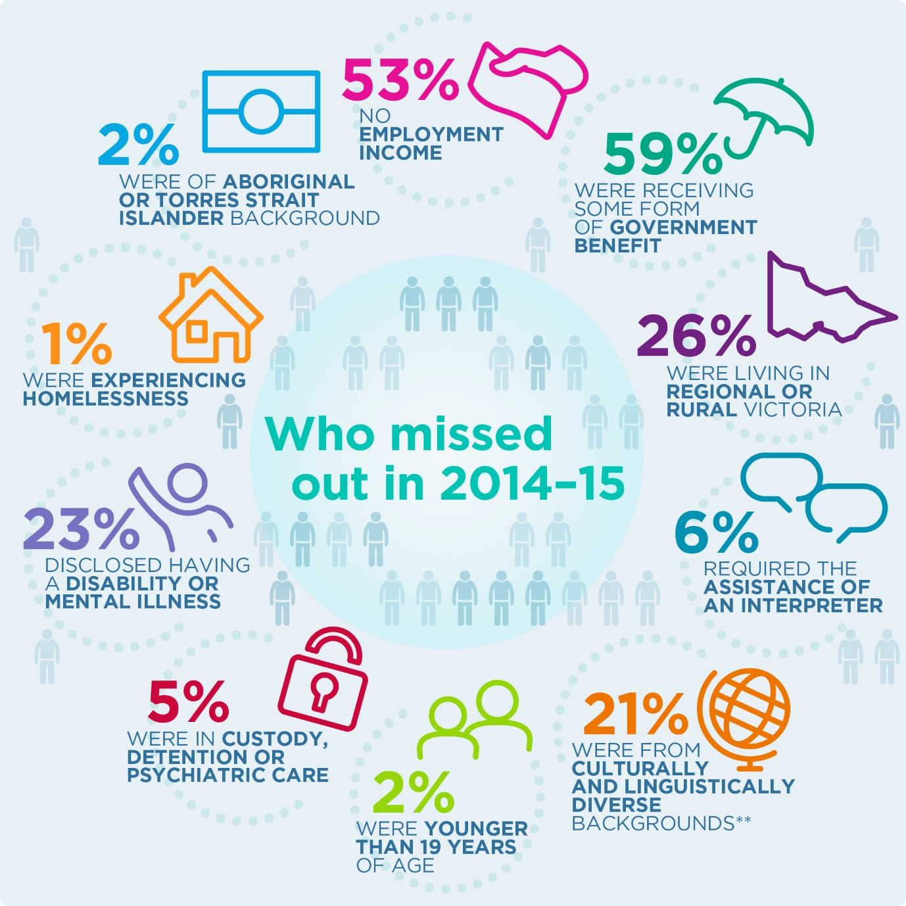
** This is based on the Australian Bureau of Statistics definition of people from culturally and linguistically diverse backgrounds. It includes people who speak a language other than English at home and people who were born in a non-English speaking country.
We know from our demographic data that there are numbers of people identified as a ‘priority client’ who are still being refused assistance because of their financial situation. Looking beyond the means of a client would mean considering these factors when assessing someone for a grant of aid.
These statistics only cover people that applied for assistance and were refused under the means test. This doesn’t capture anyone who didn’t apply because they believed, or were told by a lawyer that they wouldn’t be financially eligible. We know from our previous consultation that many people are turned away or discouraged from applying before submitting an application. There are many more people that miss out on a grant of assistance beyond those that apply and are refused. Those that don’t apply also miss out on the opportunity to seek reconsideration or independent review of a decision that is made. That is why it’s important to examine other factors that might be impacting a person’s decision to apply for assistance or not.

How can we consider factors of disadvantage when assessing relative need?
There is increasing recognition that an income and assets based assessment of financial resources may not provide a complete picture of a person’s experience of social exclusion or disadvantage. The Victorian Charter of Human Rights and Responsibilities Act 2006 recognises the importance of every person being treated as equal before the law and entitled to the equal protection of the law without discrimination. The means test attempts to address the power imbalance and disadvantage between those who can afford to pay privately for a lawyer and those who can’t. There are a number of other factors, such as education, living with a disability, being a sole parent or being from an Aboriginal or Torres Strait Islander or CALD background, that may influence a person’s legal need or whether or not they seek legal help for their problem. For these people, forging a connection with legal assistance services may be particularly important.
Income poverty is significant but not the only measure of need. There has been growing acceptance that income-based measures do not provide a comprehensive or complete picture of disadvantage and cannot map entrenched disadvantage. A broader concept that goes beyond standard inequality measures is required. The search to find a more meaningful and complete tool to assess disadvantage has led to closer examination of household expenditure, social deprivation, social exclusion, financial stress and other measures of social wellbeing.
Some analysis of the levels of social exclusion and financial stress experienced by LAC clients is available from Legal Aid NSW. As part of a review of the “at special disadvantage test”, Legal Aid NSW commissioned the Social Policy Research Centre to undertake a series of research projects examining social disadvantage. This included a survey of a cross-section of applicants for assistance over approximately 18 months to explore the extent of social exclusion, and assessing Legal Aid NSW against a range of social disadvantage indicators. This included social identity, exclusion and economic vulnerability. The study found:
- a large number of clients surveyed do not have a valid driver’s licence, tax file number or Medicare card;
- 37-49% reported having been a victim of violence within the last 12 months;
- social disengagement is far more prevalent among legal aid clients than the NSW population;
- service exclusion among the legal aid sample is far higher than the NSW population;
- many legal aid clients are unable to access basic medical and hospital services when they need them;
- a high percentage of legal aid clients are not able to afford medications prescribed by a doctor;
- around 40% do not have any money in a bank account to draw on if faced with even the most modest unanticipated (or even anticipated) event, and more than 80% do not have any unused credit on a credit card they can draw on if they needed to;
- high percentages of the legal aid sample owed a large amount of money that they cannot repay;
- very few have any form of insurance;
- between 30- 50% are dependant on the support provided by a welfare agency.
Even without looking at household incomes and expenditure, it is clear that many of these people are in precarious social and economic positions and would be unable to pay for private legal representation.

What financial criteria do other agencies assess?

Other Legal Aid Commissions
Each state and territory in Australia has a Legal Aid Commission. Eligibility guidelines, particularly in regards to financial eligibility, are structured in similar ways across all of the commissions, although the income and assets thresholds may differ. Some commissions don’t impose contributions in the same way that we do, or make a full assessment of a person’s eligibility within their Assignments unit. Generally, however, they operate like VLA. Some of the more finer differences between other Legal Aid Commissions and VLA are addressed in Part B of this paper.

International Organisations
Our review looked at legal aid commissions overseas, to see if they were assessing eligibility in different ways – particularly in countries that operate in a very different jurisdiction, or have differing understandings of ‘family’. We discovered that while all commissions do look at the financial eligibility of applicants, many had more simplified tests that made it easier to understand and to apply. Certain groups were also made exempt from the means test, in the way that VLA doesn’t apply the means test to children or war veterans.

Legal Aid Ontario
Key financial eligibility criteria
- Eligibility is based on annual gross family income calculated against the number of family members in the household
- There is a second-tier threshold where a contribution is imposed
- A higher threshold is set for family violence matters.
Applicant with no dependants or financially associated persons
Gross annual income up to $12,863 | Qualify for assistance without a contribution.
Gross annual income between $12, 863 to $14,888 | Qualify for assistance with a contribution.
Gross annual income up to $21,438 | Qualify for assistance for a domestic violence matter only.
Legal Aid Ontario is a legal assistance service like VLA, and recently expanded both their eligibility criteria and legal services to assist with more family law and mental health matters. In the last financial year the organisation incurred a deficit of 26 million dollars with an annual budget of 400 million dollars.
Legal Aid Ontario’s means criteria have the advantage of being simple and easy to follow, with assessment made against the number of people residing in the house. However, the expansion of such a test resulted in more people being eligible to an extent that it was not sustainable.
Legal Aid Ontario operates differently to VLA in that once a person is found eligible for assistance a certificate is issued. This certificate, or voucher, can then be provided to a lawyer in the person’s local area and pays for a lawyer to represent the person for a certain number of hours.
Japan Legal Support Centre
Key financial eligibility criteria
- Financially associated persons are limited to an applicant’s spouse;
- Income is based on a per household amount which takes into consideration the size of the household and the annual earned income;
- Cash savings are also considered, but other types of assets are not;
- Foreseeable medical costs and educational costs may be considered; and
- A higher threshold is reserved for larger cities.
Established in 2006, the Japan Legal Support Centre used Australian legal aid commission models as guidance for their own set up. The means test criteria applies to civil law and family law matters. For criminal matters, the Court appoints appropriate defence counsel.
Korea Legal Aid Corporation
Key financial eligibility criteria
- Eligibility is based on an average monthly income under 125% of standard median income;
- This is the median value of the national household income as set by the Minister of Health and Welfare;
- Certain groups of people are considered eligible without their finances being assessed including:
  - People with disabilities;
  - War veterans not eligible for military pension;
  - Single parent families;
  - Refugees who have escaped from North Korea;
- Contributions are required in most instances; however, the fees are much lower than paying privately.
Korea Legal Aid Corporation does not appear to consider assets or savings but only considers the household income of the applicant who is seeking assistance. This could potentially result in someone having significant savings but on a low monthly income becoming eligible for aid.
Scottish Legal Aid Board
Key financial eligibility criteria
- The means test operates differently for civil cases versus criminal cases (in this instance family law matters fall under civil), with the basis for criminal matters being the “undue hardship” test, which compares the likely cost of the trial with the person’s income and assets;
- When a person is in receipt of certain benefits; the agency does not require any further information or documentation about their financial situation;
- Financially associated persons are limited to the income and assets of the spouse or domestic partner; and
- When assessing assets, the applicant’s principal place of residence is not assessed, with equitable charges being used only where a contribution is imposed.

Evaluation
The SLAB website provides an eligibility calculator, which lets people see whether they may be eligible for aid. This is also one of the options listed in our paper. A report on the financial health of legal aid firms in Scotland was recently published finding that many firms can no longer afford to undertake legal aid work as they are operating at a loss. The means test itself seems to operate in a similar way to VLA’s means test, with notable efforts to streamline the test where it is likely that a person will be eligible for assistance – such as where a person is in receipt of benefits.

Government Agencies
Part of our review involved looking at government agencies within Australia to examine if they assessed finances differently when providing services to those in need. Many of the services that we consider essential, such as healthcare and education, have no financial testing to gain some level of access to these services, as these are considered ‘universal’ and are generally accessible to all.
Enable NSW
Enable NSW is a single state-wide service providing equipment support services for people with disabilities in NSW.
Key financial eligibility criteria
- Criteria involves three financial bands that determine the level of contribution that an applicant is required to make
- Minimum $100 co-payment for all bands
- The applicant must have a permanent or long-term disability (defined as lasting more than 12 months)
- Parents’ income is not considered for children up to the age of 16.
Band 1 | Adults on full pension and children under 16 years
Band 2 | Up to $42,000 for a single person, with a higher threshold for couples and additional amounts allowed per dependant.
Band 3 | Over $42,000 and will result in the applicant paying for 20% for devices costing $800 and above.
Centrelink
Centrelink has several different eligibility tests depending on the type of benefit that a person is seeking. We’ve reviewed two of the main benefits, the Disability Support Pension and the Newstart Allowance. Each have a very different purpose. Newstart allowance is used to provide financial support while a person is looking for employment, while the Disability Support Pension provides ongoing financial support for people who have certain disabilities. Both pensions have non-financial criteria that need to be met to qualify.
The assets tests are simplified to consider lump sum asset amounts in contrast to VLA which assigns a value to each asset. Financially associated persons are also limited to a spouse or de facto. The financial circumstances of the applicant are an ongoing consideration to the eligibility of the person receiving the pension, and therefore the requirement to keep current financial information is essential. In contrast, while VLA requires the applicant to notify us when their financial circumstances change, generally their circumstances are considered valid for 12 months without ongoing monitoring.
With a significant proportion of applicants who receive legal aid also in receipt of a benefit, it is worth considering if VLA and Centrelink could collaborate to validate the eligibility of applicants that use both our services.
(Disability Support Pension)
Key financial eligibility criteria
- They consider the income, assets and family status of an applicant;
- Member of a couple is defined as: married, registered or in a de-facto relationship (opposite or same sex);
- Then, depending on the level of income earned also determines the amount of Newstart allowance that is provided to the person.
Income
Single adult | Able to earn up to $164 a fortnight. There is a reduction of 50 cents of the allowance for each dollar earned over $164.
Couple combined (or separated due to illness) | Able to earn up to $292 a fortnight (this is $128 extra than a single person).
Single adult, under 21 and still residing at home or independent. | Able to earn up to $164 a fortnight. There is a reduction of 50 cents of the allowance for each dollar earned over $164.
Assets
- There are several exempt assets including the applicant’s principal home, any NDIS money received, or superannuation before reaching pension age.
- The amount allowed in assets is also differentiated between homeowners and non-homeowners.
Single adult (homeowner) | $250,000 in assets.
Single adult (non-homeowner) | $450,000 in assets.
Couple combined or where one person is eligible for assistance (homeowner) | $375,000 in assets.
Couple combined or where one person is eligible for assistance (non-homeowner) | $575,000 in assets.
(Newstart Allowance)
Key financial eligibility criteria
- Like the Disability Support Pension, the Newstart Allowance considers an applicant’s income, assets and family status;
- The assets are the same allowances as provided for in the Disability Support Pension;
- For income, a single person or partnered (with no dependants) can earn up to $104 a fortnight to receive the full Newstart allowance; and
- The allowance drops off gradually up until a person earns $1,024.84 a fortnight, at which point it cuts off.
One of the other types of allowances allowed through Centrelink is Austudy. In contrast to Newstart and the Disability Support Pension, an applicant can only have liquid assets of $5,500 for a single person or $11,000 for a couple or single with dependants to be eligible.

What we learnt
Many of the organisations that we reviewed had similar, if slightly different processes, for applying for assistance. Like VLA, they also had other requirements, such as guidelines and merits, that need to be met. Some organisations, like Legal Aid Ontario, relied on a more streamlined means test to make it simpler and more accessible. While this saw a significant increase in the number of grants provided it also attracted issues surrounding sustainability. Therefore, one of the key requirements when making any changes will be about ensuring the sustainability of those changes. This is discussed in more depth in Part C: Future Focus of this paper.
Some of the key elements identified in other agencies assessment criteria have been considered in more detail through the options outlined in Part B: Making the Means Test Better, including:
- Narrowing the definition of a financially associated person to the spouse or de facto of the applicant;
- Separate assets allowances for homeowners and non-homeowners;
- Simplifying the contribution scheme;
- Exempting additional groups of people from the means test;
- Allowing a higher income threshold for certain ‘priority matters’; and
- Implementing an online eligibility calculator.
Some of the elements that other agencies have, such as imposing an upfront contribution have not been included as they did not have significant support during our last consultation. If you think any of the other criteria is worth considering further, we want you to tell us, by way of a submission or feedback.
As part of our consultation process we will be consulting with legal aid commissions within and external to Australia as well as government agencies to find out more about how their assessment process works in practice. This will help us learn from others about how to best structure and assess means eligibility.

See generally, Productivity Commission (2014) Access to justice arrangements. Inquiry report, (72) p 103.; Richard Denniss, Josh Fear and Emily Millane (2012), Justice for all: Giving Australians Greater Access to the Legal System, Institute Paper No 8, Australian Institute, March 2012; Centre for Innovative Justice. (2013). Affordable Justice: A Pragmatic Path to Greater Flexibility and Access in the Private Legal Services Market. RMIT University; Coumarelos, C., Macourt, D., People, J., McDonald, H. M., Wei, Z., Iriana, R., & Ramsey, S. (2012). Legal Australia-wide survey: Legal need in Australia. Law and Justice Foundation (the LAW Survey).
See, for example, Curran, Liz and Noone, Mary Anne (2007) "The Challenge of Defining Unmet Legal Need”. Journal of Law and Social Policy 21, 63-89.
Legal Services Corporation (2009) ‘Documenting the Justice Gap In America The Current Unmet Civil Legal Needs ofLow-Income Americans’ Available at http://www.lsc.gov/sites/default/files/LSC/pdfs/documenting_the_justice_gap_in_america_2009.pdf
Law and Justice Foundation of NSW, Legal Australia Wide-Survey: Australia (2014) p 66. Other indicators present include single parents and people living in regional areas.
Productivity Commission (2014) Access to Justice Arrangements – Volume 2, p 719. In its report, the Productivity Commission used the Household Expenditure Survey (HES) to estimate the number of households that might be eligible for legal aid based on a notional means test. Based on this data, it estimated that around 8% of Australian households are eligible for legal aid without a contribution. It found that based on the income test alone, around 19% of households meet the average LAC criteria, while 15% of households meet the assets criteria alone, Australian Council of Social Service (2014) Poverty in Australia 2014, p 9.
Ibid.
See generally Australian Bureau of Statistics (2011) Household Expenditure Survey, Australia: Summary of Results 2009-10, Available at http://www.abs.gov.au/AUSSTATS/abs@.nsf/Lookup/6530.0Main+Features12009-10?OpenDocument.
NATSEM (2012), ‘Prices these Days’, p.8. Available at http://natsem.canberra.edu.au/storage/AMP_NATSEM_31_Prices_these_days_The_cost_of_living_in_Australia.pdf .
ABS (2013-2014) ‘Wealth and debt’. Available at http://www.abs.gov.au/AUSSTATS/abs@.nsf/Lookup/6523.0Main+Features312013-14?OpenDocument
NATSEM, ‘Buy now, pay later: Household debt in Australia’, p 4. Available at http://www.natsem.canberra.edu.au/storage/AMP.NATSEM%20Report_Buy%20now%20pay%20later_Household%20debt%20in%20Australia_FINAL.pdf
NATSEM (2013) ‘The cost of kids: the cost of raising children in Australia‘ (Foreword). Available at http://www.natsem.canberra.edu.au/storage/AMP_NATSEM_33.pdf.
Ibid, p 5.
NATSEM, ‘Buy now, pay later: Household debt in Australia’, p 15. Available at http://www.natsem.canberra.edu.au/storage/AMP.NATSEM%20Report_Buy%20now%20pay%20later_Household%20debt%20in%20Australia_FINAL.pdf.
See further: Melbourne Institute of Applied Economic and Social Research (2016) Household Income and Labour Dynamics in Australia Survey. Available at https://www.melbourneinstitute.com/hilda/.
Committee for Economic Development of Australia: CEDA (2015) Addressing entrenched disadvantage in Australia, p 14,35.
Productivity Commission (2014) Access to Justice Arrangements- Summary Report, p 24.
Productivity Commission (2014) Final Report, p 970.
McDonald, HM & Wei, Z 2015, How people solve legal problems: level of disadvantage and legal capability, Justice issues paper 23, Law and Justice Foundation of NSW, Sydney.Law and Justice Foundation (2016).
The LAW Survey (2012) cited in Productivity Commission, 2014, p 971.
https://www.legalaid.vic.gov.au/about-us/what-we-do/research-and-analysis/legal-needs-survey
Law and Justice Foundation of NSW, Legal Australia-Wide (LAW) survey, page xvii.
Ibid, page xviii.
Productivity Commission (2014) Summary Report, p 2.
Attorney-General’s Department: (2009) A Strategic Framework for Access to Justice, p 142.
High Court of Australia, Annual Report 2011 – 2012, 15.
Family Court of Australia, Annual Report 2015-2016, 4.
Legal and Constitutional References Committee (June, 2004) Inquiry into Legal Aid and Access to Justice, p 188.
Ibid p 187 – 188.
Institute for Sustainable Futures (February, 2006) The Economic Value of Community Legal Centres cited in A Strategic Framework for Access to Justice, p 142.
Attorney-General’s Department (2009) A Strategic Framework for Access to Justice, p 141 citing Pleasence, P (2006) Causes of Action: Civil Law and Social Justice, 2nd Edition, p.i.
Legal Aid Act 1978 (Vic), s24(3)(f).
See further VLA’s Strategic Plan 2011-14 at http://www.legalaid.vic.gov.au/about-us/our-organisation/strategic-plan.
There were a total of 825 applications refused assistance under the means test in 2014/2015; Of the 825 applications refused assistance on means, 215 of the applications had either an ATSI background, were homeless or had a disability (26%); There was a reduction of 164 refusals in the newer financial year, potentially because of the modest mean test changes that were introduced in March 2016.
Section 8(3).
See generally Productivity Commission (2013) Deep and Persistent Disadvantage in Australia. Available at http://www.pc.gov.au/research/supporting/deep-persistent-disadvantage.
Ken Henry (6 December 2007) ‘Addressing extreme disadvantage through investment in capability development.’ Keynote address to the Australian Institute of Health and Welfare Conference on ‘Australia’s Welfare 2007’, Canberra.
See, for example Melbourne Institute of Applied Economic and Social Research (University of Melbourne) ‘Household Expenditure Measure’ available at https://www.melbourneinstitute.com/miaesr/publications/indicators/hem.html.
See, for example Crawford School of Public Policy (Australian National University) ‘Individual Deprivation Measure’ available at https://crawford.anu.edu.au/research/impact/6279/individual-deprivation-measure.
See, for example NATSEM (2013) ‘Poverty Social Exclusion and Disadvantage in Australia’. Available at http://natsem.canberra.edu.au/storage/Poverty-Social-Exclusion-and-Disadvantage . Scutella, R., Wilkins, R., Horn, M., (2009) ‘Measuring Poverty and Social Exclusion in Australia: A Proposed Multidimensional Framework for Identifying Socio-Economic Disadvantage’ Melbourne Institute Working Paper No 9 Available at http://melbourneinstitute.com/downloads/working_paper_series/wp2009n04.pdf. Saunders, P (2003) ‘Can social exclusion provide a new framework for measuring poverty?’ Social Policy Research Centre Working Paper. Available at https://www.sprc.unsw.edu.au/media/SPRCFile/DP127.pdf.
See, for example Marks, G (2005) ‘Income Poverty, Subjective Poverty and Financial Stress’ Melbourne Institute of Applied Economic and Social Research. Available at http://melbourneinstitute.com/downloads/labour/42_FinReport.pdf.
See, for example Hick, Rod (2012) The capability approach: insights for a new poverty focus. Journal of social policy. Available at http://eprints.lse.ac.uk/39745/1/The_capability_approach_Insights_for_a_new_poverty_focus_(lsero).pdf.
Saunders and Wong (2012) ‘Analysis of Legal Aid NSW Client Social Exclusion Survey Data (Report prepared for Legal Aid NSW), p 14.
Ibid.
Saunders and Wong (2012) ‘Analysis of Legal Aid NSW Client Social Exclusion Survey Data (Report prepared for Legal Aid NSW), p 16.
Ibid, p 18.
Ibid
Ibid, p 19.
Ibid
Ibid
Ibid
Legal Aid Ontario, http://www.legalaid.on.ca/en/getting/eligibility.asp (Accessed 7 February 2017).
Japan Legal Support Center, http://www.houterasu.or.jp/en/about_jlsc/operation2.html (Accessed 7 February 2017).
Korea Legal Aid Corporation, http://eng.klac.or.kr/english/infor/03.php (Accessed 24 February 2017).
Scottish Legal Aid Board, http://www.slab.org.uk/public/civil/eligibility/ (Accessed 24 February 2017).
See: http://www.lawscot.org.uk/members/legal-aid-and-access-to-justice/.
Enable NSW: http://www.enable.health.nsw.gov.au/home/applying_online/applying-for-assistance-from-enablensw.
Centrelink Income: https://www.humanservices.gov.au/customer/enablers/income-test-newstart-allowance-partner-allowance-sickness-allowance-and-widow.
Centrelink Assets: https://www.humanservices.gov.au/customer/enablers/assets.
Austudy Allowance: https://www.humanservices.gov.au/customer/services/centrelink/austudy.

