Table of Contents
The year ahead 3
About us 4
Client services 5
2018–19 Budget 6
Our priorities in 2018–19 8
Clients: We listen to our clients and make meeting their diverse needs our priority 8
Impact: We design services using evidence and feedback before deciding how and where they are delivered 10
Together: We act in ways that build trust and deepen relationships with colleagues, partners and the community 11
Key performance indicators 14

The year ahead
The year ahead can be characterised as one of change and transition for Victoria Legal Aid (VLA).
Over the past 12 months VLA has embarked on a consultative process to develop our next four-year strategy as we conclude Our Strategy 2015–18. However, major changes in our organisational leadership and legal framework mean that our corporate priorities for 2018–19 will precede finalisation of our next strategy. We are currently in a transitional period adjusting to new legislative requirements and strategy approval processes with the Attorney-General and we have recently welcomed our new Managing Director – Louise Glanville. Both roles play a vital part in validating our future strategy and we look forward to finalising this work throughout the year. In the interim, there is a need to provide certainty to our staff and our sector partners about our plans for the next 12 months.
Our priorities for the year ahead have been underpinned by our strategy planning and will see our evolution towards a more client-centred organisation. In addition, legislative amendments to the Legal Aid Act 1978 have provided us with new functions as well as increased responsibilities and accountability requirements.
We will support the implementation of recommendations from two major reviews – the Coghlan Bail Review and the Harper Review into the Detention and Supervision of Serious Sex Offenders and continue to support the reform work coming out of comprehensive reviews into summary crime and child protection. Our work to support implementation of recommendations from the Royal Commission into Family Violence remains. Our focus on staff wellbeing and personal safety will also continue.
In 2018–19, we expect to continue experiencing increasing demand for our services, particularly in the areas of summary crime, youth crime, indictable crime, child protection and family violence.
The welcome investments from the State Government have reflected the overwhelming demand for our services. We are grateful for these investments, but it is not closing the gap in demand stimulated by additional police, child protection officers, changes in the law and population growth.
Our financial circumstances are tightening. While our efforts to attract revenue will not lessen, we must prepare for difficult decisions about how to contain expenditure growth. Our priorities and budget for the year ahead are deliberately contained. Without additional investment in technology and data systems we will not be able to capitalise on many opportunities for improved service efficiency and effectiveness. Our focus is to finish the reform work we have started and to support several recommendations from the Access to Justice Review. The pace of our reform work will also need to slow. In order to manage our financial future beyond this year, we will need to commence discussions with stakeholders about the ongoing viability of our current service offerings over the next 12 months.
The 2018–19 Corporate Plan sets out 13 agency-wide priority initiatives that we will deliver over the next 12 months in addition to our core role in providing access to justice for Victorians experiencing disadvantage. We will focus our efforts on:
- becoming a more client-centred organisation
- designing and delivering services with impact, and
- strengthening our relationships with our staff, partners and stakeholders.

About us
VLA plays a critical role in providing access to justice for Victorians experiencing social and economic disadvantage.
We provide free legal information and education to all Victorians, with a focus on prevention and early resolution. We prioritise more intensive legal services, such as legal advice and representation for people who meet certain eligibility criteria. This is based on their financial situation, the nature and seriousness of their problem and their individual circumstances. We also conduct strategic litigation to change policies and processes and remedy legal problems for individuals and the broader community.
Our vision
A fair and just society where rights and responsibilities are upheld.
Our purpose
To make a difference for clients and the community, through the provision of effective legal services and collaborative leadership of a strong and dynamic legal assistance sector.
Our statutory objectives
Victoria Legal Aid is established under the Legal Aid Act 1978 to:
- provide legal aid in the most effective, economic and efficient manner
- manage our resources to make legal aid available at a reasonable cost to the community and on an equitable basis throughout the state
- provide improved access to justice and legal remedies
- pursue innovative means of providing legal aid to minimise the need for individual legal services in the community.
Our values
Fairness
We stand up for what is fair.
We aim to be fair when making choices about which people we help and how we help them.
Care
We care about our clients and the community in which we live.
We look out for and take care of each other.
Courage
We act with courage backed by evidence about what is best for clients and the community.
We act with courage to be the best we can be.

Client services
Our services are carefully targeted to meet diverse client needs and to make the most efficient use of our resources. Providing a continuum of different services ensures our responses are proportionate, tailored and appropriate.
The table below provides an overview of our service delivery performance over the past three years and what we expect to deliver in 2018–19. We expect to again see an increase in the number of clients we assist and services we provide. In total, service volumes are expected to grow by 9 per cent and unique clients by 6 per cent in the coming financial year, particularly in the areas of summary crime, youth crime, indictable crime and family violence.
 | 2016–17 |  | 2017–18 |  | 2018–19
 | Target | Actual | Target | Actual | Target
Clients
Unique clients | 87,630 | 90,649 | 94,400 | 94,485 | 99,800
Calls answered by Legal Help | 132,000 | 125,512 | 131,646 | 135,193 | 147,000
 |  |  |  |  |  |  | Legal services
Grant approvals | 41,075 | 41,638 | 43,561 | 42,777 | 45,300
Duty lawyer services | 87,802 | 93,697 | 98,900 | 93,564 | 107,306
Early intervention | 39,675 | 41,725 | 43,500 | 41,680 | 43,579
Legal information | - | 111,019 | - | 111,248 | 127,400
 |  |  |  |  |  |  | Family violence services
Family violence legal services | - | - | 32,000 | 39,086 | 36,300
Community legal education and legal information services – family violence related services | - | - | 11,500 | 25,851 | 27,500
Table 1: Client and service targets
In line with the 2016 Access to Justice Review recommendation that VLA should become the central coordinator of legal information across Victoria, VLA and the Victorian Law Foundation (VLF) are working together to transition six existing VLF legal information publications and website materials to VLA by 31 December 2018 and 31 March 2019, respectively. This is the first step in our broader move to become the primary entry point for information about legal issues and services in Victoria.
VLA currently publishes 86 different fact sheets, booklets and educational resources to help people work out their legal problems. With the addition of the six existing VLF publications, we expect our current distribution level of 365,000 free legal information publications a year to increase. The extent of this increase is difficult to quantify at this stage while existing distribution data is being sought. Future Corporate Plans will provide specific measures to reflected VLA’s increased role as the coordinator of legal information across Victoria.

2018–19 Budget
The 2018–19 budget sets out our income and spending plans for the coming financial year in response to the growing and different types of legal need in the community as identified in Table 1.
VLA now finds itself moving into a more difficult financial environment than we have faced in previous years. Forecast significant increases in police, additional child protection workers, along with a variety of legislative reforms and population growth means that our future revenue growth is not keeping up with the expected demand for our services.
However, this tighter financial period means we have to reconsider our priorities and carefully review all proposals for new spending so that we are being financially responsible. Despite our support for the means test review changes aimed at making our means test, fairer, simpler and easier to understand, we can only afford very limited changes to the test at this time. We have also made some small adjustments to our child protection reform package to reduce our expenditure in that area. We are being more careful about taking on new projects, instead focusing on those already underway and recommendations from the Access to Justice Review. Finally, we are seeking new sources of funding to deliver our ambitions to improve our technology and data capabilities.
This all means we can maintain our existing eligibility criteria and operate at a deficit of $2.4 million using our cash reserves — about half of last year’s deficit.
We know this is not sustainable. While not desirable, we expect to commence a conversation with the broader legal assistance sector about service priorities and ways to reduce expenditure growth in the first half of 2019.

Our revenue
Chart 1 shows that VLA receives funding from a range of sources including State and Commonwealth Government grants, and the Legal Services Board. In 2018–19, we have budgeted for $227.4 million in revenue, an increase of just over $13 million compared to 2017–18. This growth is largely driven by additional funding provided by the Victorian Government in the last two State Budgets and additional funding from the Legal Services Board.
Revenue by source ($m)
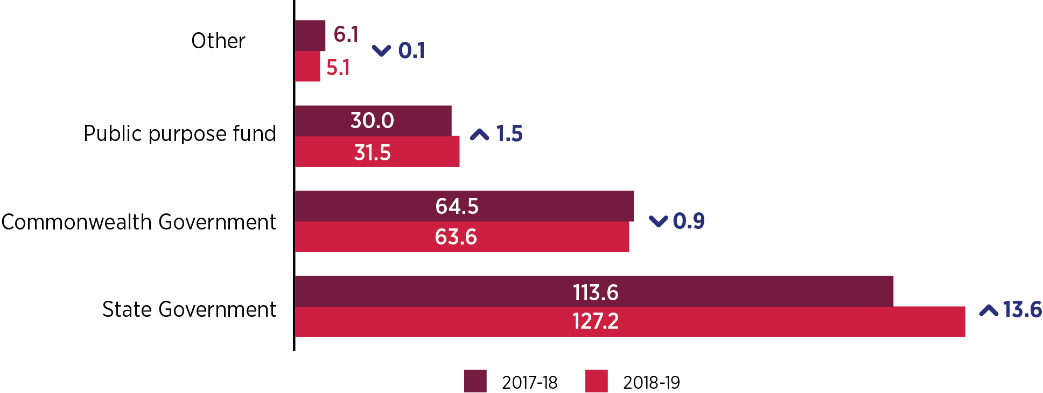
Chart 1: 2018–19 Revenue by source

Our expenditure
Overall expenditure is expected to grow by $10.4 million from $219.5 million in 2017–18 to $229.9 million in 2018–19. While this is an increase of 5 per cent, it is less than our forecast revenue growth.
Chart 2 shows a breakdown of budgeted expenditure by program. The criminal law program continues to be our largest program in terms of services and expenditure at 42 per cent of overall VLA expenditure or $95.9 million. Much of the increase in expenditure in our criminal law program relates to the growth in grant approvals to private practitioners in response to demand driven legislative and policy changes.
Expenditure in our Family, Youth and Children’s Law program area is also expected to increase in 2018–19. This growth is attributable to increased demand for family violence legal services, as well as the implementation of recommendations from the Child Protection Legal Aid Services Review.
We are also spending more in our Access and Equity program area which includes Legal Help. Calls into our Legal Help service have increased by 26 per cent over the last four years, with an average annual growth of 6 per cent. With recent changes to our Legal Help operating model, we have created capacity to answer an additional 16,000 calls in the coming year, improving our answer rate by 4 per cent despite the increase in demand.
Our investment in Community Legal Centres (CLC) will also increase by $2.3 million, or 8 per cent, compared to last financial year, reflecting the important role CLCs play in the broader legal assistance sector.

Expenditure by program area ($m)

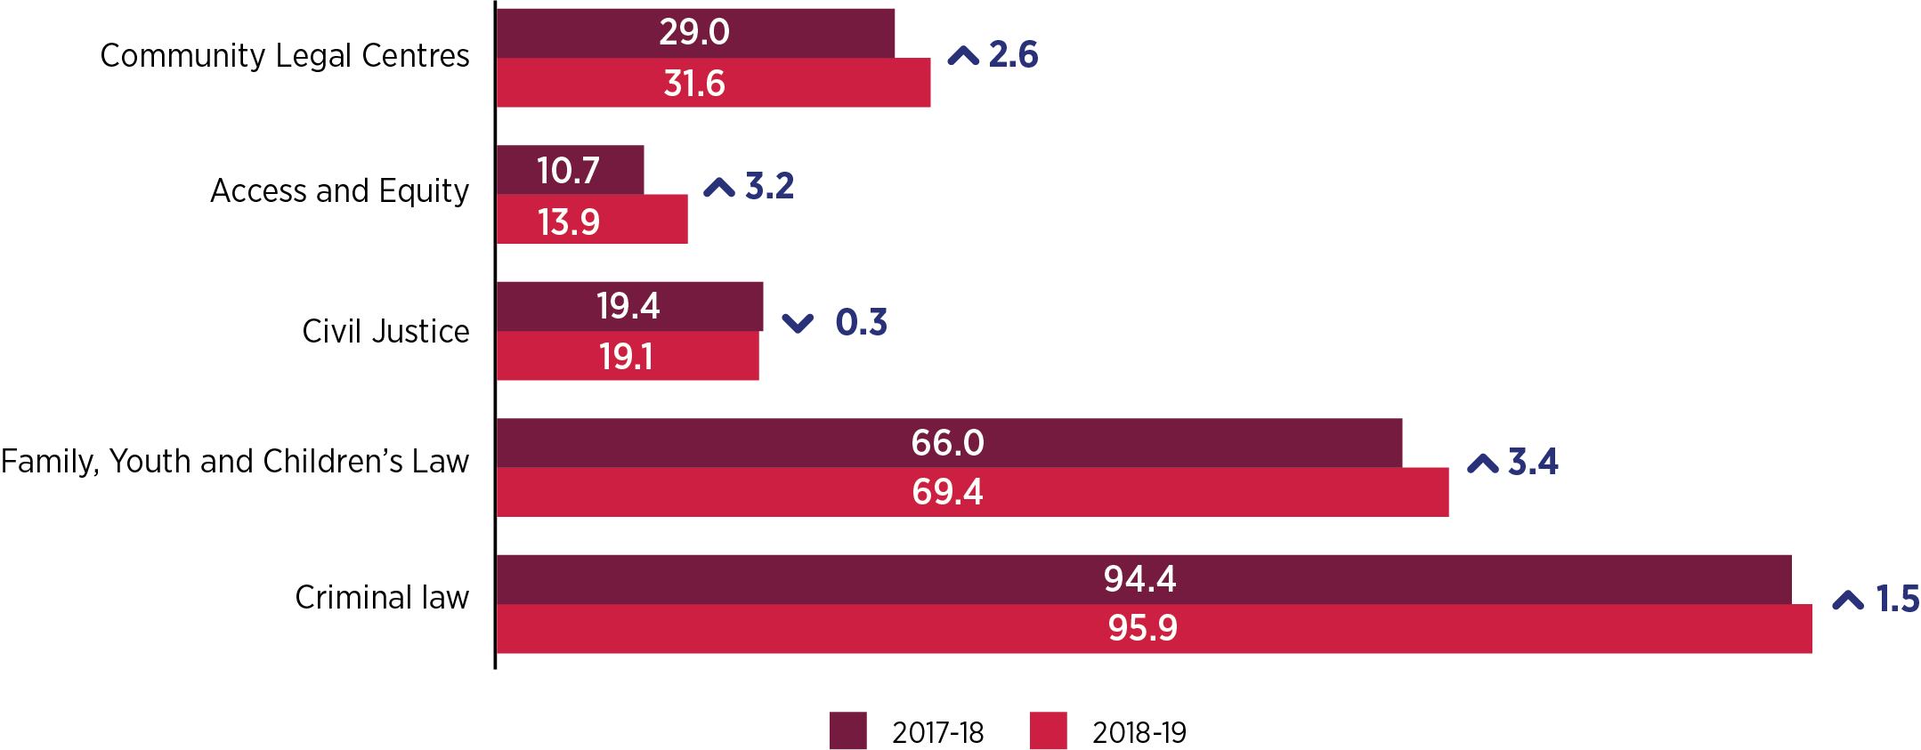
Chart 2: Expenditure by program

Our priorities in 2018–19
In 2018–19, we have committed to implementing 13 priority activities that will move us closer to achieving our vision of a fair and just society where rights and responsibilities are upheld. These priority activities also represent our responsibility to deliver on our statutory objectives and our longer-term goals. They are not intended to be a comprehensive or exhaustive picture of our work program; rather, they represent where we must focus our efforts the most if we are to significantly make a difference in the lives of our clients and the Victorian community and ensure efficient and effective use of our funds.

Clients: We listen to our clients and make meeting their diverse needs our priority
Recognising our leadership role in delivering legal services for Victorians experiencing hardship and disadvantage, we are increasing our commitment to put our clients at the centre of everything we do. Our objective is to design services based on the lived experience of our clients and to ensure services are available when and where clients need them.
In 2018–19, we will continue to focus our resources on priority clients that experience the most disadvantage in Victoria and who are in greatest need of legal assistance. We will update our Priority Client Framework to ensure it more accurately reflects the characteristics and circumstances of our clients and develop our first Client Services Strategy.
We will also focus on the needs of specific clients. We have committed to developing a second Reconciliation Action Plan to improve access to our legal services for Aboriginal and Torres Strait Islander people. Feedback from these specific groups will help VLA better understand unique barriers they may face in the justice system and improve the quality and design of our services accordingly. VLA recognises the importance of self-determination and independence of Aboriginal Community Controlled legal service providers in advancing access to justice for Aboriginal Victorians.
We will continue to respond to issues arising from the roll out of the NDIS and advocate for clients with disability to ensure they get appropriate support services and avoid interactions with the criminal justice system.
2018–19 Priority Activities | Measuring our success | Responsibility
Improve our Aboriginal and Torres Strait Islander (ATSI) services and culturally sensitive practices to ATSI clients by developing a new Reconciliation Action Plan | New Reconciliation Action Plan in place by 30 June 2019. | Executive Director, Access and Equity and Office of the Managing Director
Develop a Client Services Strategy, including an updated Priority Client Framework | Client Services Strategy (including updated policy on how VLA prioritises clients and legal need) and implementation and monitoring plan and tools in place by 30 June 2019. | Executive Director, Access and Equity
Review our conflict of interest policy to enhance client access to legal services, reduce confusion for staff and meet our legal and professional obligations | Conflict of interest policy completed by 31 March 2019. | Executive Director, Legal Practice
Produce resources, deliver training to VLA staff and develop a legal response strategy to ensure that VLA provides a holistic service to clients with a disability and responds to legal issues arising from the state-wide roll out of the NDIS | Legal practice resources and training about the National Disability Insurance Scheme is made available to VLA staff by 30 December 2018. | Executive Director, Civil Justice and Legal Practice

Impact: We design services using evidence and feedback before deciding how and where they are delivered
To be a client-centred organisation, we need to ensure we are designing and delivering services which have a positive impact on the lives of our clients and are responsive to their needs. We cannot do this without a robust evidence-based and evaluation focused approach to understanding legal need across Victoria. We want to strengthen data and evaluation capabilities across the legal sector, as well as taking a more integrated sector planning approach to addressing legal service provision.
In 2018–19, we will continue to implement recommendations from the 2017 Child Protection Legal Aid Services Review aimed at ensuring our legal services are not only timely, consistent and appropriate, but also better at supporting children, particularly those at risk of long-term disadvantage.
Recent amendments to the Legal Aid Act 1978 will see an increase in VLA’s role in coordinating the provision of legal assistance information at the State-wide level. In 2018–19 we will work closely with the community legal sector and other stakeholders, drawing up on their expertise and local knowledge in order to understand and determine the best way to deliver legal information throughout the State.
As part of our commitment to strengthen prevention, timely intervention and diversion, we will undertake and evaluate a range of targeted pilots that aim to prevent legal problems escalating by using non-legal supports.
We will commence implementation of Digital Legal Aid – our three-year strategy – that will embrace technology and data to enable better client services, improve productivity and support better information technology coordination with our sector partners. These are important strategies given the pressures on the criminal justice system, high levels of demand for legal aid, higher use of smartphones in the community, greater availability of new technologies and need for more efficient ways of working. While we will need to seek funds to support greater use of data and insight and transform the way we work, our initial focus will be to continue data driven decision making and planning through a new sector planning model and to help establish VLA as the main entry point for the sector, through the state-wide roll-out of our online booking and information tool.

2018–19 Priority Activities | Measuring our success | Responsibility
Continue to implement the recommendations of the Child Protection Legal Aid Services review to ensure children, young people, parents and carers can benefit from services that are more effective, high quality and as widely available as possible | New state-wide referral and duty lawyer processes in place by 31 January 2019.  New Funding arrangements for Aboriginal legal services in place by 31 January 2019. | Executive Director, Family, Youth and Children’s Law
Commence implementation of Digital Legal Aid to improve access to services by implementing an online booking and information tool and improve data-driven planning and decision making by implementing a new sector planning model | By 30 June 2019, 90% of applicable VLA teams use an online booking and information tool for bookings and referral matching and 80% of CLCs funded by VLA use an online booking and information tool for referral matching.  Implement a new collaborative service planning model, and by 30 June 2019;  - Place-based planning with legal assistance sector partners completed in at least 3 regions  - All VLA regional offices apply legal needs insights in regional planning  - Insights from the place-based planning pilots and the associated legal needs methodology is reported to the Collaborative Planning Committee | Executive Director, Access and Equity and Services and Innovation
Improve coordination of legal information across the legal assistance sector by transitioning functions and the website from Victoria Law Foundation | VLA engages with stakeholders and communicates transition to legal assistance sector by 30 June 2019.  Print content is transitioned to VLA by 31 December 2018. Editorial assessment of each title by 30 June 2019.  Complete transition of the Everyday Law website and content from Victoria Law Foundation to VLA ownership by 31 March 2019. | Executive Director, Corporate Affairs and Access and Equity
Undertake targeted pilots in child protection, youth crime and mental health services that aim to prevent legal problems escalating through greater use of non-legal services | Child protection non-legal advocacy pilot is providing services to clients in two sites from October 2018 with monitoring and evaluation plan and data recording in place.  The Youth Crime Therapeutically Informed Legal Service Trial is commenced by mid-2018 with an evaluation in place by 2019. It is anticipated the trial will commence in September 2018. | Executive Director, FYCL, Criminal Law and Civil Justice

Together: We act in ways that build trust and deepen relationships with colleagues, partners and the community
Our clients are among the most disadvantaged in Victoria and are increasingly presenting with complex legal needs. The effective provision of legal aid requires a holistic approach where we work effectively with our partners and stakeholders to respond to the legal and related needs of the community. To do this, we must build and maintain the trust of our legal and community sector partners and clearly communicate the value and benefit of the services we provide.
In 2018–19, we will continue to place a strong emphasis on collaborative approaches to service delivery by working closely with partners such as the Magistrates’ Court and Victoria Police to respond to and better manage demand for summary crime services. We also recognise the need to provide further professional support and guidance for our private practitioners as part of our commitment to the mixed model approach to providing high quality legal services.
We will implement a key recommendation arising out of the Access to Justice Review which requires VLA to establish a Collaborative Planning Committee to provide strategic, evidence-based advice to the VLA Board about legal and related community needs, the provision of legal aid, and VLA's coordination functions.
We will also continue to contribute to the implementation of many family violence reforms, including the rollout of specialist family violence courts and connecting legal help into the new Support and Safety Hubs across Victoria.
Last year we commenced a range of work to improve workload and wellbeing for our staff. We are pleased to have seen a growth in additional staff and private practitioner work to alleviate workload pressures, particularly in the Magistrates Court and provide important guidance to staff and managers on workload management. Work to improve the range and type of psychological wellbeing services and staff safety in courts and tribunals will continue into its second year.
2018–19 Priority Activities | Measuring our success | Responsibility
Respond to significant changes in the criminal law system and continue to work with our partners, including government, police and courts, to manage demand and reform the summary crime system | Establishment of a High-Level Summary Crime Working Group with representatives from VLA, Victoria Police, Magistrates’ Court Victoria, DJR and DPC.  A joint action plan in response to demand will be agreed to by the end of November 2018 and progressed over 2018–19. | Executive Director, Criminal Law
Develop a VLA Education Strategy for partners and staff that promotes service quality | VLA Education Strategy developed in consultation with our practice partners and approved by Board by 31 March 2019. | Executive Director, Legal Practice and Corporate Affairs
Establish the Collaborative Planning Committee as part of the ongoing implementation of Access to Justice Review recommendations | Establish the Collaborative Planning Committee as part of the ongoing implementation of Access to Justice recommendations;  - Invite membership of Committee and draft terms of reference by 31 December 2018  - Convene first meetings by 31 March 2019 | Executive Director, Services and Innovation
Continue to work collaboratively with our partners to deliver family violence legal services and support the rollout of Support and Safety Hubs and specialist family violence courts in Victoria | Meet or exceed our 2018–19 state budget targets for large increases in family violence legal information and legal services provided to clients. | Executive Director, Family, Youth and Children’s Law
Continue to implement our Personal Safety Project – expand our new court induction process to courts and tribunals beyond the magistrates’ court, complete our client safety training, introduce a new safe driving policy and settle a model for the provision of psychological wellbeing services | 100% assessment of key offsite locations and 70% of key locations have implemented induction processes.  90% of client facing staff will have completed safe client interactions training.  Consultation process on draft Safe Driving guidance undertaken and implementation on the new guidance completed.  Psychological Wellbeing programs and plans agreed and implemented. | Executive Director, Corporate Affairs

Key performance indicators
In addition to the below key performance indicators and Budget Paper 3 measures, a qualitative assessment of performance against our 2018–19 Corporate Plan Priorities Activities will be provided to the VLA Board on a six-monthly basis to help us assess the progress we have made towards achieving our intended outcomes.
Client measures
Type of indicator | Measure | Target | Current levels
Client satisfaction | Overall client satisfaction | 80% | 70%
Timeliness of service | Average call wait time to the Legal Help phone line | <10 minutes | 8.49 minutes
Number of services | Number of calls to the Legal Help line answered | 147,000 | 130,743
 | Number of unique clients helped | 99,787 | 94,400

Staff and stakeholder health measures
Type of indicator | Measure | Target | Current levels
Organisational health | Staff turnover | 10% | 10%
 | Sick days per person per annum | 9 | 9
Practice partner satisfaction | Overall practice partner satisfaction | 65% | 60%

Financial measures
Type of indicator | Measure | Target | Current levels
Financial health | Net result margin | More than 0% | -2.6%
 | Liquidity (ratio) | More than 1.0 | 1.6

Due to a change in the reporting of legal assistance service data from 2018–19 onwards, targets for 2016–17 and 2017–18 are not available.
New performance measure in 2017–18 to reflect the Government’s priority in responding to family violence and providing assistance to those involved in family violence related incidents. As such, performance data is only available from 2017–18 onwards.
As above.
Target is in line with Budget Paper 3 measures. As a result of reforms to the Legal Help line, it is expected that VLA will continue to maintain or reduce further current wait times.
Typically, a 10% exit rate is considered an optimal balance between a stable workforce and enough movement to allow growth and new experience.

