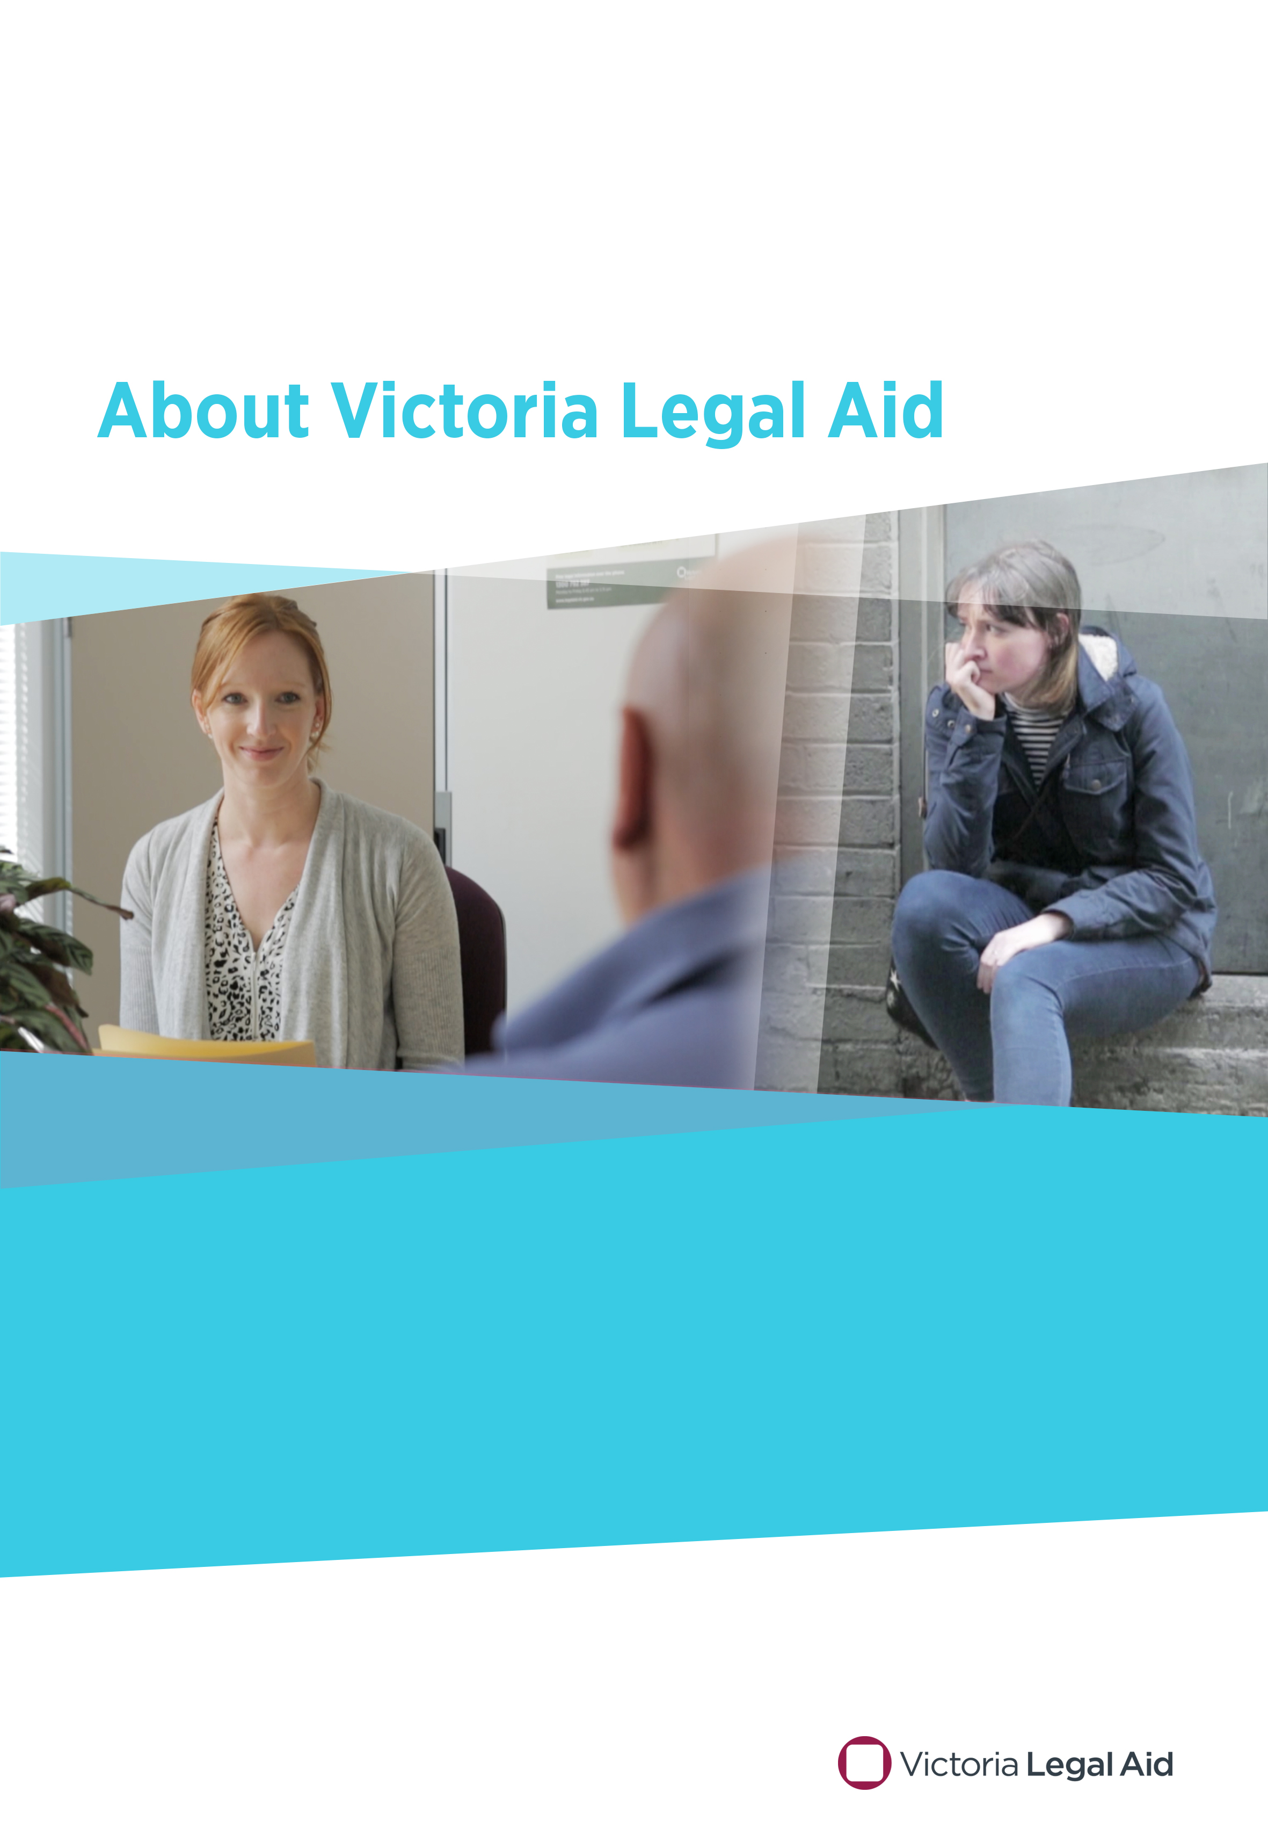
April 2017

Speakers’ notes
Do you need this resource in a different format?
Please ring us on (03) 9269 0234 and ask for Publications. We can talk with you about what you need.
Produced by the Community Legal Education team, Victoria Legal Aid
Tel: (03) 9269 0234
Email: cle@vla.vic.gov.au
First edition April 2017
© 2017 Victoria Legal Aid.
This work is licensed under a Creative Commons Attribution 4.0 licence. You are free to re-use the work under that licence, on the condition that you credit Victoria Legal Aid as author, indicate if changes were made and comply with other licence terms. The licence does not apply to any images, photographs or branding including the Victoria Legal Aid logo.
Disclaimer: The material in this publication is a general guide only. It is not legal advice. If you need to, please get legal advice about your own particular situation.

Contents
About Victoria Legal Aid – the kit 4
Who the kit is for? 4
Where to get copies of the kit 4
Suggested presentation format 6
10-minute presentation 6
30-minute presentation 6
Video transcript 7
Overview of the PowerPoint 8
Speakers’ notes 9
Slide one: introductory slide 9
Slide two: What does Victoria Legal Aid do? 9
Slide three: What can’t Victoria Legal Aid help people with? 11
Slide four: How do our lawyers work with clients? 11
Slide five: What sort of people do we help? 13
Slide six: How can someone contact us? 14
Slide seven: What happens when someone contacts us? 15
Slide eight: How can we work with you? 17
Suggested activity 18
Other useful notes 19

About Victoria Legal Aid – the kit
This kit describes what Victoria Legal Aid does for clients. It includes:
- a two-minute online video – see the video transcript
- a PowerPoint – see the overview of the PowerPoint
- these speakers’ notes, which support the video and PowerPoint.

Who the kit is for?
The kit is for any Victoria Legal Aid staff member who may be asked to present to intermediary workers about what we do.
Intermediary workers often play a crucial role in connecting us with clients. They might include:
- case managers
- family and youth workers
- health workers, such as drug and alcohol counsellors
- disability and mental health advocates
- community leaders (including culturally and linguistically diverse community leaders)
- staff from multicultural services like Spectrum and Migrant Resource Centres
- public sector and government staff from:
- police
- courts and tribunals
- prisons
- Centrelink
- local councils.
These intermediary workers might help their clients by:
- assisting their client to identify that they have a legal problem
- providing referrals to legal services
- providing legal information, such as booklets, brochures or links to online resources
- assisting with documentation
- accompanying their clients to appointments with lawyers and assisting in communication with lawyers
- coming to court with their client.

Where to get copies of the kit

The kit is available on our website
Go to www.legalaid.vic.gov.au and search ‘About VLA kit’ to download these speakers’ notes and the PowerPoint presentation and to show the video when you are presenting.
Note that the video can only be viewed online. Ensure that you have internet access if you’re planning to show the video.

Use the most up-to-date copies
We released the first edition of the kit in April 2017.
As we review and modify the PowerPoint or speakers’ notes, we will upload the revised versions on the website.
To ensure you’re using the most up-to-date versions, download these files from the website each time you use them.

Adapt this content to suit your needs
We encourage you to adapt the PowerPoint and these speakers’ notes to the needs of your presentation. Cut and paste content that’s relevant to your audience, and add in tailored content as needed.

Questions or feedback
Please contact the Community Legal Education team. Call us on (03) 9269 0223 or email us at cle@vla.vic.gov.au.

Suggested presentation format

10-minute presentation
Time | Task | Resources needed
2 minutes | Introduce yourself
8 minutes | Play the video  Invite discussion:  - What were some things you found out about Victoria Legal Aid?  - What are some of the questions your clients have about Victoria Legal Aid? | Video  Laptop or tablet  Data projector  Internet connection

30-minute presentation
Time | Task | Resources needed
5–10 minutes | Introduce yourself  Go around the room, if possible, and get the workers to introduce themselves
10 minutes | Invite discussion:  - What do you think Victoria Legal Aid does?  - Have you dealt with Victoria Legal Aid before on behalf of your clients?  - What are some of the questions your clients have about Victoria Legal Aid?  Play the video  Invite discussion:  - What were some things you found out about Victoria Legal Aid? | Video  Laptop or tablet  Data projector  Internet connection
10–15 minutes | Go through your tailored version of the PowerPoint.  Invite discussion or conduct an activity. | PowerPoint  Speakers’ notes  Laptop or tablet  Data projector

Video transcript
This is a transcript of the voice-over from the video URL:
Legal aid provides legal assistance to many people who can’t afford to pay for it.
But we all know it can be hard for people with complex problems to get the help they need.
If you work with people who are disadvantaged or at risk, you’ll have clients who need legal help.
Victoria Legal Aid provides free legal information and education services for everyone in the community, and more intensive forms of help to those who need them most.
We prioritise helping people facing serious consequences and those with complex needs.
We help people at court every day, visit prisons and mental health facilities, and provide help in many areas of law at our offices and outreach locations.
There are four main ways people can access help.
Visit our website for up-to-date information about a wide range of legal issues and to order free publications and education kits in English and many community languages.
For a new legal problem, call Legal Help, our state-wide telephone service where lawyers are on hand.
Visit the nearest Victoria Legal Aid office.
Speak to one of our lawyers on duty at many courts and tribunals across Victoria. It's a good idea to phone our Legal Help line first so we can help you prepare for court.
What happens once someone contacts us?
Our staff speak a range of languages and can get an interpreter if people need information in their own language.
We work out what type of help each person is eligible for.
We can provide information on the spot, or link a person with one of our services.
We can also refer people to other services or a community legal centre.
By helping your clients to use our services, you’ll be working with us to improve access to justice in the Victorian community.
For free information about the law and how we can help you, call Legal Help on 1300 792 387
Monday to Friday, between 8.45 am and 5.15 pm
To find your nearest office or for more information visit our website:
www.legalaid.vic.gov.au

Overview of the PowerPoint
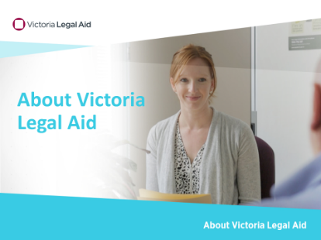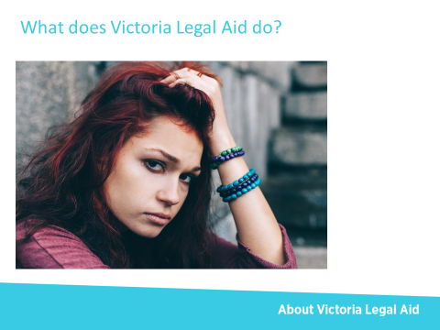
Slide one Slide two
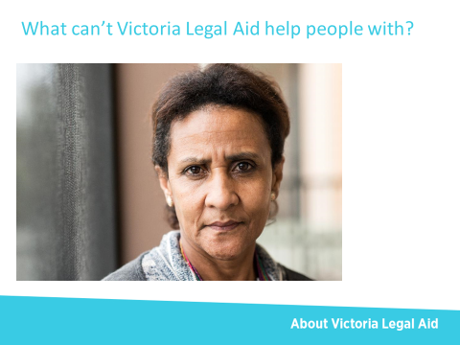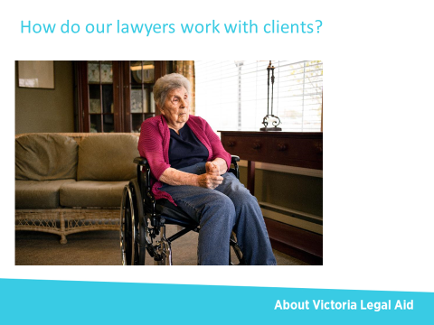
Slide three Slide four
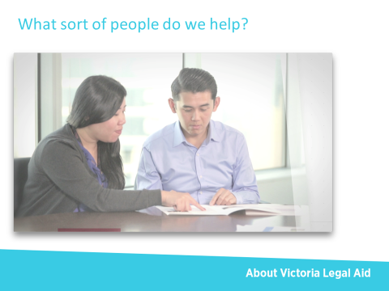 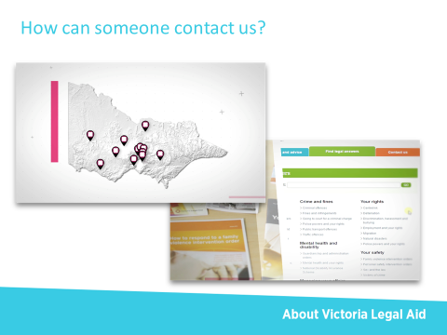\
Slide five Slide six
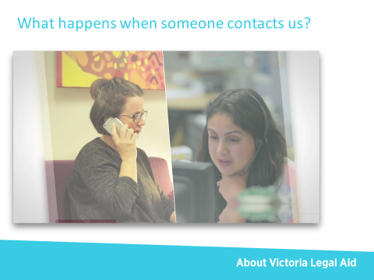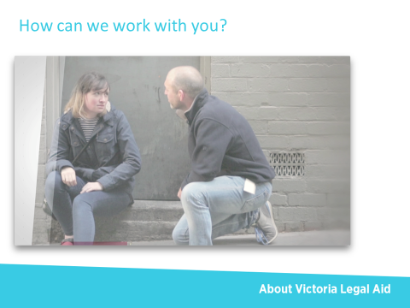
Slide seven Slide eight

Speakers’ notes

Slide one: introductory slide
No notes.

Slide two: What does Victoria Legal Aid do?
We help Victorian people in a variety of ways. In the video, we mentioned that we provide free information and education for everyone in the community, and more intensive forms of help to those who need them most. In this part of the presentation, we will go into more detail about the forms/types of help that Victoria Legal Aid offers.

Key messages
- We help Victorian people with their legal problems.
- We help across a wide variety of legal areas.
- We help individuals and we also work on changing the system.

We help Victorian people with their legal problems
- We are a government-funded agency with a legal mandate to help Victorian people with their legal problems.

We help across a wide variety of legal areas
- We help with legal problems about criminal matters, family breakdown, child protection, family violence, child support, migration, social security, mental health, discrimination, guardianship and administration, tenancy, debt and fines.

We help in a variety of ways
- We provide individuals with information and education, including:
- legal information on our website
- legal information booklets, which can be ordered from our website
- community legal education programs
- information and advice over the phone through our Legal Help phone service.
- We may be able to give advice or representation to an individual when an organisation, such as a government body, believes that an individual has done something wrong, such as:
- owing Centrelink money
- owing money on unpaid fines
- breaching immigration law.
- We may be able to give advice or representation to an individual when that person’s rights or personal freedoms are affected by:
- losing rights when detained in hospital under mental health laws
- losing rights as a tenant in public or private housing
- being treated unfairly because of discrimination or sexual harassment
- restrictions on employment or loss of employment because of being refused a Working with Children Check
- suffering injury as a victim of crime.
- We may be able to give advice or representation to an individual when the police have charged that person with a crime and the person is:
- getting ready for court and going through the court process
- going through a sentencing process.
- For young people under 18, we give advice or representation to an individual when the police have charged that person with a crime and the person is:
- getting ready for the Children’s Court and going through the court process
- going through a sentencing process.
- We may be able to give advice or representation to an individual when that person has legal issues to do with their relationship with their partner and with their children. The type of assistance we provide may include:
- assisting a parent or child to navigate child protection proceedings with the Department of Health and Human Services in the Children’s Court
- resolving issues with child support payments or obligations to pay. This includes establishing parentage to claim or cancel child support payments, seeking changes to child support assessments so parents pay a fairer share, and cancelling or adjusting child support debts
- resolving issues with spousal maintenance
- supporting parents to make parenting orders about living and contact arrangements for their children post separation that are safe and workable.
- We may be able to facilitate mediation with parents who have separated and are trying to reach an agreement about family arrangements.

We work on improving the legal system
- We contribute to law reform, including submitting to inquiries about changes to the law.
- For example, in 2015, Victoria Legal Aid made a submission to the Royal Commission into Family Violence. Our submission recommended ways to improve the legal response to family violence and maximise the effectiveness of legal services and court intervention to interrupt the cycle of violence. Some of our senior lawyers made witness statements and we provided statistics and data. (Note to the speaker – feel free to give another example about law reform).
- We run ‘strategic litigation’ cases for one or a few clients, where the outcomes could change the law for the benefit of more individuals.
- For example, we ran a case for a client where we challenged a decision by the Victorian Civil and Administrative Tribunal that if a home was rented out in poor condition from the outset, a landlord then had no obligation to bring it up to ‘good repair’. The Supreme Court found in favour of our client. The client was a disability support pensioner and had been struggling with mental illness and was living in her car before she took up tenancy in the dilapidated home. The decision will mean that more than 250,000 low-income Victorians in the private rental market are not forced to accept sub-standard, poor quality and sometimes dangerous housing. (Note to the speaker – feel free to give another example about strategic litigation).
- We work on making sure that our own legal services are accessible and high-quality.
- We support and train our lawyers to be client-oriented, professional and skilled.
- We undertake research and analysis to support the effective delivery of services.

What do we mean by ‘information’ and ‘advice’?
- You may hear us talk about legal ‘information’ and about legal ‘advice’.
- Legal information is general and cannot be relied upon as a recommendation for what a person should do; it is more about what they could do and what options they may have. We provide legal information via our staff (lawyers and non-lawyers) and in community legal education sessions, as well as in our publications and on our website.
- Legal advice takes into account the personal circumstances of the client and their legal matter. It can be relied on as a recommendation for what the client should do. The law says that only lawyers are qualified to give legal advice.

What do we mean by ‘grant of legal assistance’?
- You may hear us talk about our services in term of a ‘grant of legal assistance’.
- ‘A grant of legal assistance’ generally means getting a lawyer to help a client one-on-one, and that client getting representation.
- A grant of legal assistance is something that allows a lawyer to allocate time to work on a client’s matter, and usually means the lawyer can put in the time in to prepare a case and represent a client.
- Different people can apply for a grant of legal assistance:
- the individual with the legal matter can apply for this. However, the application form can be complex
- a private lawyer can apply for a grant on a client’s behalf to run that client’s case
- legal aid lawyers must apply for a grant when taking on more complex cases.
- Sometimes we refer individuals to a private lawyer because we cannot represent that person due to a conflict of interest. We may have represented, or be currently representing, the other party or someone involved in the matter such as a witness or co-accused.
- We have a section within Victoria Legal Aid that decides on the outcomes of legal aid grant applications.
- For more information see ‘Get a lawyer to run your case’ on the Victoria Legal Aid website.

Slide three: What can’t Victoria Legal Aid help people with?
In this part of the presentation, we are going to go into more detail about the types of legal issues that Victoria Legal Aid cannot help with or provides limited help with.

Key messages
- There are some legal matters that we cannot help with or that we provide limited help with.
- You and your clients can still call us to find out who else can provide help.

We do not help with all legal matters
- There are some legal matters that Victoria Legal Aid does not give legal advice about or provide representation for. This includes:
- business and commercial matters
- building, buying and selling houses and land
- defamation
- intellectual property
- pay disputes
- work injuries
- wills and deceased estates.
- Your client can still call us about these issues and we can give your client referrals about where to find help.

Slide four: How do our lawyers work with clients?
In the video, we talked about the various places where we can help people: at court, in prisons and mental health facilities, and at our offices and outreach locations. In this part of the presentation, we are going to talk about the different ways a lawyer works with a client. Your client may deal with receptionists and administrative staff too but we are going to focus on the work between a lawyer and a client. In a later part of the presentation we will talk about where clients can access our services.

Key messages
- Generally, our lawyers work on the client’s instructions.
- Our lawyers help in a variety of ways, from writing letters to appearing for your client in court.
- Our lawyers can connect clients to other services too.
- Our lawyers may help your client on a once-off basis or may be involved in an ongoing way with your client.
- Sometimes we meet with clients in our offices.
- Sometimes we are based where clients are.

We follow the client’s instructions
- This is a general principle that underpins the work of our lawyers.
- Our lawyers outline options and consequences to a client, and can advise on what they think the client should do. Ultimately, the lawyer works on the client’s instructions, provided they do not breach our overriding duty to the court and other ethical obligations.
- There are some exceptions to working on a client’s instructions. For example, when an accused client is unfit to plead, a child is too young to given instructions and has a best interests lawyer or a child in the family law courts is being represented by an Independent Children’s Lawyer
- Our lawyers act on a client’s instructions and this may differ from approaches taken by support workers who, when aiming to act in the client’s best interests may in some circumstances make decisions for the client that are not what the client wants.
- For example, we may have a client on a compulsory treatment order who is appearing before the Mental Health Tribunal. The client instructs their lawyer that they are not mentally ill and should not be on compulsory treatment even though there is strong evidence of a mental illness and a strong case from the treating team for treatment. Our lawyer would appear to represent the client before the tribunal, and present the client’s arguments as to why they do not meet the definition of mentally ill and therefore do not meet satisfy the criteria to be on a compulsory treatment order. (Note to the speaker – feel free to give another example about working on a client’s instructions).
- While we work on instructions, usually a judge, magistrate or tribunal member will make a final ruling or decision.

We work confidentially
- Anything a client says to our lawyers is confidential.
- We cannot share confidential information with carers, support workers or with the client’s family members, unless the client gives us permission.
- Phone calls to our Legal Help service are recorded for training purposes and for quality checks.

We do a variety of tasks when helping clients
- In providing advice or representation, our lawyers might:
- speak with the client about their legal issue and their current personal circumstances, and review letters or documents the client may have about it
- explain what the law says about the client’s legal issue or case and clarify the things the client may not understand or have misunderstood
- explain the next steps the client could undertake, including advising on time limits for taking certain actions
- explain the possible consequences if the client takes no action
- explain the possible penalties a magistrate or judge may give
- make referrals to non-legal services for other support
- get support letters or medical reports to support the client’s legal action
- provide self-help kits, worksheets or other resources so that clients can better prepare their own matters or responses.
- Our lawyers may write letters for the client or help the client to fill in legal documents and application forms.
- Our lawyers may make phone calls on the client’s behalf.
- Our lawyers may take instructions from the client and appear on their behalf in court or at a tribunal, and argue the client’s case. They may also brief another lawyer or a barrister to do this.
- Our lawyers may advise a client as to how the court or tribunal works, and how to prepare for being in court or tribunal.
- Our lawyers may send follow-up letters to clients after meetings or court/tribunal hearings explaining the outcome, options or next steps.

We may work with clients once-off or in an ongoing way
- How long we work with a client depends on the legal issue, the client’s circumstances and at what stage the client approached us. The lawyer may help on a once-off basis or in a more ongoing way.

We service clients in different locations
- Our lawyers are based in one of our 14 offices across Victoria. A client may meet with one of our lawyers at the office, speak to them over the phone or have a video conference or face-to-face visit if they are in prison.
- We also have lawyers working in an outreach model – we refer to these as duty lawyers. We have duty lawyers at:
- most Magistrates’ Courts across Victoria
- most Children’s Courts in the city and across Victoria
- the Victorian Civil and Administrative Tribunal in the city
- most mental health wards in public hospitals across Victoria.
- Our duty lawyers may be based at these sites every day or on a weekly or fortnightly basis.
- In some areas of Victoria, our lawyers may have arrangements to be onsite in other organisations, such as within a secondary school or community centre.

Slide five: What sort of people do we help?
In this part of the presentation, we are going to talk more about who we help. We will talk about our priority audiences.

Key messages
- We help all Victorians but we provide different levels of services to different people.
- Our more intensive services are for people facing serious consequences and people living on low incomes and with complex needs.
- We triage and assess people’s legal problems to make a decision about the best way to assist them.
- It is best for the person who has the legal problem to call through to our Legal Help phone service to find out exactly how we can help.

We have different levels of service
- We help all Victorians; it is within our legal mandate to do so.
- Some of our services are available to everyone – anyone in Victoria can call our Legal Help phone service, get information on a range of legal topics our website, or order one of our free factsheets or booklets.
- Our more intensive services are for people facing serious consequences and people on low incomes and with complex needs. More intensive services include one-on-one time with a lawyer for tailored legal advice or representation.

We prioritise helping people facing serious consequences
We prioritise helping people facing serious consequences. This includes:
- people in a psychiatric in-patient unit
- children or young people going to the Children’s Court
- people who are at court for applying for or responding to a family violence intervention order or are at risk of family violence
- people who are in custody or facing a serious penalty such as a prison sentence, being put on a community correction order or getting a big fine.

We prioritise people on a low income
We prioritise people living on low incomes, such as a Centrelink benefit. We also seek to identify people with complex needs, such as:
- people with an intellectual disability, an acquired brain injury or mental illness
- people who are experiencing or at risk of homelessness
- people who cannot speak, read or write well in English
- people who are Aboriginal or Torres Strait Islander
- children and young people under 18.
Understanding when a client has complex needs helps us to tailor our services and assess what level of service the client may be able to receive.

We triage and assess people
- We discuss What happens when people contact us in a later slide.
Note to the speaker – you can go into detail later or talk about triaging and assessing at this point.

Confirming if your client can get advice or representation
- We recommend that your client call our Legal Help phone service to see how we can help. Our guidelines for who we can help and what legal problems we can help with do change over time – we review what we do on a regular basis and from time to time we receive different funding for new services.
- It is important individuals with a legal problem speak directly to us about what sort of help they might be eligible to receive. Don’t rule out a client based on what you may have heard, or based on your own experience with other clients – ask them to call us. Our guidelines can be complex and each person’s circumstances are different.

Slide six: How can someone contact us?
In the video, we talked about the four main ways that you access Victoria Legal Aid: our website, on the phone through our Legal Help, one of our offices, and at many courts and tribunals across Victoria. In this part of the presentation we are going to talk more about these access points.

Key messages
- We have offices across the state.
- We provide some services on site within other organisations.
- We have a website and a phone line.
- Clients can call or visit, or we may be visiting your clients where they are.
- Some clients will have existing relationships with our lawyers.
- Our services are free or low-cost.

We work throughout Victoria
- Victoria Legal Aid employs nearly 800 staff. We are located at 14 offices across Victoria:
- in the city
- in metropolitan suburbs covering north, south, west and east: Broadmeadows, Dandenong, Frankston, Ringwood, and Sunshine
- in regional areas: Ballarat, Bairnsdale, Bendigo, Geelong, Horsham, Mildura, Morwell, Shepparton, and Warrnambool.
- We are also located in an outreach model in:
- courts and tribunals
- mental health facilities in public hospitals
- several outreach locations in Melbourne and in country areas.
- We visit or provide video conference appointments for people in Victorian prisons and are piloting a dedicated prisoner phone line within some prisons.
- We have new Aboriginal Community Engagement Officers in two locations (Morwell and Melbourne) and will soon have an Aboriginal Community Engagement Officer in Mildura. These officers assist clients with family and civil law matters.

We are online and on the phone
- Our website is www.legalaid.vic.gov.au.
- In the section Get legal services and advice you can find information about:
- how to get free legal advice
- who is eligible for help
- how to get a lawyer to run your case
- family dispute resolution
- clients’ rights and what to expect from Victoria Legal Aid services.
- Our Legal Help phone service is open Monday to Friday, from 8.45 am to 5.15 pm. We have language lines with bi-lingual workers. (Note to staff – please refer to the Speak to us in your language page on our website for a list of current languages).
- If we do not have a bi-lingual worker who speaks your client’s language, or the bi-lingual worker is not available to take the call, your client can phone the Translating and Interpreting Service on 131 450 for an interpreter in their language and then ask to be put through to Legal Help.
- People who are deaf or have a hearing or speech impairment can use the National Relay Service to call us over the internet on 1300 792 387. This is a free service. TTY users can call 133 677 and then ask for 1300 792 387. Speak and listen users can call 1300 555 727 and then ask for 1300 792 387.
- Our Prisoner Legal Help phone service is available in some prisons.

Supporting your clients to contact us
- If your client has got a court or tribunal date, we recommend that they phone our Legal Help phone service first so we can help them prepare for court. There may be things your client can do ahead of time that can help them on the day of their court hearing.
- Your client can call, visit, look at our website or find the duty lawyer at court or you can help on their behalf. In some cases, your clients may have used our services before or may be an existing client.
- You can be a support person for your client if they have a meeting with us or have an appearance at court or at a tribunal.
- We also talk about How we can work with you in a later slide.

We are low-cost or free
- The following services are free:
- calling Legal Help or Prisoner Legal Help (available in some prisons)
- using the website or ordering a booklet
- having a community legal education session delivered
- getting some basic advice on a legal matter (if eligible).
If a client needs an interpreter, they will not have to pay for this.
- Usually, anyone on a Centrelink benefit will not pay for representation.
- A client who is a young person under 18 will not pay for our services.
- Some services that involve representation or a grant of legal assistance may have a cost, depending on the financial situation (income and assets) of the client. These costs are usually small co-contributions.

Slide seven: What happens when someone contacts us?
The video explains what someone can expect when they contact us:
- we have accessible services for people who do not speak English or speak very little English
- we undertake a triaging and assessment process to work out what help is best for the person
- we may give information on the spot or link a person with one of our services
- we can refer people to other services or a community legal centre.
In this part of the presentation we are going to talk more about accessibility, our triaging and assessment, and internal and external referrals.

Key messages
- We try to ensure that our services are accessible to people who speak no or little English, people with a disability and to Aboriginal and Torres Strait Islanders.
- We assess and triage people for our more intensive services.
- We may make a referral into our own organisation or refer someone out to another organisation.

We have accessible services
Language
- We have many bi-lingual workers working in our Legal Help phone service.
- If we do not speak someone’s language, we can organise an interpreter. We can do this for phone calls and for meetings. Sometimes when our lawyers are on duty in outreach locations, we may not be able to organise an interpreter immediately. Some places, like courts, may have interpreters they use.
- Some of our publications are also translated, and basic information about our services is translated on our website.
Disability
- We can use the National Relay Service for phone calls where the person calling has a communication disability.
- All our offices are wheel-chair accessible. Our staff are accommodating for clients who wish to bring along a carer or support person.
- Appointments can often be extended for people who may require more time to process information and advice.
- The information, media and downloads on our website meet government guidelines for accessibility for people with a visual disability.
Aboriginal and Torres Strait Islander clients
- We have a Reconciliation Action Plan and are committed to working more effectively with Aboriginal-led organisations and Aboriginal and Torres Strait Islander clients.
- If we cannot assist a client, or if they want to use an Aboriginal organisation, such as the Victorian Aboriginal Legal Service or the Aboriginal Family Violence Prevention and Legal Service, we can assist with referrals.
- Aboriginal flags and acknowledgement of county are clearly displayed in each office to provide an initial sign of respect and welcoming atmosphere.
- Many of our staff have undertaken Aboriginal awareness cultural training.

Dealing sensitively with clients
- Our staff are experienced when it comes to communicating with people who may be alcohol or drug affected, experiencing a mental illness, who have an acquired brain injury or who may be experiencing extreme emotional stress.

We triage and assess people for eligibility for our more intensive services
- Anyone can access information from our website and order our publications.
- For more intensive services, we have triaging and assessment processes that we use to assess what level of help we can provide.
When someone calls us:
- the caller will be asked a series of triaging questions about:
- their personal circumstances (such as income)
- their legal matter.
- If it is a legal matter we can help with, the phone worker will assess:
- if the caller needs information or advice that can be provided within the phone-call
- if the caller needs advice from a specialist lawyer, which may result in transferring the call through or booking an appointment
- what other legal aid services and assistance can be provided. We may make arrangements for an appointment or tell the person how to get the appointment.
- If it is not a legal matter we can help with, the phone worker will:
- let the caller know and provide a referral to an appropriate service.
When someone visits one of our offices
- The client may arrive at one of our reception desks and ask to see a lawyer. Note that there are no drop-in, face-to-face legal advice services at our offices, the client would be attended to by one of our receptionists.
- The receptionist will ask a series of questions about:
- their personal circumstances
- their legal matter.
- If it is a legal matter we can help with, the receptionist will assess:
- if the client needs to be referred to call our Legal Help phone service
- if the caller needs advice from a specialist lawyer, which may result in booking an appointment. This is generally for a later date and the client will need to come back.
- If it is not a legal matter we can help with, the receptionist will:
- let the client know and provide a referral to an appropriate service.
When someone uses one of our outreach services:
- they may arrive at a designated office or meeting place where one of our lawyers is stationed.
- A clerk or the lawyer will ask a series of triaging questions about:
- the client’s personal circumstances
- their legal matter.
- If it is a legal matter we can help with, the clerk or the lawyer will assess if the client needs legal information, advice or representation.
- If it is not a legal matter we can help with, the clerk or lawyer will let the client know and provide a referral to an appropriate service.

We may refer a person into our own organisation or out to another organisation
- Sometimes we refer a person into one of our own services. We may provide some preliminary information at the time of making the referral/booking.
- We may also refer someone to another organisation or to a private lawyer who can apply for a grant of legal assistance. Sometimes we cannot help someone because we do not provide help with their particular legal matter or because there is a conflict of interest.

Who else can help your clients with their legal issues?
- Community legal centres also provide legal services to the public:
- some community legal centres provide services to particular groups in the community, such as people with a disability or focus on particular areas of law, such as consumer issues. Other community legal centres provide services to people living or working within their region
- see the Federation of Community Legal Centres website (www.communitylaw.org.au) to find a community legal centre near your client or who can help with your client.
- Community legal centres and Victoria Legal Aid provide similar services, and sometimes we work closely together. Understandably, sometimes people confuse the two. However, we are separate organisationally from community legal centres.
- Some private lawyers can apply for a ‘grant of legal assistance’ from us, and this allows them to represent a client for matters that are eligible for legal aid.

Slide eight: How can we work with you?
In the video, we focussed on how Victoria Legal Aid supports clients. In this part of the presentation, we are going to talk about the ways we can work with you.

Key messages
- We may work with you directly in relation to a shared client.
- We can provide training to workers in other organisations on some areas of the law, with an emphasis on clients’ rights and responsibilities.
- We work with partners like you to educate individuals in group settings, on issues that are likely to affect that group.
- We can work together on projects and service delivery.

We may work together with a shared client
- We may refer a client to you or you may refer a client into Victoria Legal Aid.
- You may be supporting your client at meetings with a Victoria Legal Aid lawyer. For reasons of confidentiality we may need to see the client alone, at least for part of the interview or meeting.
- We may contact you for letters or documentation.

We can train you in some areas of the law
- We have expertise in areas of civil and administrative law, criminal law, youth law and family law.
- We can tailor training for your staff as it relates to the rights and responsibilities of your clients. We generally do not deliver training about your professional legal obligations.

We can deliver education for your clients
- We collaborate with other organisations across Victoria and nationally on legal education projects targeted to particular groups or to address specific legal issues.
- We can work with you to deliver one-off education sessions or a program of sessions.
- We also have existing programs that we can deliver or you may want to deliver:
- Settled and Safe: for newly arrived communities about Australian laws regarding family relationships
- Learning the law: teaching tools for secondary specialist school teachers
- Sex, young people and the law: legal education about sexuality for secondary school students
- What's the law? Australian law for new arrivals: addresses common legal issues encountered by new arrivals in their first years of settlement
- Australian law in orientation: a simplified version of What’s the law?
- These kits for these programs are all on the Victoria Legal Aid website (www.legalaid.vic.gov.au/find-legal-answers/all-publications-and-resources).

We can partner together on projects and services
- Sometimes when an issue, timing and resources align, we may find ourselves working together on projects or service delivery.
- At other times, we may sit on your advisory groups and vice versa.

Suggested activity
You run this activity if you have time if it’s suitable for your audience.

Activity – Helping Kim
Scenario:
During your last meeting, Kim mentioned that he was worried about all the speeding fines he had collected. He laughed them off a bit but was worried he might end up without a licence and with an even bigger fine. ‘Doesn’t matter. I’ll just drive without a licence if I want to anyway. They can’t stop me. I wasn’t really speeding that much. They can’t make me pay, can they?’
Questions:
- Are you confident to answer this client’s questions?
- How would you assist this client to seek legal advice? What can you tell or do for him?
- What do you think Victoria Legal Aid could do for Kim?

Other useful notes

Common calls to Legal Help
In 2015-16, Legal Help received 186,389 calls, an increase of 13.5 per cent. We dealt with 111,504 of these calls (2 per cent less than last year) and 121,771 matters (9 per cent less than the year before).
The top five matters dealt with by our Legal Help telephone service were:
- family law
- driving and traffic charges
- family violence
- infringements
- property settlement.

Popular publications

Am I old enough? | Police powers
Safe at home | Your day at court

Popular pages on our website
Writing a character reference (www.legalaid.vic.gov.au/find-legal-answers/going-to-court-for-criminal-charge/writing-character-reference)
Criminal records (www.legalaid.vic.gov.au/find-legal-answers/going-to-court-for-criminal-charge/possible-outcomes-for-criminal-offences/criminal-records)
Age of consent (www.legalaid.vic.gov.au/find-legal-answers/sex-and-law/age-of-consent)
Drug possession (www.legalaid.vic.gov.au/find-legal-answers/criminal-offences/drug-possession)
Driving and accidents (www.legalaid.vic.gov.au/find-legal-answers/traffic-offences/driving-and-accidents)
What the court considers when making a parenting order (www.legalaid.vic.gov.au/find-legal-answers/parenting-arrangements-and-child-contact/parenting-orders/what-court-considers-when-making-parenting-order)
Divorce (www.legalaid.vic.gov.au/find-legal-answers/separation-divorce-and-marriage-annulment/divorce)
Family violence intervention orders (www.legalaid.vic.gov.au/find-legal-answers/family-violence-intervention-orders)
Demerit points (www.legalaid.vic.gov.au/find-legal-answers/traffic-offences/possible-outcomes-for-traffic-offences/demerit-points)

