Training materials: Day two
Settled & Safe

© 2026 Victoria Legal Aid. Reproduction without express written permission is prohibited. Written requests should be directed to Victoria Legal Aid, Research and Communications, 350 Queen Street, Melbourne Vic 3000.
Disclaimer. The material in this publication has been prepared for Victoria Legal Aid staff and community legal centre staff and volunteers for study purposes only. The information contained should not be relied upon as legal advice, and should be checked carefully before being relied upon in any context. Victoria Legal Aid expressly disclaims any liability howsoever caused to any person in respect of any legal advice given or any action taken in reliance on the contents of the publication.
Contents
Training materials: Day two 1
About this training 1
Introduction 1
Aims and objectives 1
Information not advice 1
Victoria Legal Aid services 1
Call us for help with your legal problem 2
Publications 2
Activity: Reflections 2
Family violence activity: What behaviours are violent, non-violent and depends 2
Violent 2
Not violent 2
Depends 2
Family violence: Family Violence Protection Act 2008 2
Definition of family violence. 2
Family violence is behaviour that: 3
Family violence: Discussion 3
Family violence: Defining the issues 3
Criminal 3
Grounds for an intervention order 3
Family violence: Police response 4
Victoria Police Options Model 4
Family violence: Activity – explaining intervention orders 4
Family violence: Intervention order process 5
Intervention Order Process 5
Family violence activity: Barriers disclosing family violence 5

Training materials: Day two

About this training

Introduction
Settled & Safe is designed to increase awareness of family law and family violence in newly emerging communities by:
- increasing settlement service providers’ knowledge of family violence, Victorian legal responses to family violence, and VLA services
- collaborating with settlement service providers to deliver legal information sharing programs to newly emerging communities
- increasing VLA’s organisational responsiveness to newly emerging communities with a particular focus on the prevention of family violence.

Aims and objectives
Settlement worker training aims to improve settlement workers’ understanding of the laws and legal processes for resolving family matters, and how members of newly emerging communities can access legal help and services. By the end of each legal session settlement workers will be able to:
- describe the process of a matter through the relevant system
- describe roles in the system
- identify key principles of the relevant legislation
- refer clients for legal advice or assistance.
The training is delivered over two days. This training program must be undertaken by settlement workers if they are partnering with a legal service provider to deliver the Settled & Safe information sharing program.

Information not advice
This training and the related materials are intended as a general guide only. Recipients of training should not act on the basis of any material in this training without getting legal advice about their own particular situation. Victoria Legal Aid expressly disclaims any liability howsoever caused to any person in respect of any action taken in reliance on the contents of this publication.
The materials that support this training reflect the law and legal processes in April 2014. To check for changes in the law you can:
- call Victoria Legal Aid’s Legal Help phone line on 1300 792 387
- visit Victoria Legal Aid’s website at www.legalaid.vic.gov.au

Victoria Legal Aid services
Victoria Legal Aid is a statewide organisation that helps people with their legal problems. We focus on helping and protecting the rights of socially and economically disadvantaged Victorians.
We have lawyers in offices in most major metropolitan and country regions. We also fund private lawyers to provide legal services to the public.

Call us for help with your legal problem
Call us on 1300 792 387, Monday to Friday, 8.45am to 5.15pm for free information about the law and how we can help you.

Publications
Victoria Legal Aid has publications in various languages targeting common issues of concern for newly emerging communities, such as:
- driving
- consumer issues
- fines
- debt.
There are also publications specifically about family violence and family law.
Publications can be downloaded or ordered for free by visiting the Victoria Legal Aid website and following the links to: free publications.

Activity: Reflections
In small groups share with each other (5 minutes):
What was the most important piece of information you learnt from day one?

What is one thing you are hoping to learn today?

Family violence activity: What behaviours are violent, non-violent and depends
In small groups consider each of the behaviours listed by the presenter and decide if you think the behaviour is family violence. Write each of the behaviours in one of the three columns provided – violent, not violent or depends. If the answer is ‘depends’, write down what it depends on (15 min).
Violent | Not violent | Depends

Family violence: Family Violence Protection Act 2008

Definition of family violence.
Family violence is behaviour that is:
- physically or sexually abusive
- emotionally or psychologically abusive
- economically abusive
- threatening or coercive.

Family violence is behaviour that:
- controls or dominates a family member and causes that person to feel fear for their safety or wellbeing (or anyone else)
- causes a child to hear or witness, or otherwise be exposed to, the effects of family violence.
Notes:
___________________________________________________________________________________________________________________________________________________________________________________________________________________________

Family violence: Discussion
What are your thoughts on the Jaber and Zahara video?

What support does this family need? (Think about each of the characters individually)

Family violence: Defining the issues
Activity: Has Jaber done anything wrong?
Criminal | Grounds for an intervention order

Family violence: Police response

Victoria Police Options Model
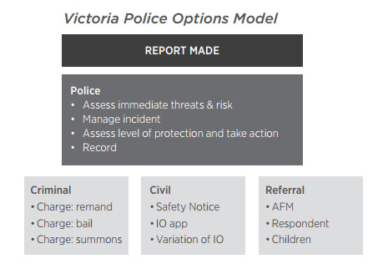
Notes:
_____________________________________________________________________________________________________________________________________________________________________________________________________________________________________________

Family violence: Activity – explaining intervention orders
Take turns in explaining to other members of your group what an intervention order is.
What are the key elements of a good explanation?

Notes:
_____________________________________________________________________________________________________________________________________________________________________________________________________________________________________________

Family violence: Intervention order process

Intervention Order Process
Application at Magistrates’ Court family violence safety notice
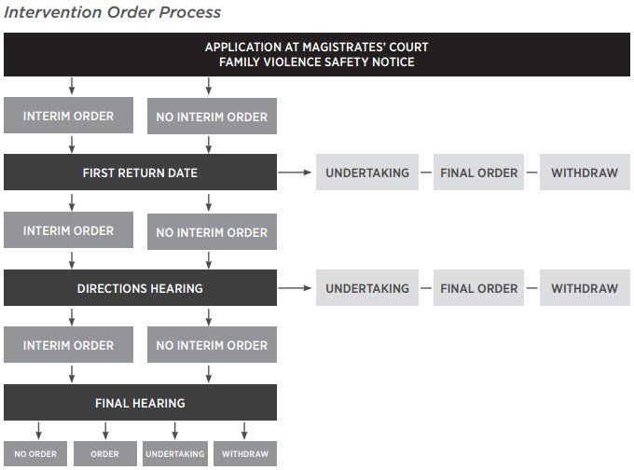
Notes:
_____________________________________________________________________________________________________________________________________________________________________________________________________________________________________________

Family violence activity: Barriers disclosing family violence
In small groups discuss the following.
What ideas or beliefs might stop someone from seeking assistance?

What ideas or beliefs might support someone to seek assistance for their safety?

